Table S1. Details on previous studies from which the analyzed samples were obtained
Country | Study site | Study ID | Year | Study design | Study participants
Tanzania | Muheza designated district hospital, and Morogoro Regional Hospital | 1007-PF-TZ-DUFFY | 2010 | Longitudinal, and Cross-sectional study designs | Pregnant women, children and infants
Tanzania | Muleba, Muheza and Nachingwea | 1095-PF-TZ-ISHENGOMA | 2013 | Clinical trial (Therapeutic Efficacy Studies) | Patients attending clinics/hospitals
Tanzania | Muheza Designated District hospital and Ujiji Health Centre | 1167-PF-TZ-ISHENGOMA-SM | 2014 | Randomized clinical trial | Infants (6 months) and children aged up to 10 years with uncomplicated Malaria
Kenya | Kilifi | 1015-PF-KE-NZILA | 2007 | Cross-sectional studies | Children with acute febrile malaria
Kenya | Kilifi | 1027-PF-KE-BULL | 2007 | Not Available | Not Available
Kenya | Kisumu | 1107-PF-KEN-KAMAU | 2014 | Cross-sectional studies | Patients with uncomplicated malaria aged between 6 months and 65 years
Kenya | Kilifi | 1132-PF-K1000G-DBS-KE-BEJON | 1994 - 2018 | Longitudinal cohort studies | Symptomatic and asymptomatic participants in Kilifi regions
Uganda | Apac | 1024-PF-UG-BOUSEMA | 2010 | Cross-sectional and longitudinal studies | Children and adults residing in malaria endemic region
Ethiopia | Amhara, Oromia | 1098-PF-ET-GOLASSA | 2013-2015 | Cross-sectional studies | P. falciparum malaria patients

Assessment of per-site missingness across the phistb gene
The biallelic filtered VCF data was used to assess per-site missingness of the phistb gene. VCFtools was used to assess the per-site missingness of the phistb gene and the observed values were plotted as a fraction of per-site missingness against genomic positions (Supplementary figure 1).

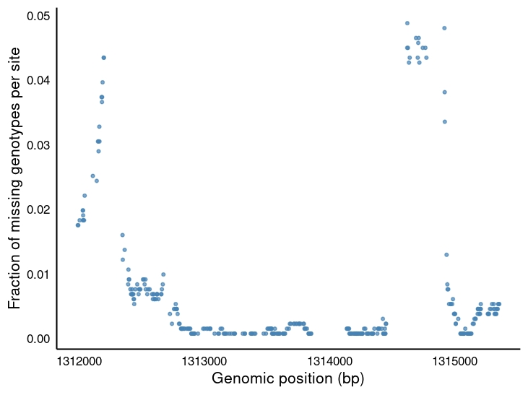
Figure S1. Fraction of missing data per site across genomic positions along the phistb gene. Each dot represents an individual genomic position, plotted by its location within the gene (x-axis) and the fraction of SNPs with missing genotype data at that site.

Comparison of clonality estimations between MalariaGEN whole genome-based,and phistb-based estimations
MalariaGEN provides a whole genome-based estimation of clonality. To have a deeper understanding of the clonality, we analyzed clonality based on phistb gene using the FWS metrics. Our phistb-based values were then plotted for each subpopulation (supplementary figure2), and compared to those generated by the MalariaGEN. The proportion of samples classified as monoclonal differed significantly between the two approaches (54.7% for MalariaGEN and 66.7% for phistb-based estimates; two-sample test for equality of proportions, p < 0.001), indicating a systematic difference in classification. Agreement between methods was assessed using a 2 × 2 contingency table comparing sample-level classifications. Overall agreement was 81.63%, with most discrepancies arising from samples classified as polyclonal by MalariaGEN but monoclonal by the phistb-based approach (Supplementary Table 1, 2 &3), likely due to methodological differences (whole-genome vs gene-based estimation).

Table S2. Clonality Classification Using MalariaGEN Whole-Genome Fws and phistb-Based Fws
 | MalariaGEN_Fws (n, %) | phistb-based_Fws (n, %)
Monoclonal | 718(54.73%) | 875 (66.7%)
Polyclonal | 594(45.27%) | 437 (33.3%)
Total | 1312 | 1312

Table S3. Comparison of Clonality assessment using MalariaGEN Whole-Genome Fws and phistb-Based Fws
Comparison | Proportion (Monoclonal) | x-squared | Df | 95%CI (difference) | p-value
MalariaGEN vs phistb-based clonality | 0.547 vs 0.667 | 38.88 | 1 | −0.158 to −0.082 | 4.50 × 10⁻¹⁰

Table S4. Agreement between MalariaGEN and phistb-based methods for clonality assessment.
phistb-based estimation | MalariaGEN-based estimation
phistb-based estimation | Monoclonal | Polyclonal
Monoclonal | 676 | 42
Polyclonal | 199 | 395

Agreement: (Number of agreements)/Total observation

((676 + 395)/1312) * 100 = 81.63%

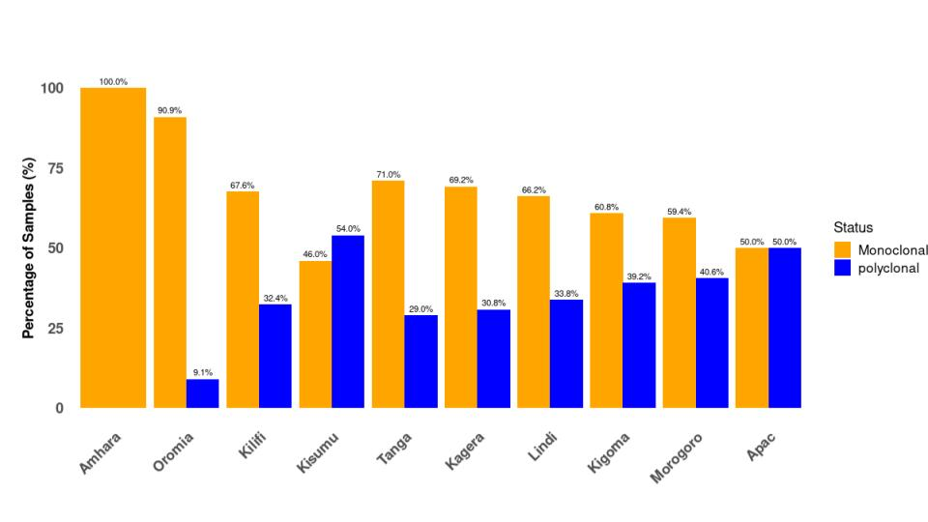
Figure S2. A bar plot showing infection clonality status across the study sub-populations, used to assess within-host diversity based on the FWS metric. The x-axis represents the study sub-populations, while the y-axis represents the percentage of sample. The orange color represents Monoclonal infections while blue represents a polyclonal infection.

Table S5. Genetic diversity metrics of the phistb gene among the Ethiopia, Kenya, Tanzania, and Uganda sub-populations.
Population | (n) | (s) | H | K | π | Hd
Amhara | 10 | 9 | 4 | 2.73 | 0.000 | 0.77
Apac | 12 | 7 | 6 | 2.39 | 0.000 | 0.87
Kagera | 52 | 14 | 20 | 3.49 | 0.001 | 0.88
Kigoma | 143 | 29 | 67 | 3.26 | 0.000 | 0.87
Kilifi | 627 | 46 | 115 | 3.17 | 0.009 | 0.88
Kisumu | 63 | 18 | 30 | 3.65 | 0.001 | 0.92
Lindi | 65 | 15 | 23 | 2.81 | 0.000 | 0.84
Morogoro | 32 | 16 | 16 | 3.8 | 0.001 | 0.9
Oromia | 11 | 3 | 3 | 1.38 | 0.000 | 0.72
Tanga | 297 | 23 | 60 | 3.15 | 0.009 | 0.87

Table S6. FST values for genetic differentiation among the ten subpopulations studied
 | Kilifi | Kisumu | Tanga | Morogoro | Lindi | Kagera | Apac | Oromia | Amhara | Kigoma
Kilifi | 0 | 0.0016 | 3.00E-04 | 0 | -6.00E-04 | -5.00E-04 | 0.0054 | 0.0059 | -1.00E-04 | 0.0011
Kisumu | 0.0016 | 0 | 0.0021 | -1.00E-04 | 0.0017 | 4.00E-04 | 0.0121 | 0.0097 | 0.0023 | 0.0044
Tanga | 3.00E-04 | 0.0021 | 0 | 2.00E-04 | -5.00E-04 | 4.00E-04 | 0.0028 | 0.0051 | -9.00E-04 | 2.00E-04
Morogoro | 0 | -1.00E-04 | 2.00E-04 | 0 | 3.00E-04 | -0.0012 | 0.0091 | 0.0072 | -0.0023 | 0.0019
Lindi | -6.00E-04 | 0.0017 | -5.00E-04 | 3.00E-04 | 0 | -2.00E-04 | 0.0037 | 0.0037 | -0.001 | 2.00E-04
Kagera | -5.00E-04 | 4.00E-04 | 4.00E-04 | -0.0012 | -2.00E-04 | 0 | 0.0068 | 0.0099 | 0.0014 | 0.0015
Apac | 0.0054 | 0.0121 | 0.0028 | 0.0091 | 0.0037 | 0.0068 | 0 | 0.008 | 0.0045 | 0
Oromia | 0.0059 | 0.0097 | 0.0051 | 0.0072 | 0.0037 | 0.0099 | 0.008 | 0 | -0.003 | 0.0039
Amhara | -1.00E-04 | 0.0023 | -9.00E-04 | -0.0023 | -0.001 | 0.0014 | 0.0045 | -0.003 | 0 | -0.0012
Kigoma | 0.0011 | 0.0044 | 2.00E-04 | 0.0019 | 2.00E-04 | 0.0015 | 0 | 0.0039 | -0.0012 | 0

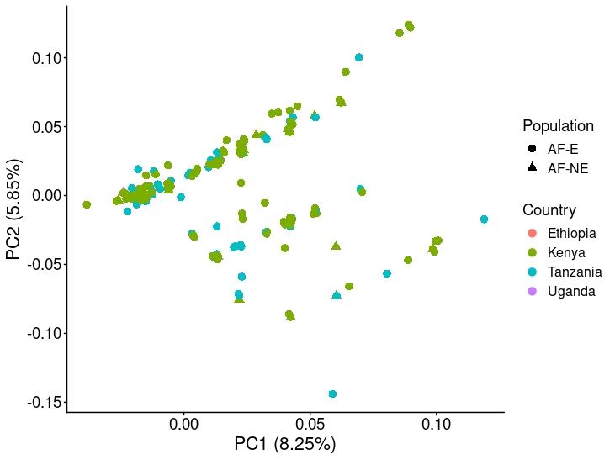

Figure S3. A plot on the first and second Principal components (PC1 & PC2) for Tanzania, Kenya, Uganda, and Ethiopia parasites population. The shape and color of the dots represents the population and country where the samples were taken.

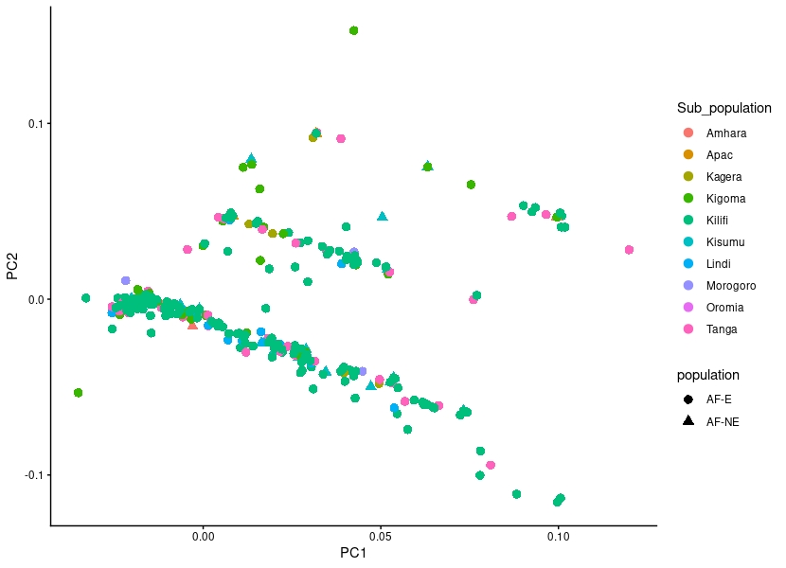
Figure. S4. Plot of the first and second Principal components (PC1 & PC2) for parasites collected from all sub-populations in the four countries, each color used indicates one subpopulation.

