West African hut – Window Slit
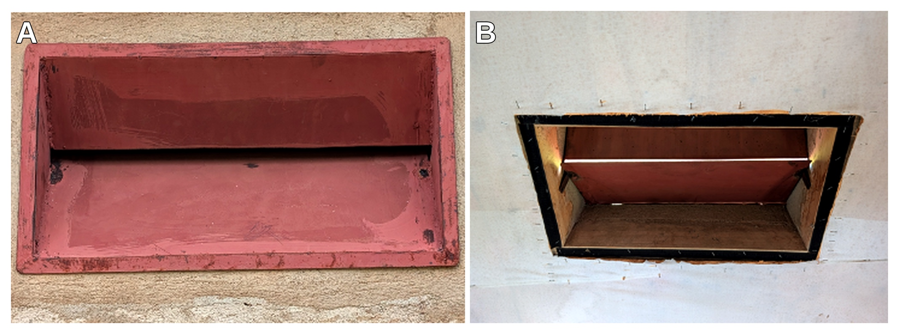

Figure S1. West African hut window slit. (A) Outer view: outermost window slit opening 52 × 40 cm (≈ 2080 cm²); hinged iron flaps — upper inserted 21 cm, lower inserted 27 cm — funnel it to a final 1 cm slit. (B) Inner view of the funnelled slit (≈1 × 52 cm ≈ 52 cm²)

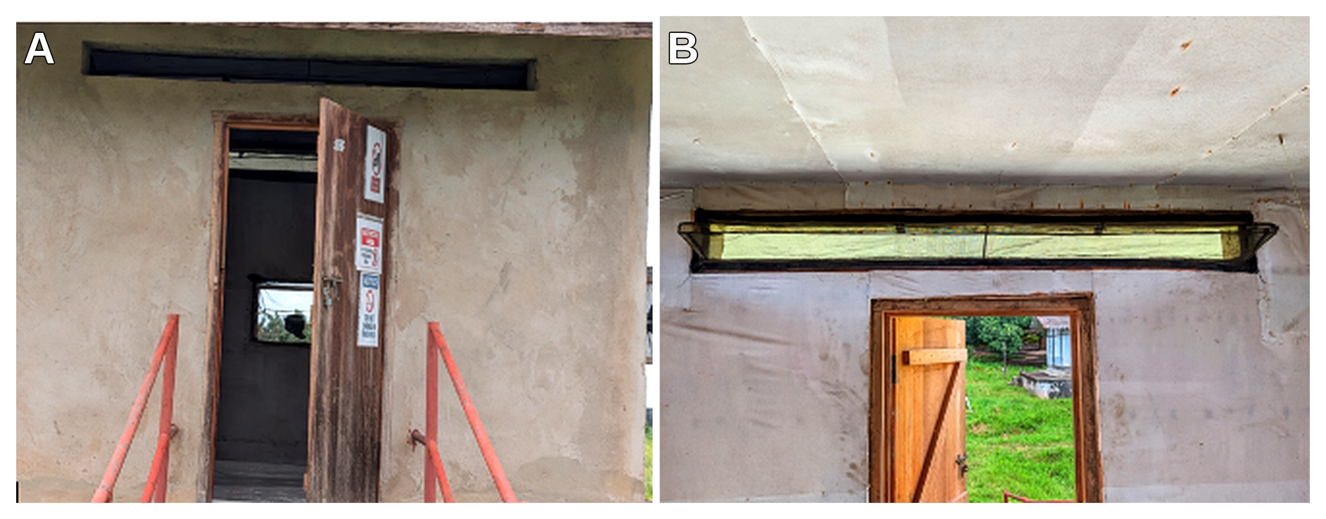

Figure S2. Rapley hut entry point. (A) Outer view; (B) inner view. The eave points funnels from 200 × 15 cm (3000 cm²) to a 200 × 2 cm entry (400 cm²) on four sides.

IFAKARA HUTS
Figure S3. Ifakara hut, (A) inner view of the eave entry, (B) Outside view. Outermost entry is 330 cm long, gable eave is 365cm by 10cm (eave physical opening). On the inside, the eave opening is 6 cm(i.e, the outer eave funnels to 6cm in the inside).

EAST AFRICAN HUTS
Figure S4. East African (Lupiro) hut eave entry. (A) Inner view: the eave funnels to a 20 × 5 cm entry slit. (B)Outside view — showing the eave opening (outermost opening , Inside the veranda) ≈ 140 × 15 cm.

