Supplementary Material

Methods

Genotyping Methods for Confirmation of Mosquito Species, Identification of An. stephensi Biotypes and Assessment of Insecticide Resistance Markers
Individual An. stephensi mosquito specimens were homogenised and DNA extracted using the Qiagen DNeasy Blood & Tissue kit (Qiagen, Manchester, UK) following the manufacturer’s protocol. Briefly, this involved homogenising the sample followed by DNA purification using a spin column and elution in 30 µl DNAse-free water. DNA yield was measured using an N60 spectrophotometer (Implen, Munich, Germany).
Endpoint PCR molecular assays performed on the An. stephensi DNA extracted included an assessment of DNA integrity (using the Actin-4 gene), species and biotype identification (Firooziyan et al., 2018; Kent et al., 2004; Gholizadeh et al., 2015) and testing for the presence of target site mutations conferring resistance to pyrethroid insecticides (Singh et al., 2011).
Supplementary Table 1. Conditions of the molecular diagnostic assays performed on An. stephensi samples collected in Djibouti.
Target (Accession number) | Purpose | Primer sequence 5’-3’ | Thermocycling condition | References
Actin-4  (LOC118503559) | DNA integrity | CAATCGAAGCGAGGTATCCTCACCC | 94°C 2 min  10 cycles of:  94°C 15 s  60°C 30 s  72°C 20 s  25 cycles of:  94°C 15 s  55°C 30 s  72°C 20 s  72°C 7 min | (Lacroix et al., 2012)
Actin-4  (LOC118503559) | DNA integrity | CTGGGTACATGGTGGTACCACCAGAC |  | (Lacroix et al., 2012)
28S rDNA  An. gambiae AF417813,  An. stephensi AF417820,  An. freeborni  AF417824,  An. quadrimaculatus AY569555,  An. funestus AY569553 | Species ID | TCTGAATAGAGAGTCAAATAGTACG | 95°C 5 min  30 cycles of:  94°C 1 min  55°C 90 s  72°C 2 min  72°C 5 min | (Kent et al., 2004)
 | Species ID | GGGAGCGGCCGCCAAGC |  | (Kent et al., 2004)
 | Species ID | CGCTACCGTCTGCCCACCG |  | (Kent et al., 2004)
 | Species ID | ATTGTGCTACATCGCCGA |  | (Kent et al., 2004)
 | Species ID | CTAACGCTCCGGCATACACT |  | (Kent et al., 2004)
 | Species ID | GCGCCTTTCACACCCGAG |  | (Kent et al., 2004)
Odorant binding protein 1 (OBP)  (LOC118502746) | Biotype | CGTAGGTGGAATATAGGTGG | Same as the DNA integrity assay | (Firooziyan et al., 2018; Gholizadeh et al., 2015)
Odorant binding protein 1 (OBP)  (LOC118502746) | Biotype | TCGGCGTAACCATATTTGC | Same as the DNA integrity assay | (Firooziyan et al., 2018; Gholizadeh et al., 2015)
Voltage-gated sodium channel (VGSC)  LOC118512426 | Pyrethroid resistance molecular marker | TCCAGTTAGAAAAGCGCGAGAT | 98°C 10 min  4 cycles of  98°C 15 s  69°C 25 s  72°C 30 s  10 cycles of  98°C 15 s  67°C 25 s, delta t = - 0.3C  72°C 30 s  19 cycles of  98°C 15 s  64°C 25 s  72°C 30 s  72°C 8 min | (Singh et al., 2011)
Voltage-gated sodium channel (VGSC)  LOC118512426 | Pyrethroid resistance molecular marker | TGAGCTGTCGTTTCATTACCCA |  | (Singh et al., 2011)
Voltage-gated sodium channel (VGSC)  LOC118512426 | Pyrethroid resistance molecular marker | CTCGTATCGGTCAAATAGCTCCA |  | (Singh et al., 2011)
Voltage-gated sodium channel (VGSC)  LOC118512426 | Pyrethroid resistance molecular marker | TTCATGATTGTGTTCCGTGTGC |  | (Singh et al., 2011)
Voltage-gated sodium channel (VGSC)  LOC118512426 | Pyrethroid resistance molecular marker | TTTCTCTTTCTCTCTGCCTCTGTG |  | (Singh et al., 2011)

DNA integrity and species identification assays relied on the detection of specific PCR products on agarose gels. For the biotype assay, PCR products were purified and sequenced using Sanger sequencing (Source Bioscience, Cambridge, UK). Sequencing results were aligned against published sequences from the type, intermediate and mysorensis individuals and evaluated based on the presence of biotype-specific nucleotides (Gholizadeh et al., 2015) using Geneious Prime software (Geneious, 2020).
To determine the presence of previously characterised kdr mutations at the L1014 locus, 40 ng of extracted DNA was used as template for a 20 μL endpoint PCR reaction using Q5 polymerase (NEB) and VGSC primers listed in Supplementary Table 1 using a nested PCR approach. The obtained amplicon was purified using a GeneJet PCR purification kit (ThermoFisher) and analysed via Sanger sequencing. Sequence data were analysed using Geneious Prime software (Geneious, 2020).

Results

An. stephensi Species Identification

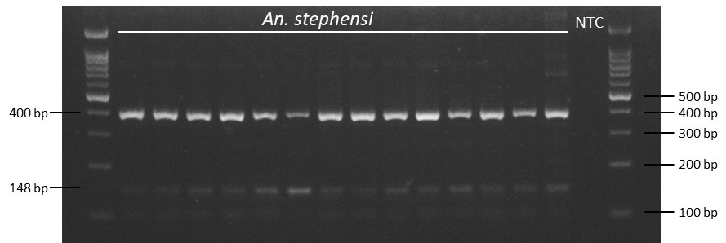
Supplementary Figure 1. Agarose gel image of species ID PCR products indicating the expected amplicon size for An. stephensi.

Aedes aegypti Abundance
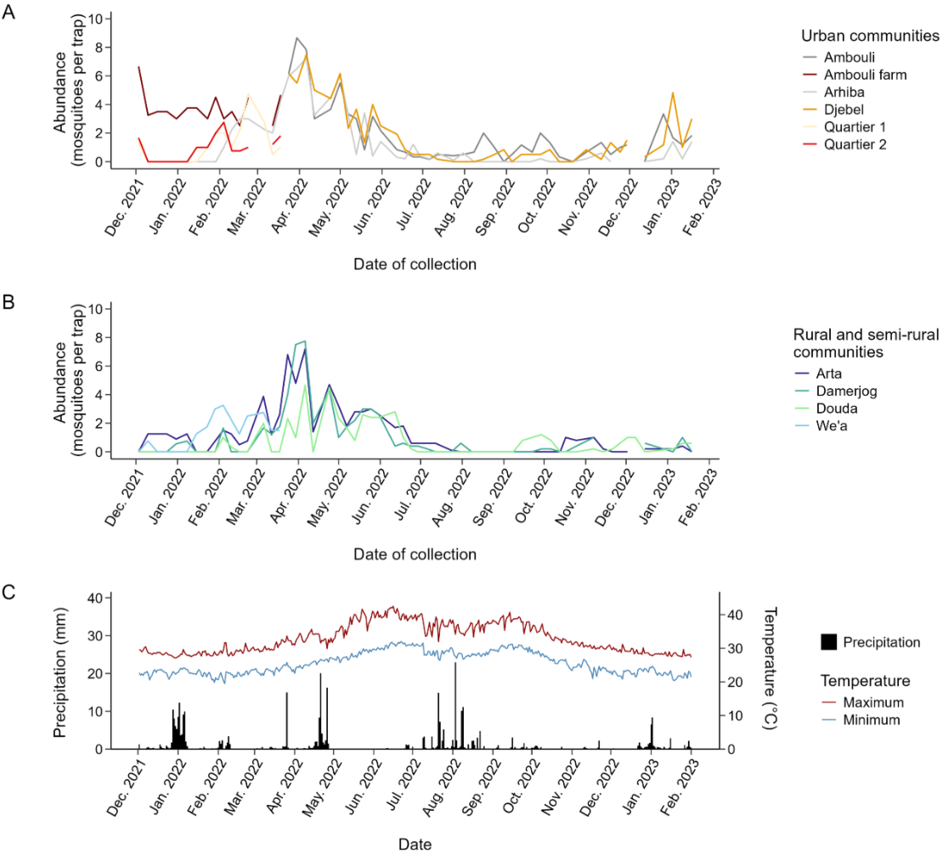
Supplementary Figure 2. Ae. aegypti weekly abundance (mosquitoes per trap collected over a 48-h period per week) at the sites surveyed in Djibouti City. A) Study areas in urban communities. B) Study areas in rural/semi-rural communities. C) Temperature and precipitation data throughout the monitoring period (NASA, 2022). Note there was a break in data collection for a 2-week period in December 2022.
Ae. aegypti abundance during the first 16 weeks of monitoring (Supplementary Figure 1) showed an average of 1.7±0.4 (95% CL) mosquitoes/trap/week in the urban settings and 0.8±0.2 (95% CL) mosquitoes/trap/week at the rural/semi-rural sites. From the end of March 2022 to the end of April 2022, the Ae. aegypti average abundance increased in both urban and rural/semi-rural settings, to 5.7±0.7 (95% CL) and 3.9±1.1 (95% CL) mosquitoes/trap/week respectively. The populations then declined in both urban and rural/semi-rural sites from April 2022 to July 2022, likely in response to the increasing temperatures, to 1.2 ±0.4 (95% CL) at both urban and rural/semi-rural sites. From July 2022 to December 2022 mosquito abundance decreased even further to 0.5 ±0.2 (95% CL) and 0.9 ±1.7 (95% CL) at the urban and rural/semi-rural sites respectively.

Culex Abundance
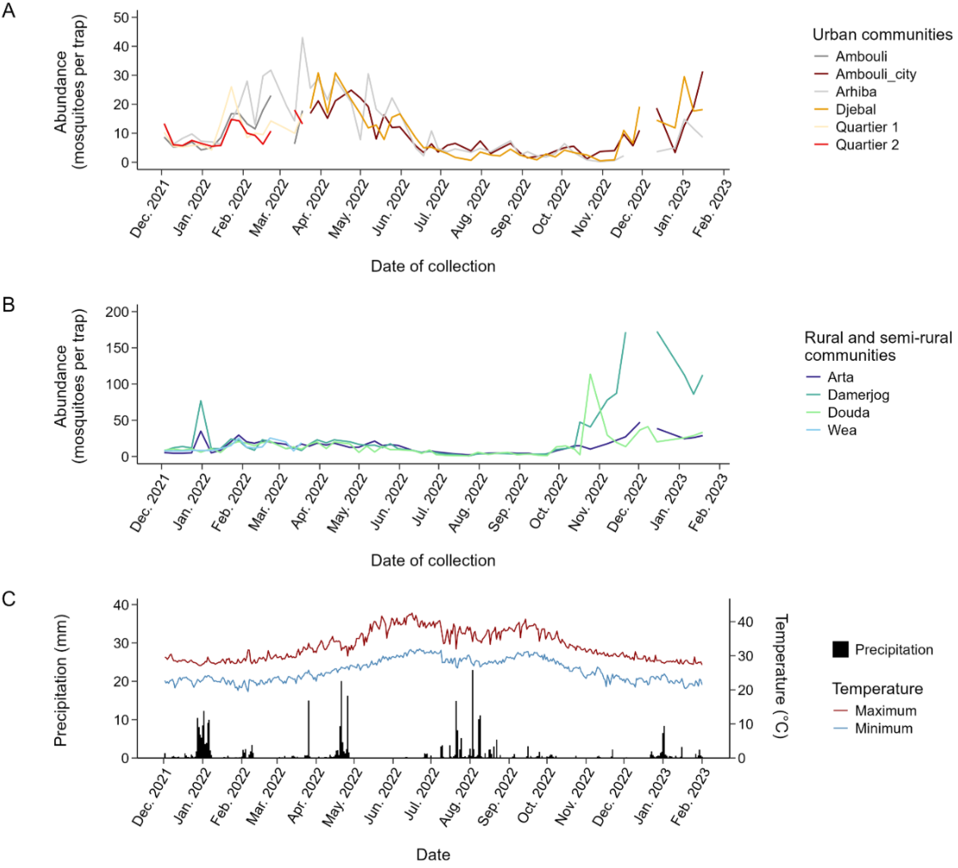
Supplementary Figure 3. Culex sp. weekly abundance (mosquitoes per trap collected over a 48-h period per week) at the sites surveyed in Djibouti City. A) Study areas in urban communities. B) Study areas in rural/semi-rural communities. C) Temperature and precipitation data throughout the monitoring period (NASA, 2022). Note there was a break in data collection for a 2-week period in December 2022.
Culex sp. abundance was at similar levels in the urban and rural sites monitored between December 2021 and end of May 2022 – 14.5 ±1.6 (95% CL) and 15.1 ±1.7 (95% CL) mosquitoes/trap/week respectively (Supplementary Figure 2). This period coincides with milder temperatures recorded in Djibouti. Between June and the end of September – the hot season – the population decreased significantly at both the urban and rural sites to 3.9 ±0.6 (95% CL) and 4.6±0.7 (95% CL) respectively. From October 2022 to January 2023 (end of the monitoring period), the Culex sp. population increased to 8.2±2.3 (95% CL) in urban areas and 50.3±15 (95% CL) at the rural sites. Across the rural sites, abundance was especially high at Damerjog, in both December 2021-January 2022 and December 2022-January 2023. This level changes across years – there was a sixfold increase of Culex sp. abundance between December 2021-January 2022 and the same period in 2022-2023.

