Site number | Site type | Source | Sun cover | Vegetation | Water flow | Wet days | Imm. present (days) | Length (cm) | Width (cm) | Depth (cm)
1 | shallow puddle | natural | sun | yes | no | 19 | 0 | 309.6 | 148.6 | 4.93
2 | shallow puddle | natural | sun | yes | no | 19 | 0 | 308.6 | 171.1 | 3.42
3 | shallow puddle | natural | sun | yes | no | 9 | 0 | 230.4 | 85.0 | 3.10
4 | shallow puddle | natural | sun | yes | no | 14 | 0 | 234.9 | 65.5 | 2.43
5 | shallow puddle | natural | sun | yes | no | 9 | 0 | 117.3 | 74.3 | 2.74
6 | shallow puddle | natural | sun | yes | no | 8 | 0 | 119.1 | 56.3 | 2.13
7 | shallow puddle | natural | sun | yes | no | 29 | 4 | 48.2 | 29.3 | 5.57
8 | shallow puddle | natural | sun | yes | no | 59 | 20 | 51.4 | 43.9 | 7.61
9 | shallow puddle | natural | partial | yes | no | 42 | 31 | 118.5 | 49.3 | 4.48
10 | shallow puddle | natural | shade | yes | no | 54 | 35 | 115.6 | 44.1 | 4.34
11 | shallow puddle | natural | shade | yes | no | 39 | 15 | 104.5 | 42.1 | 3.77
12 | shallow puddle | natural | shade | yes | no | 40 | 16 | 193.1 | 48.3 | 4.24
13 | shallow puddle | natural | shade | yes | no | 34 | 14 | 103.4 | 68.4 | 3.09
14 | shallow puddle | natural | sun | yes | no | 10 | 1 | 93.6 | 56.1 | 2.64
15 | ditch | artificial | partial | yes | no | 39 | 5 | 37.0 | 32.1 | 5.83
16 | ditch | artificial | sun | yes | no | 123 | 57 | 66.2 | 59.2 | 15.46
17 | shallow puddle | natural | sun | no | no | 34 | 1 | 138.5 | 120.6 | 3.57
18 | shallow puddle | natural | sun | no | no | 36 | 1 | 392.5 | 229.0 | 3.57
19 | shallow puddle | natural | sun | no | no | 48 | 3 | 529.1 | 309.8 | 8.86
20 | puddle | natural | shade | yes | no | 24 | 12 | 208.6 | 172.0 | 11.95
21 | puddle | natural | shade | yes | no | 23 | 6 | 185.9 | 142.1 | 9.38
22 | shallow puddle | natural | sun | no | no | 23 | 0 | 248.1 | 151.3 | 3.16
23 | shallow puddle | natural | sun | no | no | 20 | 0 | 182.3 | 71.0 | 2.57
24 | ditch | natural | shade | no | yes | 53 | 13 | 176.3 | 29.6 | 2.13
25 | shallow puddle | natural | sun | yes | no | 30 | 0 | 398.2 | 148.1 | 3.29
26 | ditch | natural | partial | yes | yes | 77 | 23 | 96.4 | 48.6 | 3.45
27 | shallow puddle | natural | sun | yes | no | 7 | 0 | 213.3 | 111.2 | 2.89
28 | shallow puddle | natural | partial | yes | no | 21 | 2 | 185.4 | 118.5 | 4.06
29 | shallow puddle | natural | sun | yes | no | 33 | 14 | 232.4 | 61.1 | 3.72
30 | shallow puddle | natural | sun | yes | no | 17 | 6 | 183.5 | 53.5 | 3.75
31 | shallow puddle | natural | shade | yes | no | 10 | 1 | 398.8 | 165.5 | 4.39
32 | shallow puddle | natural | sun | no | no | 36 | 2 | 538.5 | 238.1 | 6.39
Supplementary Information
Table S1 Parameters for each of the 32 waterbodies included in the study. Source indicates if the site was fed by natural or manmade sources. Imm. present is the number of days immature mosquitoes were present out of the 123-day observation period. Length, width and depth are given as means across the observation period.
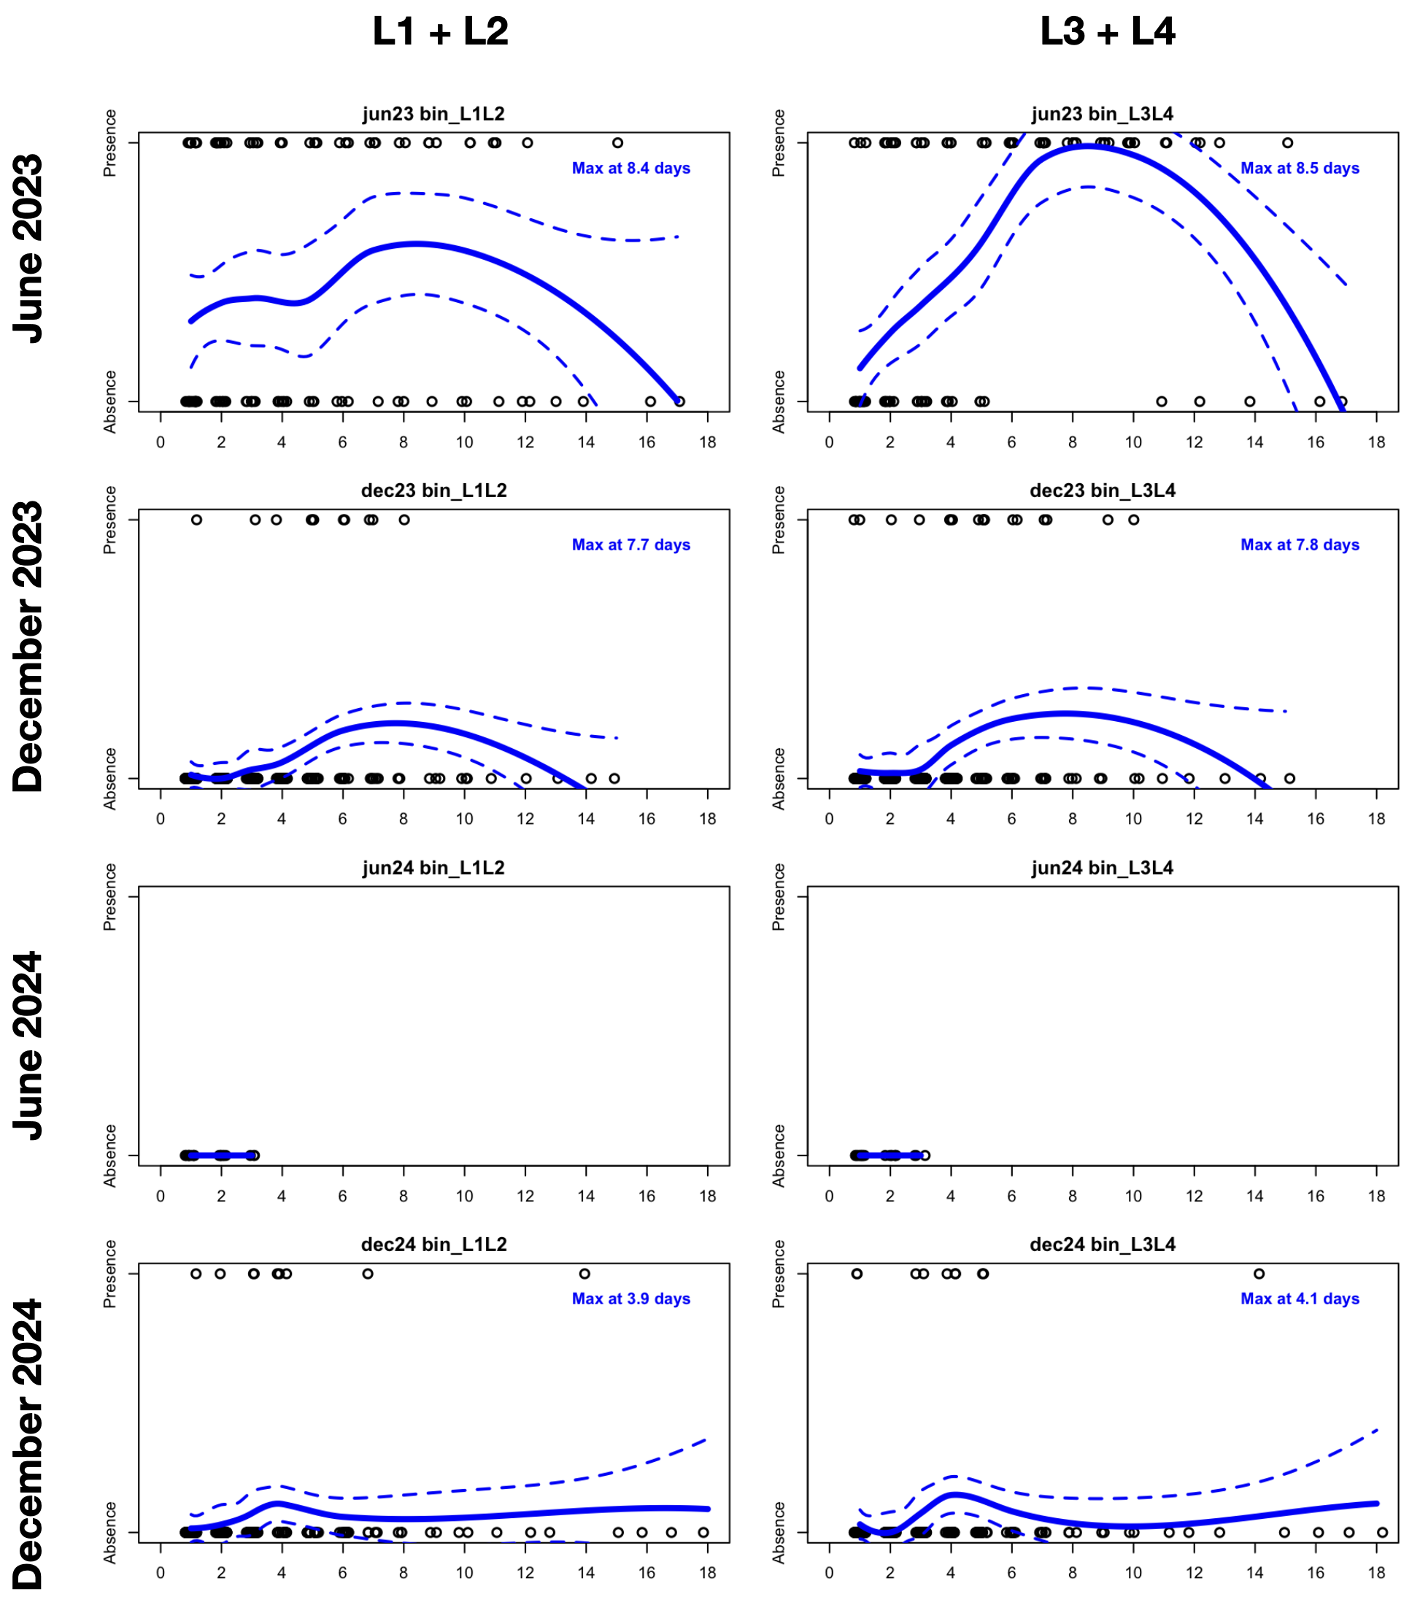
DSD
Figure S1 Relationship between mosquito larval presence and days since dry (DSD) - the number of days since standing water was last absent - across four sampling periods. Each panel shows larval presence as a function of DSD, for early instars (L1-L2) and late instars (L3-L4) in June and December of 2023 and 2024. Open circles represent observed values, jittered horizontally; solid blue lines indicate LOESS fits, with 95% confidence intervals shown as dashed lines. Blue annotations mark the estimated peak in larval abundance based on the LOESS curve. Sites with permanent water are excluded because DSD could not be calculated. Flat lines in June 2024 reflect the absence of larvae at all temporary sites.

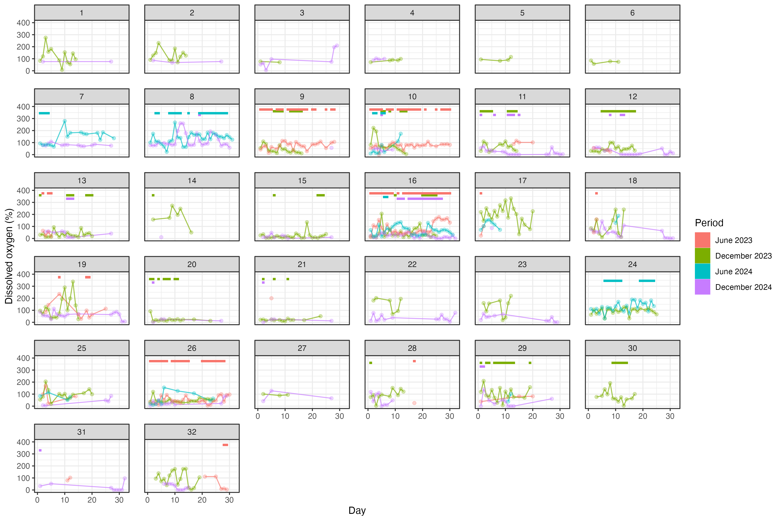 Figure S2 Temporal pattern of dissolved oxygen (%) per site (1 – 32) over 30 days by collection period. Tiles at the top of plots represent the presence of mosquito immatures at a site on a given day and are colored by period. N = 937.
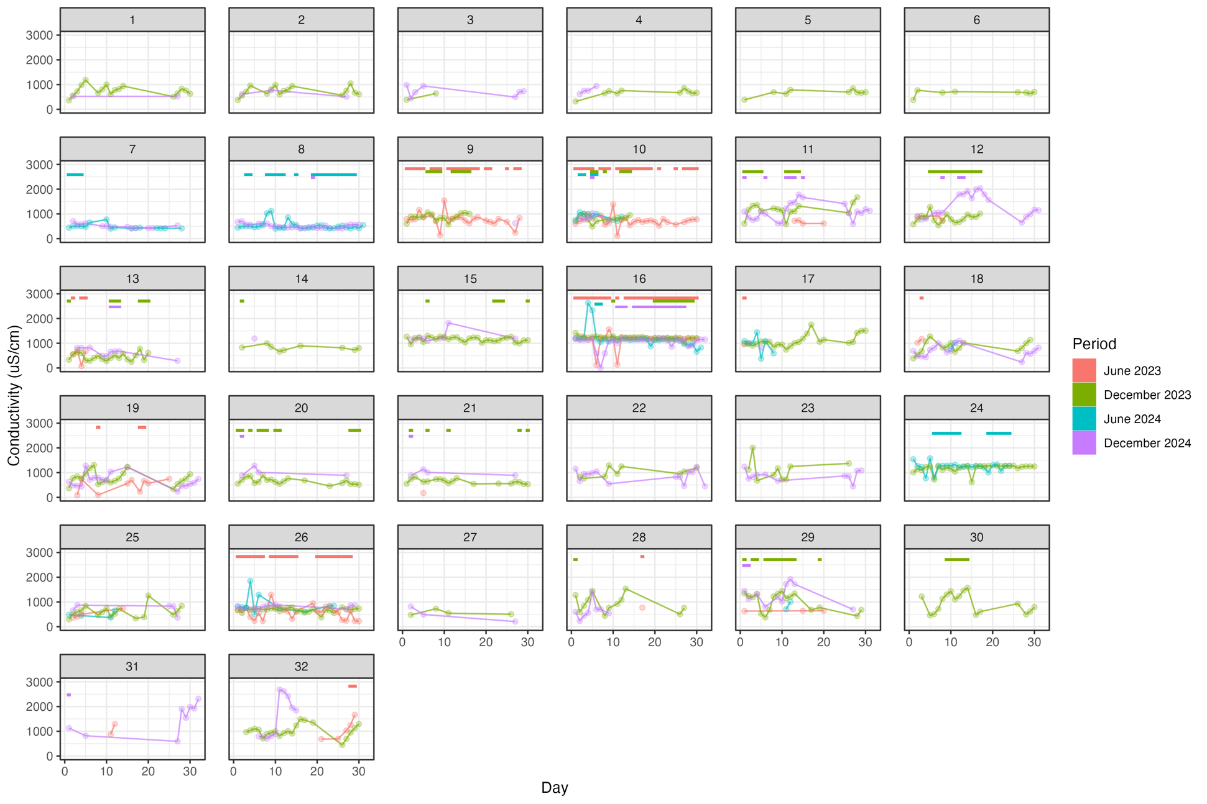
Figure S3 Temporal pattern of conductivity (μS/cm) per site (1 – 32) over 30 days by collection period. Tiles at the top of plots represent the presence of mosquito immatures at a site on a given day and are colored by period. N = 937.
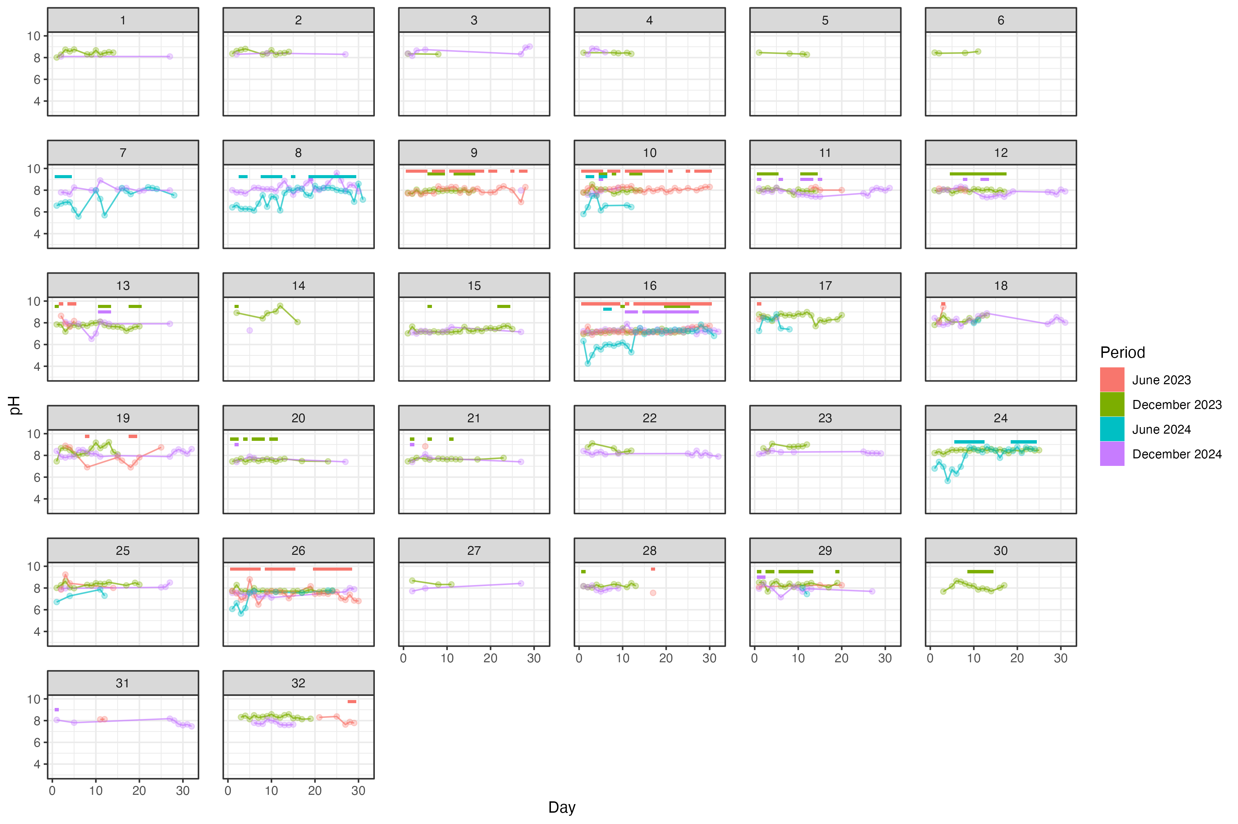 Figure S4 Temporal pattern of pH per site (1 – 32) over 30 days by collection period. Tiles at the top of plots represent the presence of mosquito immatures at a site on a given day and are colored by period. N = 937.
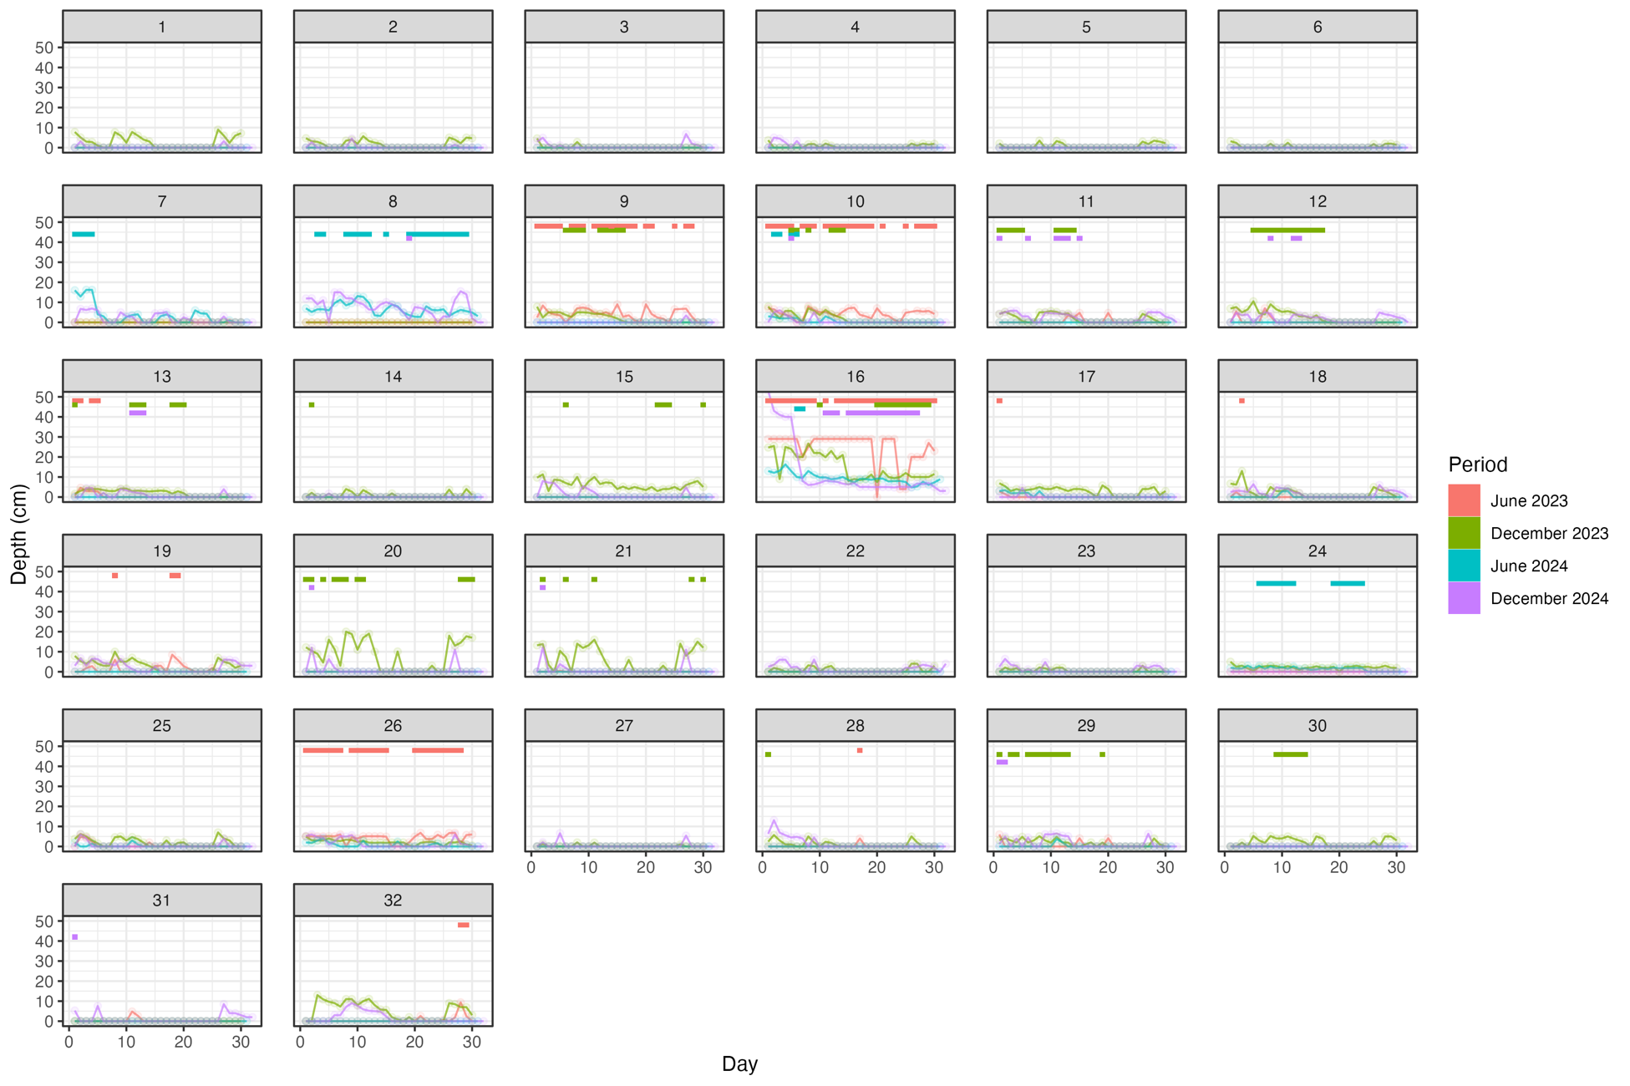
Figure S5 Temporal pattern of depth (cm) per site (1 – 32) over 30 days by collection period. Tiles at the top of plots represent the presence of mosquito immatures at a site on a given day and are colored by period. Data contains zeros which represent when the site was dry. Note that sites 15 and 16 are artificially fed by water with all other sites naturally fed. N = 937.
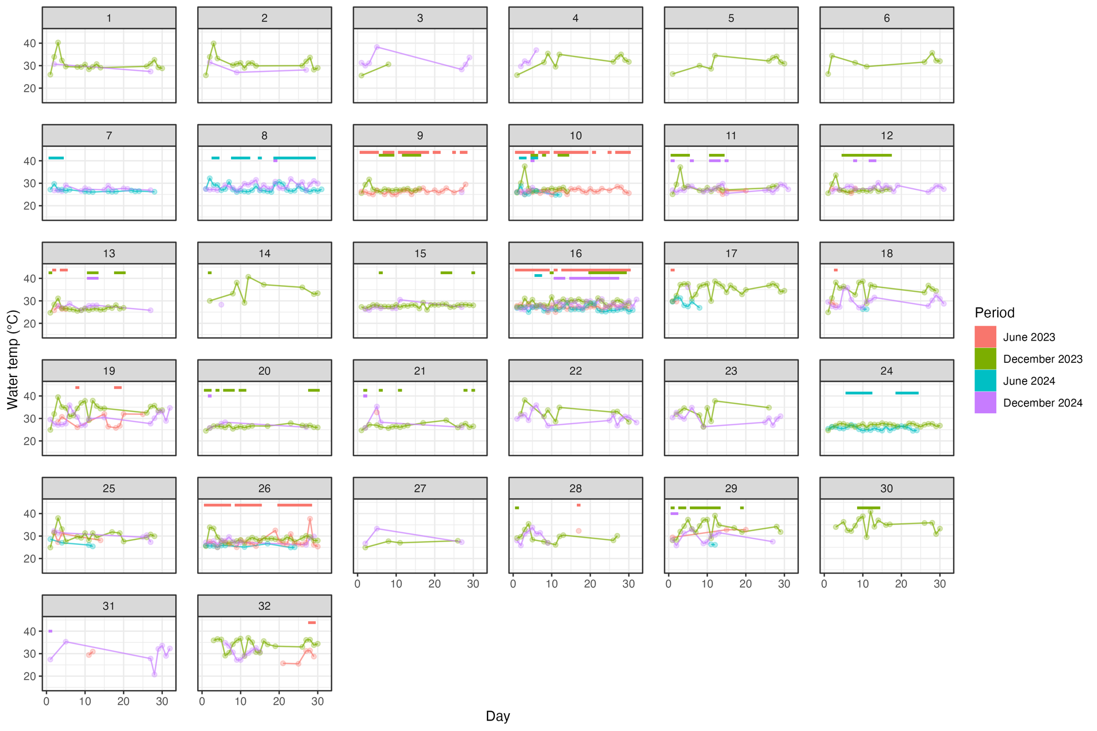
Figure S6 Temporal pattern of temperature (°C) per site (1 – 32) over 30 days by collection period. Tiles at the top of plots represent the presence of mosquito immatures at a site on a given day and are colored by period. N = 937.
Table S2 Binomial Generalized Additive Model (GAM) results investigating the effect of site stability on presence of immature Anopheles coluzzii mosquitoes. The model controlled for site exposure time (days since dry). Sites were defined as stable if they were wet for 11 or more days, based on immature development time. Significant results are highlighted in bold font.
Variable | Odds ratio | Confidence interval | Z statistic | P value
(Intercept) | 0.13 | (0.04 - 0.43) | -3.32 | 0.001
Stability (unstable) | 0.08 | (0.03 - 0.20) | -5.23 | <0.001
Season (Dry) | 23.67 | (8.20 - 68.35) | 5.85 | <0.001
Smooth terms: | Edf |  | χ² | P value
Days since dry | 2.97 | - | 16.28 | 0.002

Table S3 Sensitivity analysis for binomial Generalized Additive Model (GAM) comparing how water parameters affect Anopheles coluzzii immature presence in potential breeding sites. June 2023 has been excluded as measurements were taken at 1:00 - 3:30 pm, rather than 8:00 -10:30 am to see if this difference affects model results. Significant results are highlighted in bold font.
Variable | Odds ratio | Confidence interval | Z statistic | P value
(Intercept) | <0.01 | (<0.01 - 0.03) | -4.72 | 0.00
Vegetation (Yes) | 35.32 | (2.82 - 442) | 2.76 | 0.01
Sun cover (Partial) | 0.24 | (0.04 - 1.40) | -1.58 | 0.11
Sun cover (Shade) | 2.37 | (0.79 - 7.13) | 1.53 | 0.13
Smooth terms: | Edf |  | χ² | P value
Water temperature | 1.00 | - | 1.28 | 0.26
Conductivity | 3.47 | - | 18.40 | <0.001
pH | 1.00 | - | 0.00 | 0.99
Dissolved oxygen | 1.00 | - | 2.38 | 0.12
Depth | 1.00 | - | 0.03 | 0.86

