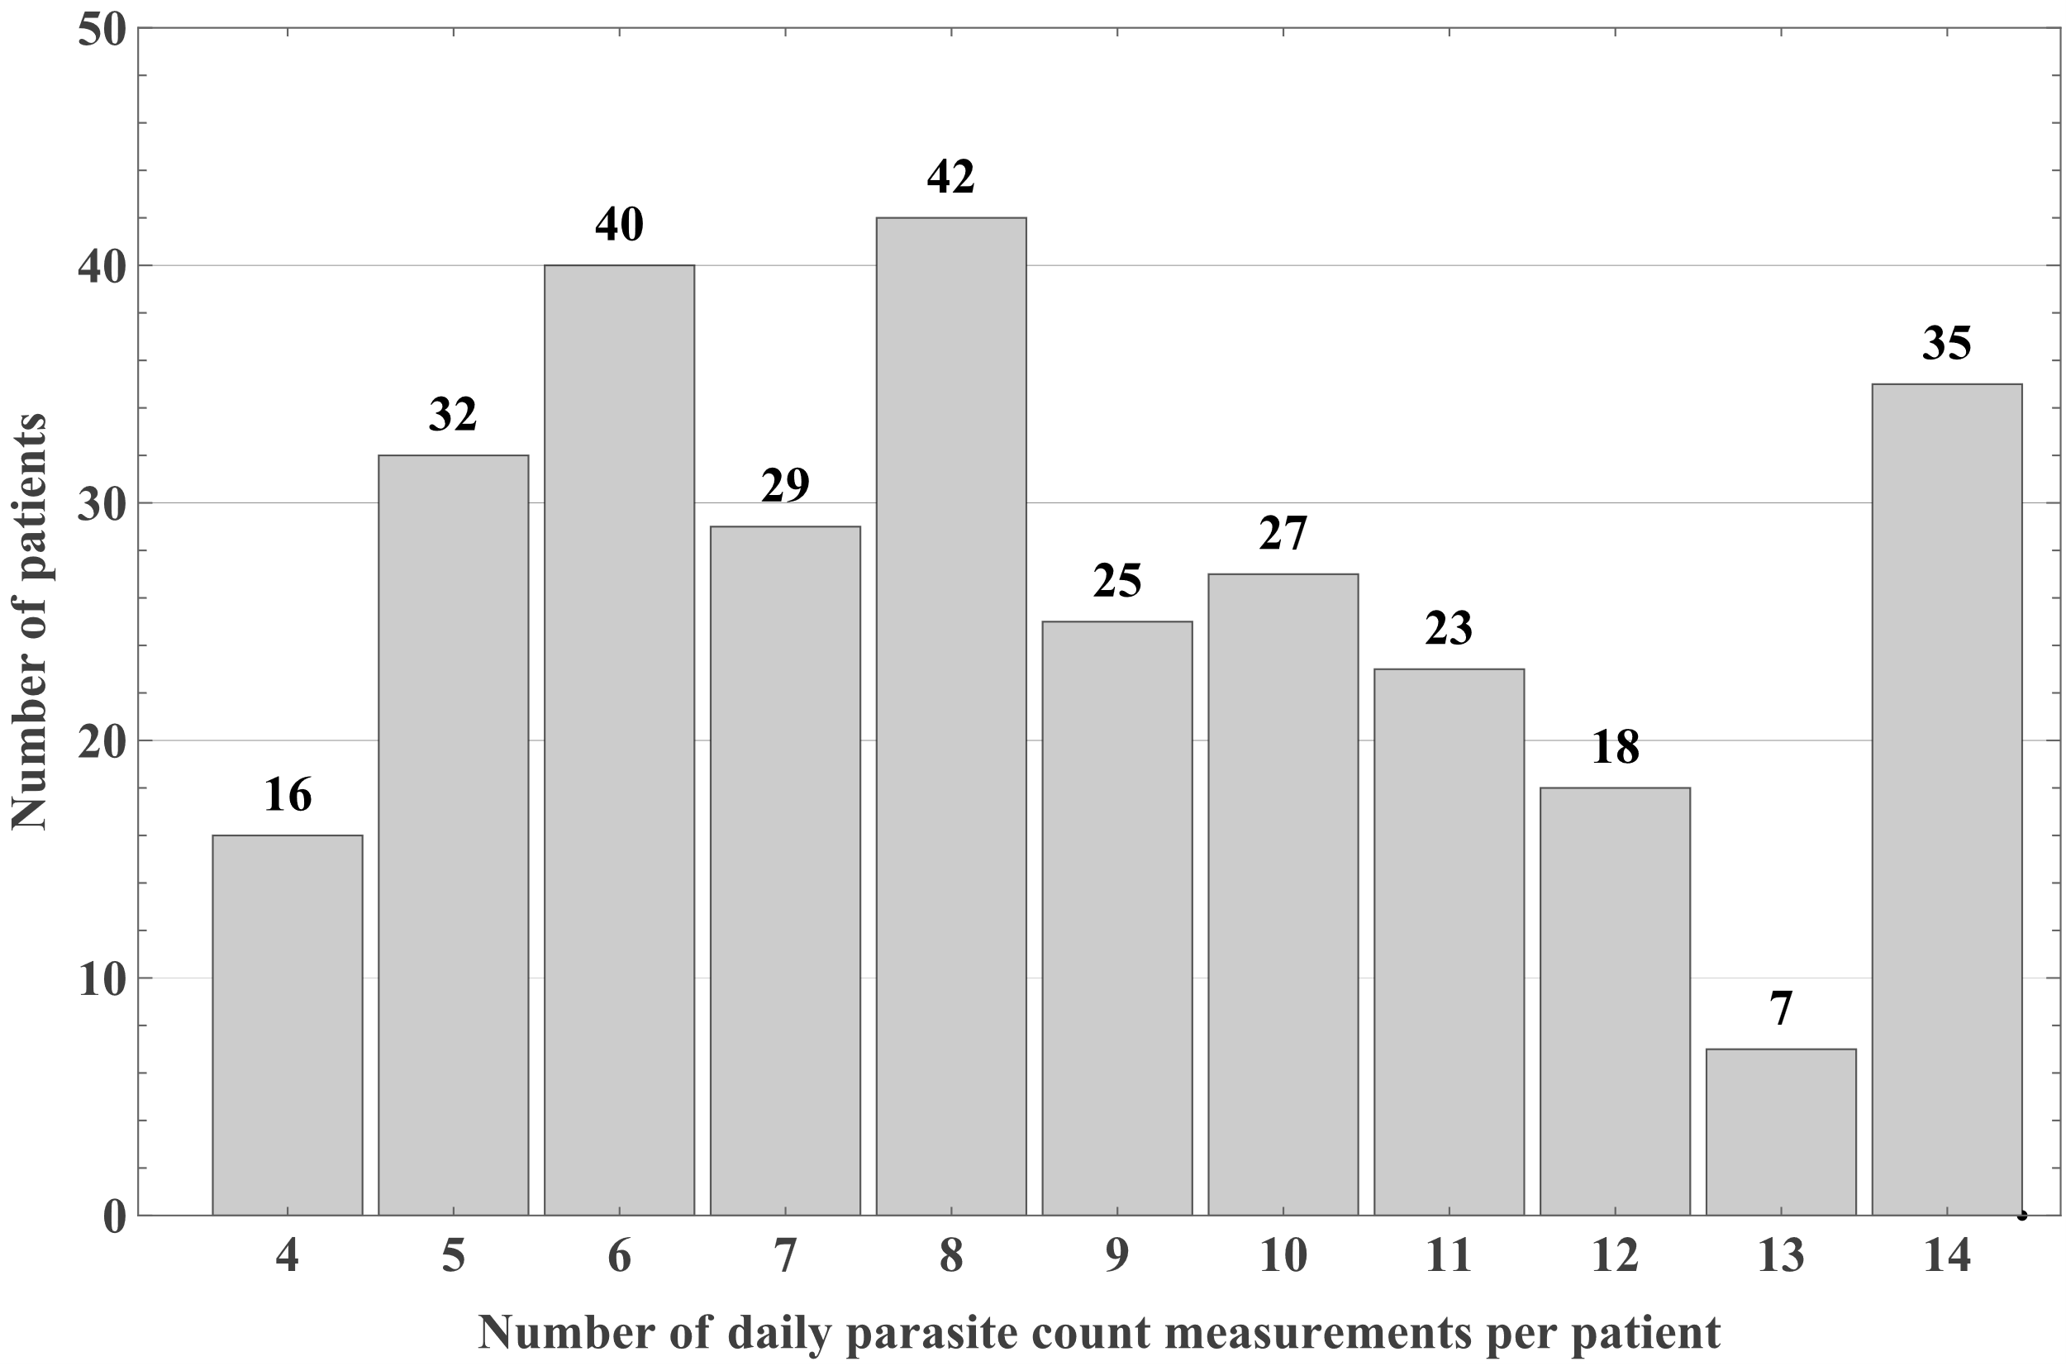
Figure S1 Distribution of number of daily parasite count measurements available for analysis per patient. Parasite count measurements were censored at the day before gametocytes were observed, or before receiving any antimalarial drugs.

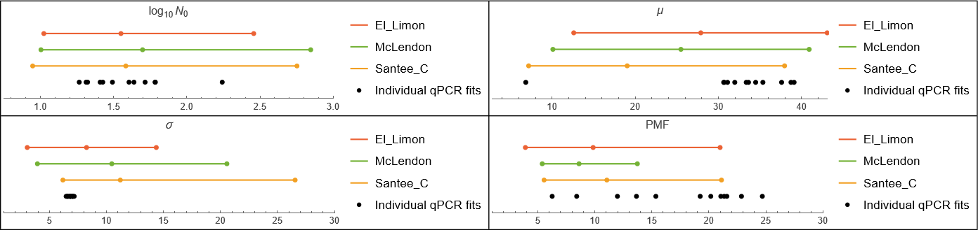
Figure S2 Comparison of parameter estimates from malariotherapy and qPCR-based CHMI data. Coloured horizontal lines and points represent the 95% credible intervals and posterior medians, respectively, of strain-specific population-level parameters estimated by fitting the White et al. model to malariotherapy data. Black points represent parameter estimates from individual fits of the same model to qPCR-based CHMI parasite trajectories. Results are shown for initial parasite density ($\log_{10}{N_{0}}$), mean parasite age ($μ$), standard deviation of parasite age ($σ$), and parasite multiplication factor (PMF).

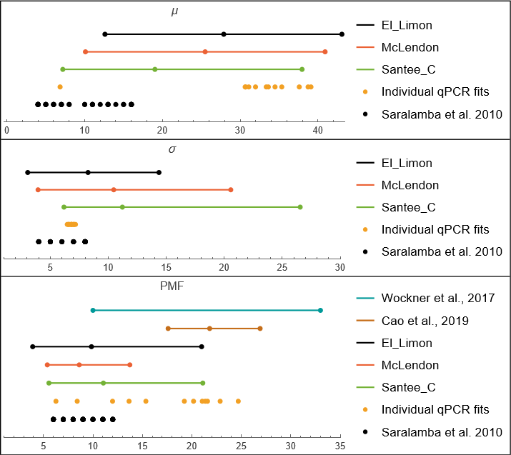
Figure S3 Comparison of estimated within-host parasite parameters across malariotherapy, qPCR-based CHMI, and previous studies.

