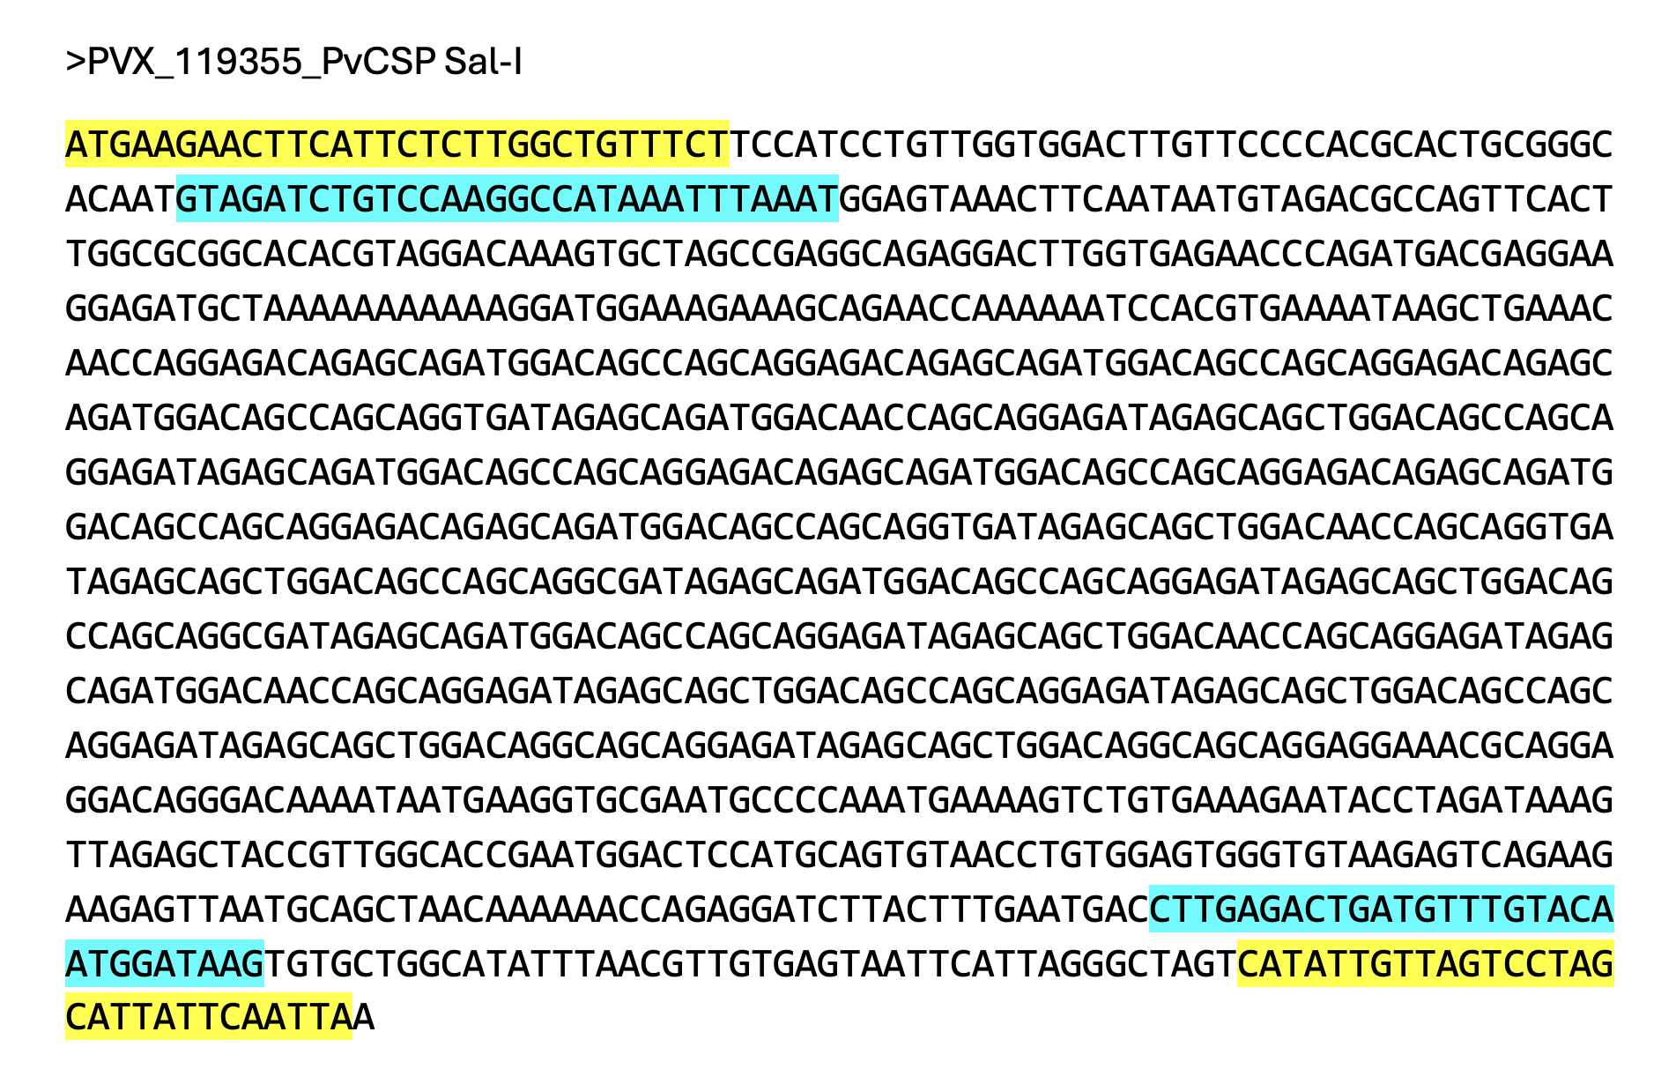
Supplementary Fig. 1. Primer binding sites for nested PCR amplification of P. vivax circumsporozoite protein (PvCSP). Nucleotide sequence of the PvCSP gene (reference strain Sal-I, PVX_119355). Highlighted regions indicate outer primers used for the first round (yellow) and inner primers used for the second round (cyan).

Supplementary Fig. 2. Distribution of predicted CD8+ T cell epitopes across PvCSP (reference strain Sal-I) relative to their position on the full-length PvCSP amino acid sequence (x-axis). Each horizontal bar represents a unique peptide sequence, categorized by its predicted binding affinity to specific HLA-A alleles (indicated by color coding and y-axis labels).

Supplementary Fig. 3. Distribution of predicted CD8+ T cell epitopes across PvCSP (reference strain Sal-I) relative to their position on the full-length PvCSP amino acid sequence (x-axis). Each horizontal bar represents a unique peptide sequence, categorized by its predicted binding affinity to specific HLA-B alleles (indicated by color coding and y-axis labels).

Supplementary Fig. 4. Distribution of predicted CD8+ T cell epitopes across PvCSP (reference strain Sal-I) relative to their position on the full-length PvCSP amino acid sequence (x-axis). Each horizontal bar represents a unique peptide sequence, categorized by its predicted binding affinity to specific HLA-C alleles (indicated by color coding and y-axis labels).

Supplementary Fig. 5. Distribution of predicted CD4+ T cell epitopes across PvCSP (reference strain Sal-I) relative to their position on the full-length PvCSP amino acid sequence (x-axis). Each horizontal bar represents a unique peptide sequence, categorized by its predicted binding affinity to specific HLA-DQA1/DQB1 alleles (indicated by color coding and y-axis labels).

Supplementary Fig. 6. Distribution of predicted CD4+ T cell epitopes across PvCSP (reference strain Sal-I) relative to their position on the full-length PvCSP amino acid sequence (x-axis). Each horizontal bar represents a unique peptide sequence, categorized by its predicted binding affinity to specific HLA-DRB1 alleles (indicated by color coding and y-axis labels).

