Additional file 1

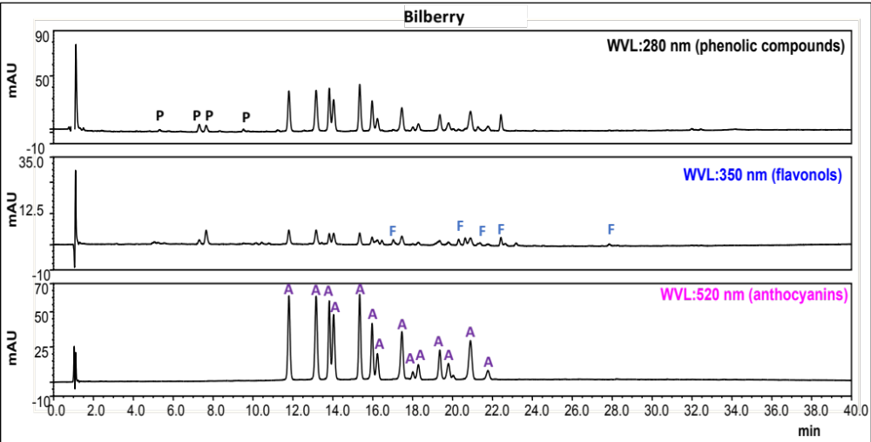
Supplementary Figure S1. Chromatograms corresponding to the HPLC-DAD analysis of bilberry beverage at 280 nm, 350 nm and 520 nm. P, phenolic compounds; F, flavonols; and A, anthocyanins.

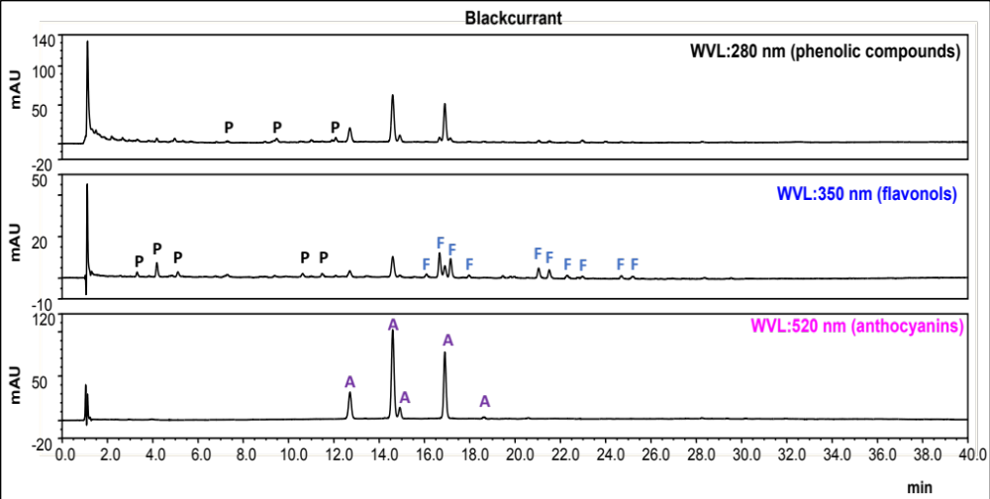
Supplementary Figure S2. Chromatograms corresponding to the HPLC-DAD analysis of blackcurrant beverage at 280 nm, 350 nm and 520 nm. P, phenolic compounds; F, flavonols; and A, anthocyanins.

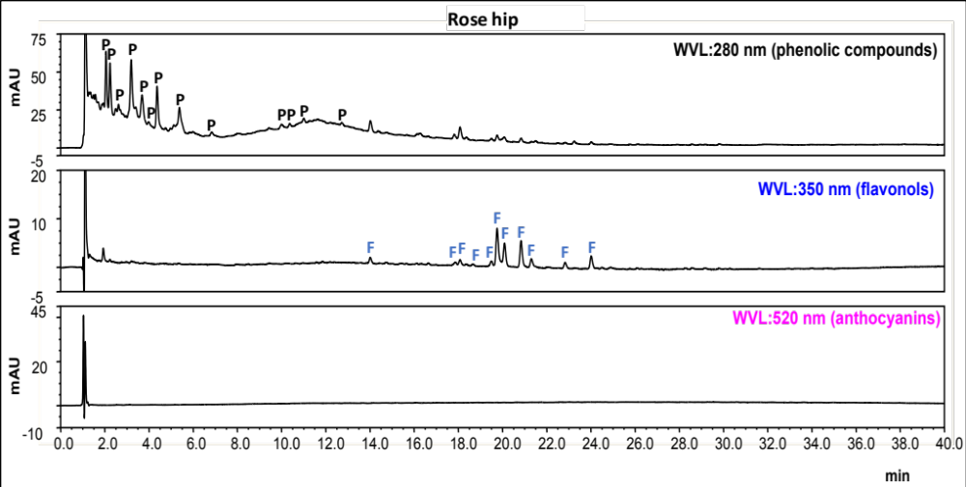
Supplementary Figure S3. Chromatograms corresponding to the HPLC-DAD analysis of Rose hip beverage at 280 nm, 350 nm and 520 nm. P, phenolic compounds; and F, flavonols.

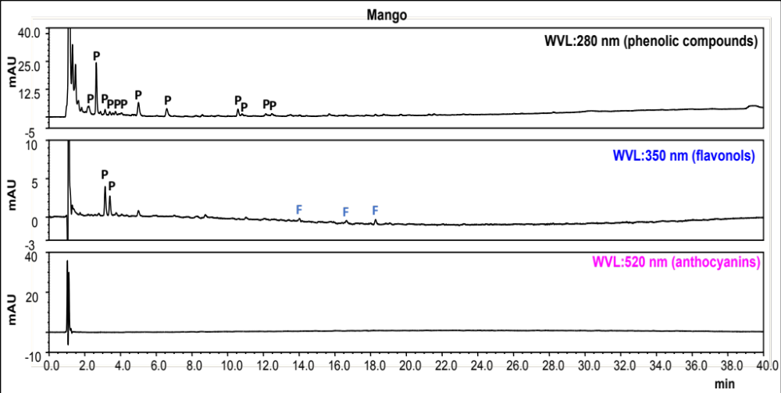
Supplementary Figure S4. Chromatograms corresponding to the HPLC-DAD analysis of Mango beverage at 280 nm, 350 nm and 520 nm. P, phenolic compounds; and F, flavonols.

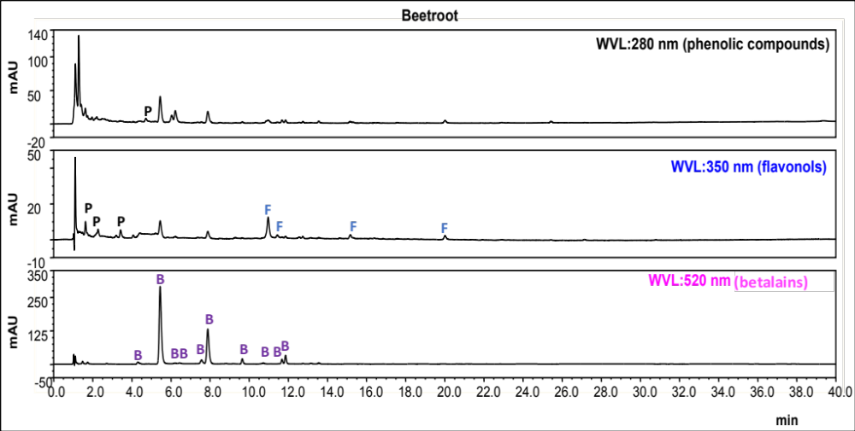
Supplementary Figure S5. Chromatograms corresponding to the HPLC-DAD analysis of beetroot beverage at 280 nm, 350 nm and 520 nm. P, phenolic compounds; F, flavonols; and B, betalains.

