Supplementary data

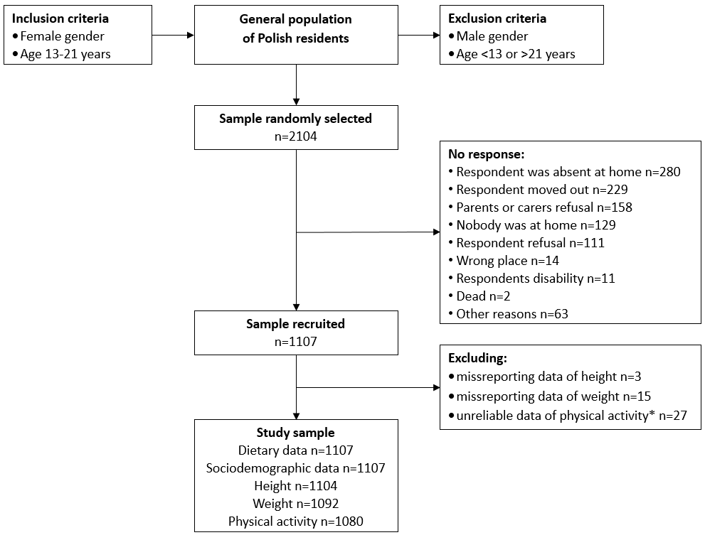

Figure S1. Flow chart of sample collection. Notes: *mean weekly time of activity >960 minutes/day.

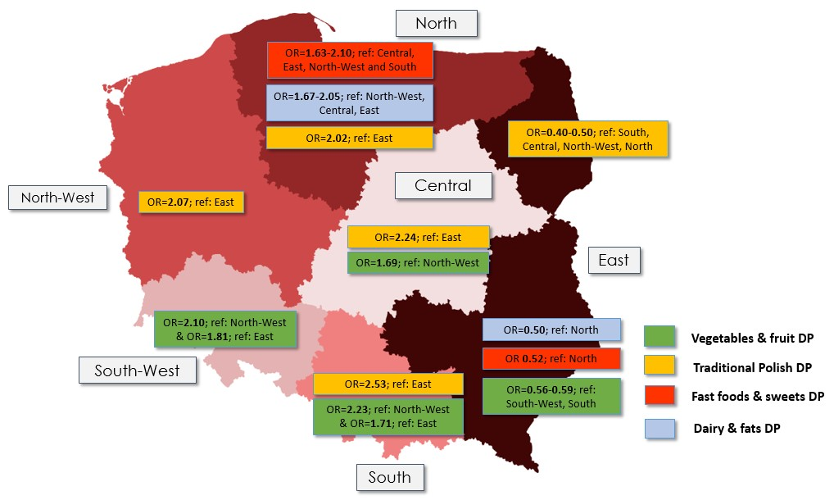

Figure S2. Visual representation of the regional distribution of dietary patterns: odds ratios adjusted for age (years) and BMI (as categorical variable according to IOTF standards [37); for girls 13-18 years old according to age-sex-specific BMI cut-offs; for girls >18 years old according to cut-offs for girls at age 18)
Table S1. Characteristics of Poland by regions, based on the national statistical office data (GUS)
Variables | Poland | East | North | North-West | South | South-West | Central
General population ª
Gross Domestic Product (%) | 100 | 69.7 | 84.8 | 95.1 | 98.8 | 104.8 | 140.4
Average monthly per capita expenditures of households (%)
On food and non-alcoholic beverages | 26.0 | 29.1 | 26.8 | 27.0 | 25.9 | 25.6 | 23.2
On recreation and culture | 6.8 | 6.1 | 6.4 | 6.1 | 6.7 | 6.9 | 8.0
Average monthly gross wages and salaries (%) | 100 | 87.3 | 91.1 | 90.0 | 99.2 | 97.8 | 116.5
Unemployment rate (%) | 10.3 | 12.0 | 11.2 | 9.3 | 10.2 | 10.8 | 9.1
Life expectancy (years) ^{b}
Males | 73.8 | 74.2 | 73.6 | 73.5 | 74.4 | 73.9 | 73.0
Females | 81.7 | 82.6 | 81.5 | 81.1 | 81.9 | 81.4 | 81.4
Females aged 15-29 year ^{c}
Self-reported health (%)
Good or very good | 89.1 | 91.0 | 87.8 | 87.8 | 88.9 | 90.1 | 87.9
Below good | 10.9 | 9.1 | 12.2 | 12.2 | 11.1 | 10.0 | 12.1
Chronic diseases occurrence (%) | 31.0 | 22.2 | 35.7 | 32.1 | 32.3 | 30.4 | 33.7
Body Mass Index # (%)
Underweight | 11.9 | 12.0 | 11.1 | 9.5 | 14.3 | 13.2 | 12.5
Normal weight | 72.0 | 73.6 | 71.8 | 71.1 | 72.6 | 70.5 | 69.8
Overweight and obese | 16.2 | 14.5 | 17.1 | 19.4 | 13.2 | 16.3 | 17.7
Smoking (%) | 16.0 | 13.3 | 20.3 | 16.7 | 15.1 | 17.7 | 15.4
Alcohol consumption at least once a week (%) | 10.0 | 7.9 | 11.1 | 9.8 | 10.1 | 12.2 | 10.4
Notes: data extracted from National Statistical Office (GUS): ª Regions of Poland (GUS, 2014) [24], ^{b} Expectancy tables of Poland in 2018 (GUS, 2019) [25] ^{c} Health status of population in Poland in 2014 (GUS, 2016) [26]. # BMI was based on self-reported data and was categorised according to WHO criateria for adults as follows: < 18.50 kg/m²(underweight), 18.50–24.99 kg/m² (normal weight), 25.00-29.99 kg/m² (overweight), and ≥ 30 kg/m² (obesity) [37].
Table S2. Sample distribution (%) in relation to family socioeconomic status (SES) and its single factors by country regions ª
Variables | Total | East | North | North-West | South | South-West | Central | P
Number of respondents | 1107 | 200 | 164 | 182 | 236 | 106 | 218
SES index ^{b} |  |  |  |  |  |  |  | 0.0740
low | 36.2 | 39.9 | 34.0 | 37.6 | 38.7 | 31.0 | 33.0
average | 30.7 | 28.1 | 38.5 | 31.5 | 24.8 | 39.3 | 28.6
high | 33.2 | 32.0 | 27.6 | 30.9 | 36.5 | 29.7 | 38.4
Components of SES index
Mother’s education |  |  |  |  |  |  |  | 0.2386
primary/lower secondary | 39.8 | 37.2 | 43.5 | 43.1 | 39.5 | 46.9 | 33.5
upper secondary | 43.8 | 44.1 | 45.3 | 40.1 | 45.5 | 38.3 | 46.1
higher | 16.5 | 18.7 | 11.2 | 16.8 | 15.0 | 14.8 | 20.4
Father’s education |  |  |  |  |  |  |  | 0.0004
primary/lower secondary | 52.4 | 51.5 | 53.7 | 58.1 | 51.1 | 59.0 | 45.5
upper secondary | 35.1 | 40.7 | 39.6 | 28.5 | 36.9 | 28.8 | 33.3
higher | 12.5 | 7.8 | 6.7 | 13.4 | 12.0 | 12.1 | 21.2
Economic status |  |  |  |  |  |  |  | 0.0210
below average | 3.9 | 5.1 | 3.6 | 1.7 | 4.8 | 5.7 | 3.2
average | 80.0 | 83.0 | 82.6 | 87.8 | 76.4 | 70.7 | 77.0
above average | 16.1 | 11.9 | 13.8 | 10.6 | 18.7 | 23.5 | 19.9
Description of household – we live: |  |  |  |  |  |  |  | 0.0814
modestly ^{c} | 8.2 | 7.8 | 9.8 | 6.0 | 12.0 | 6.8 | 5.9
relatively thriftily | 49.6 | 53.3 | 49.4 | 56.1 | 41.9 | 43.9 | 51.8
well ^{d} | 42.2 | 38.9 | 40.8 | 37.9 | 46.1 | 49.2 | 42.3
Notes: Sample size may vary in each variables due to missing data; All data adjusted for sample weights; ª Regions of Poland ranked by Gross Domestic Product (GDP) from less to more wealthy: East GDP=69.7, North GDP=84.8, North-West GDP=95.1, South GDP=98.8, South-West GDP=104.8, Central GDP=140.4, Poland GDP=100 [24] ^{b} SES index categories based on tertile distribution; ^{c} ‘Modestly’ category was developed by combining two answers: ‘we live poorly’ and ‘we live modestly’;
^{d} ‘Well’ category was developed by combining two answers: ‘we live well’ and ‘we live very well’; P – significance level of the chi² test.

Table S3. Factor-loading matrix for the 4 major dietary patterns identified by principal component analysis.
Dietary characteristics | Factor 1 | Factor 2 | Factor 3 | Factor 4
Dietary characteristics | ‘Traditional Polish’ | ‘Fruit and vegetables’ | ‘Fast food and sweets’ | ‘Dairy and fats’
Food frequency consumption of ª:
White bread (including biscuits, muffins) | 0.65
Potatoes | 0.52
Red meats | 0.51
Margarine or butter | 0.45 |  |  | 0.45
Fried chicken | 0.42
Wholegrain bread | -0.48
Green salad |  | 0.57
Fruit (without juices) |  | 0.55
Prepared vegetables |  | 0.55
Beans |  | 0.45
French fries or potato chips or corn chips or popcorn |  |  | 0.71
Hamburgers or cheeseburgers |  |  | 0.60
Ice cream |  |  | 0.52
Doughnuts or pastries or cake or cookies |  |  | 0.50
Salad dressings or mayonnaise (not diet) |  |  | 0.42
Cheese or cheese spread |  |  |  | 0.54
Whole milk |  |  |  | 0.49
Food intake variety by food groups ^{b}:
Meats, fish and eggs | 0.60
Fats | 0.45 |  |  | 0.43
Vegetables |  | 0.60
Fruit |  | 0.54
Sweets and snacks |  |  | 0.47
Cereals and potatoes |  |  |  | 0.56
Dairy products |  |  |  | 0.54
Eigenvalues | 4.36 | 2.39 | 1.68 | 1.44
Variance explained (%)^{c} | 14.5 | 9.0 | 5.6 | 4.8
Notes: Factor loadings of ≤ |0.40| are not shown in the table for simplicity; Sorted by loadings from 1st to 4th factor; All data adjusted for sample weights; ª Food frequency consumption was expressed in points (range 0-4 points); ^{b} Food intake variety was expressed in foods consumed per week (with ranges from 0-4 to 0-14 foods/week); ^{c} Total variance in dietary variables explained by 4 dietary patterns is 33.9%.

Table S4. Sample characteristics by age and weight status (mean and 95 % confidence interval or % of the sample).
Variables | Total | East | North | North-West | South | South-West | Central | P
Number of participants | 1107 | 200 | 165 | 182 | 236 | 106 | 218
Age (years) | 17.3  (17.1-17.4) | 17.2  (16.9-17.6) | 17.2  (16.8-17.6) | 17.3  (16.9-17.7) | 17.3  (17.0-17.6) | 17.2  (16.7-17.7) | 17.3  (17.0-17.7) | 0.8750
BMI (kg/m²) | 21.0  (20.9-21.2) | 20.7  (20.3-21.1) | 20.9  (20.5-21.4) | 21.6  (21.1-22.0) | 20.9  (20.5-21.2) | 21.5  (20.8-22.2) | 21.0  (20.7-21.4) | 0.0574
BMI categories #
thinnest grade 3 | 0 | 0 | 0 | 0 | 0 | 0 | 0 | 0.0828
thinnest grade 2 | 0.5 | 0.9 | 0.0 | 1.1 | 0.7 | 0.0 | 0.0
thinnest grade 1 | 9.7 | 11.8 | 12.4 ª | 6.1 ª | 8.9 | 9.5 | 9.6
normal weight | 77.7 | 80.8 | 73.8 | 76.2 | 79.2 | 72.7 | 80.2
overweight | 10.5 | 5.3 ^{b,c,d} | 13.5 ^{b} | 13.8 ^{c} | 10.2 | 13.4 ^{d} | 9.1
obesity | 1.6 | 1.2 | 0.3 ^{e} | 2.9 | 1.1 | 4.4 ^{e} | 1.1
Notes: Sample size may vary in each variables due to missing data; All data adjusted for sample weights; # BMI was categorised according to IOTF standards [37], for girls 13-18 years old according to age-sex-specific BMI cut-offs, for girls >18 years old according to cut-offs for girls at age 18) [37] as follows: < 16.0 kg/m² (thinnest grade 3), 16.0–16.9 kg/m² (thinnest grade 2), 17.0–18.4 kg/m² (thinnest grade 1), 18.5–24.9 kg/m² (normal weight), 25.0–29.9 kg/m² (overweight) and ≥ 30 kg/m² (obesity). P – significance level of the Kruskal-Wallis’ test (for means) or chi² test (for percentage distribution). ^{a-a, b-b, …, e-e} – signifficant differences in pairs of the sample precentages.

Table S5. Adjusted ª odds ratios (95% Confidence intervals) for single factors of family socioeconomic status by tertiles of dietary patterns.
Variables | Bottom tertile | ‘Traditional Polish’ |  | ‘Fruit and vegetables’ |  | ‘Fast food and sweets’ |  | ‘Dairy and fats’
Variables | Bottom tertile | Upper tertile | P | Upper tertile | P | Upper tertile | P | Upper tertile | P
Mother’s education
primary/lower secondary | Ref. | 1.00 |  | 1.00 |  | 1.00 |  | 1.00
upper secondary |  | 0.52 (0.38-0.70) | <0.0001 | 1.36 (1.01-1.83) | 0.0447 | 0.62 (0.46-0.84) | 0.0020 | 1.22 (0.90-1.65) | 0.1948
higher |  | 0.24 (0.15-0.36) | <0.0001 | 1.78 (1.18-2.68) | 0.0060 | 0.65 (0.43-0.98) | 0.0375 | 0.53 (0.35-0.81) | 0.0028
Father’s education
primary/lower secondary | Ref. | 1.00 |  | 1.00 |  | 1.00 |  | 1.00
upper secondary |  | 0.50 (0.37-0.67) | <0.0001 | 1.87 (1.38-2.53) | <0.0001 | 0.66 (0.49-0.89) | 0.0060 | 1.14 (0.84-1.54) | 0.3986
higher |  | 0.27 (0.17-0.43) | <0.0001 | 2.96 (1.86-4.71) | <0.0001 | 0.55 (0.36-0.86) | 0.0087 | 0.62 (0.41-0.96) | 0.0309
Economic status
below average | Ref. | 1.00 |  | 1.00 |  | 1.00 |  | 1.00
average |  | 0.44 (0.20-0.93) | 0.0319 | 1.85 (0.94-3.64) | 0.0735 | 0.92 (0.44-1.92) | 0.8285 | 1.57 (0.72-3.42) | 0.2531
above average |  | 0.29 (0.12-0.66) | 0.0032 | 2.11 (0.99-4.50) | 0.0525 | 1.28 (0.59-2.81) | 0.5272 | 1.09 (0.47-2.52) | 0.8367
Description of household – we live:
modestly ^{b} | Ref. | 1.00 |  | 1.00 |  | 1.00 |  | 1.00
relatively thriftily |  | 0.47 (0.26-0.83) | 0.0093 | 1.31 (0.80-2.16) | 0.2842 | 1.21 (0.71-2.05) | 0.4751 | 0.62 (0.37-1.04) | 0.0701
well ^{c} |  | 0.27 (0.15-0.49) | <0.0001 | 1.75 (1.06-2.90) | 0.0294 | 1.60 (0.64-3.97) | 0.3133 | 0.57 (0.34-0.97) | 0.0358
Notes: Sample size may vary in each variables due to missing data; All data adjusted for sample weights; ª Odds ratios adjusted for age (years) and BMI (as categorical variable according to IOTF standards [37]); for girls 13-18 years old according to age-sex-specific BMI cut-offs; for girls >18 years old according to cut-offs for girls at age 18); ^{b} ‘Modestly’ category was developed by combining two answers: ‘we live poorly’ and ‘we live modestly’; ^{c} ‘Well’ category was developed by combining two answers: ‘we live well’ and ‘we live very well’; P – significance level of the Wald’s test. Significant odds ratios are bolded.

Table S6. Crude odd ratios (95% confidence intervals) for country region and family socioeconomic status (SES), and its single factors, by tertiles of dietary patterns.
Variables | Bottom tertile | ‘Traditional Polish’ |  | ‘Fruit and vegetables’ |  | ‘Fast food and sweets’ |  | ‘Dairy and fats’
Variables | Bottom tertile | Upper tertile | P | Upper tertile | P | Upper tertile | P | Upper tertile | P
Regionª
East | Ref. | 1.00 |  | 1.00 |  | 1.00 |  | 1.00
North |  | 1.94 (1.21-3.09) | 0.0053 | 1.41 (0.89-2.24) | 0.1442 | 1.79 (1.12-2.87) | 0.0146 | 1.86 (1.16-2.99) | 0.0099
North-West |  | 2.11 (1.32-3.36) | 0.0017 | 0.87 (0.54-1.38) | 0.5444 | 0.91 (0.58-1.44) | 0.6911 | 1.13 (0.72-1.78) | 0.5827
South |  | 2.46 (1.56-3.87) | <0.0001 | 1.75 (1.13-2.71) | 0.0118 | 0.89 (0.58-1.36) | 0.5791 | 1.38 (0.90-2.11) | 0.1427
South-West |  | 1.58 (0.93-2.70) | 0.0914 | 1.87 (1.11-3.14) | 0.0179 | 1.10 (0.65-1.87) | 0.7197 | 1.48 (0.87-2.52) | 0.1414
Central |  | 2.06 (1.31-3.25) | 0.0017 | 1.55 (0.99-2.40) | 0.0520 | 1.08 (0.70-1.66) | 0.7374 | 1.07 (0.69-1.68) | 0.7557
North | Ref. | 1.00 |  | 1.00 |  | 1.00 |  | 1.00
East |  | 0.52 (0.32-0.82) | 0.0053 | 0.71 (0.45-1.13) | 0.1441 | 0.56 (0.35-0.89) | 0.0146 | 0.54 (0.33-0.86) | 0.0099
North-West |  | 1.09 (0.68-1.73) | 0.7296 | 0.61 (0.38-1.00) | 0.0493 | 0.51 (0.31-0.83) | 0.0066 | 0.61 (0.37-0.99) | 0.0463
South |  | 1.27 (0.81-2.00) | 0.3010 | 1.24 (0.78-1.96) | 0.3545 | 0.49 (0.31-0.78) | 0.0027 | 0.74 (0.46-1.18) | 0.2031
South-West |  | 0.82 (0.48-1.39) | 0.4529 | 1.32 (0.77-2.26) | 0.3038 | 0.61 (0.35-1.08) | 0.0869 | 0.80 (0.45-1.40) | 0.4269
Central |  | 1.06 (0.67-1.68) | 0.7872 | 1.10 (0.69-1.73) | 0.6923 | 0.60 (0.37-0.96) | 0.0333 | 0.54 (0.34-0.86) | 0.0100
North-West | Ref. | 1.00 |  | 1.00 |  | 1.00 |  | 1.00
East |  | 0.48 (0.30-0.76) | 0.0017 | 1.16 (0.72-1.85) | 0.5442 | 1.10 (0.69-1.73) | 0.6926 | 0.88 (0.56-1.39) | 0.5866
North |  | 0.92 (0.58-1.47) | 0.7293 | 1.63 (1.00-2.66) | 0.0493 | 1.97 (1.20-3.21) | 0.0066 | 1.64 (1.01-2.68) | 0.0463
South |  | 1.17 (0.75-1.83) | 0.4958 | 2.02 (1.27-3.21) | 0.0028 | 0.97 (0.62-1.52) | 0.8976 | 1.21 (0.78-1.89) | 0.3934
South-West |  | 0.75 (0.44-1.28) | 0.2918 | 2.16 (1.25-3.71) | 0.0052 | 1.21 (0.70-2.09) | 0.4980 | 1.31 (0.76-2.25) | 0.3287
Central |  | 0.98 (0.62-1.55) | 0.9330 | 1.79 (1.12-2.85) | 0.0147 | 1.18 (0.75-1.86) | 0.4754 | 0.88 (0.56-1.40) | 0.5944
South | Ref. | 1.00 |  | 1.00 |  | 1.00 |  | 1.00
East |  | 0.41 (0.26-0.64) | <0.0001 | 0.57 (0.37-0.88) | 0.0117 | 1.13 (0.74-1.73) | 0.5755 | 0.73 (0.47-1.12) | 0.1428
North |  | 0.79 (0.50-1.24) | 0.3011 | 0.81 (0.51-1.27) | 0.3548 | 2.02 (1.27-3.21) | 0.0027 | 1.35 (0.85-2.16) | 0.2026
North-West |  | 0.86 (0.54-1.34) | 0.4977 | 0.49 (0.31-0.79) | 0.0028 | 1.03 (0.66-1.61) | 0.8968 | 0.82 (0.53-1.29) | 0.3931
South-West |  | 0.64 (0.38-1.08) | 0.0955 | 1.07 (0.64-1.78) | 0.8030 | 1.24 (0.74-2.10) | 0.4126 | 1.08 (0.64-1.82) | 0.7750
Central |  | 0.84 (0.54-1.30) | 0.4319 | 0.88 (0.57-1.37) | 0.5777 | 1.22 (0.79-1.86) | 0.3699 | 0.73 (0.48-1.12) | 0.1441
South-West | Ref. | 1.00 |  | 1.00 |  | 1.00 |  | 1.00
East |  | 0.63 (0.37-1.08) | 0.0915 | 0.54 (0.32-0.90) | 0.0179 | 0.91 (0.53-1.54) | 0.7195 | 0.67 (0.40-1.14) | 0.1412
North |  | 1.23 (0.72-2.09) | 0.4535 | 0.76 (0.44-1.29) | 0.3036 | 1.63 (0.93-2.85) | 0.0869 | 1.25 (0.72-2.17) | 0.4170
North-West |  | 1.33 (0.78-2.27) | 0.2917 | 0.46 (0.27-0.80) | 0.0052 | 0.83 (0.48-1.43) | 0.4983 | 0.76 (0.44-1.31) | 0.3288
South |  | 1.56 (0.92-2.62) | 0.0956 | 0.94 (0.56-1.57) | 0.8035 | 0.80 (0.48-1.36) | 0.4133 | 0.93 (0.55-1.56) | 0.7747
Central |  | 1.31 (0.77-2.21) | 0.3171 | 0.83 (0.49-1.39) | 0.4733 | 0.98 (0.57-1.68) | 0.9335 | 0.68 (0.40-1.14) | 0.1427
Central | Ref. | 1.00 |  | 1.00 |  | 1.00 |  | 1.00
East |  | 0.48 (0.31-0.76) | 0.0017 | 0.65 (0.42-1.01) | 0.0521 | 0.93 (0.60-1.44) | 0.7393 | 0.93 (0.59-1.46) | 0.7557
North |  | 0.94 (0.60-1.48) | 0.7871 | 0.91 (0.58-1.45) | 0.6956 | 1.67 (1.04-2.67) | 0.0333 | 1.86 (1.16-2.98) | 0.0100
North-West |  | 1.02 (0.64-1.63) | 0.9343 | 0.56 (0.35-0.89) | 0.0147 | 0.85 (0.54-1.34) | 0.4756 | 1.13 (0.72-1.77) | 0.5879
South |  | 1.25 (0.80-1.95) | 0.3370 | 1.13 (0.77-1.67) | 0.5321 | 0.82 (0.54-1.26) | 0.3693 | 1.37 (0.90-2.10) | 0.1440
South-West |  | 0.77 (0.45-1.29) | 0.3165 | 1.21 (0.72-2.03) | 0.4734 | 1.02 (0.60-1.74) | 0.9320 | 1.48 (0.87-2.51) | 0.1426
SES index ^{b}
low | Ref. | 1.00 |  | 1.00 |  | 1.00 |  | 1.00
average |  | 0.60 (0.43-0.84) | 0.0027 | 1.81 (1.30-2.52) | 0.0004 | 0.89 (0.64-1.24) | 0.5054 | 1.26 (0.90-1.75) | 0.1778
high |  | 0.28 (0.20-0.39) | <0.0001 | 1.97 (1.42-2.74) | <0.0001 | 0.95 (0.69-1.32) | 0.7717 | 0.92 (0.67-1.26) | 0.6016
Mother’s education
primary/lower secondary | Ref. | 1.00 |  | 1.00 |  | 1.00 |  | 1.00
upper secondary |  | 0.52 (0.39-0.70) | <0.0001 | 1.34 (1.00-1.80) | 0.0523 | 0.64 (0.48-0.87) | 0.0036 | 1.22 (0.91-1.63) | 0.1911
higher |  | 0.24 (0.15-0.36) | <0.0001 | 1.72 (1.15-2.58) | 0.0079 | 0.67 (0.45-1.00) | 0.0513 | 0.59 (0.40-0.88) | 0.0101
Father’s education
primary/lower secondary | Ref. | 1.00 |  | 1.00 |  | 1.00 |  | 1.00
upper secondary |  | 0.49 (0.37-0.66) | <0.0001 | 1.79 (1.33-2.41) | 0.0001 | 0.67 (0.50-0.90) | 0.0070 | 1.18 (0.88-1.58) | 0.2716
higher |  | 0.26 (0.16-0.42) | <0.0001 | 2.95 (1.86-4.68) | <0.0001 | 0.58 (0.38-0.89) | 0.0127 | 0.66 (0.43-1.00) | 0.0476
Economic status
below average | Ref. | 1.00 |  | 1.00 |  | 1.00 |  | 1.00
average |  | 0.43 (0.20-0.91) | 0.0278 | 1.74 (0.91-3.35) | 0.0954 | 0.86 (0.43-1.75) | 0.6855 | 1.46 (0.68-3.14) | 0.3344
above average |  | 0.29 (0.13-0.65) | 0.0026 | 1.95 (0.93-4.09) | 0.0729 | 1.26 (0.58-2.75) | 0.5535 | 1.10 (0.48-2.52) | 0.8217
Description of household – we live:
modestly ^{c} | Ref. | 1.00 |  | 1.00 |  | 1.00 |  | 1.00
relatively thriftily |  | 0.45 (0.25-0.80) | 0.0066 | 1.29 (0.79-2.09) | 0.3117 | 1.20 (0.72-2.02) | 0.4806 | 0.61 (0.37-1.02) | 0.0597
well ^{d} |  | 0.28 (0.16-0.51) | <0.0001 | 1.63 (1.00-2.68) | 0.0514 | 1.58 (0.93-2.66) | 0.0872 | 0.59 (0.35-0.99) | 0.0431
Notes: Sample size may vary in each variables due to missing data; All data adjusted for sample weights; ª Regions of Poland ranked by Gross Domestic Product (GDP) from less to more wealthy: East GDP=69.7, North GDP=84.8, North-West GDP=95.1, South GDP=98.8, South-West GDP=104.8, Central GDP=140.4, Poland GDP=100 [24]; ^{b} SES index categories based on tertile distribution; ^{c} ‘Modestly’ category was developed by combining two answers: ‘we live poorly’ and ‘we live modestly’; ^{d} ‘Well’ category was developed by combining two answers: ‘we live well’ and ‘we live very well’; P – significance level of the Wald’s test. Significant odds ratios are bolded.

