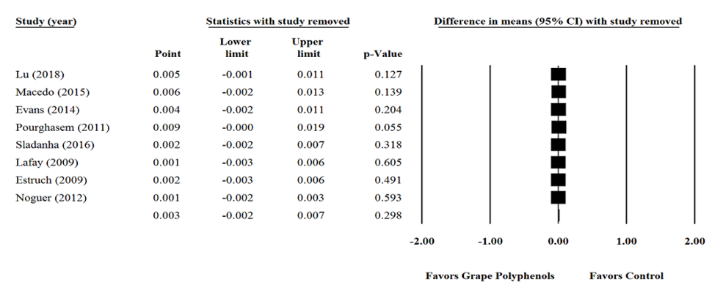
Supplementary figure 1. Sensitivity analysis was performed using a random effect model for impact of grape products containing polyphenols (GPCP) and superoxide dismutase.

