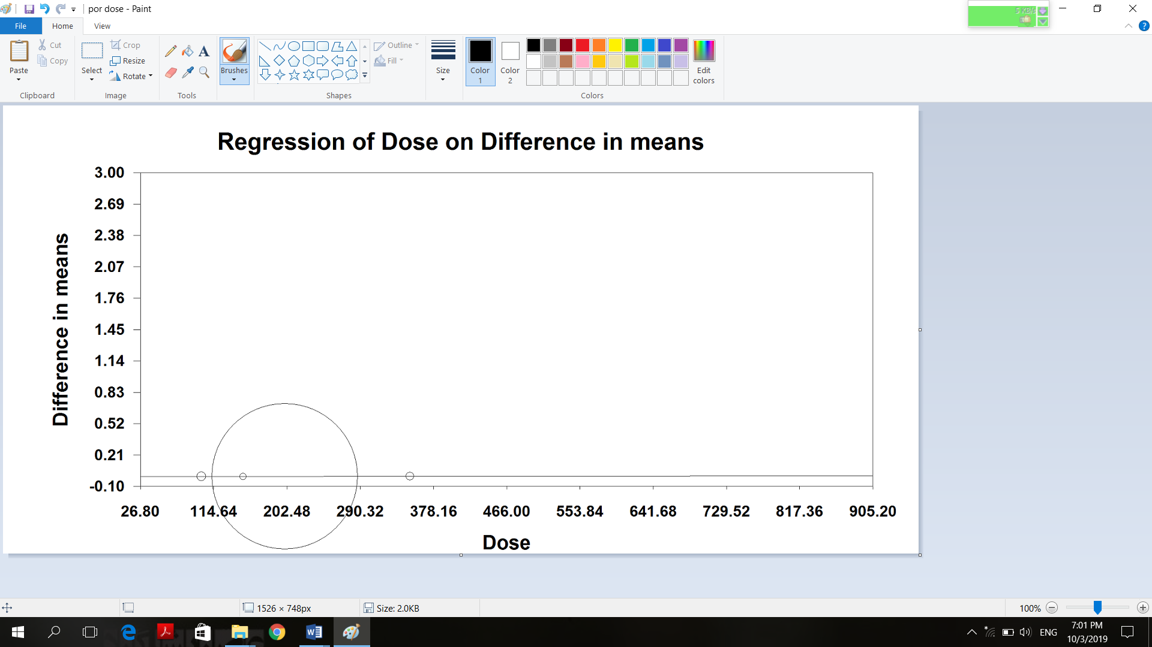
A

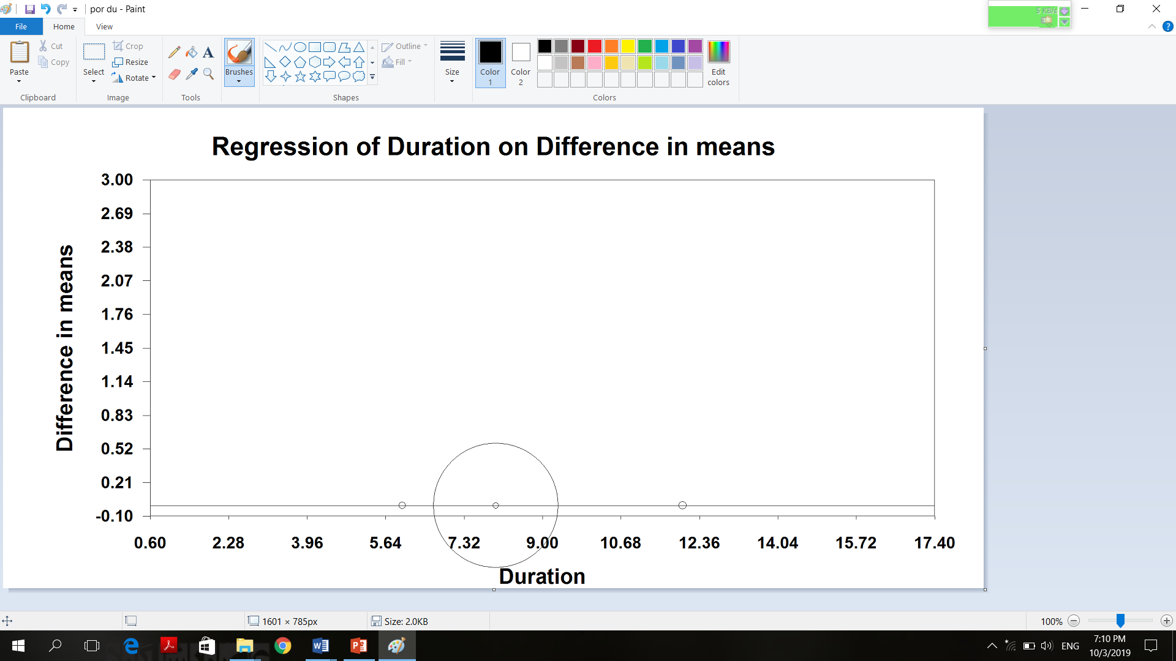
B
Figure 3. Meta-regression plots of the association between weighted mean difference in plasma superoxide dismutase concentrations values after grape products containing polyphenols (GPCP) intake with dose (A) and duration (B) of intake. The size of each circle is inversely proportional to the variance of change.

