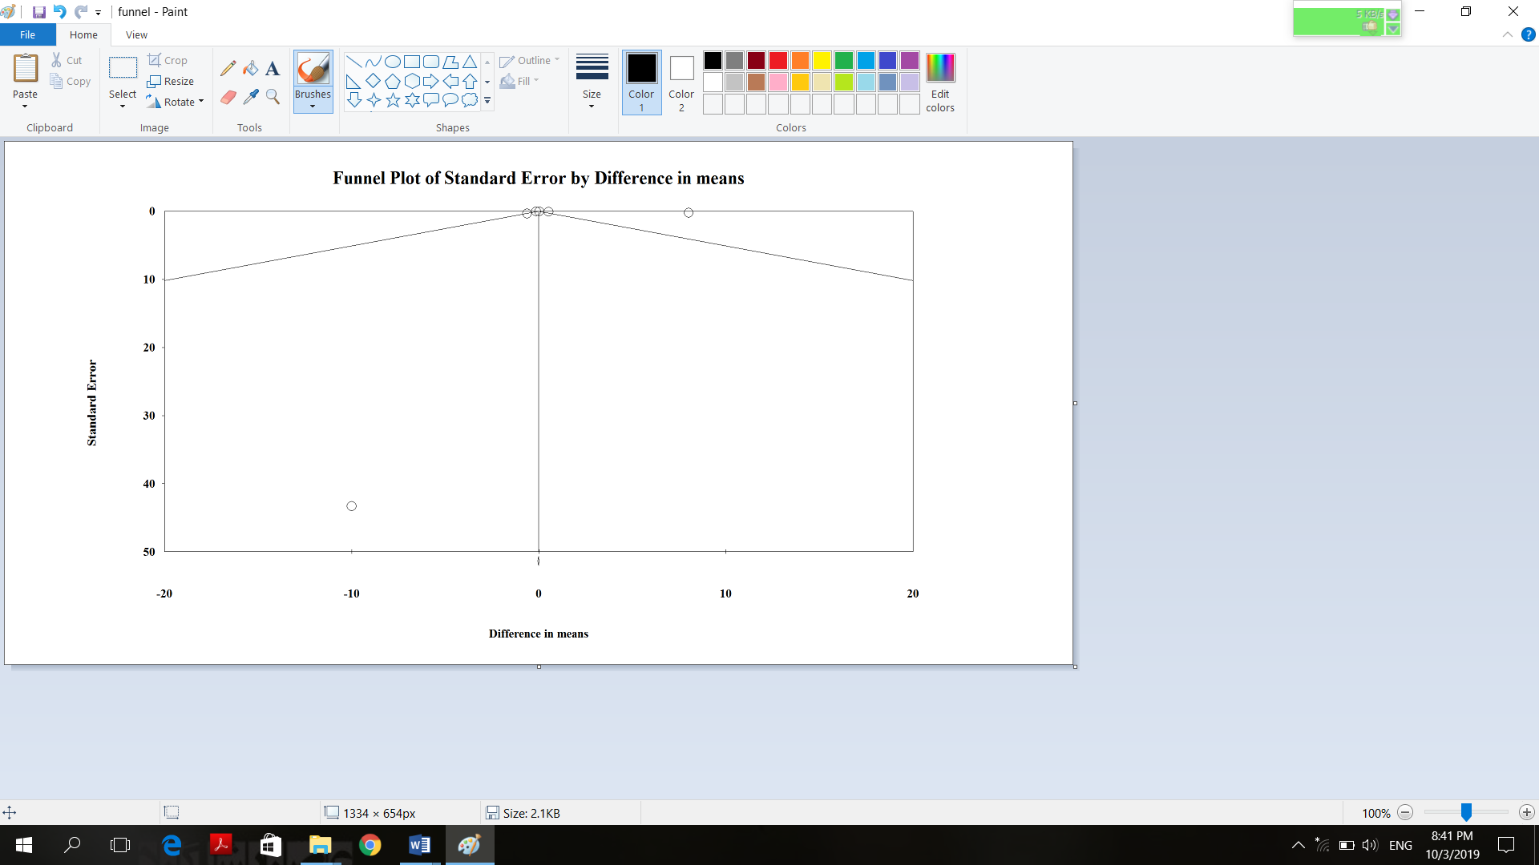
Supplementary figure 5. Funnel plot of weighted mean differences total antioxidant capacity concentration with grape products containing polyphenols (GPCP).

