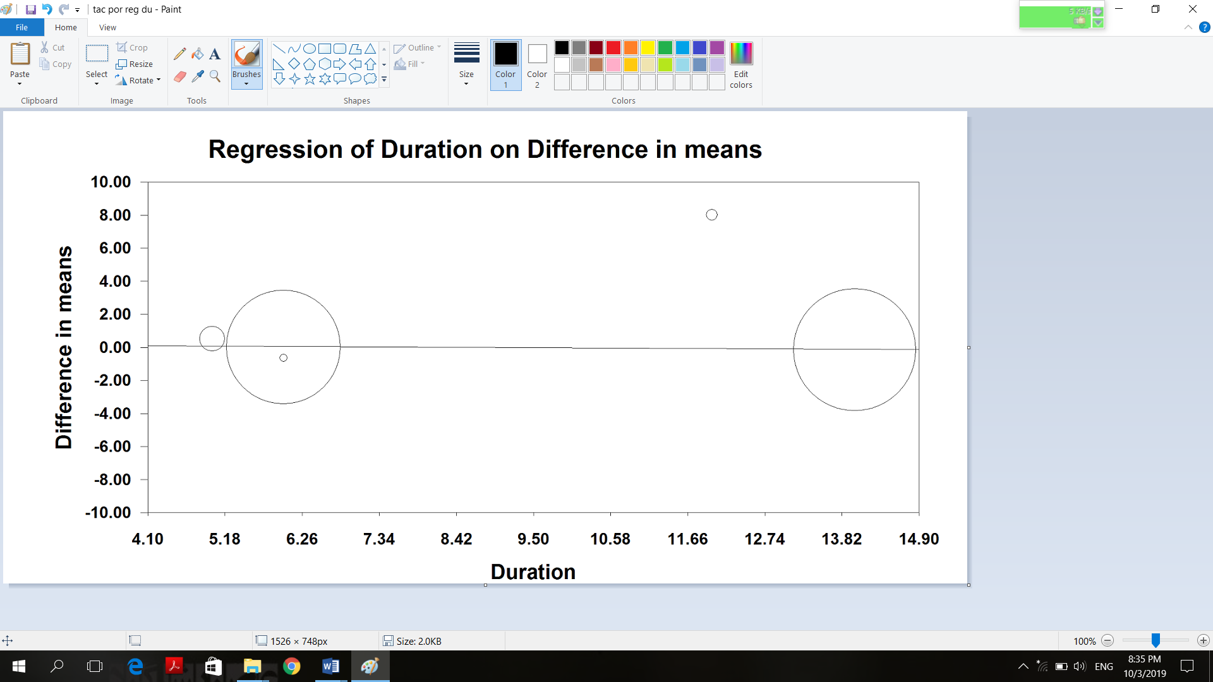
A

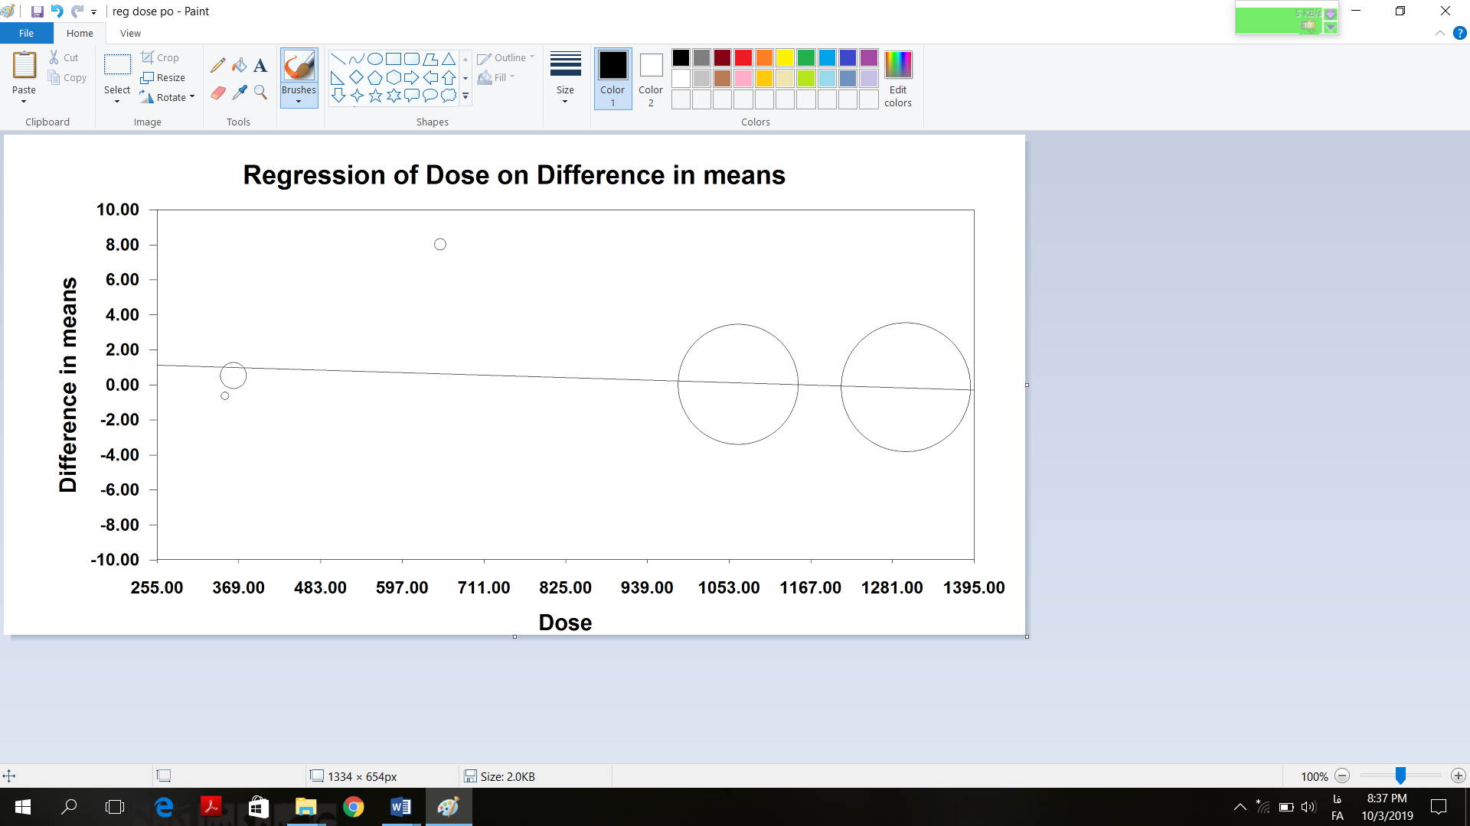
B

Supplementary figure 6. Meta-regression plots of the association between weighted mean difference in plasma total antioxidant capacity concentrations values after grape products containing polyphenols (GPCP) intake with duration (A) and dose (B) of intake. The size of each circle is inversely proportional to the variance of change.

