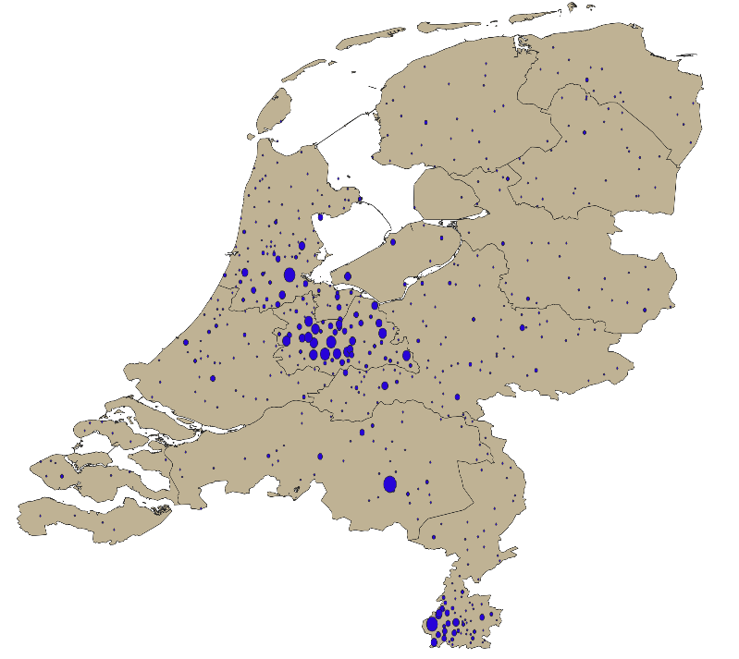
Additional file 1. Distribution of home locations in 2015 in the study population.

