Supplementary Table 1
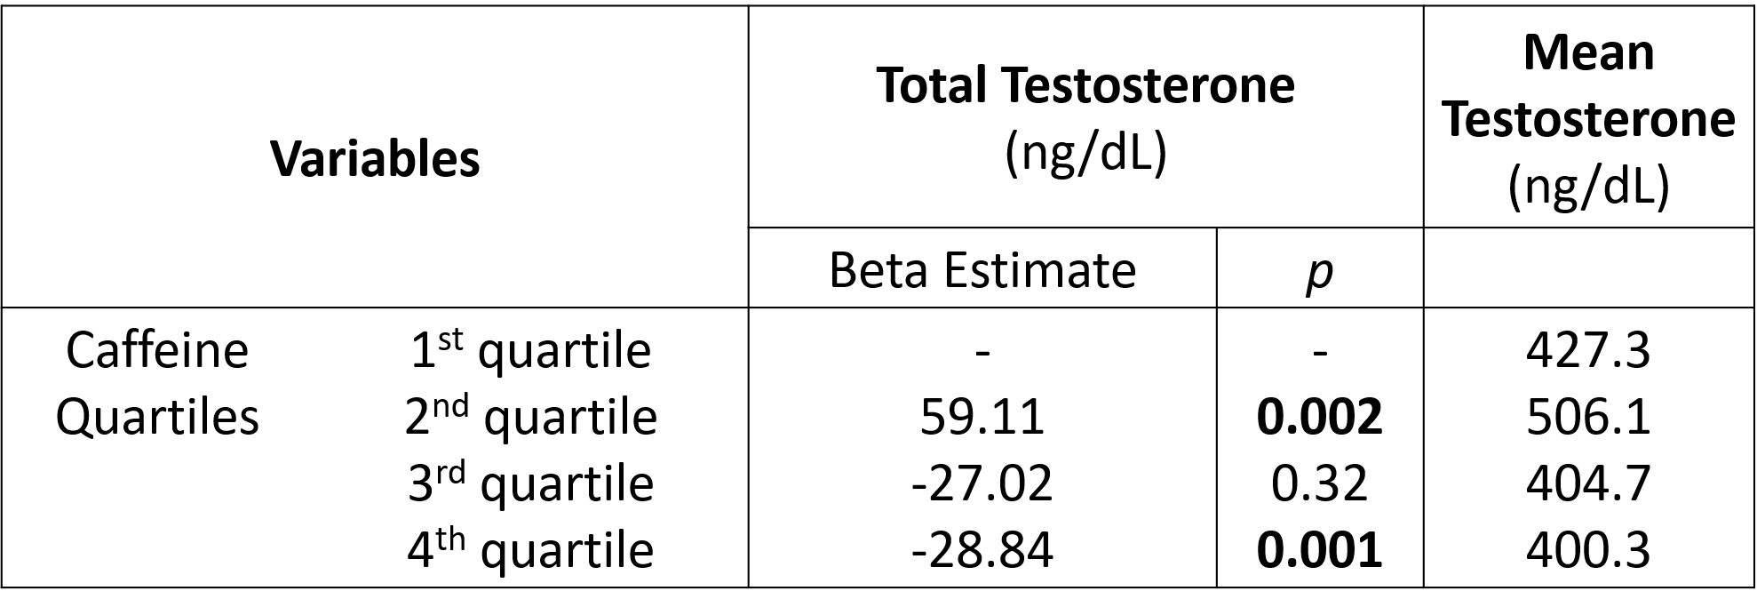
Supplementary table showing the beta estimates for expected change in testosterone for each quartile of urinary caffeine concentration. The first quartile was used as the reference in each case. A p-value <0.05 was used as the cutoff for statistical significance.
Supplementary Table 2
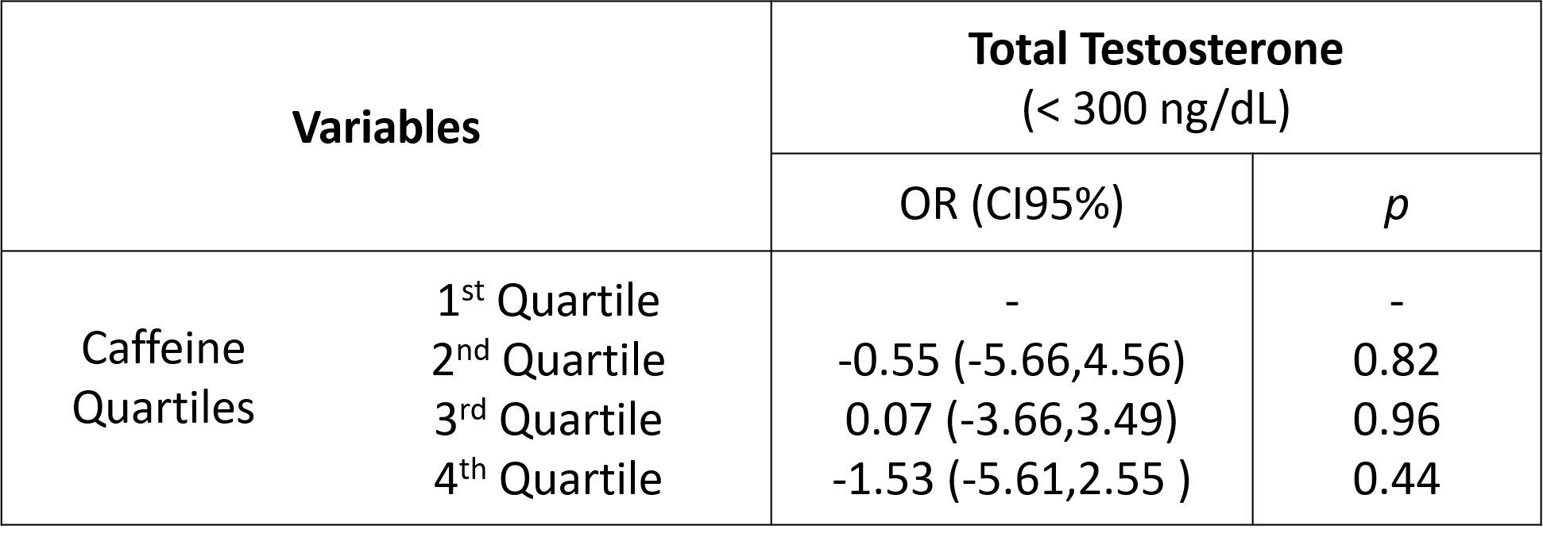
Supplementary table showing the odds ratios for low testosterone given each quartile of caffeine. Quartile 1 was used as the reference in each case. A p-value of <0.05 was used as the cutoff for statistical significance.

Supplementary Table 3
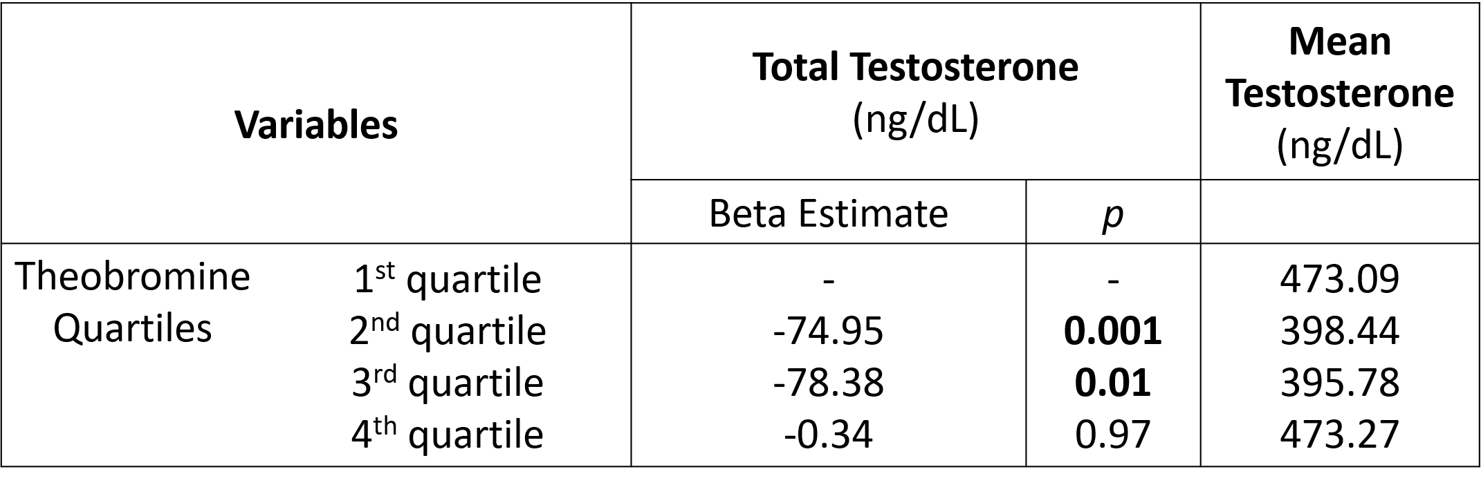
Supplementary table showing the beta estimates for expected change in testosterone for each quartile of urinary theobromine concentration. The first quartile was used as the reference in each case. A p-value <0.05 was used as the cutoff for statistical significance.
Supplementary Table 4
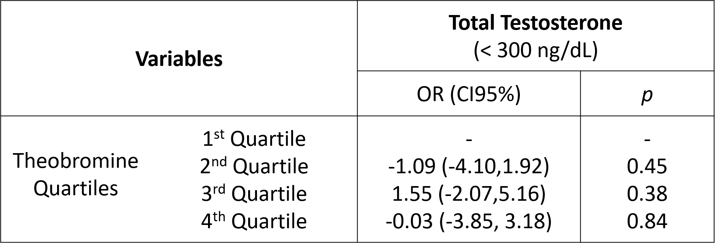
Supplementary table showing the odds ratios for low testosterone given each quartile of theobromine. Quartile 1 was used as the reference in each case. A p-value of <0.05 was used as the cutoff for statistical significance.

Supplementary Table 5
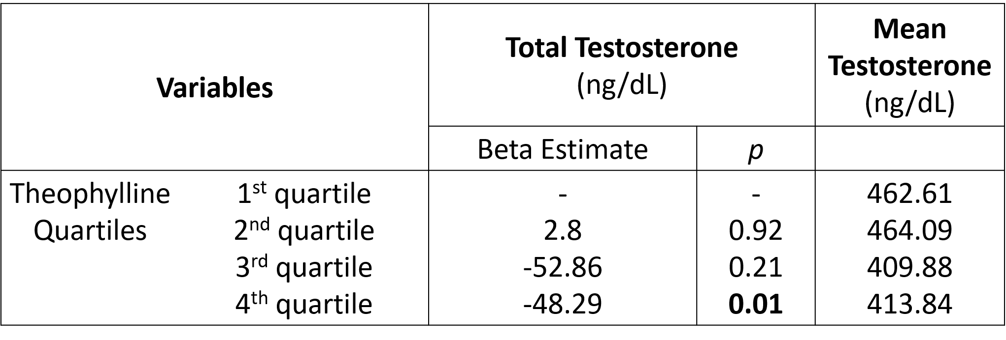
Supplementary table showing the beta estimates for expected change in testosterone for each quartile of urinary theophylline concentration. The first quartile was used as the reference in each case. A p-value <0.05 was used as the cutoff for statistical significance.
Supplementary Table 6
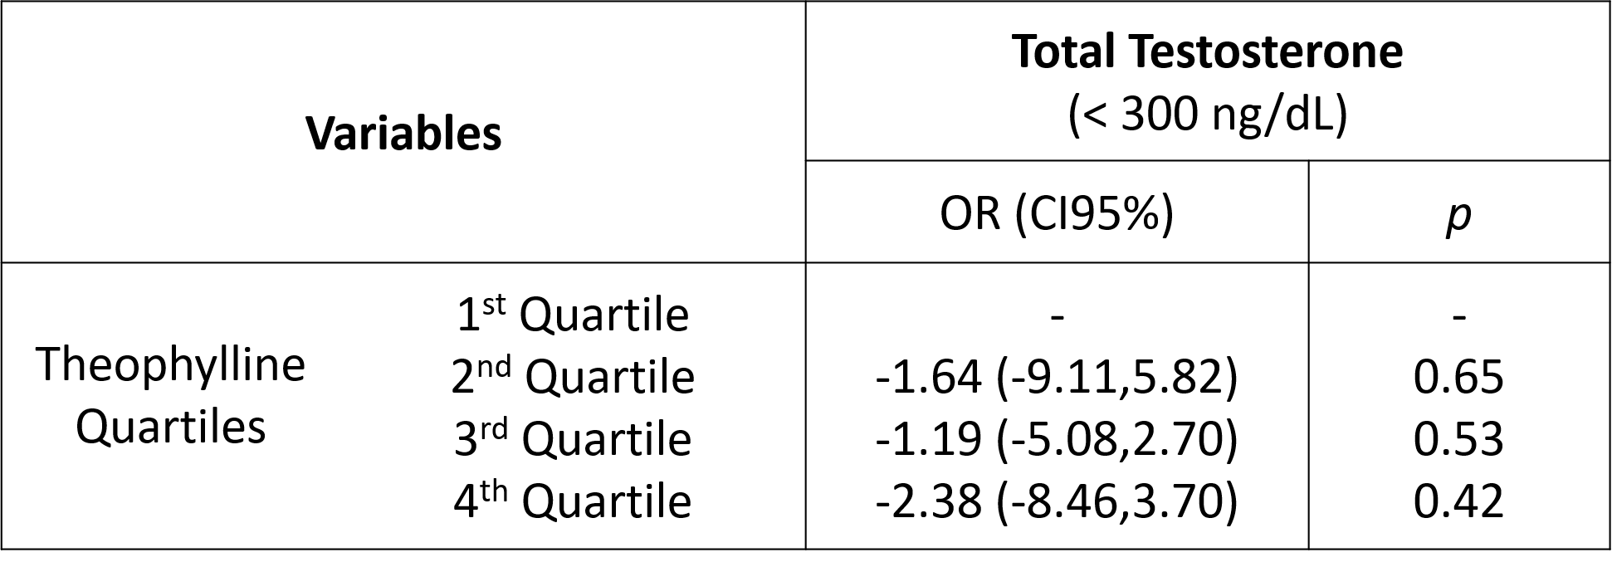
Supplementary table showing the odds ratios for low testosterone given each quartile of theophylline. Quartile 1 was used as the reference in each case. A p-value of <0.05 was used as the cutoff for statistical significance.

