Supplementary Table 1. Nutrient Profiles per Serving of Whole Food Plant-Based Proteins, Plant-Based Meat Alternatives, and Animal Meat¹
Product |  | Serving Size² | Kcals |  | Protein,  g | Carbs, g | Total fat, g | Sat fat,  g | Fiber, g | Sodium, mg
Whole Food Plant-Based
Tofu³ |  | 3 oz |  | 88 | 10 | 3 | 5 | 1 | 1 | 14
Tempeh |  | 3 oz |  | 163 | 17 | 6 | 9 | 2 | 0 | 8
Quinoa |  | ½ cup |  | 250 | 10 | 44 | 4 | 0 | 5 | 3
Black Beans |  | ½ cup |  | 96 | 6 | 18 | 0 | 0 | 7 | 265
Plant-Based Meat Alternatives  Impossible Burger |  | 4 oz |  | 240 | 19 | 9 | 14 | 8 | 3 | 370
Beyond Beef Ground |  | 4 oz |  | 230 | 20 | 7 | 14 | 5 | 2 | 390
Gardein Chick’n Strips |  | 4 oz |  | 164 | 18 | 6 | 8 | 1 | 0 | 387
Animal Meat ⁴
Burger |  | 3 oz |  | 216 | 21 | 0 | 14 | 5 | 0 | 57
Pork |  | 3 oz |  | 214 | 23 | 0 | 13 | 5 | 0 | 41
Chicken Breast |  | 3 oz |  | 147 | 26 | 0 | 4 | 1 | 0 | 65
¹All nutrient profiles obtained from NDSR Software Food and Nutrient Database.
Dairy and egg were minimized in WFPB, and consumption was not emphasized and did not count as a primary protein source in PBMA or Animal.
²4 oz of PBMA was chosen to more closely achieve caloric and protein equivalence with 3 oz of Animal
³Tofu is minimally processed and thus considered WFPB rather than PBMA
⁴Animal emphasized protein intake from red meat and poultry. Fish limited to once per week.

Supplementary Table 2. Weekly Adherence to Consistent Physical Activity Across Diet Phases
Outcome | WFPB |  |  |  |  | PBMA | Animal
 | Median | IQR |  |  | Median | IQR | Median | IQR
Runners
Volume
Minutes of running | 157 | (97 - 213) |  |  | 161 | (111 - 241) | 139 | (115 - 228)
Minutes of other activity | 123 | (91 - 153) |  |  | 132 | (87 - 188) | 105 | (83 - 159)
Miles per week | 18.9 | (11.3 - 23.1) |  |  | 19.0 | (9.5 - 25.8) | 17.0 | (10.7 - 24.0)
Intensity  Average sRPE¹ | 12.4 | (11.3 - 13) |  |  | 12.3 | (11.4 -12.7) | 12.5 | (11.3 - 13)
Resistance Trainers
Volume
Minutes of resistance training | 206 | (156 - 256) |  |  | 165 | (133 - 248) | 203 | (123 - 259)
Minutes of other activity² | 114 | (84 - 190) |  |  | 188 | (146 - 341) | 131 | (75 - 202)
Intensity  Average sRPE | 14.8 | (12.9 – 15.5) |  |  | 14.8 | (13.1 - 16.3) | 14.8 | (13.1 - 15.9)
¹sRPE refers to “session RPE,” the training intensity of individual workouts throughout each diet rated on the 6-20 Borg RPE scale
²Other activity included cycling, climbing, hiking, or other cross-training activities for the purpose of exercise

Supplementary Table 3. Rate of Perceived Exertion (RPE) on Athletic Field Test
Outcome | WFPB | PBMA | Animal | WFPB - Animal | PBMA - Animal
 | Mean ± SD | Mean ± SD | Mean ± SD | Mean Difference¹,  95% CI | Mean Difference, 95% CI
Runners
12 minute timed run | 17.3 ± 3.1 | 16.9 ± 2.5 | 17.5 ± 2.6 | -0.3 (-0.8, 0.3) | -0.6 (-1.5, 0.2)
Resistance Trainers
Chest press | 16.5 ± 2.9 | 17.4 ± 2.7 | 17.6 ± 2.2 | -1.1 (-2.2, 0) | -1.3 (-1.3, 0.7)
Leg press | 16.7 ± 2.8 | 17.3 ± 2.5 | 17.4 ± 2.1 | -0.6 (-1.8, 0.6) | -0.1 (-1.0, 0.8)
Lat pull-down | 17.1 ± 2.7 | 17.2 ± 2.6 | 17.5 ± 2 | -0.4 (-1.7, 1.0) | -0.3 (-1.5, 0.9)
Push-up | 16.1 ± 3.3 | 17.2 ± 2.4 | 17 ± 2.6 | -0.9 (-1.9, 0.1) | 0.2 (-0.5, 0.9)
Pull-up | 16.7 ± 2.9 | 16.9 ± 2.6 | 17 ± 2.5 | -0.3 (-1.4, 0.8) | -0.1 (-1.0, 0.8)
¹Mean Difference was the average of individual differences (WFPB - Animal or PBMA - Animal) between diets

Supplementary Table 4. Anthropometric Measures after 4-wk diet phases
Outcome | WFPB  Mean ± SD | PBMA  Mean ± SD | Animal  Mean ± SD | WFPB - Animal  Mean Difference,¹  95% CI | PBMA - Animal  Mean Difference, 95% CI
Runners
Body weight, kg | 63.5 ± 8.2 | 63.5 ± 8.2 | 64 ± 8.2 | -0.5 (-0.8, -0.3) | -0.3 (-0.8, 0.3)
Body fat, % | 14.8 ± 3.8 | 14.8 ± 3.7 | 15.0 ± 3.7 | -0.2 (-0.3, -0.1) | -0.2 (-0.4, -0.1)
Resistance Trainers
Body weight, kg | 64 ± 12.7 | 64.9 ± 13.2 | 64.9 ± 13.2 | -0.9 (-1.6, 0) | 0 (-0.5, 0.5)
Body fat, % | 14.7 ± 4.0 | 15.1 ± 4.3 | 15.1 ± 4.3 | -0.4 (-0.7, 0) | 0.1 (-0.1, 0.2)
¹Mean Difference was the average of individual differences (WFPB - Animal or PBMA - Animal) between diets

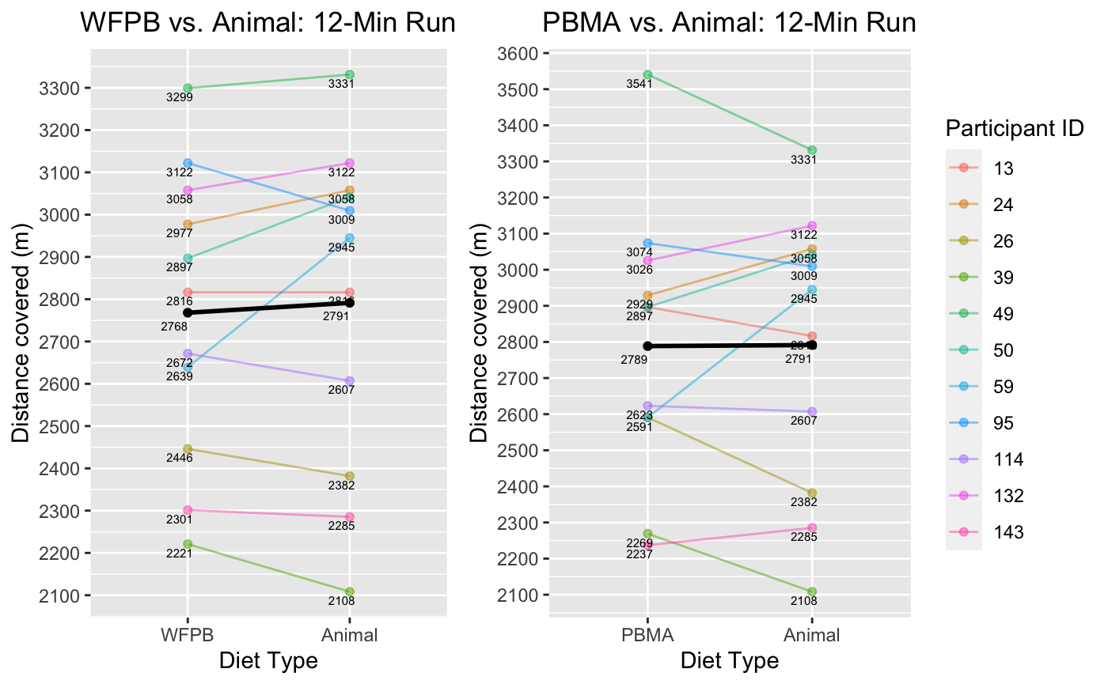
Supplementary Figure 1. Primary Athletic Field Test Outcome (Runners):
12-Minute Timed Run

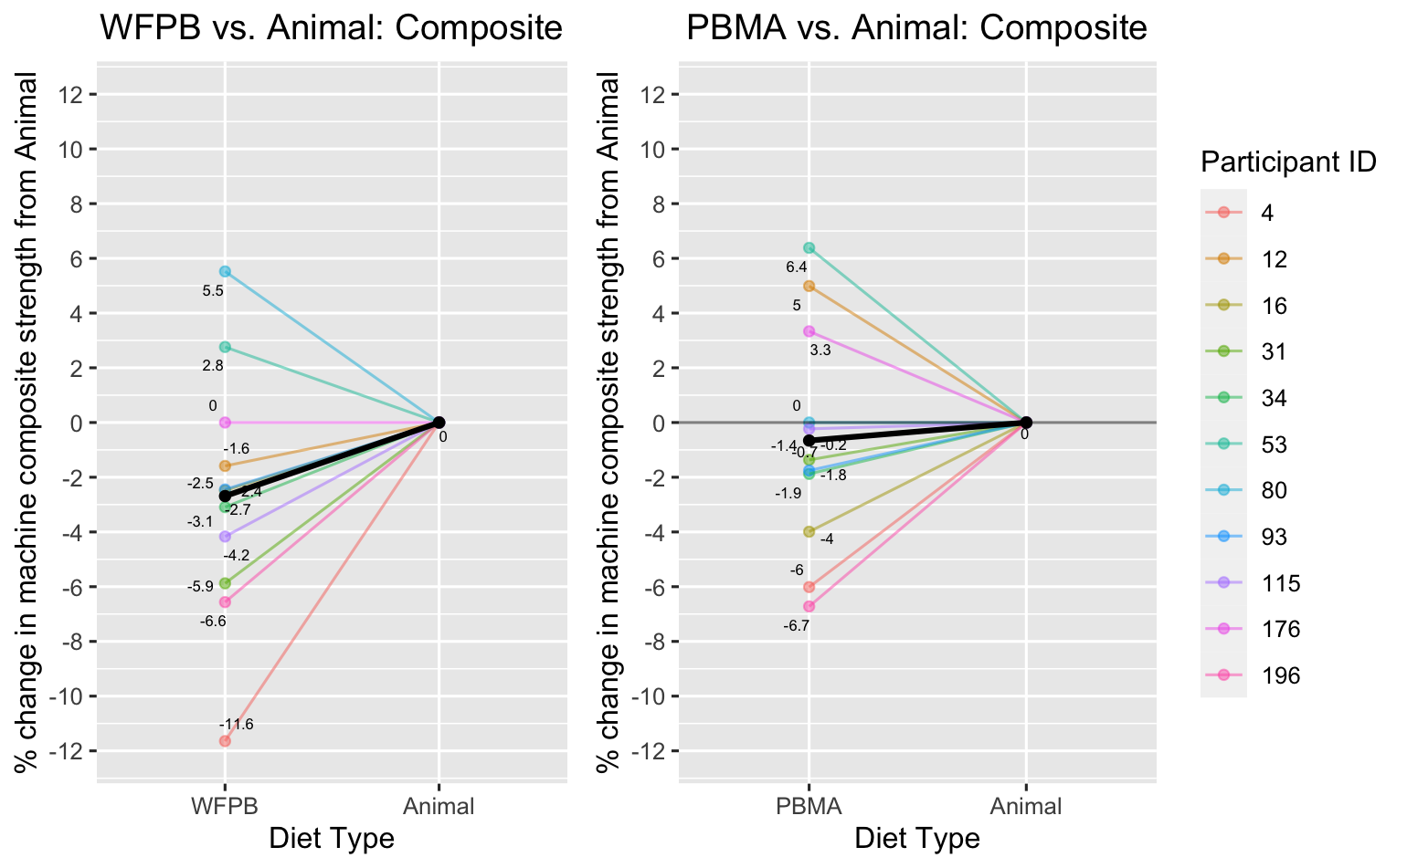

Supplementary Figure 2. Primary Athletic Field Test Outcome (Resistance Trainers): Machine Composite Strength

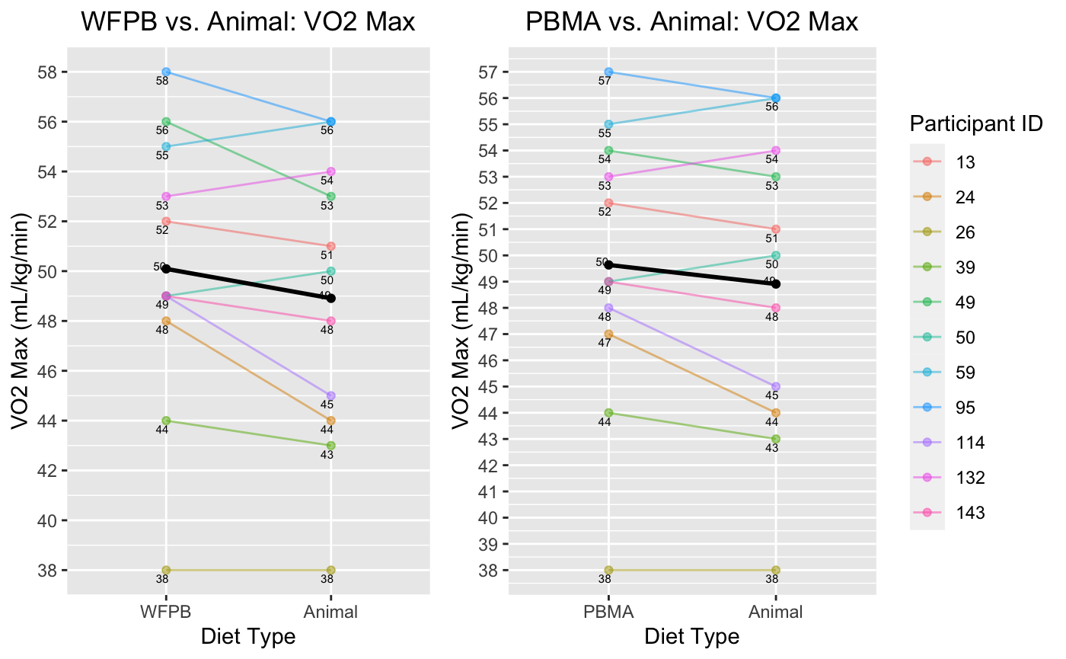
Supplementary Figure 3. Secondary Athletic Field Test Outcome (Runners):
VO₂ Max

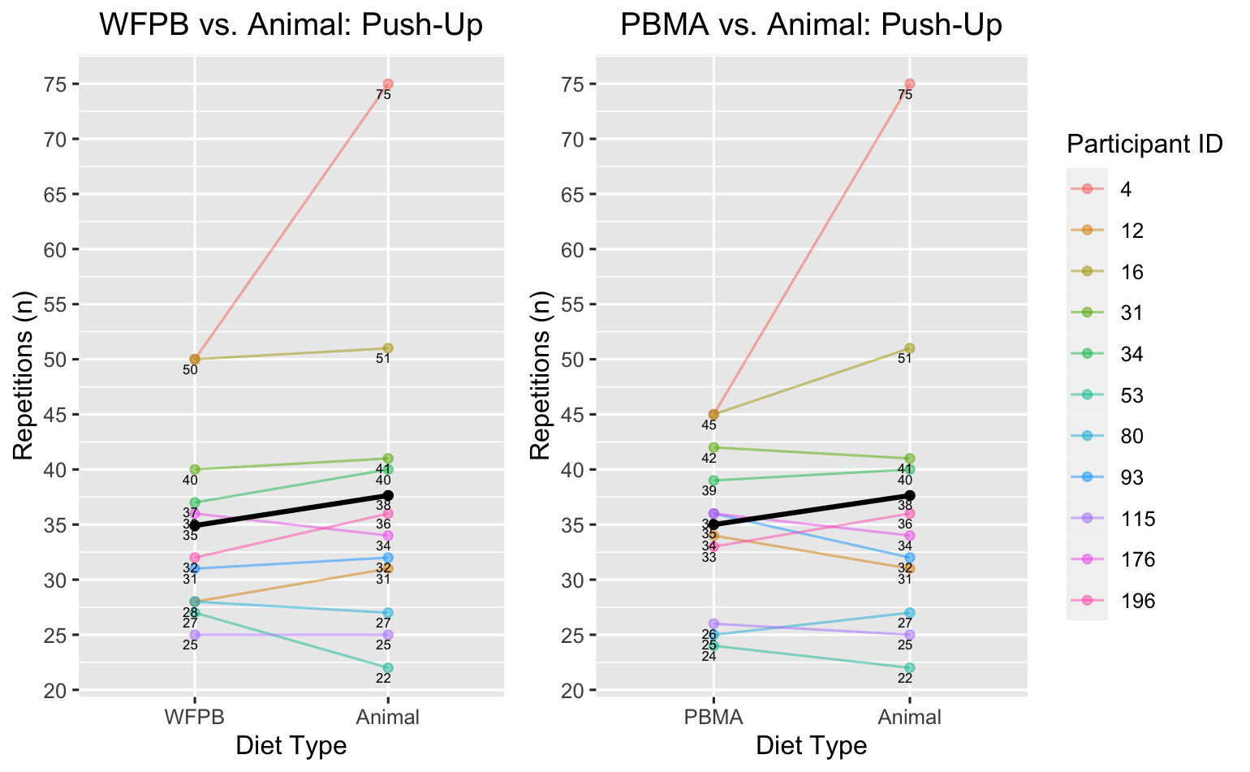

Supplementary Figure 4a. Secondary Athletic Field Test Outcome (Resistance Trainers): Push-Up

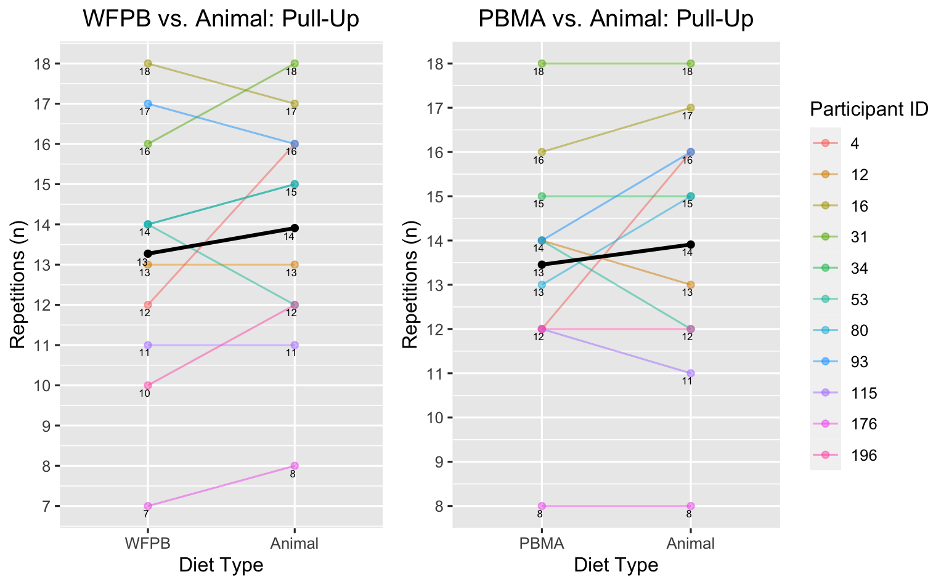Supplementary Figure 4b. Secondary Athletic Field Test Outcome (Resistance Trainers): Pull-Up
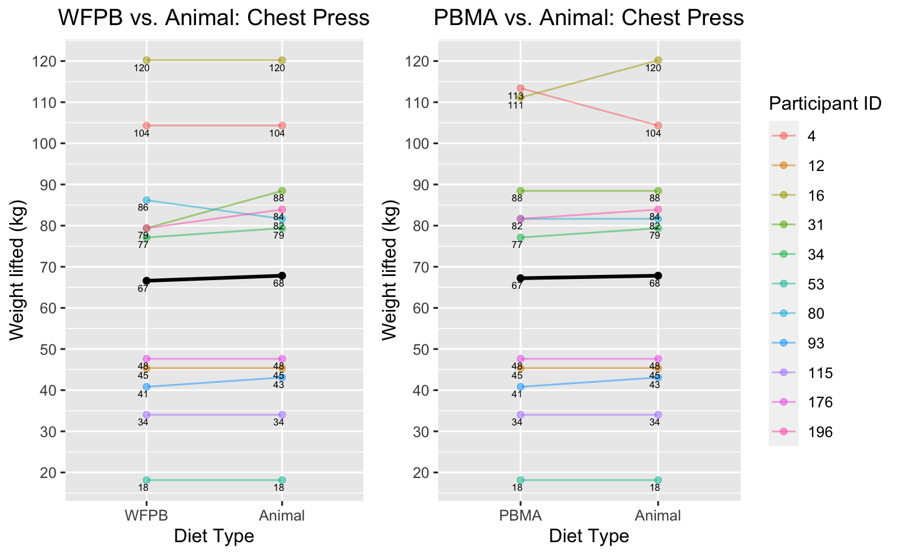
Supplementary Figure 4c. Secondary Athletic Field Test Outcome (Resistance Trainers): Chest Press

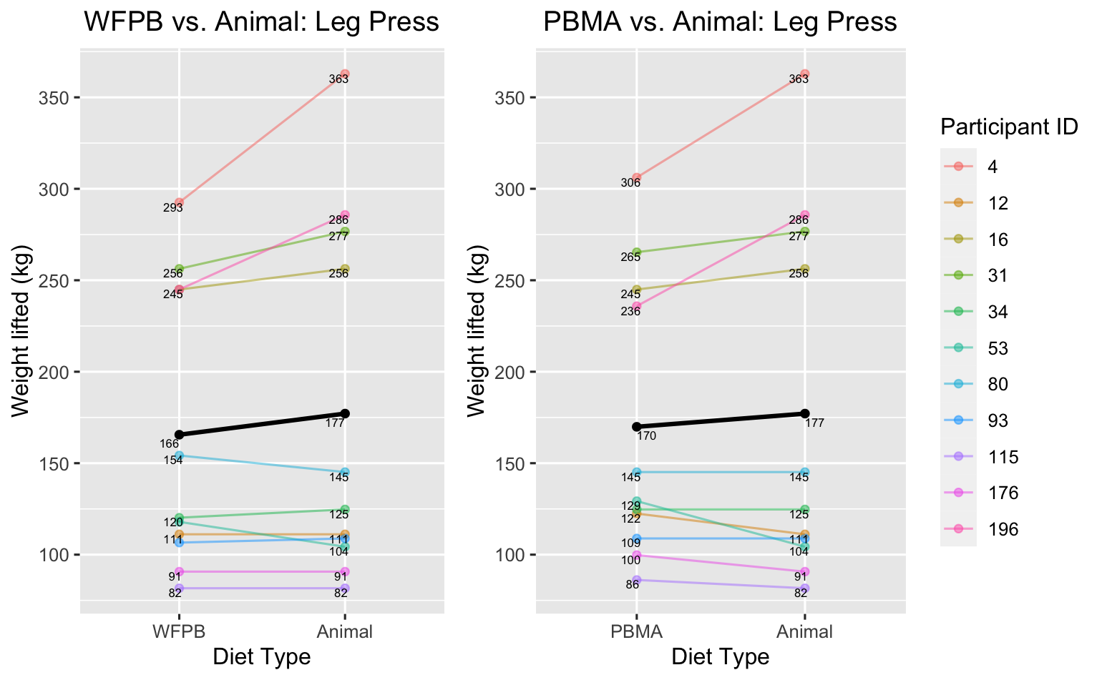

Supplementary Figure 4d. Secondary Athletic Field Test Outcome (Resistance Trainers): Leg Press
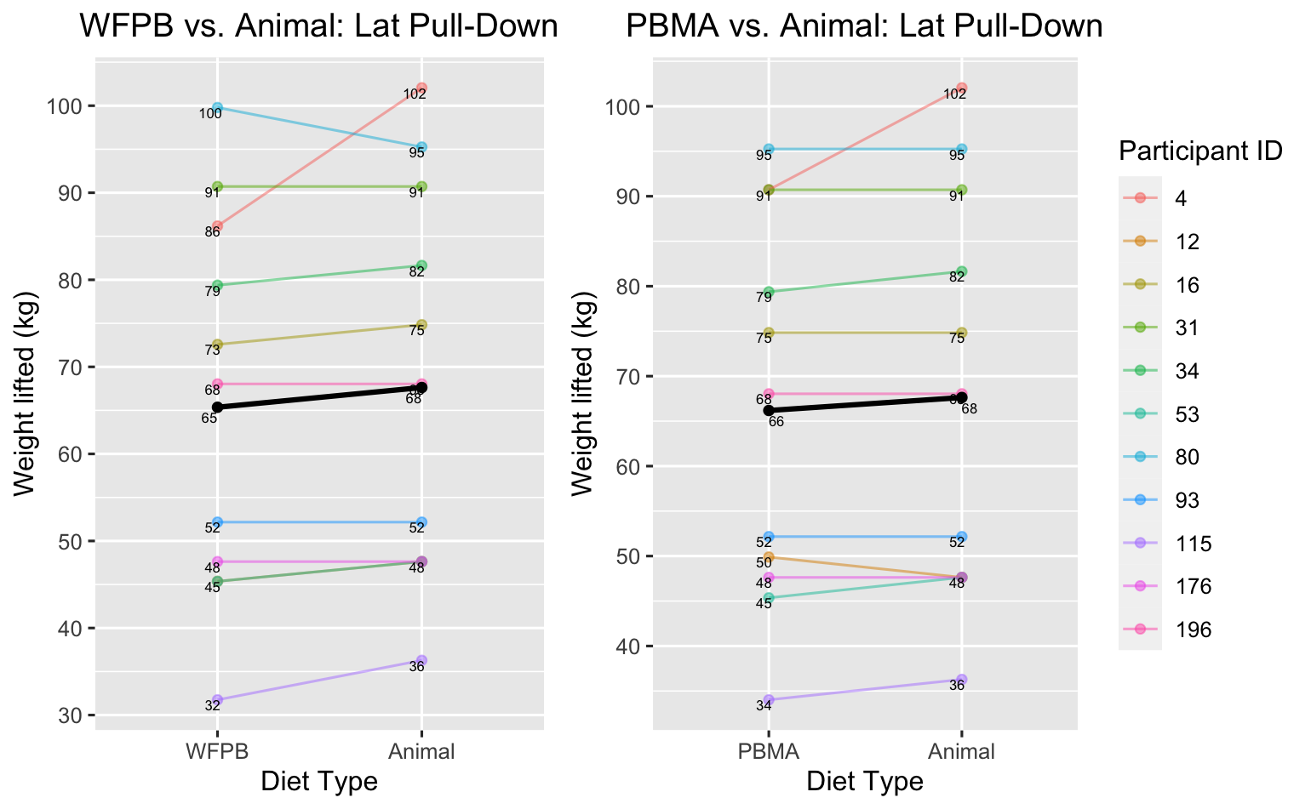

Supplementary Figure 4e. Secondary Athletic Field Test Outcome (Resistance Trainers): Lat Pull-Down

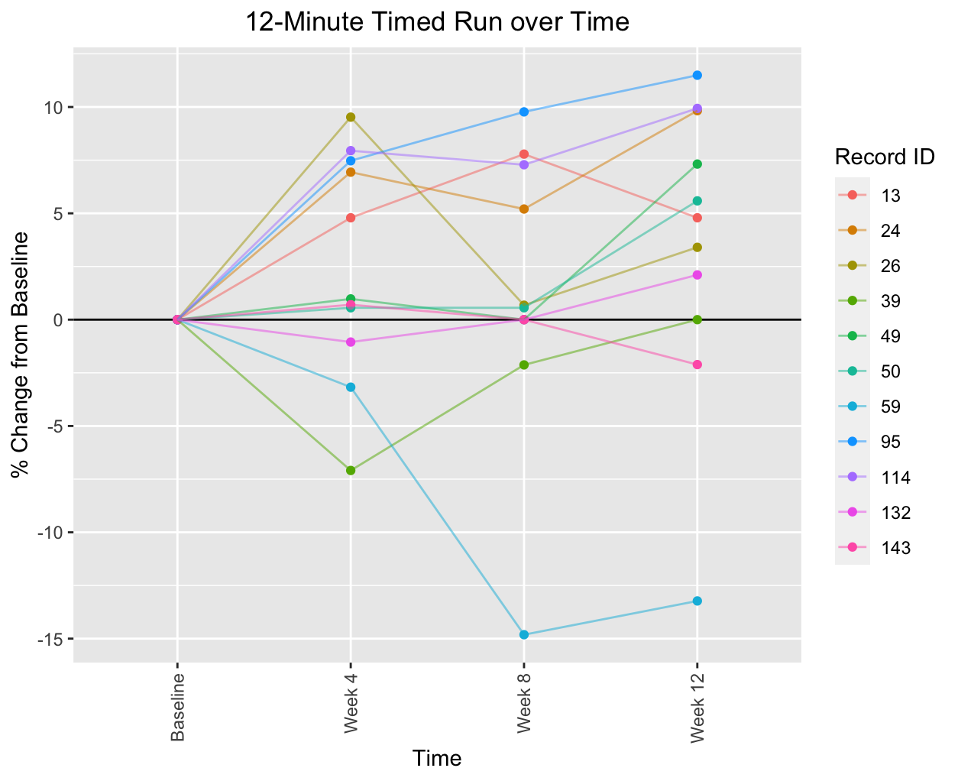
Supplementary Figure 5a. Athletic Performance over the 12-week intervention: 12-minute timed run

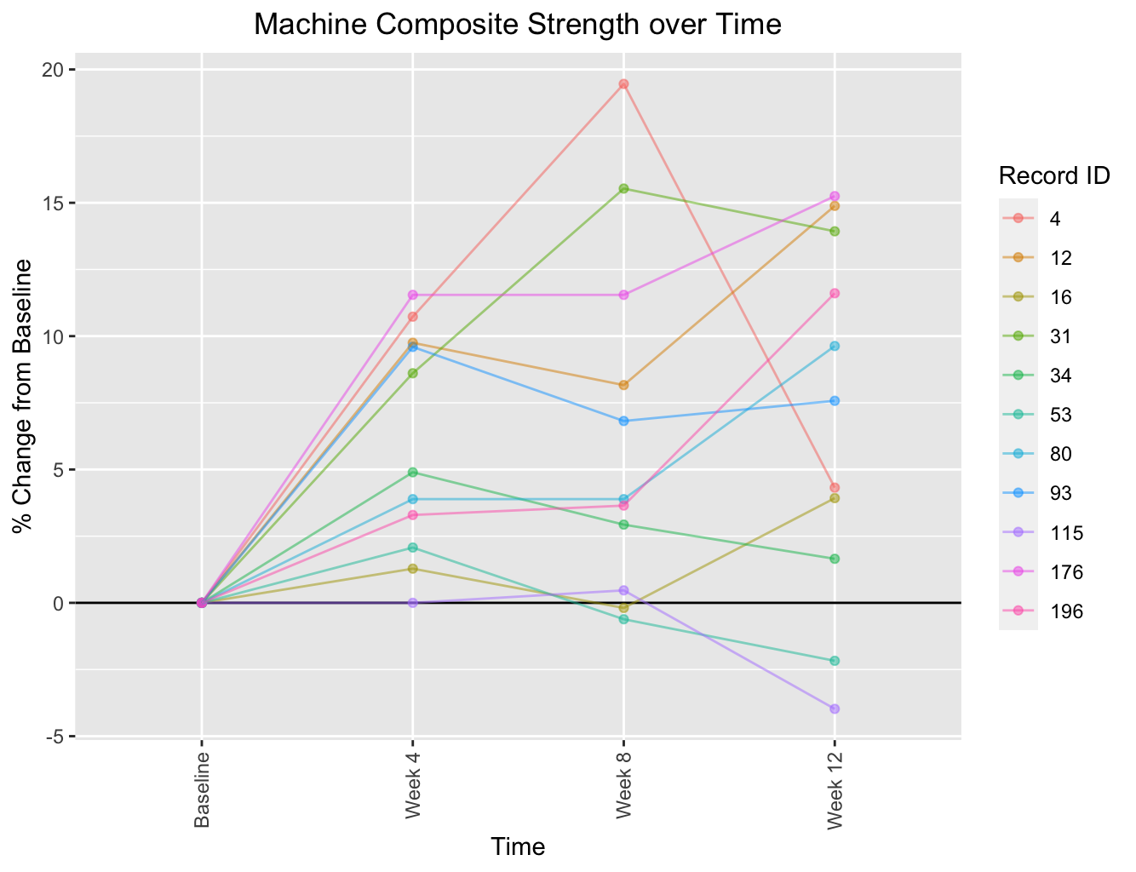
Supplementary Figure 5b. Athletic Performance over the 12-week intervention: machine composite strength

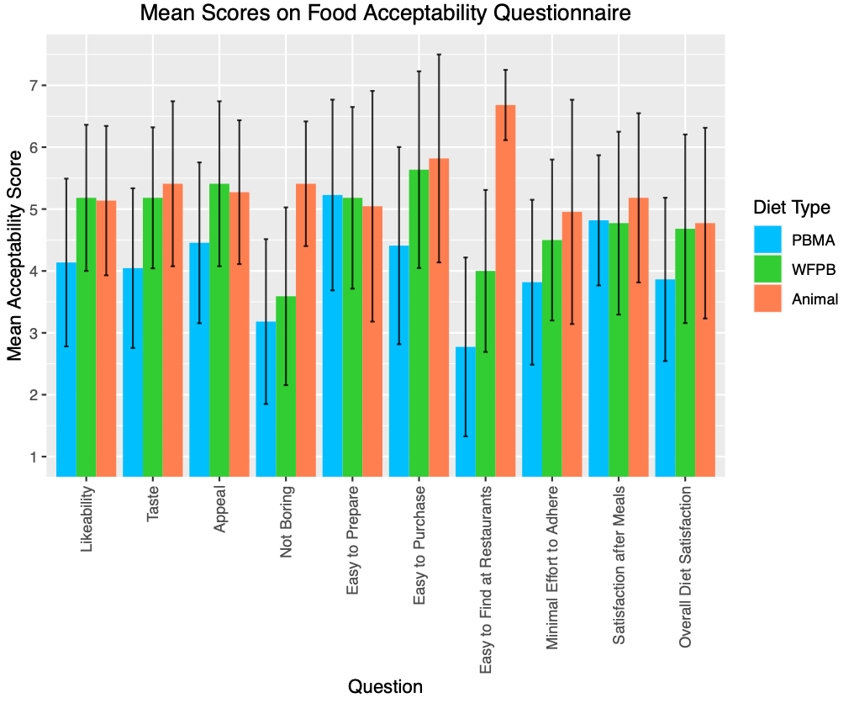

Supplementary Figure 6. Diet Satisfaction
Error bars indicate mean ± standard deviation

