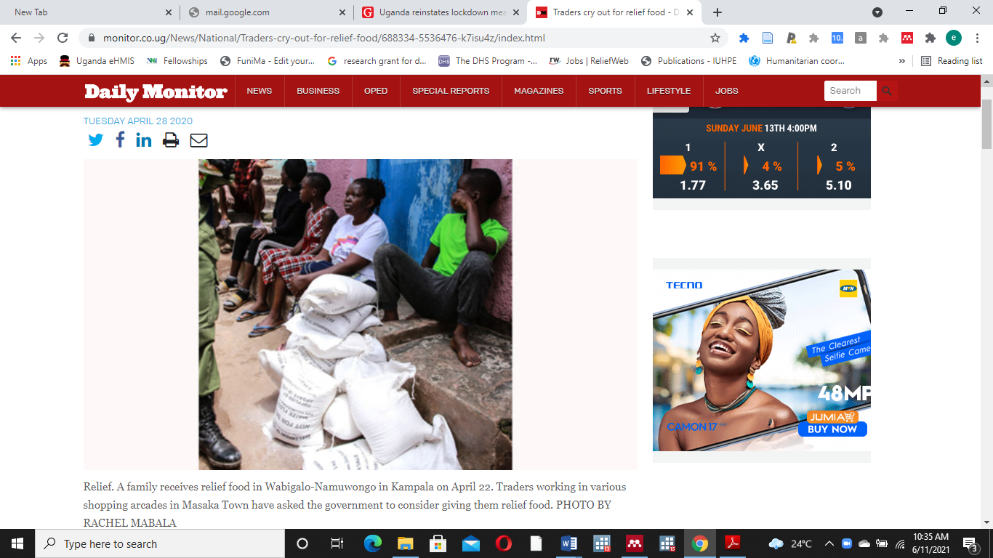
Figure 1: A family receives food aid in Wabigalo-Namuwongo in urban Kampala on April 22 (30).

