Supplementary Figure S1 Scatter plot for the correlation of eating midpoint with eGFR
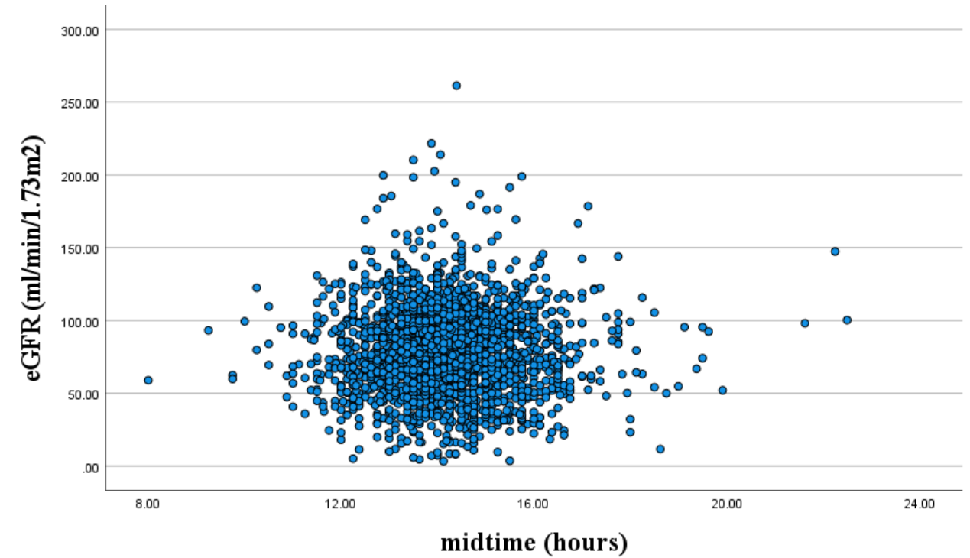

Supplementary Figure S2 Scatter plot for the correlation of eating midpoint with ln(UACR)
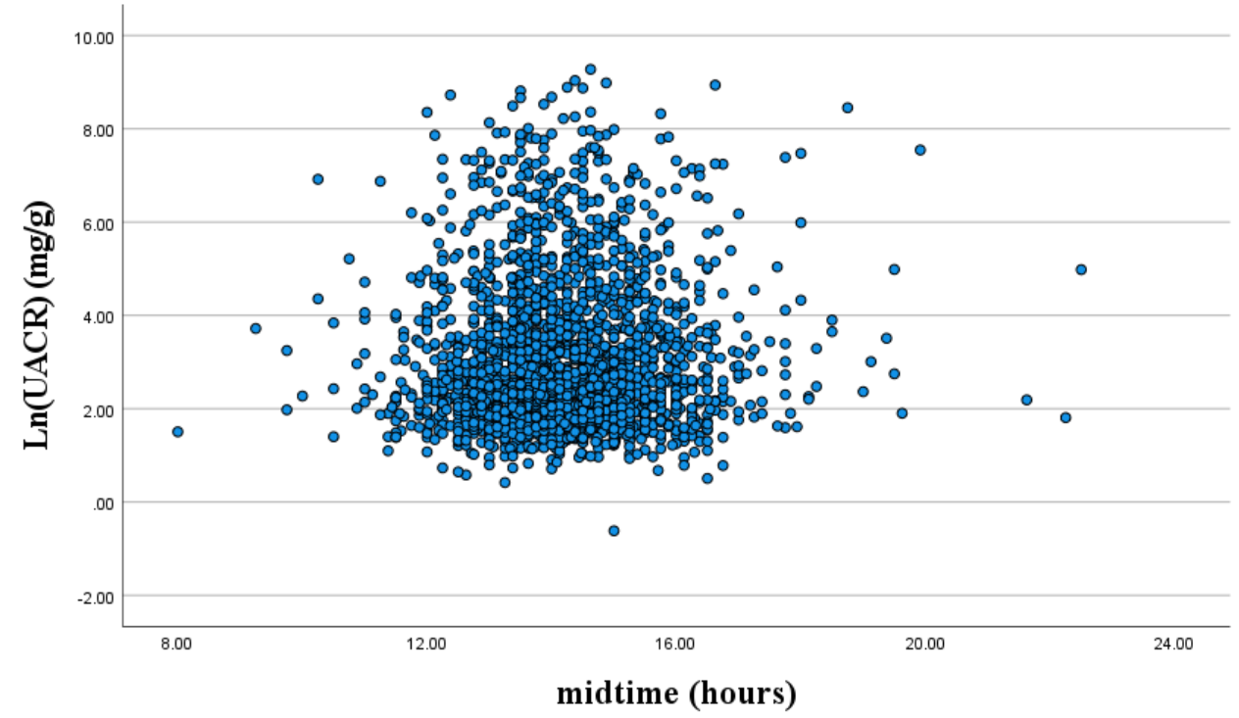

Supplementary Table S1 Scatter plot for the correlation of eating midpoint with eGFR

Supplementary Table S2 Scatter plot for the correlation of eating midpoint with ln(UACR)

Supplementary Table S3 Clinical characteristics of the study participants
Variables | Total | Low eating duration | High eating duration | P value
Eating duration (hours) | 11.78±2.35 | < 12 | ≥ 12
n | 2194 | 1084 | 1110
eGFR (ml/min/1.73m²) | 78.95±30.04 | 78.15±31.08 | 79.74±28.97 | 0.216
UACR (mg/g) | 13.73(7.36-46.70) | 14.05(7.50-49.71) | 13.18(7.18-43.91) | 0.218
DKD, n (%) | 1019(46.4) | 526(48.5) | 493(44.4) | 0.059
Normally distributed values in the table are given as the mean ± SD, skewed distributed values are given as the median (25 and 75% interquartiles), and categorical variables are given as frequency (percentage)
All times in this study are expressed on a 24-hour scale and converted into hours
eGFR estimated glomerular filtration rate, UACR urinary albumin-to-creatinine ratio, DKD diabetic kidney disease

Supplementary Table S4 ORs (95% CIs) of DKD according to the binary classifications of eating duration
Eating duration | Model 0 | P value | Model 1 | P value | Model 2 | P value
< 12 hours | 1-reference | - | 1-reference | - | 1-reference | -
≥ 12 hours | 0.85(0.72-1.00) | 0.054 | 0.87(0.71-1.05) | 0.137 | 0.85(0.70-1.05) | 0.126
Model 0: unadjusted model
Model 1: adjusted for age, sex, ethnicity, household income, BMI
Model 2: additionally adjusted for smoking status, drinking status, energy intake, HbA1c

