SUPPLEMENTARY MATERIAL

The Effect of Omega-3 Polyunsaturated Fatty Acid (PUFA) Prescription Preparations on the Prevention of Clinical Cardiovascular Disease: A Meta-Analysis of RCTs

Online-only Data Supplement

Table S1 | Full search strategy and search terms | 3
Figure S1 | Forest plot of cardiovascular events with prediction intervals | 5
Figure S2 | Forest plot of MACE with prediction intervals | 6
Figure S3 | Forest plot of cardiovascular death with prediction intervals | 7
Figure S4 | Forest plot of all-cause mortality with prediction intervals | 8
Figure S5 | Forest plot of MI with prediction intervals | 9
Figure S6 | Forest plot of stroke with prediction intervals | 10
Figure S7 | Forest plot of revascularization with prediction intervals | 11
Figure S8 | Forest plot illustrating the subgroup analysis for cardiovascular events: onlyEPA and EPA+DHA | 12
Figure S9 | Forest plot illustrating the subgroup analysis for cardiovascular events: 1g and >1g | 13
Figure S10 | Forest plot illustrating the subgroup analysis for cardiovascular events: <3y and ≥3y | 14
Figure S11 | Forest plot illustrating the subgroup analysis for cardiovascular events: primary prevention, mix prevention and secondary prevention | 15
Figure S12 | Forest plot illustrating the subgroup analysis for MACEs: onlyEPA and EPA+DHA MACEs MACEs | 16
Figure S13 | Forest plot illustrating the subgroup analysis for MACEs: <3y and ≥3y | 17
Figure S14 | Forest plot illustrating the subgroup analysis for MACEs: primary prevention, mix prevention and secondary prevention | 18
Figure S15 | Forest plot illustrating the subgroup analysis for cardiac death: onlyEPA and EPA+DHA | 19
Figure S16 | Forest plot illustrating the subgroup analysis for cardiac death: 1g and >1g | 20
Figure S17 | Forest plot illustrating the subgroup analysis for cardiac death: <3y and ≥3y | 21
Figure S18 | Forest plot illustrating the subgroup analysis for cardiac death: primary prevention, mix prevention and secondary prevention | 22
Figure S19 | Forest plot illustrating the subgroup analysis for all-cause mortality: onlyEPA and EPA+DHA | 23
Figure S20 | Forest plot illustrating the subgroup analysis for all-cause mortality: 1g and >1g | 24
Figure S21 | Forest plot illustrating the subgroup analysis for all-cause mortality: <3y and ≥3y | 25
Figure S22 | Forest plot illustrating the subgroup analysis for all-cause mortality: primary prevention, mix prevention and secondary prevention | 26
Figure S23 | Forest plot illustrating the subgroup analysis for MI: onlyEPA and EPA+DHA | 27
Figure S24 | Forest plot illustrating the subgroup analysis for MI: 1g and >1g | 28
Figure S25 | Forest plot illustrating the subgroup analysis for MI: <3y and ≥3y | 29
Figure S26 | Forest plot illustrating the subgroup analysis for MI: primary prevention, mix prevention and secondary prevention | 30

Supplementary Table 1. Full search strategy and search terms
Database | Search strategy | Results
PubMed | ((((((((((((Cardiovascular Diseases[MeSH Terms]) OR (Cardiovascular Disease)) OR (Disease, Cardiovascular)) OR (Major Adverse Cardiac Events)) OR (Cardiac Events)) OR (Cardiac Event)) OR (Event, Cardiac)) OR (Adverse Cardiac Event)) OR (Adverse Cardiac Events)) OR (Cardiac Event, Adverse)) OR (Cardiac Events, Adverse)) OR ((cardiac) OR (cardiovascular))) AND (((((((((((((((((((((((((((((((((((((((((((((((((((((((((((((Fatty Acids, Omega-3[MeSH Terms]) OR (Omega-3 Fatty Acid)) OR (Acid, Omega-3 Fatty)) OR (Fatty Acid, Omega-3)) OR (Omega 3 Fatty Acid)) OR (Omega-3 Fatty Acids)) OR (n-3 Oil)) OR (Oil, n-3)) OR (n 3 Oil)) OR (n3 Oil)) OR (Oil, n3)) OR (n-3 Fatty Acids)) OR (n 3 Fatty Acids)) OR (Omega 3 Fatty Acids)) OR (n-3 PUFA)) OR (PUFA, n-3)) OR (n 3 PUFA)) OR (n3 Fatty Acid)) OR (Fatty Acid, n3)) OR (n3 PUFA)) OR (PUFA, n3)) OR (n3 Polyunsaturated Fatty Acid)) OR (n3 Oils)) OR (n-3 Oils)) OR (n 3 Oils)) OR (N-3 Fatty Acid)) OR (Acid, N-3 Fatty)) OR (Fatty Acid, N-3)) OR (N 3 Fatty Acid)) OR (n-3 Polyunsaturated Fatty Acid)) OR (n 3 Polyunsaturated Fatty Acid)) OR (n-3 Polyunsaturated Fatty Acids)) OR (n 3 Polyunsaturated Fatty Acids)) OR (n3 Polyunsaturated Fatty Acids)) OR (Fatty Acids, N-3)) OR (Fatty Acids, n3)) OR (n-3 PUFAs)) OR (n 3 PUFAs)) OR (n3 PUFAs)) OR (PUFAs, n3)) OR (Ethyl-Ester Omega-3 Fatty Acid)) OR (omega-3 ethyl esters 90)) OR (omega-3-acid ethyl esters 90)) OR (omega-3 Fatty Acids Ethyl Esters)) OR (omega-3 Acid Ethyl Ester)) OR (eicosapentaenoic acid)) OR (EPA)) OR (docosahexaenoic acid)) OR (DHA)) OR (n-3 long-chain polyunsaturated fatty acids)) OR (long chain omega-3 polyunsaturated fatty acids)) OR (Omega-3 Long-Chain Polyunsaturated Fatty Acid)) OR (n-3 long chain PUFA)) OR (Polyunsaturated n-3 fatty acids)) OR (omega-3-acid ethyl esters)) OR (LOVAZA)) OR (OMACOR)) OR (TAK-085)) OR (Omtryg)) OR (Lotriga))) | 15995
Embase | ('omega-3'/exp OR 'omega-3 fatty acid' OR 'acid, omega-3 fatty' OR 'fatty acid, omega-3' OR 'omega 3 fatty acid' OR 'omega-3 fatty acids' OR 'n-3 oil' OR 'oil, n-3' OR 'n 3 oil' OR 'n3 oil' OR 'oil, n3' OR 'n-3 fatty acids' OR 'n 3 fatty acids' OR 'omega 3 fatty acids' OR 'n-3 pufa' OR 'pufa, n-3' OR 'n 3 pufa' OR 'n3 fatty acid' OR 'fatty acid, n3' OR 'n3 pufa' OR 'pufa, n3' OR 'n3 polyunsaturated fatty acid' OR 'n3 oils' OR 'n-3 oils' OR 'n 3 oils' OR 'n-3 fatty acid' OR 'acid, n-3 fatty' OR 'fatty acid, n-3' OR 'n 3 fatty acid' OR 'n-3 polyunsaturated fatty acid' OR 'n 3 polyunsaturated fatty acid' OR 'n-3 polyunsaturated fatty acids' OR 'n 3 polyunsaturated fatty acids' OR 'n3 polyunsaturated fatty acids' OR 'fatty acids, n-3' OR 'fatty acids, n3' OR 'n-3 pufas' OR 'n 3 pufas' OR 'n3 pufas' OR 'pufas, n3' OR 'ethyl-ester omega-3 fatty acid' OR 'omega-3 ethyl esters 90' OR 'omega-3-acid ethyl esters 90' OR 'omega-3 fatty acids ethyl esters' OR 'omega-3 acid ethyl ester' OR 'eicosapentaenoic acid' OR 'epa' OR 'docosahexaenoic acid' OR 'dha' OR 'n-3 long-chain polyunsaturated fatty acids' OR 'long chain omega-3 polyunsaturated fatty acids' OR 'omega-3 long-chain polyunsaturated fatty acid' OR 'n-3 long chain pufa' OR 'polyunsaturated n-3 fatty acids' OR 'omega-3-acid ethyl esters' OR 'lovaza' OR 'omacor' OR 'tak-085' OR 'omtryg' OR 'lotriga') AND ('cardiovascular disease'/exp OR 'cardiovascular disease' OR 'disease, cardiovascular' OR 'major adverse cardiac events' OR 'cardiac events' OR 'cardiac event' OR 'event, cardiac' OR 'adverse cardiac event' OR 'adverse cardiac events' OR 'cardiac event, adverse' OR 'cardiac events, adverse' OR 'cardiac' OR 'cardiovascular') | 23767
Search was conducted to identify articles up to September 30, 2023

Figure S1. Forest plot of cardiovascular events with prediction intervals
Figure S2. Forest plot of MACE with prediction intervals
Supplementary Figure3. Forest plot of cardiovascular death with prediction intervals

Supplementary Figure4. Forest plot of all-cause mortality with prediction intervals
Supplementary Figure5. Forest plot of MI with prediction intervals

Supplementary Figure6. Forest plot of stroke with prediction intervals

Supplementary Figure7. Forest plot of revascularization with prediction intervals
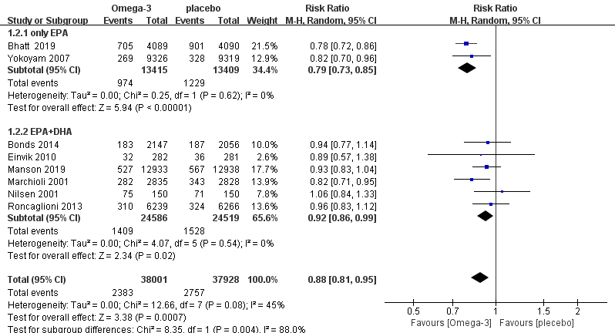

Supplementary Figure 8. Forest plot illustrating the subgroup analysis for cardiovascular events: onlyEPA and EPA+DHA

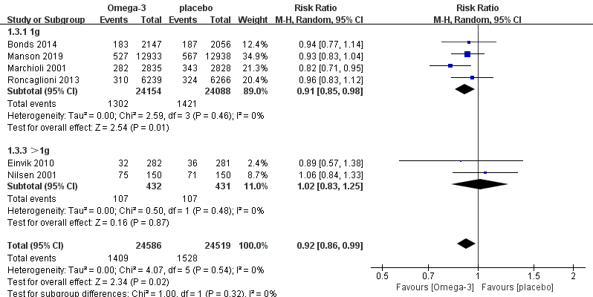

Supplementary Figure 9. Forest plot illustrating the subgroup analysis for cardiovascular events: 1g and >1g

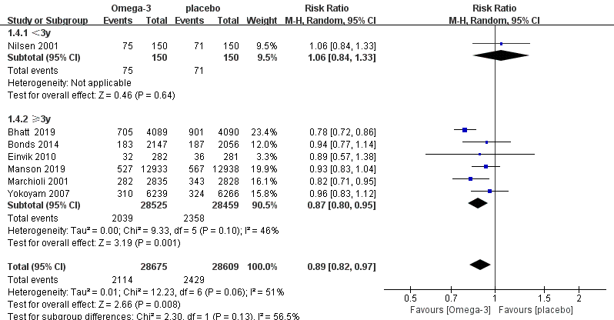

Supplementary Figure 10. Forest plot illustrating the subgroup analysis for cardiovascular events: <3y and ≥3y

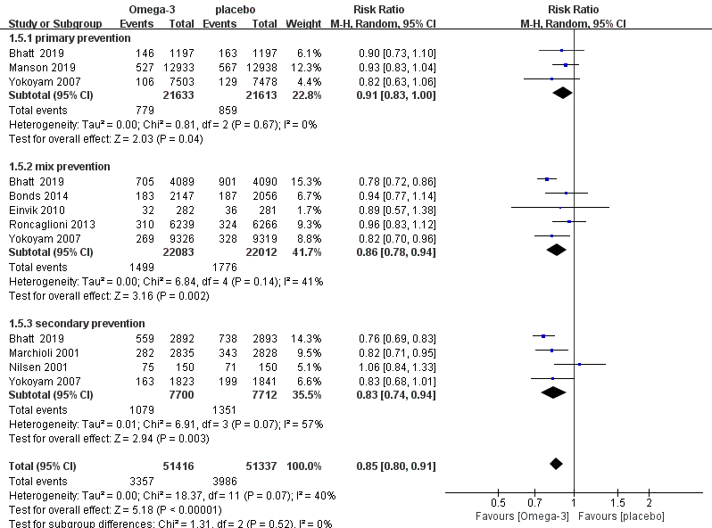

Supplementary Figure 11. Forest plot illustrating the subgroup analysis for cardiovascular events: primary prevention, mix prevention and secondary prevention

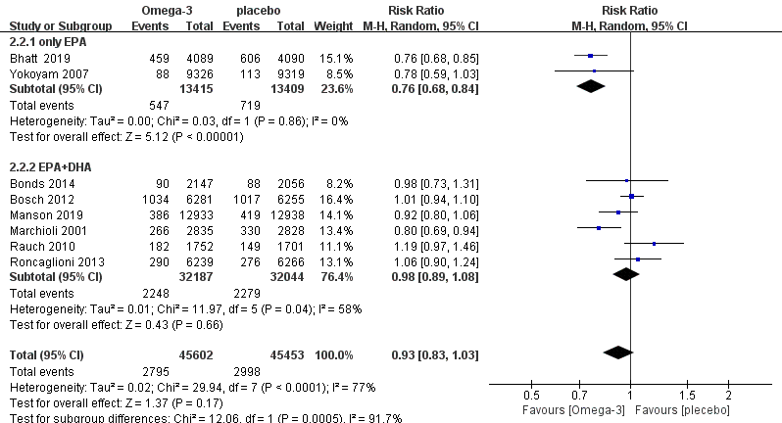

Supplementary Figure 12. Forest plot illustrating the subgroup analysis for MACEs: onlyEPA and EPA+DHA

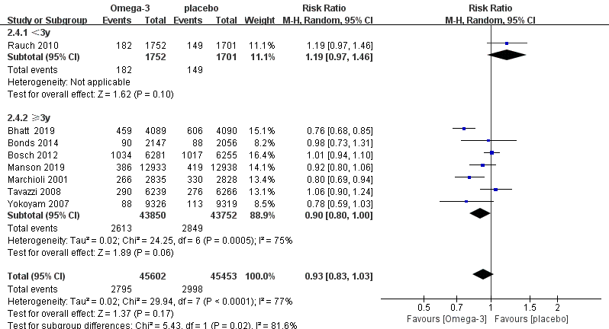

Supplementary Figure 13. Forest plot illustrating the subgroup analysis for MACEs: <3y and ≥3y

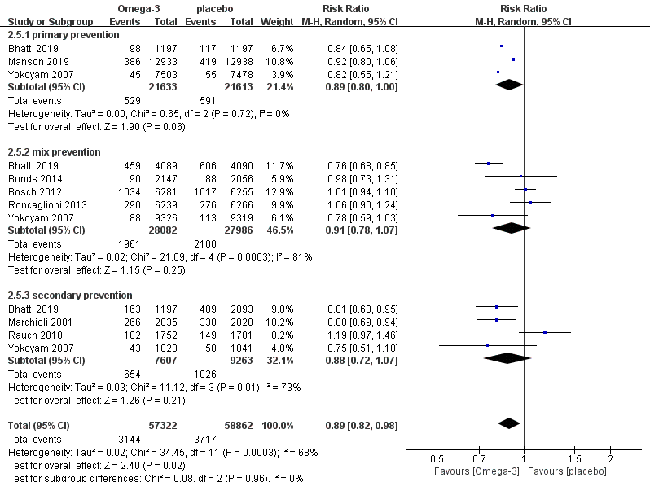

Supplementary Figure 14. Forest plot illustrating the subgroup analysis for MACEs: primary prevention, mix prevention and secondary prevention

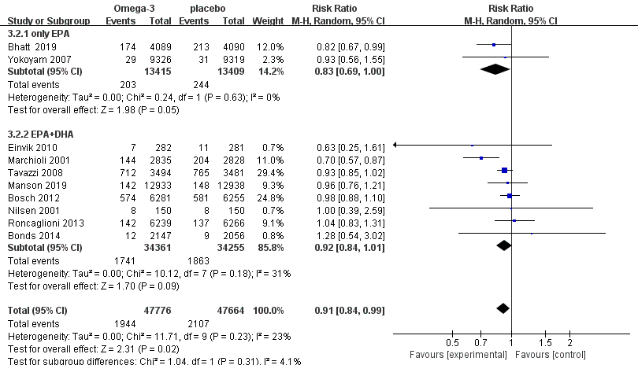

Supplementary Figure 15. Forest plot illustrating the subgroup analysis for cardiac death: onlyEPA and EPA+DHA

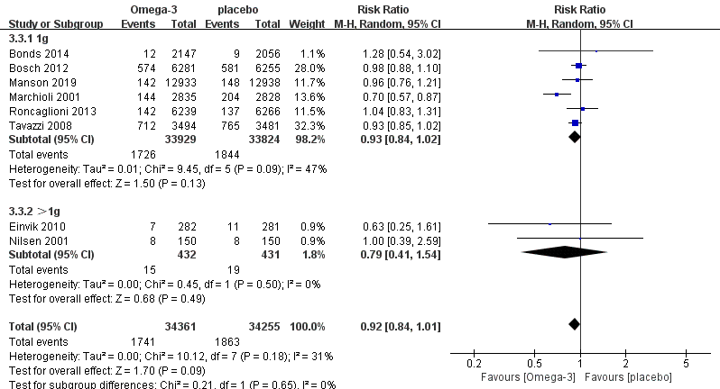

Supplementary Figure 16. Forest plot illustrating the subgroup analysis for cardiac death: 1g and >1g

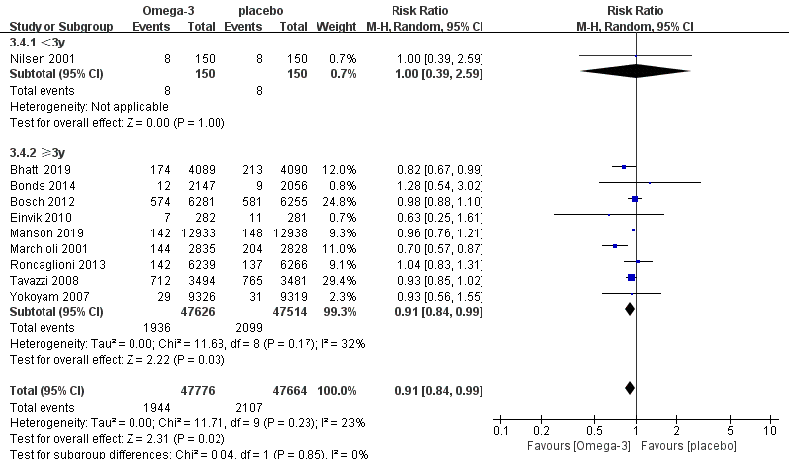

Supplementary Figure 17. Forest plot illustrating the subgroup analysis for cardiac death: <3y and ≥3y

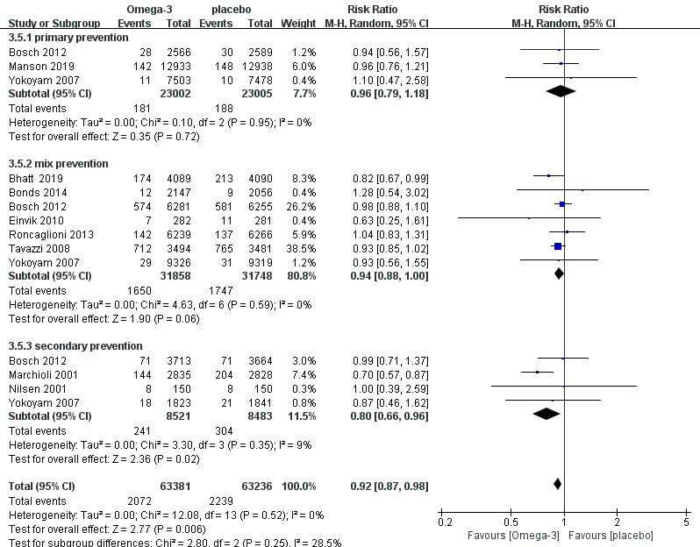

Supplementary Figure 18. Forest plot illustrating the subgroup analysis for cardiac death: primary prevention, mix prevention and secondary prevention

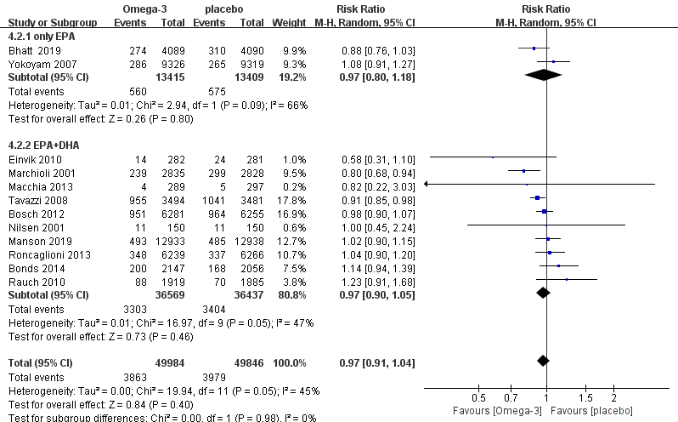

Supplementary Figure 19. Forest plot illustrating the subgroup analysis for all-cause mortality: onlyEPA and EPA+DHA

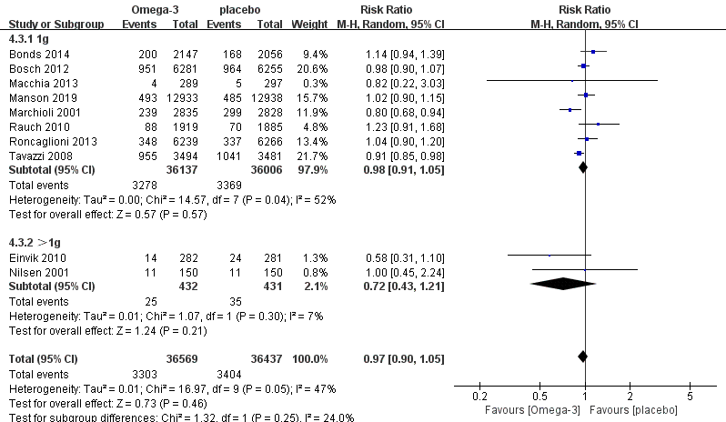

Supplementary Figure 20. Forest plot illustrating the subgroup analysis for all-cause mortality: 1g and >1g

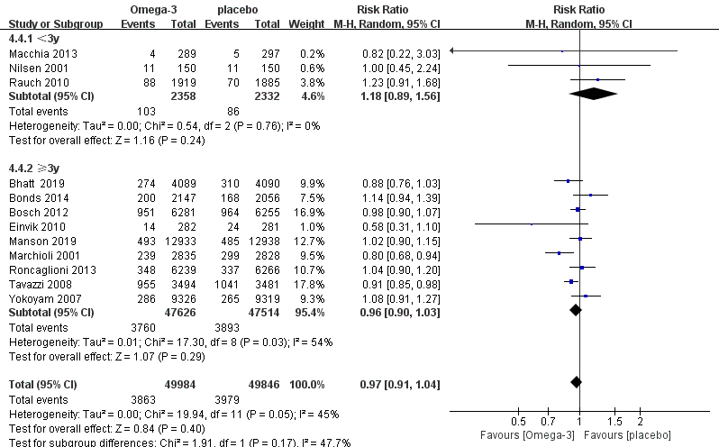

Supplementary Figure 21. Forest plot illustrating the subgroup analysis for all-cause mortality: <3y and ≥3y

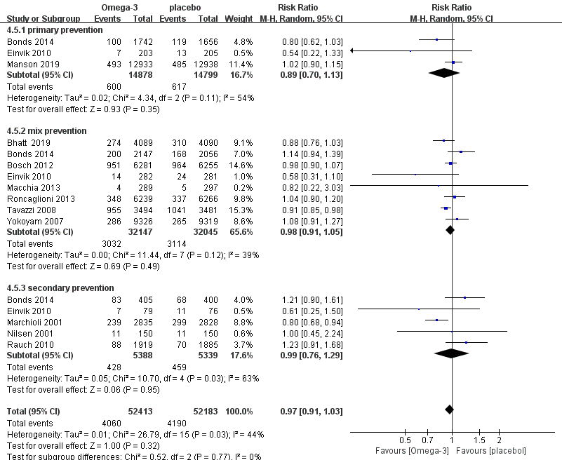

Supplementary Figure 22. Forest plot illustrating the subgroup analysis for all-cause mortality: primary prevention, mix prevention and secondary prevention

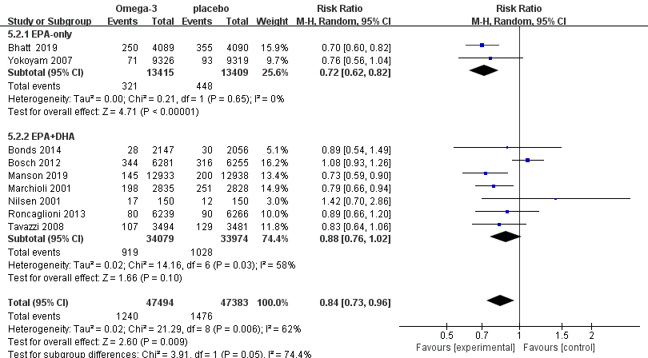

Supplementary Figure 23. Forest plot illustrating the subgroup analysis for MI: onlyEPA and EPA+DHA

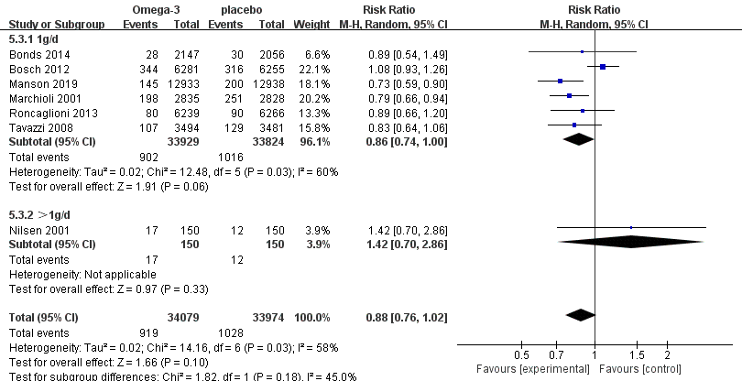

Supplementary Figure 24. Forest plot illustrating the subgroup analysis for MI: 1g and >1g

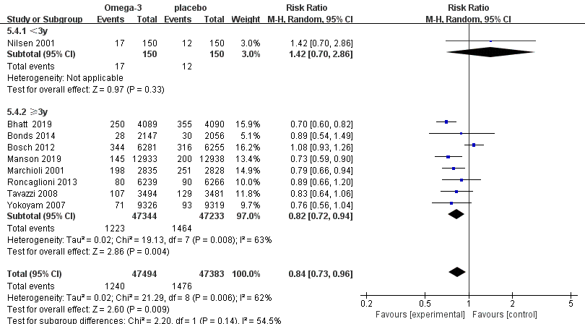

Supplementary Figure 25. Forest plot illustrating the subgroup analysis for MI: <3y and ≥3y

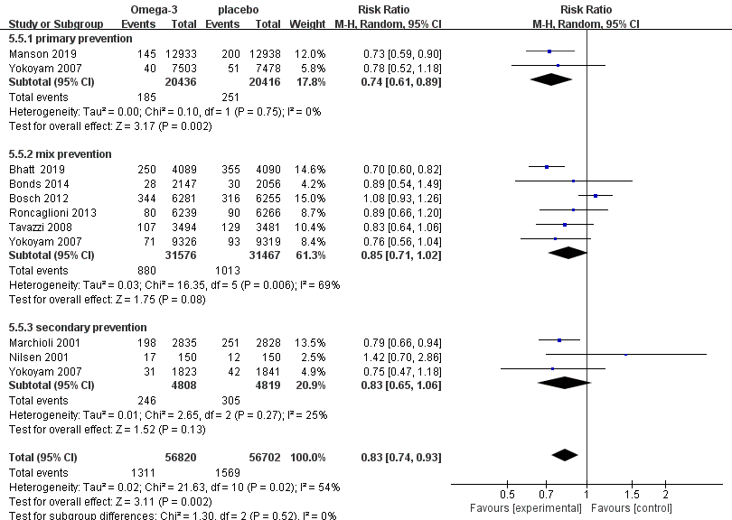

Supplementary Figure 26. Forest plot illustrating the subgroup analysis for MI: primary prevention, mix prevention and secondary prevention

