Supplementary Methods
Metabolomic assessment in the UK biobank
In brief, high precision automated liquid handlers were used to add 90uL of EDTA plasma samples to 96-well plates prepared by the UK biobank laboratory (Stockport, UK). The samples were packed in dry ice and dispatched to Nightingale Health laboratories in Finland and stored at −80 °C. Samples were thawed overnight at 4 °C, centrifuged, and transferred into NMR tubes in which an equal amount of a buffer was mixed. The samples were then measured at +6 °C using six 500 MHz NMR spectrometers (Bruker AVANCE IIIHD), and two spectral recordings were taken for each sample, one for large, and one for low molecular-weight biomarkers. Proprietary software developed by Nightingale Health (quantification library 2020) was employed to simultaneously quantify 249 metabolites per EDTA sample [18].

Table 1 Classification of food items into NOVA groups
NOVA class | Food groups  Field ID | Food items
Unprocessed/minimally processed foods | Beverages
 | 100150 | Drinking water
 | 100210 | Pure fruit/vegetable juice
 | 100220 | Fruit smoothie
 | 100230 | Dairy smoothie
 | 100270 | Filtered coffee
 | 100290 | Cappuccino
 | 100300 | Latte
 | 100310 | Espresso
 | 100400 | Standard tea
 | 100410 | Rooibos tea
 | 100420 | Green tea
 | 100430 | Herbal tea
 | 100440 | Other tea
 | 100470 | Decaffeinated tea
 | 100520 | Milk
 | Cereal
 | 100770 | Porridge
 | Milk/eggs/cheese
 | 102940 | Whole egg
 | 102950 | Omelette
 | 102960 | Eggs in sandwiches
 | 102970 | Scotch egg
 | 102980 | Other egg
 | Bread/pasta/cereal
 | 102710 | White pasta
 | 102720 | Wholemeal pasta
 | 102730 | White rice
 | 102740 | Brown rice
 | 102750 | Sushi
 | 102770 | Couscous
 | 102780 | Other grains
 | Soups/snacks/pastries
 | 102420 | Unsalted peanuts
 | 102440 | Unsalted nuts
 | 102450 | Seeds
 | 102490 | Olives
 | 102620 | Homemade soup
 | Meat/fish
 | 103020 | Beef
 | 103030 | Pork
 | 103040 | Lamb
 | 103060 | Poultry
 | 103090 | Liver
 | 103100 | Other meat
 | 103160 | Oily fish
 | 103190 | White fish
 | 103200 | Prawns
 | 103210 | Lobster/crab
 | 103220 | Shellfish
 | 103230 | Other fish
 | Vegetarian alternative
 | 103270 | Tofu
 | Fruits and vegetables
 | 104010 | Pulses
 | 104030 | Boiled/baked potatoes
 | 104060 | Mixed vegetable
 | 104070 | Vegetable pieces
 | 104080 | Coleslaw
 | 104090 | Side salad
 | 104100 | Avocado
 | 104110 | Broad bean
 | 104120 | Green bean
 | 104130 | Beetroot
 | 104140 | Broccoli
 | 104150 | Butternut squash
 | 104160 | Cabbage/kale
 | 104170 | Carrot
 | 104180 | Cauliflower
 | 104190 | Celery
 | 104200 | Courgette
 | 104210 | Cucumber
 | 104220 | Garlic
 | 104230 | Leek
 | 104240 | Lettuce
 | 104250 | Mushroom
 | 104260 | Onion
 | 104270 | Parsnip
 | 104280 | Pea
 | 104290 | Sweet pepper
 | 104300 | Spinach
 | 104310 | Sprouts
 | 104320 | Sweetcorn
 | 104330 | Sweet potato
 | 104340 | Fresh tomato
 | 104360 | Turnip/swede
 | 104370 | Watercress
 | 104380 | Other vegetables
 | 104400 | Fruit consumers
 | 104410 | Stewed fruit
 | 104420 | Prune
 | 104430 | Dried fruit
 | 104440 | Mixed fruit
 | 104450 | Apple
 | 104460 | Banana
 | 104470 | Berry
 | 104480 | Cherry
 | 104490 | Grapefruit
 | 104500 | Grape
 | 104510 | Mango
 | 104520 | Melon
 | 104530 | Orange
 | 104540 | Satsuma
 | 104550 | Peach/nectarine
 | 104560 | Pear
 | 104570 | Pineapple
 | 104580 | Plum
 | 104590 | Other fruit
Processed foods | Alcohol
 | 26067 | Beer and cider
 | 26151 | Fortified wine
 | 26152 | Red wine
 | 26153 | White wine
 | Milk/eggs/cheese
 | 26099 | High fat cheese
 | 26102 | Low fat yogurt
 | 26103 | Medium and low-fat cheese
 | Cereal
 | 26124 | Rice/oat milk
 | 26136 | Soy milk
 | Soups/snacks/pastries
 | 26108 | Salted nuts and seeds
 | 102540 | Canned soup
 | Fruits/vegetables
 | 104350 | Tinned tomato
 | Meat/fish
 | 103150 | Tinned tuna
 | Bread/pasta/rice
 | 101020 | Baguette
Ultra-processed foods | Non-alcoholic beverages
 | 100160 | Low calorie drink
 | 100170 | Fizzy drink
 | 100180 | Squash
 | 100190 | Orange juice
 | 100200 | Grapefruit juice
 | 100250 | Instant coffee
 | 100380 | Artificial sweetener in coffee
 | 100500 | Artificial sweetener in tea
 | 100510 | Other non-alcoholic drinks
 | 100530 | Flavoured milk
 | 100540 | Low calorie hot chocolate
 | 100550 | Hot chocolate
 | 100560 | Other drink
 | Alcoholic beverages
 | 100730 | Spirits
 | Cereal
 | 100800 | Muesli
 | 100810 | Oat crunch
 | 100820 | Sweetened cereal
 | 100830 | Plain cereal
 | 100840 | Bran cereal
 | 100850 | Whole-wheat cereal
 | 100860 | Other cereal
 | Bread/pasta/rice
 | 100950 | Sliced bread
 | 101090 | Bap
 | 101160 | Bread roll
 | 101230 | Naan bread
 | 101240 | Garlic bread
 | 101250 | Crispbread
 | 101260 | Oatcakes
 | 101270 | Other bread
 | 101300 | Butter/margarine on bread/crackers
 | 102760 | Snackpot
 | 102770
 | Soups, snacks, pastries
 | 101970 | Double crust pastry
 | 101980 | Single crust pastry
 | 101990 | Crumble
 | 102000 | Pizza
 | 102010 | Pancake
 | 102020 | Scotch pancake
 | 102030 | Yorkshire pudding
 | 102040 | Indian snacks
 | 102050 | Croissant
 | 102060 | Danish pastry
 | 102070 | Scone
 | 102120 | Ice-cream
 | 102140 | Milk-based pudding
 | 102150 | Other milk-based pudding
 | 102170 | Soya dessert
 | 102180 | Fruitcake
 | 102190 | Cake
 | 102200 | Doughnut
 | 102210 | Sponge pudding
 | 102220 | Cheesecake
 | 102230 | Other dessert
 | 102260 | Chocolate bar
 | 102270 | White chocolate
 | 102280 | Milk chocolate
 | 102290 | Dark chocolate
 | 102300 | Chocolate-covered raisin
 | 102310 | Chocolate sweet
 | 102320 | Diet sweets
 | 102330 | Sweets
 | 102340 | Chocolate-covered biscuits
 | 102350 | Chocolate biscuits
 | 102360 | Sweet biscuits
 | 102370 | Cereal bar
 | 102380 | Other sweets
 | 102460 | Crisps
 | 102470 | Savoury biscuits

Table 2A. Demographic characteristics according to UPF and UNPF consumption
 | UPF |  |  |  | UNPF
Characteristic | Tertile 1 | Tertile 2 | Tertile 3 |  | Tertile 1 | Tertile 2 | Tertile 3
Age, years, mean (SD) | 56 (8.0) | 57 (8.0) | 56 (8.0) |  | 56 (8.0) | 57 (8.0) | 56 (8.0)
Sex, %
Men | 9,824 (40.0) | 11,202 (46.0) | 11,977 (49.0) |  | 14,261 (59.0) | 10,878 (45.0) | 7,864 (32.0)
Highest education level, %
None | 1,794 (7.4) | 2,065 (8.5) | 2,557 (11.0) |  | 2,504 (10.0) | 2,032 (8.4) | 1,880 (7.7)
Vocational | 1,110 (4.6) | 1,379 (5.7) | 1,582 (6.5) |  | 1,672 (6.9) | 1,313 (5.4) | 1,086 (4.5)
O-level | 5,413 (22.0) | 5,968 (25.0) | 7,075 (29.0) |  | 7,023 (29.0) | 5,919 (24.0) | 5,514 (23.0)
A-level | 3,057 (13.0) | 3,150 (13.0) | 3,153 (13.0) |  | 3,152 (13.0) | 3,091 (13.0) | 3,117 (13.0)
College | 12,899 (53.0) | 11,710 (48.0) | 9,905 (41.0) |  | 9,922 (41.0) | 11,917 (49.0) | 12,675 (52.0)
Annual income, £, %
<18000 | 3,692 (15.0) | 4,099 (17.0) | 4,871 (20.0) |  | 4,434 (18.0) | 4,056 (17.0) | 4,172 (17.0)
18000-30999 | 5,788 (24.0) | 6,159 (25.0) | 6,494 (27.0) |  | 6,275 (26.0) | 6,314 (26.0) | 5,852 (24.0)
31000-51999 | 6,797 (28.0) | 6,799 (28.0) | 6,703 (28.0) |  | 6,886 (28.0) | 6,749 (28.0) | 6,664 (27.0)
52000-100,000 | 6,000 (25.0) | 5,610 (23.0) | 4,984 (21.0) |  | 5,303 (22.0) | 5,508 (23.0) | 5,783 (24.0)
>100,000 | 1,996 (8.2) | 1,605 (6.6) | 1,220 (5.0) |  | 1,375 (5.7) | 1,645 (6.8) | 1,801 (7.4)
Employed, % | 14,781 (61.0) | 14,331 (59.0) | 14,710 (61.0) |  | 14,962 (62.0) | 14,163 (58.0) | 14,697 (61.0)
IMD | -2.22 (-3.68, 0.16) | -2.48 (-3.81, -0.20) | -2.35 (-3.73, 0.00) |  | -2.38 (-3.75, -0.08) | -2.45 (-3.80, -0.20) | -2.19 (-3.67, 0.23)
Ethnicity, %
White | 23,276 (96.0) | 23,491 (97.0) | 23,509 (97.0) |  | 23,754 (98.0) | 23,562 (97.0) | 22,960 (95.0)
IMD, Index of multiple deprivation
Table 2B. Lifestyle characteristics according to UPF and UNPF consumption
 | UPF |  |  |  | UNPF
 | Tertile 1 | Tertile 2 | Tertile 3 |  | Tertile 1 | Tertile 2 | Tertile 3
Alcohol consumption, %
Current | 22,872 (94.0) | 22,825 (94.0) | 22,440 (92.0) |  | 23,044 (95.0) | 22,874 (94.0) | 22,219 (92.0)
Previous | 653 (2.7) | 696 (2.9) | 900 (3.7) |  | 627 (2.6) | 674 (2.8) | 948 (3.9)
Never drinker | 748 (3.1) | 751 (3.1) | 932 (3.8) |  | 602 (2.5) | 724 (3.0) | 1,105 (4.6)
Smoking status, %
Current | 1,580 (6.5) | 1,632 (6.7) | 2,185 (9.0) |  | 2,442 (10) | 1,588 (6.5) | 1,367 (5.6)
Previous | 8,968 (37.0) | 8,411 (35.0) | 8,161 (34.0) |  | 8,917 (37.0) | 8,525 (35.0) | 8,098 (33.0)
Never smoked | 13,725 (57.0) | 14,229 (59.0) | 13,926 (57.0) |  | 12,914 (53.0) | 14,159 (58.0) | 14,807 (61.0)
MET-min/week, median (IQR) | 1,872 (923, 3,453) | 1,782 (864, 3,420) | 1,644 (747, 3,330) |  | 1,653 (753, 3,306) | 1,778 (862, 3,377) | 1,870 (918, 3,519)
Sleep duration, h/d, median (IQR) | 7.18 (0.99) | 7.17 (0.98) | 7.14 (1.04) |  | 7.14 (1.02) | 7.18 (0.98) | 7.16 (1.01)
BMI, kg/m², mean (SD) | 26.4 (4.4) | 26.7 (4.5) | 27.7 (4.9) |  | 27.7 (4.7) | 26.8 (4.5) | 26.4 (4.6)
Have obesity | 4,170 (17.0) | 4,680 (19.0) | 6,340 (26.0) |  | 6,128 (25.0) | 4,698 (19.0) | 4,364 (18.0)
Abdominal obesity, % | 5,670 (23.0) | 6,187 (25.0) | 7,791 (32.0) |  | 7,556 (31.0) | 6,207 (26.0) | 5,885 (24.0)
Diet
Total energy intake, kcal/d, median (IQR) | 1,877 (1,529, 2,296) | 2,049 (1,675, 2,494) | 2,053 (1,655, 2,530) |  | 2,161 (1,738, 2,651) | 2,040 (1,678, 2,467) | 1,802 (1,469, 2,186)
% UPF, median (IQR) | 12.6 (8.9, 15.7) | 24.5 (21.5, 27.6) | 41 (35, 49) |  | 39 (28, 49) | 26 (20, 32) | 15 (10, 20)
% UNPF, median (IQR) | 70 (61, 78) | 60 (52, 66) | 44 (34, 52) |  | 39 (31, 45) | 57.5 (53.8, 61.2) | 73 (68, 78)
Plausible energy reporters | 23,759 (98.0) | 23,390 (96.0) | 23,120 (95.0) |  | 22,851 (94.0) | 23,491 (97.0) | 23,927 (99.0)
Table 2C. Pre-existing health conditions and biochemical markers according to UPF and UNPF consumption
 | UPF |  |  |  | UNPF
 | Tertile 1 | Tertile 2 | Tertile 3 |  | Tertile 1 | Tertile 2 | Tertile 3
CVD, % | 471 (1.9) | 519 (2.1) | 554 (2.3) |  | 596 (2.5) | 491 (2.0) | 457 (1.9)
Cancer, % | 2,222 (9.2) | 2,151 (8.9) | 1,968 (8.1) |  | 1,842 (7.6) | 2,180 (9.0) | 2,319 (9.6)
Diabetes, % | 720 (3.0) | 751 (3.1) | 1,095 (4.5) |  | 1,003 (4.1) | 772 (3.2) | 791 (3.3)
Use of medication, % | 20,070 (83.0) | 20,579 (85.0) | 21,323 (88.0) |  | 21,768 (90.0) | 20,590 (85.0) | 19,614 (81.0)
CRP, median (IQR) | 1.06 (0.54, 2.24) | 1.15 (0.58, 2.33) | 1.31 (0.66, 2.70) |  | 1.30 (0.66, 2.65) | 1.15 (0.58, 2.33) | 1.08 (0.54, 2.29)
SHBG, median (IQR) | 49 (35, 69) | 46 (33, 65) | 44 (32, 62) |  | 42 (31, 58) | 47 (34, 65) | 51 (36, 72)
Testosterone, median (IQR) | 1.5 (0.9, 10.9) | 1.9 (1.0, 11.5) | 2.7 (1.0, 11.7) |  | 8.5 (1.1, 12.3) | 1.8 (0.9, 11.4) | 1.3 (0.8, 9.6)
IGF-1, median (IQR) | 21.6 (18.0, 25.1) | 21.7 (18.1, 25.2) | 21.6 (17.9, 25.2) |  | 21.5 (17.9, 25.1) | 21.7 (18.1, 25.2) | 21.6 (18.0, 25.2)

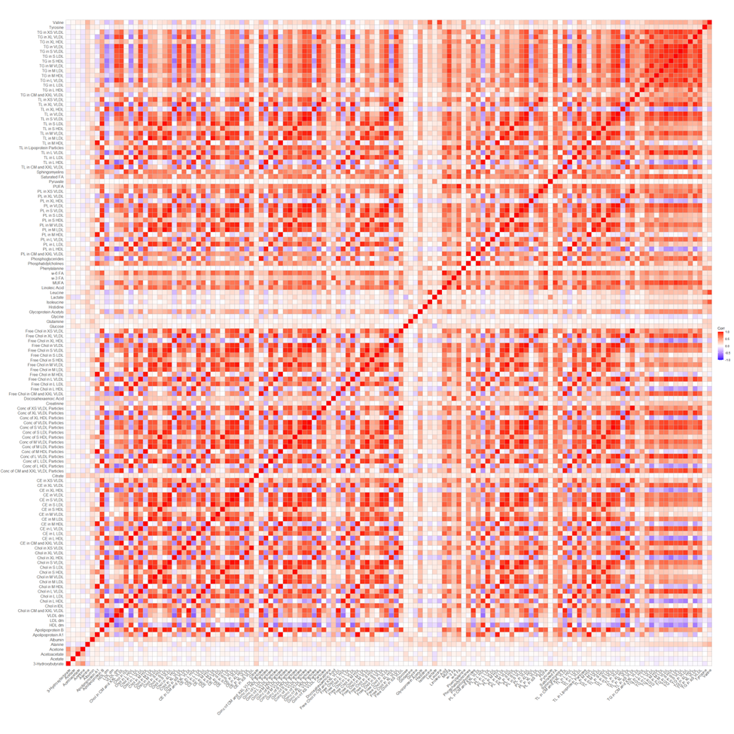
Figure 1. Correlation matrix of 134 serum metabolites. Chol, cholesterol, CE, cholesterol esters, CM, chylomicron, conc, concentration, DM, diameter, HDL, high density lipoprotein, L, large, LDL. Low-density lipoprotein, M, medium, S, small, VLDL, PL, phospholipids, TG, triglycerides, very low-density lipoprotein, XL, very large, XS, extremely small

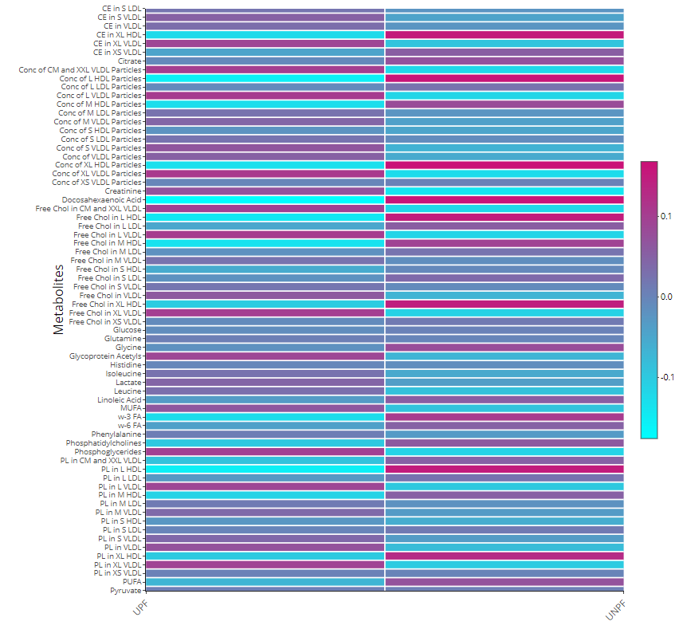 Figure 2. Correlation of 134 serum metabolites with UPF and UNPF intake. Chol, cholesterol, CE, cholesterol esters, CM, chylomicron, conc, concentration, DM, diameter, HDL, high density lipoprotein, L, large, LDL. Low-density lipoprotein, M, medium, S, small, VLDL, PL, phospholipids, TG, triglycerides, very low-density lipoprotein, XL, very large, XS, extremely small

Table 3. Elastic net regression coefficients for UPF, UNPF and serum metabolites
 |  | β
# | Metabolites | UPF |  | UNPF
1 | Acetoacetate | -0.002 |  | -
2 | Acetone | -0.006 |  | 0.016
3 | Albumin | - |  | 0.001
4 | HDL dm | -0.006 |  | 0.007
5 | Docosahexaenoic Acid | -0.076 |  | 0.071
6 | Free Chol in XS VLDL | 0.004 |  | -0.021
7 | Glutamine | 0.016 |  | -0.009
8 | Glycine | 0.008 |  | -0.002
9 | Glycoprotein Acetyls | 0.026 |  | -0.035
10 | Lactate | 0.006 |  | -
11 | Linoleic Acid | -0.055 |  | 0.038
12 | ω-3 FA | -0.035 |  | 0.039
13 | Saturated FA | 0.039 |  | -0.0394
14 | Sphingomyelins | 0.032 |  | -
15 | TL in L HDL | -0.014 |  | 0.001
16 | TG in L LDL | 0.023 |  | -0.009
17 | TG in M HDL | 0.018 |  | -0.006
18 | Valine | -0.043 |  | 0.015

Dm, diameter; FA, fatty acid; L, large; M, medium; TL, total lipids; XS extremely small

Table 4. UPF-related metabolites in participants who only responded to the 1st 24-hour recall and metabolomic assessment.
Only 1st assessment, n = 33,209 |  |  | Any one assessment, n = 72,817
Metabolite | β |  | Metabolites | β
Acetone | -0.020 |  | Acetone | -0.006
Acetoacetate | -0.001 |  | Acetoacetate | -0.002
Docosahexaenoic Acid | -0.088 |  | Docosahexaenoic Acid | -0.076
Free Chol in XL HDL | -0.002
Glucose | 0.015
Glutamine | -0.001 |  | Glutamine | 0.016
Glycine | 0.032 |  | Glycine | 0.008
Glycoprotein Acetyls | 0.008 |  | Glycoprotein Acetyls | 0.026
Leucine | 0.037
 |  |  | Lactate | 0.007
Linoleic Acid | 0.026 |  | Linoleic Acid | -0.055
ω-3 FA | -0.106 |  | ω-3 FA | -0.035
Phenylalanine | 0.036
Pyruvate | -0.053
Saturated FA | 0.006 |  | Saturated FA | 0.040
Sphingomyelins | -0.006 |  | Sphingomyelins | 0.032
TL in L HDL | 0.036 |  | TL in L HDL | -0.015
TG in L LDL | 0.080 |  | TG in L LDL | 0.023
TG in M HDL | -0.001 |  | TG in M HDL | 0.018
Tyrosine | 0.053
Valine | -0.083 |  | Valine | -0.043
Dm, diameter; FA, fatty acid; L, large; M, medium; TL, total lipids; XS extremely small, XL, extremely large
Table 5. Quantile regression coefficients for the association between metabolites with biochemical markers
Metabolite | CRP | IGF-1 | SHBG | Testosterone
Acetoacetate | 0.044 (0.016,0.072) | 0.518 (0.336,0.701) | -0.006 (-0.025,0.014) | 0.020 (-0.023,0.063)
Acetone | -0.035 (-0.063, -0.007) | 0.599 (0.413,0.784) | -0.011 (-0.031,0.009) | -0.059 (-0.103,-0.016)
HDL dm | 0.592 (0.495,0.69) | 7.011 (6.372,7.649) | -0.405 (-0.472,-0.337) | 0.110 (-0.040,0.261)
Docosahexaenoic Acid | 0.151 (0.067,0.235) | 2.310 (1.761,2.859) | 0.244 (0.186,0.302) | 0.130 (0.000,0.259)
Free Chol in XS VLDL | 0.614 (0.565,0.664) | -1.647 (-1.973,-1.32) | 0.355 (0.321,0.39) | 0.278 (0.201,0.355)
Glutamine | -0.435 (-0.464, -0.407) | 0.393 (0.209,0.577) | 0.121 (0.101,0.14) | -0.139 (-0.182,-0.095)
Glycine | -0.338 (-0.365, -0.31) | -0.194 (-0.375,-0.013) | 0.000 (-0.019,0.019) | -0.087 (-0.130,-0.045)
Glycoprotein Acetyls | 2.335 (2.298,2.372) | -3.401 (-3.643,-3.159) | -0.203 (-0.229,-0.177) | 0.459 (0.402,0.516)
Lactate | -0.088 (-0.114,-0.061) | 0.087 (-0.088,0.262) | 0.093 (0.074,0.111) | 0.176 (0.135,0.217)
Linoleic Acid | -0.847 (-0.894,-0.8) | 1.259 (0.952,1.567) | 0.085 (0.052,0.117) | 0.308 (0.236,0.381)
w-3 FA | -0.793 (-0.876,-0.71) | -2.007 (-2.552,-1.462) | -0.327 (-0.385,-0.269) | 0.596 (0.468,0.724)
Saturated FA | -0.670 (-0.757,-0.584) | -5.744 (-6.308,-5.18) | -0.274 (-0.334,-0.214) | -0.307 (-0.440,-0.174)
Sphingomyelins | -0.131 (-0.208,-0.054) | 3.818 (3.315,4.322) | 0.162 (0.108,0.215) | -0.201 (-0.320,-0.082)
TL in L HDL | 0.352 (0.240,0.465) | -2.776 (-3.513,-2.039) | 0.312 (0.233,0.39) | -0.404 (-0.578,-0.231)
TG in L LDL | 0.521 (0.461,0.581) | 1.976 (1.581,2.371) | -0.251 (-0.293,-0.209) | -1.192 (-1.285,-1.099)
TG in M HDL | -0.383 (-0.439,-0.328) | 3.693 (3.331,4.054) | 0.09 (0.051,0.128) | 0.215 (0.130,0.301)
Valine | -0.205 (-0.237,-0.174) | -3.365 (-3.568,-3.162) | -0.159 (-0.181,-0.138) | 0.237 (0.189,0.284)
Dm, diameter; FA, fatty acid; L, large; M, medium; TL, total lipids; XS extremely small

