Supplementary material

Figure 1. Likert plot of SHED’s healthy eating domain
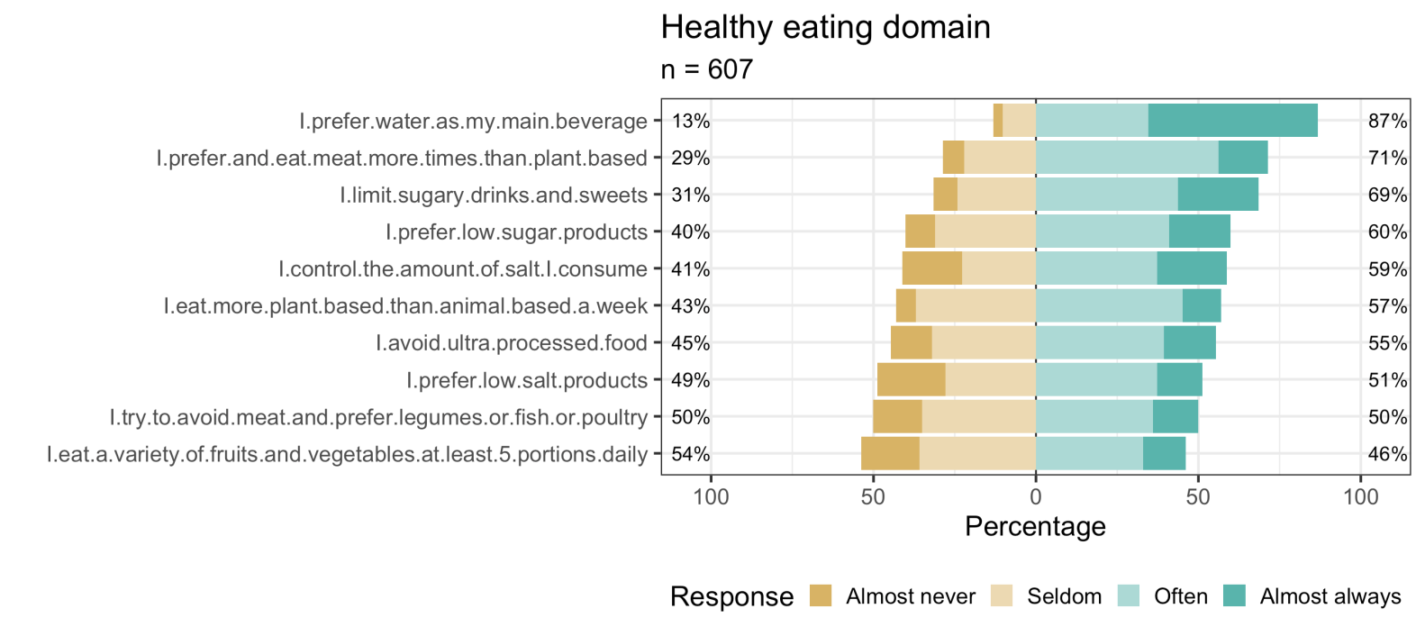

SHED: Sustainable HEalthy Diet [13]

Figure 2. Likert plot of SHED’s sustainable eating domain
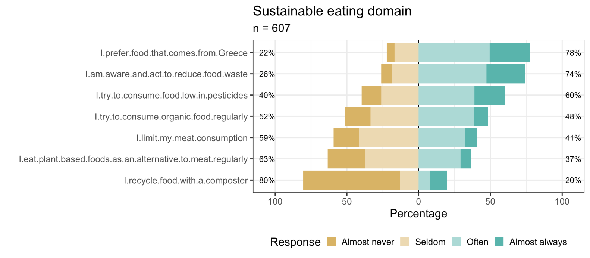
SHED: Sustainable HEalthy Diet [13]

Figure 3. Likert plot of SHED’s BFV domain
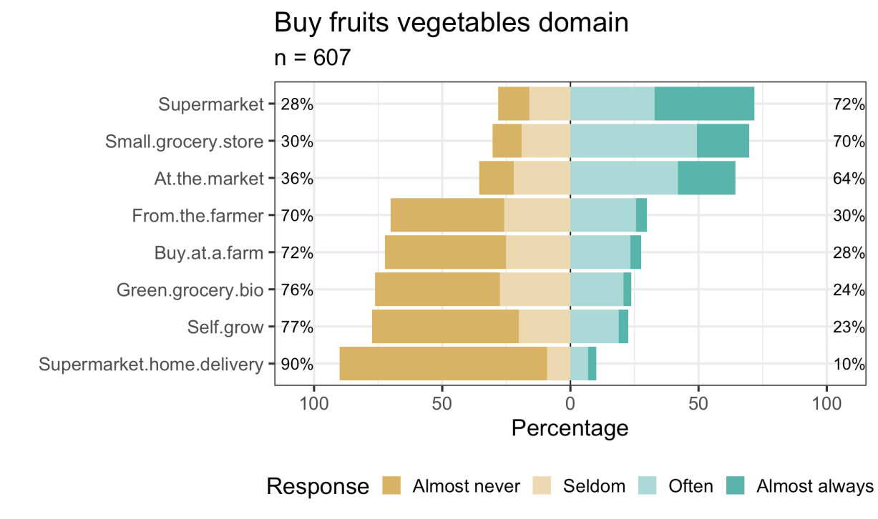
SHED: Sustainable HEalthy Diet [13]

Figure 4. Likert plot of SHED’s ready meals domain
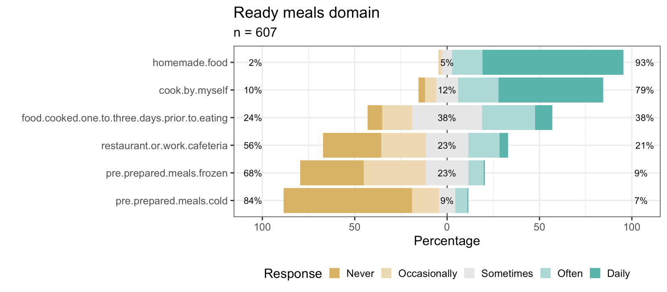
SHED: Sustainable HEalthy Diet [13]

Figure 5. Likert plot of SHED’s water score domain
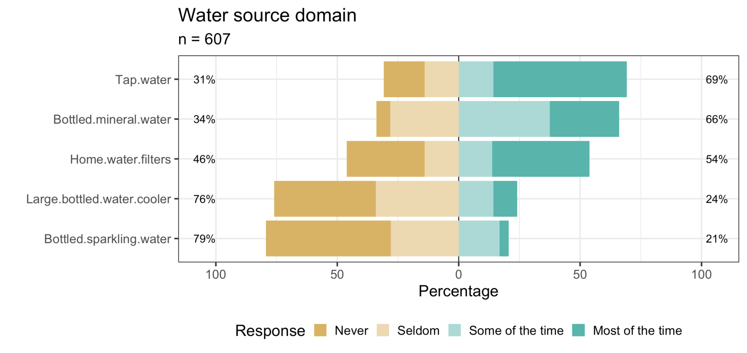
SHED: Sustainable HEalthy Diet [13]

Figure 6. Likert plot of SHED’s soda score domain
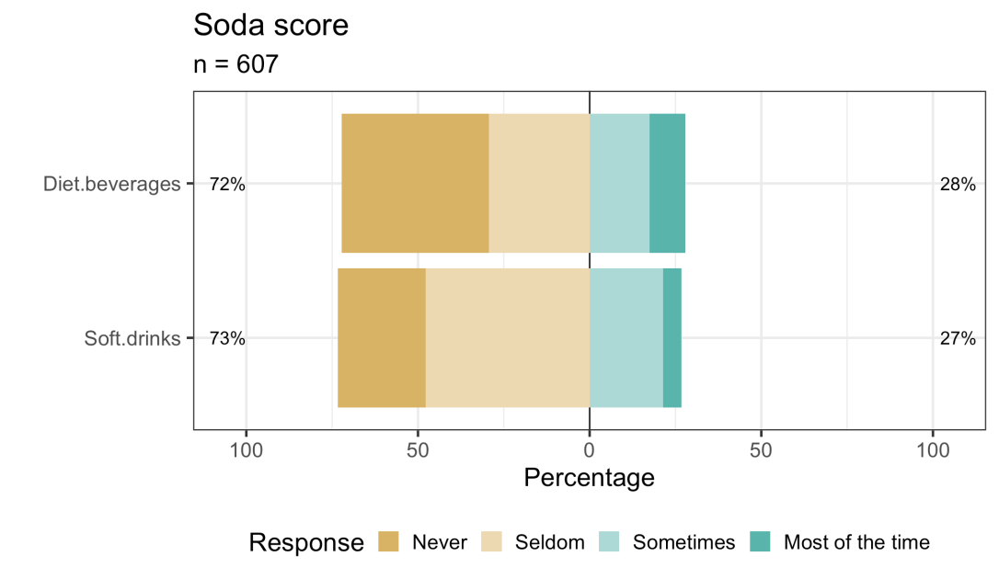
SHED: Sustainable HEalthy Diet [13]

