The Impact of Intermittent Fasting on Body Composition and Cardiometabolic Outcomes in Overweight and Obese Adults: A Systematic Review and Meta-Analysis of Randomized Controlled Trials

Supplementary Tables and Figures
Supplementary Table 1. Search strategy
Databases | Search strategy | Result
PubMed | ((((((((((Intermittent Fasting[Mesh]) OR (Intermittent Energy Restriction[Title/Abstract])) OR (Time-Restricted Eating[Title/Abstract])) OR (Alternate Day Fasting[Title/Abstract])) OR (Twice-Weekly Fasting[Title/Abstract])) OR (continuous energy restriction[Title/Abstract])) OR (5:2 diet[Title/Abstract])) OR (fasting-mimicking diet[Title/Abstract])) OR (time-restricted feeding[Title/Abstract])) AND (((((((obesity[Mesh]) OR (obesities[Title/Abstract])) OR (obeses[Title/Abstract])) OR (overweights[Title/Abstract])) OR (overweight[Title/Abstract])) OR (overweightness[Title/Abstract])) OR (overweighted[Title/Abstract]))) | 173
Embase | #9 #8 AND 'randomized controlled trial'/de  #8 #3 AND #6 AND [english]/lim AND [humans]/lim  #7 #3 AND #6  #6 #4 OR #5  #5 obesity:ab,ti OR 'adipose tissue hyperplasia':ab,ti OR adipositas:ab,ti OR adiposity:ab,ti OR 'intermittent fasting':ab,ti OR 'alimentary obesity':ab,ti OR 'body weight, excess':ab,ti OR corpulency:ab,ti OR 'fat overload syndrome':ab,ti OR 'nutritional obesity':ab,ti OR obesitas:ab,ti OR overweight:ab,ti  #4 'obesity'/exp  #3 #1 OR #2  #2 'intermittent energy restriction':ab,ti OR 'intermittent fast diet':ab,ti OR 'intermittently fasting':ab,ti OR 'intermittent fasting':ab,ti  #1 'intermittent fasting'/exp | 336
Web of Science | #1：((((((((TS=(Intermittent Fasting)) OR TI=(Intermittent Energy Restriction)) OR TI=(Time-Restricted Eating)) OR TI=(Alternate Day Fasting)) OR TI=(Twice-Weekly Fasting)) OR TI=(continuous energy restriction)) OR TI=(5:2 diet)) OR TI=(fasting-mimicking diet)) OR TI=(time-restricted feeding)  #2：((TS=(obesity)) OR TI=(obeses)) OR TI=(overweight)  #1 AND #2 | 469

Supplementary Figure 1. Risk of bias graph
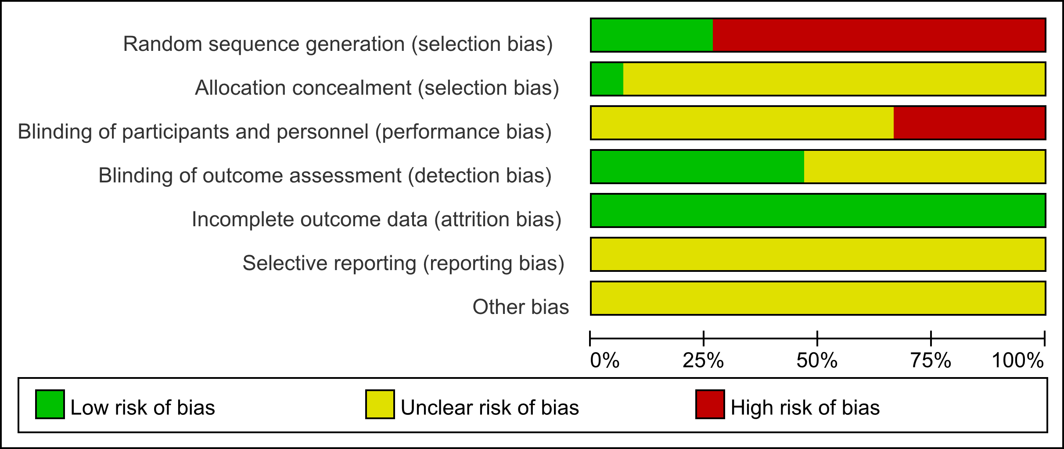
Supplementary Figure 2. Risk of bias summary
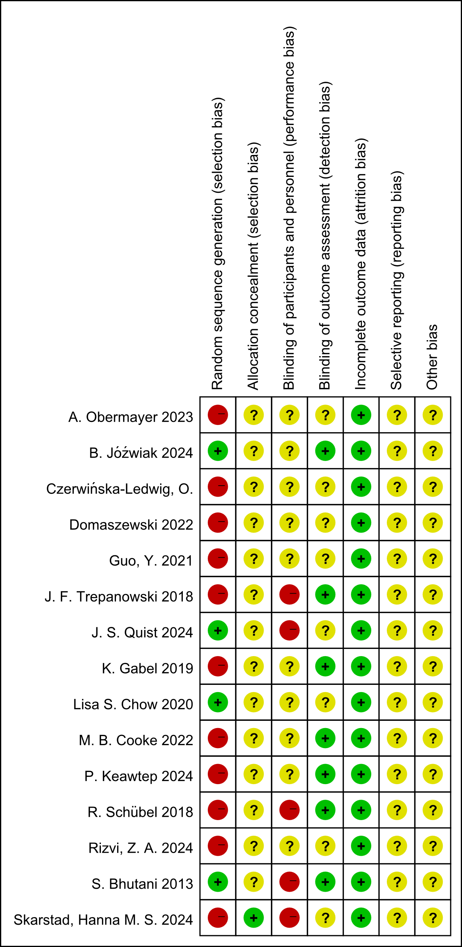

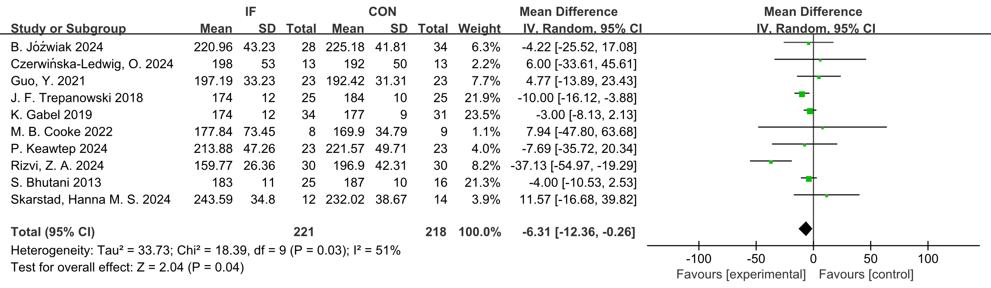
Supplementary Figure 3. Forest plot of the effects of intermittent fasting (IF) versus control diet (CON) on TC.
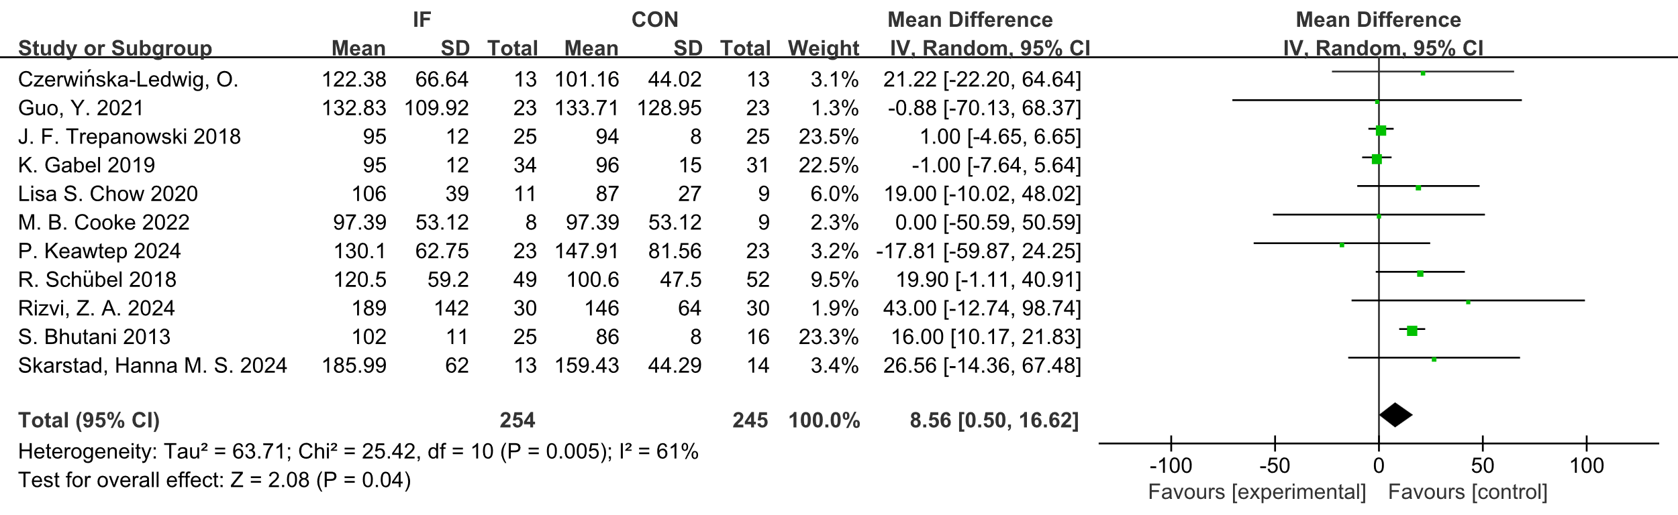
Supplementary Figure 4. Forest plot of the effects of intermittent fasting (IF) versus control diet (CON) on TG.
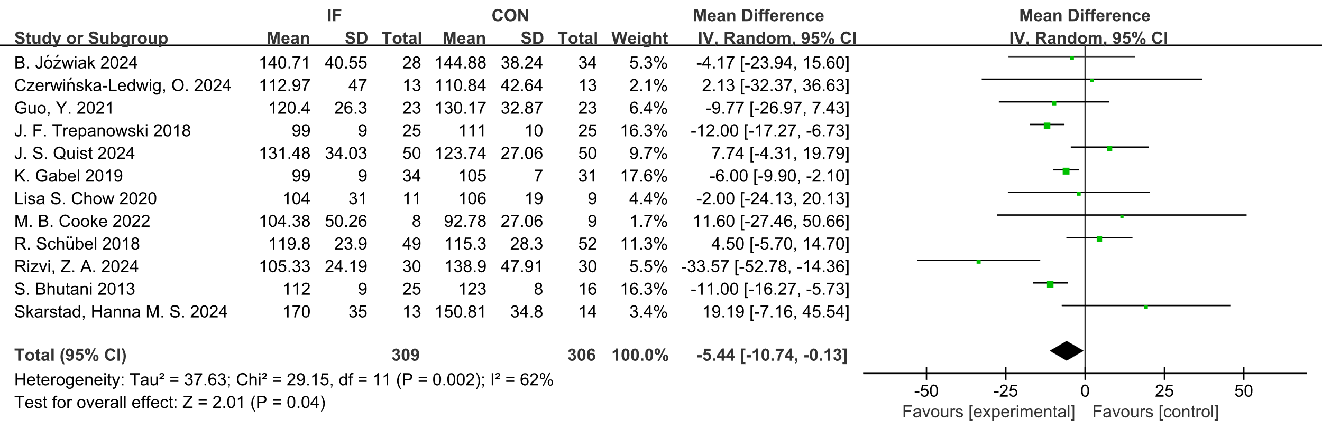
Supplementary Figure 5. Forest plot of the effects of intermittent fasting (IF) versus control diet (CON) on LDL.
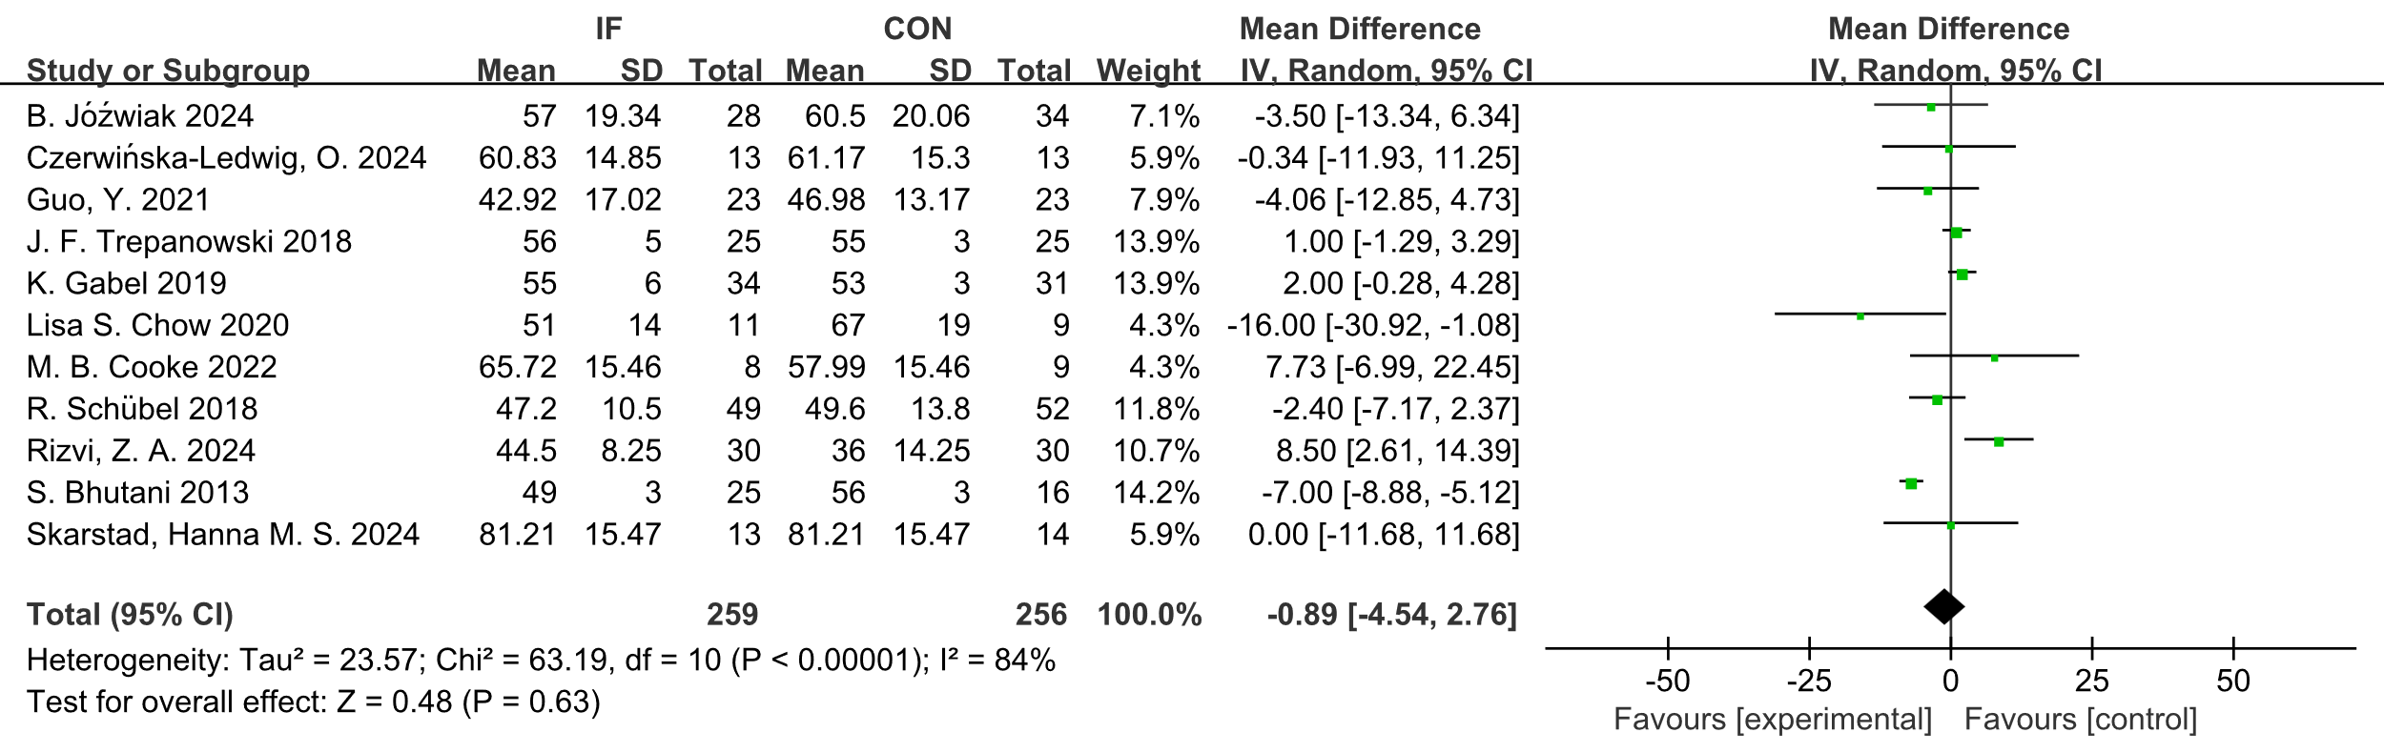
Supplementary Figure 6. Forest plot of the effects of intermittent fasting (IF) versus control diet (CON) on HDL.
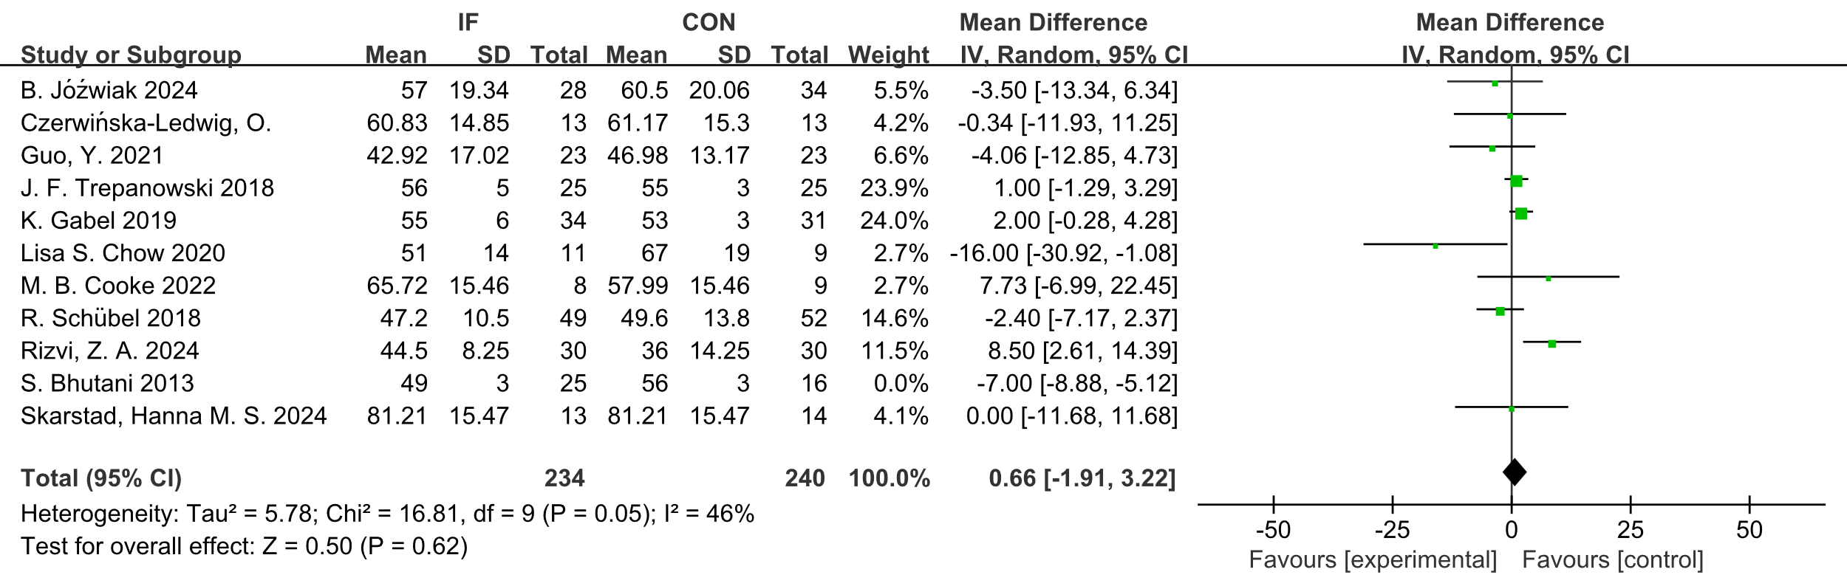
Supplementary Figure 7. Sensitivity – analysis forest plot of the effects of intermittent fasting (IF) versus control diet (CON) on HDL.

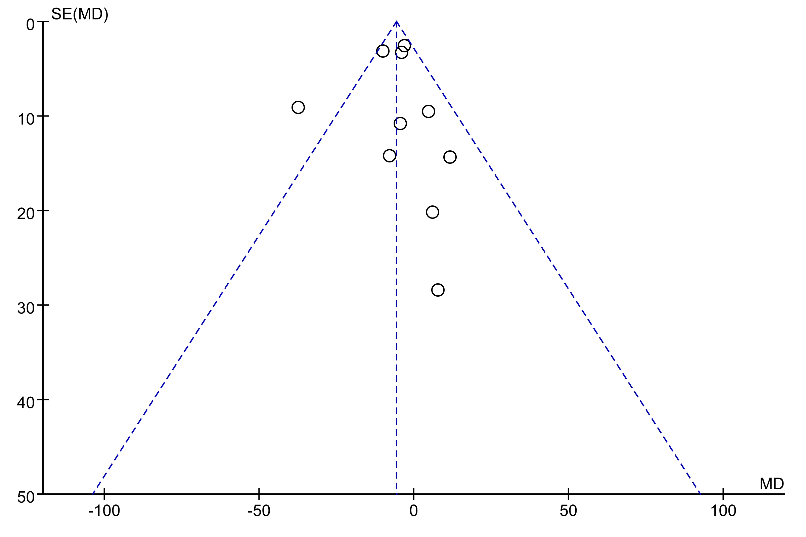
Supplementary Figure 8. Funnel plot of the effects of intermittent fasting (IF) versus control diet (CON) on total cholesterol.
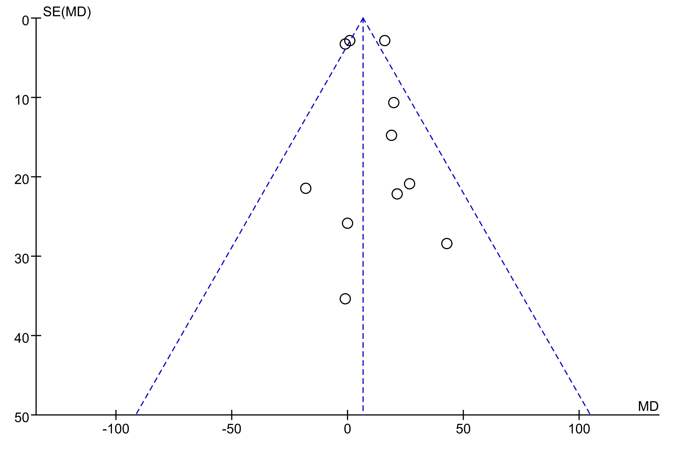
Supplementary Figure 9. Funnel plot of the effects of intermittent fasting (IF) versus control diet (CON) on triglyceride.
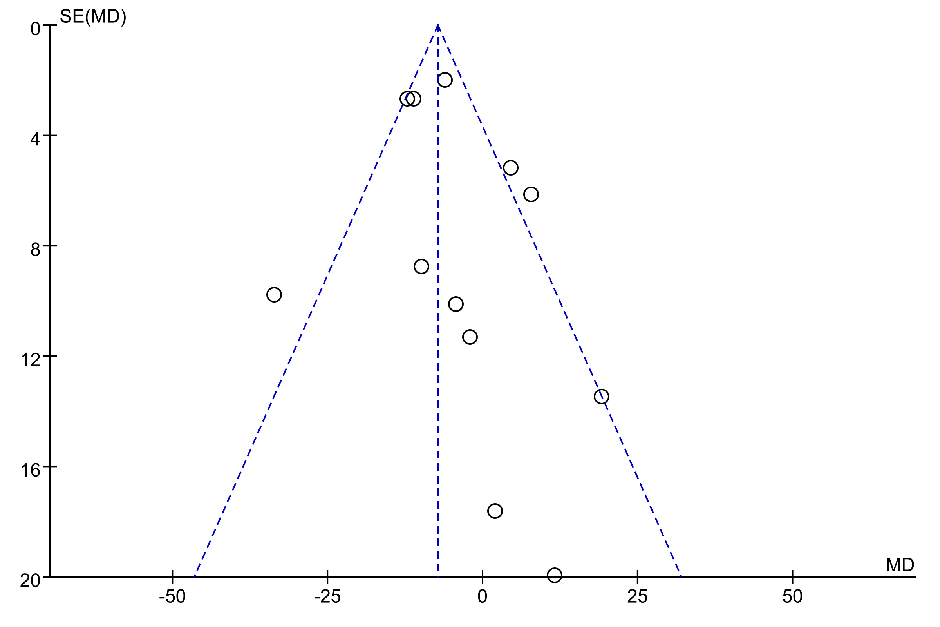
Supplementary Figure 10. Funnel plot of the effects of intermittent fasting (IF) versus control diet (CON) on low-density lipoprotein.
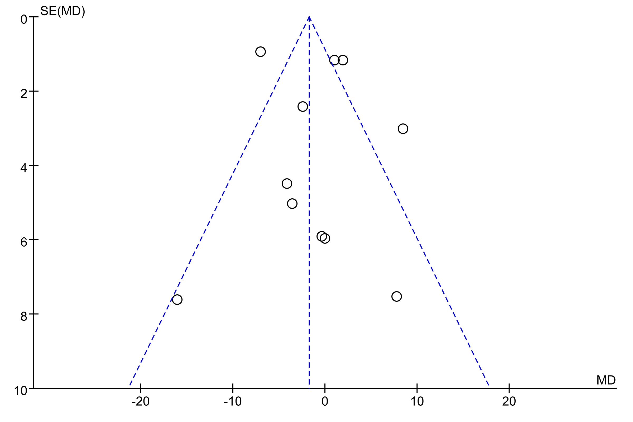
Supplementary Figure 11. Funnel plot of the effects of intermittent fasting (IF) versus control diet (CON) on high-density lipoprotein.
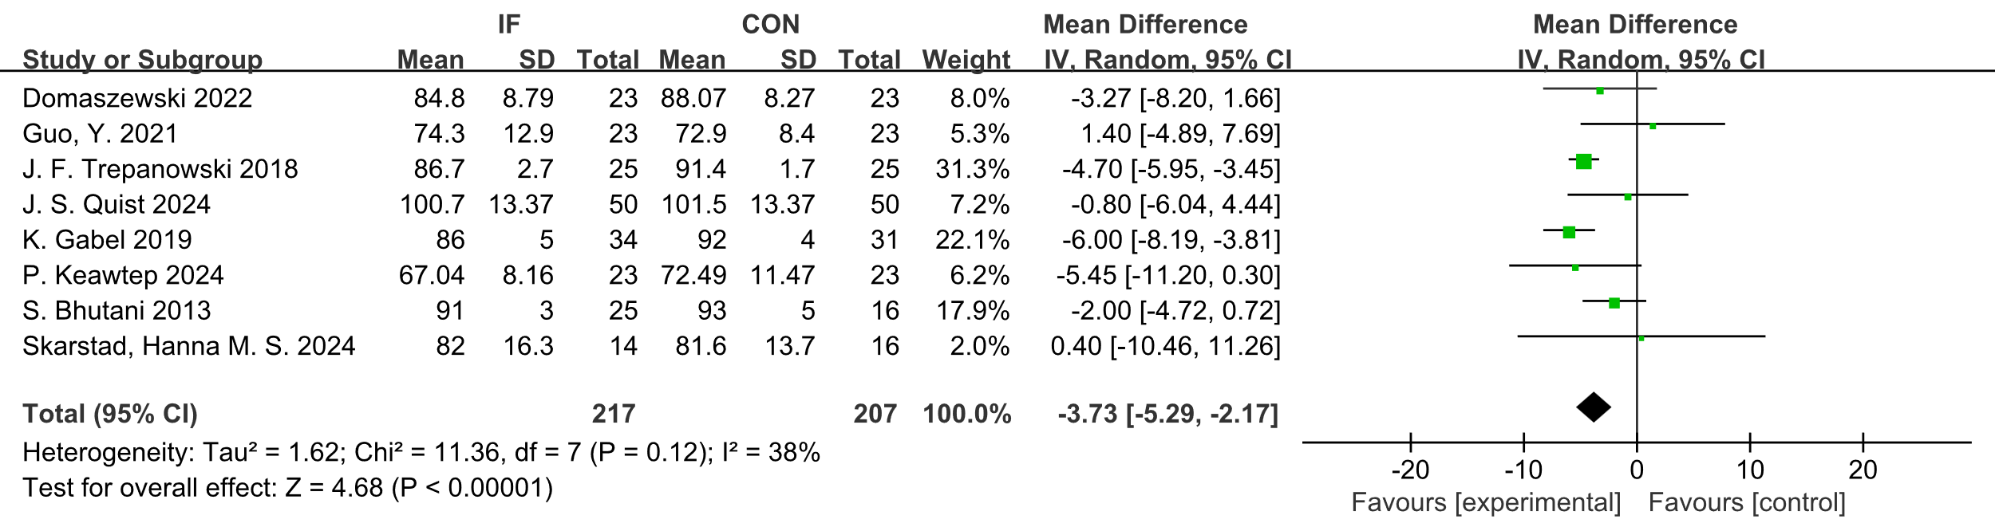
Supplementary Figure 12. Forest plot of the effects of intermittent fasting (IF) versus control diet (CON) on BW.
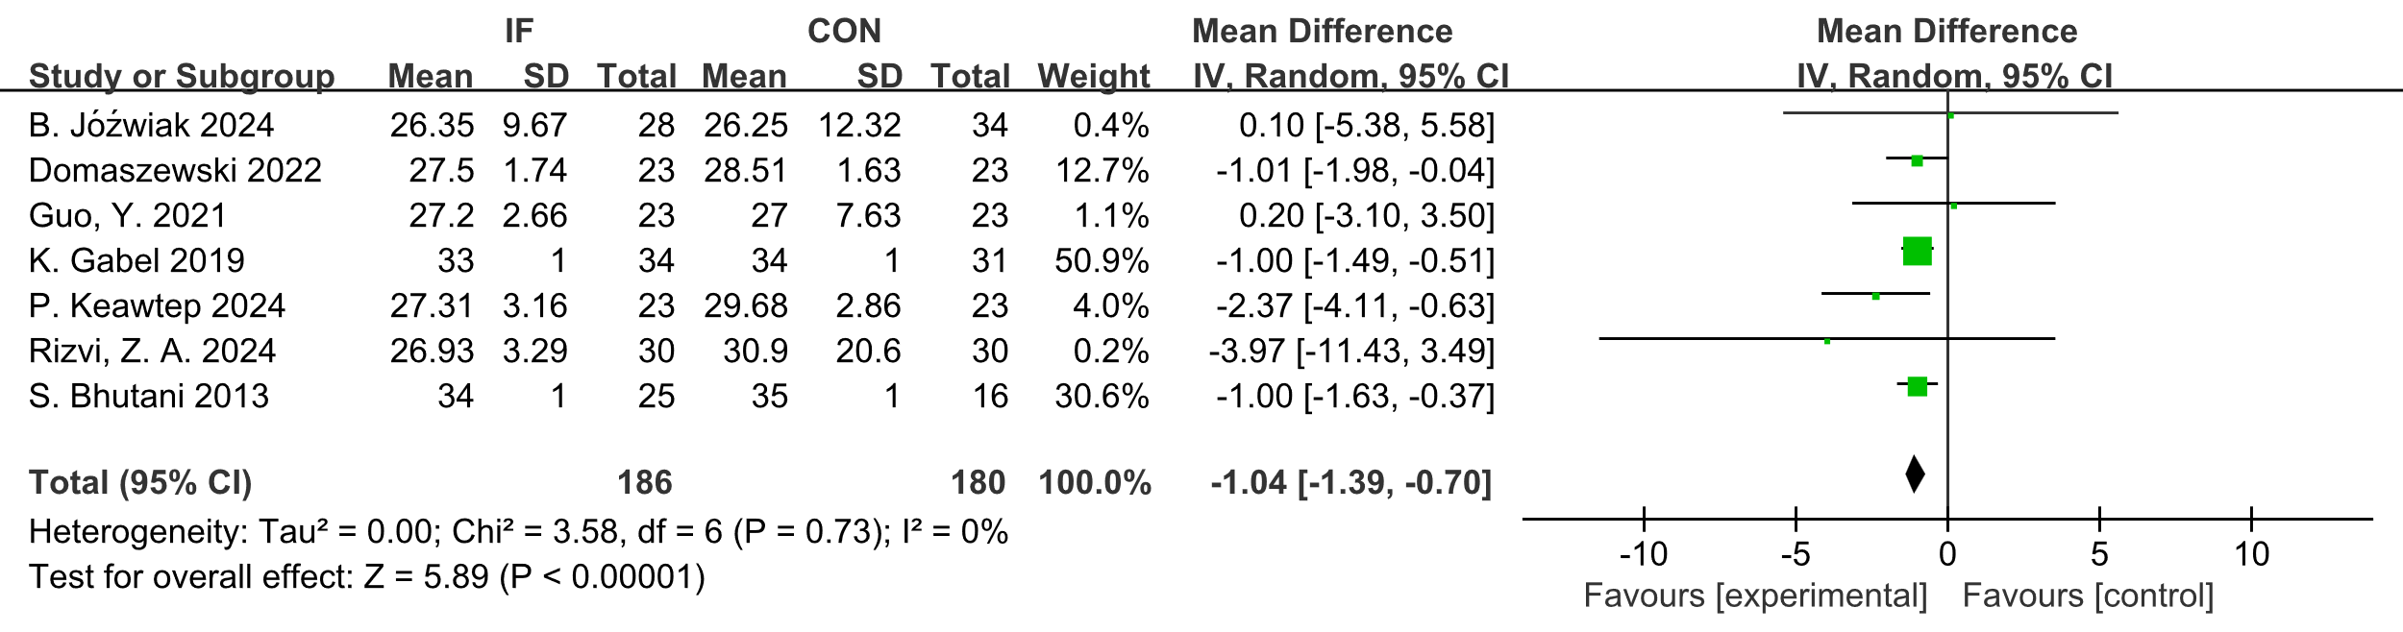
Supplementary Figure 13. Forest plot of the effects of intermittent fasting (IF) versus control diet (CON) on BMI.
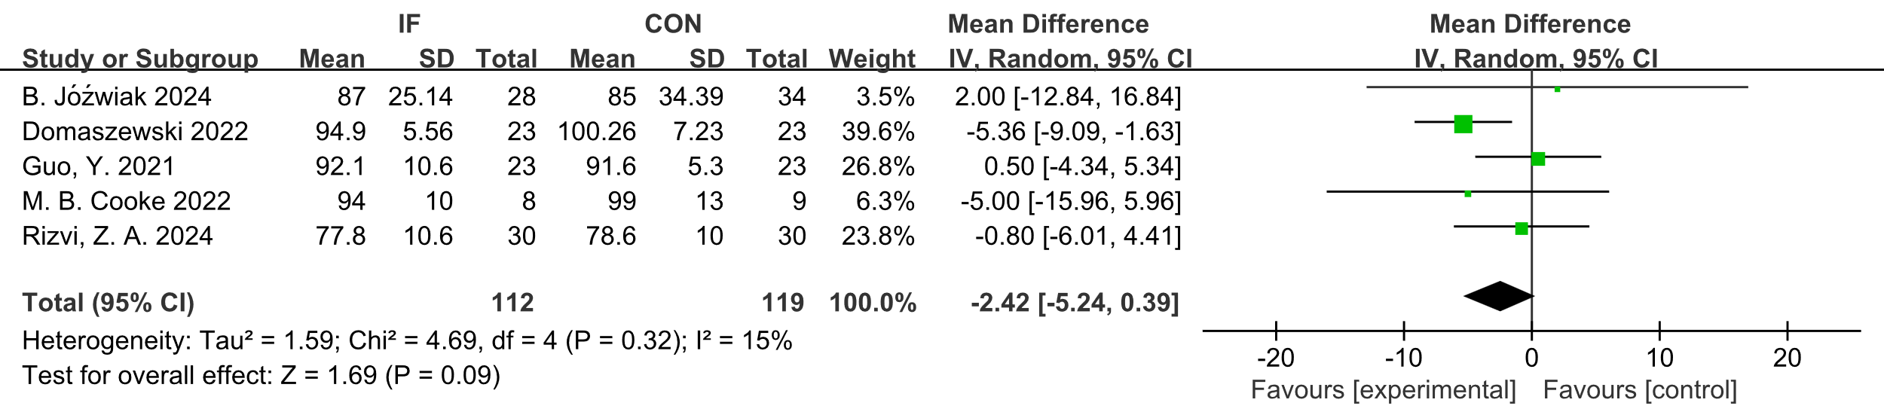
Supplementary Figure 14. Forest plot of the effects of intermittent fasting (IF) versus control diet (CON) on WC.
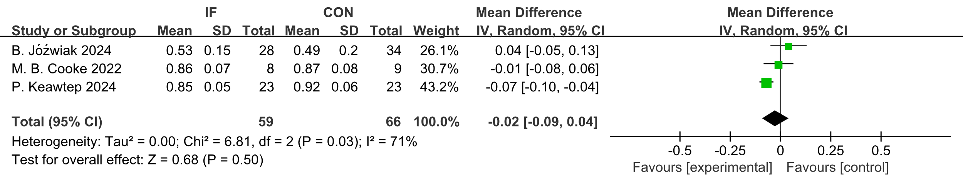
Supplementary Figure 15. Forest plot of the effects of intermittent fasting (IF) versus control diet (CON) on WHR.

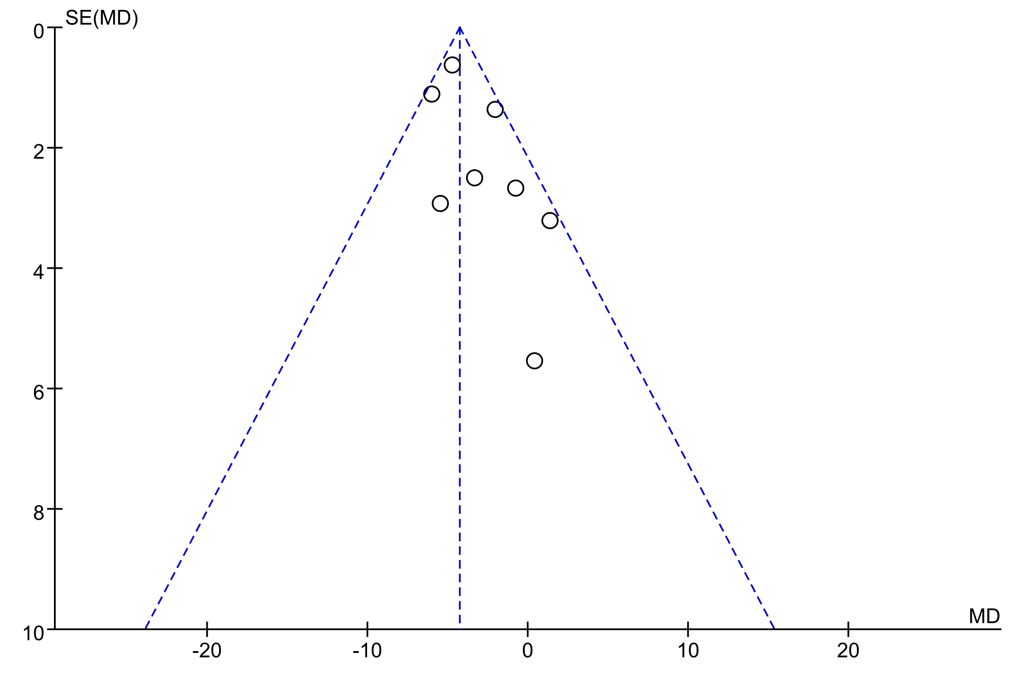
Supplementary Figure 16. Funnel plot of the effects of intermittent fasting (IF) versus control diet (CON) on body weight.

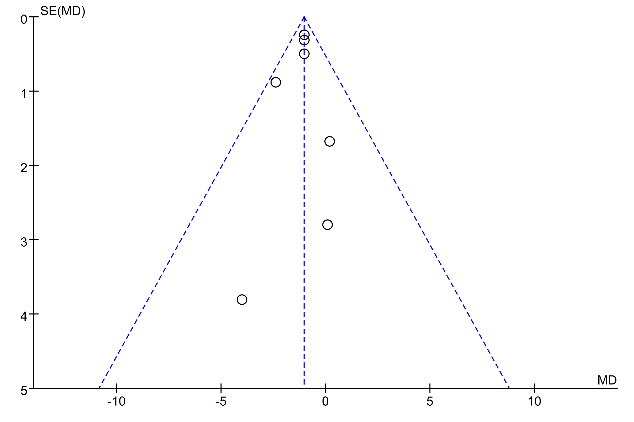
Supplementary Figure 17. Funnel plot of the effects of intermittent fasting (IF) versus control diet (CON) on body mass index.
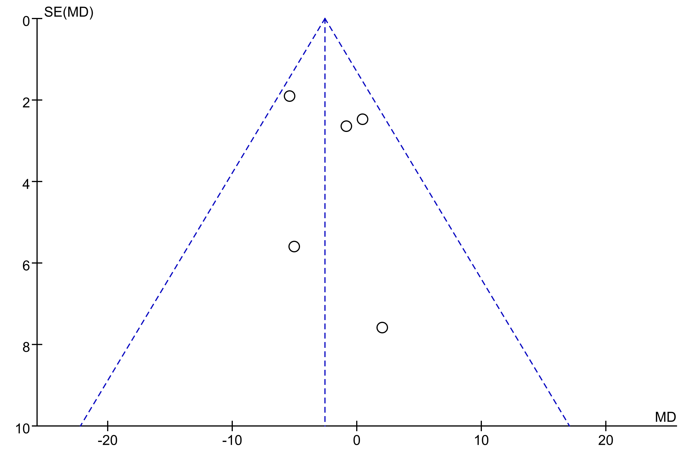
Supplementary Figure 18. Funnel plot of the effects of intermittent fasting (IF) versus control diet (CON) on waist circumference.
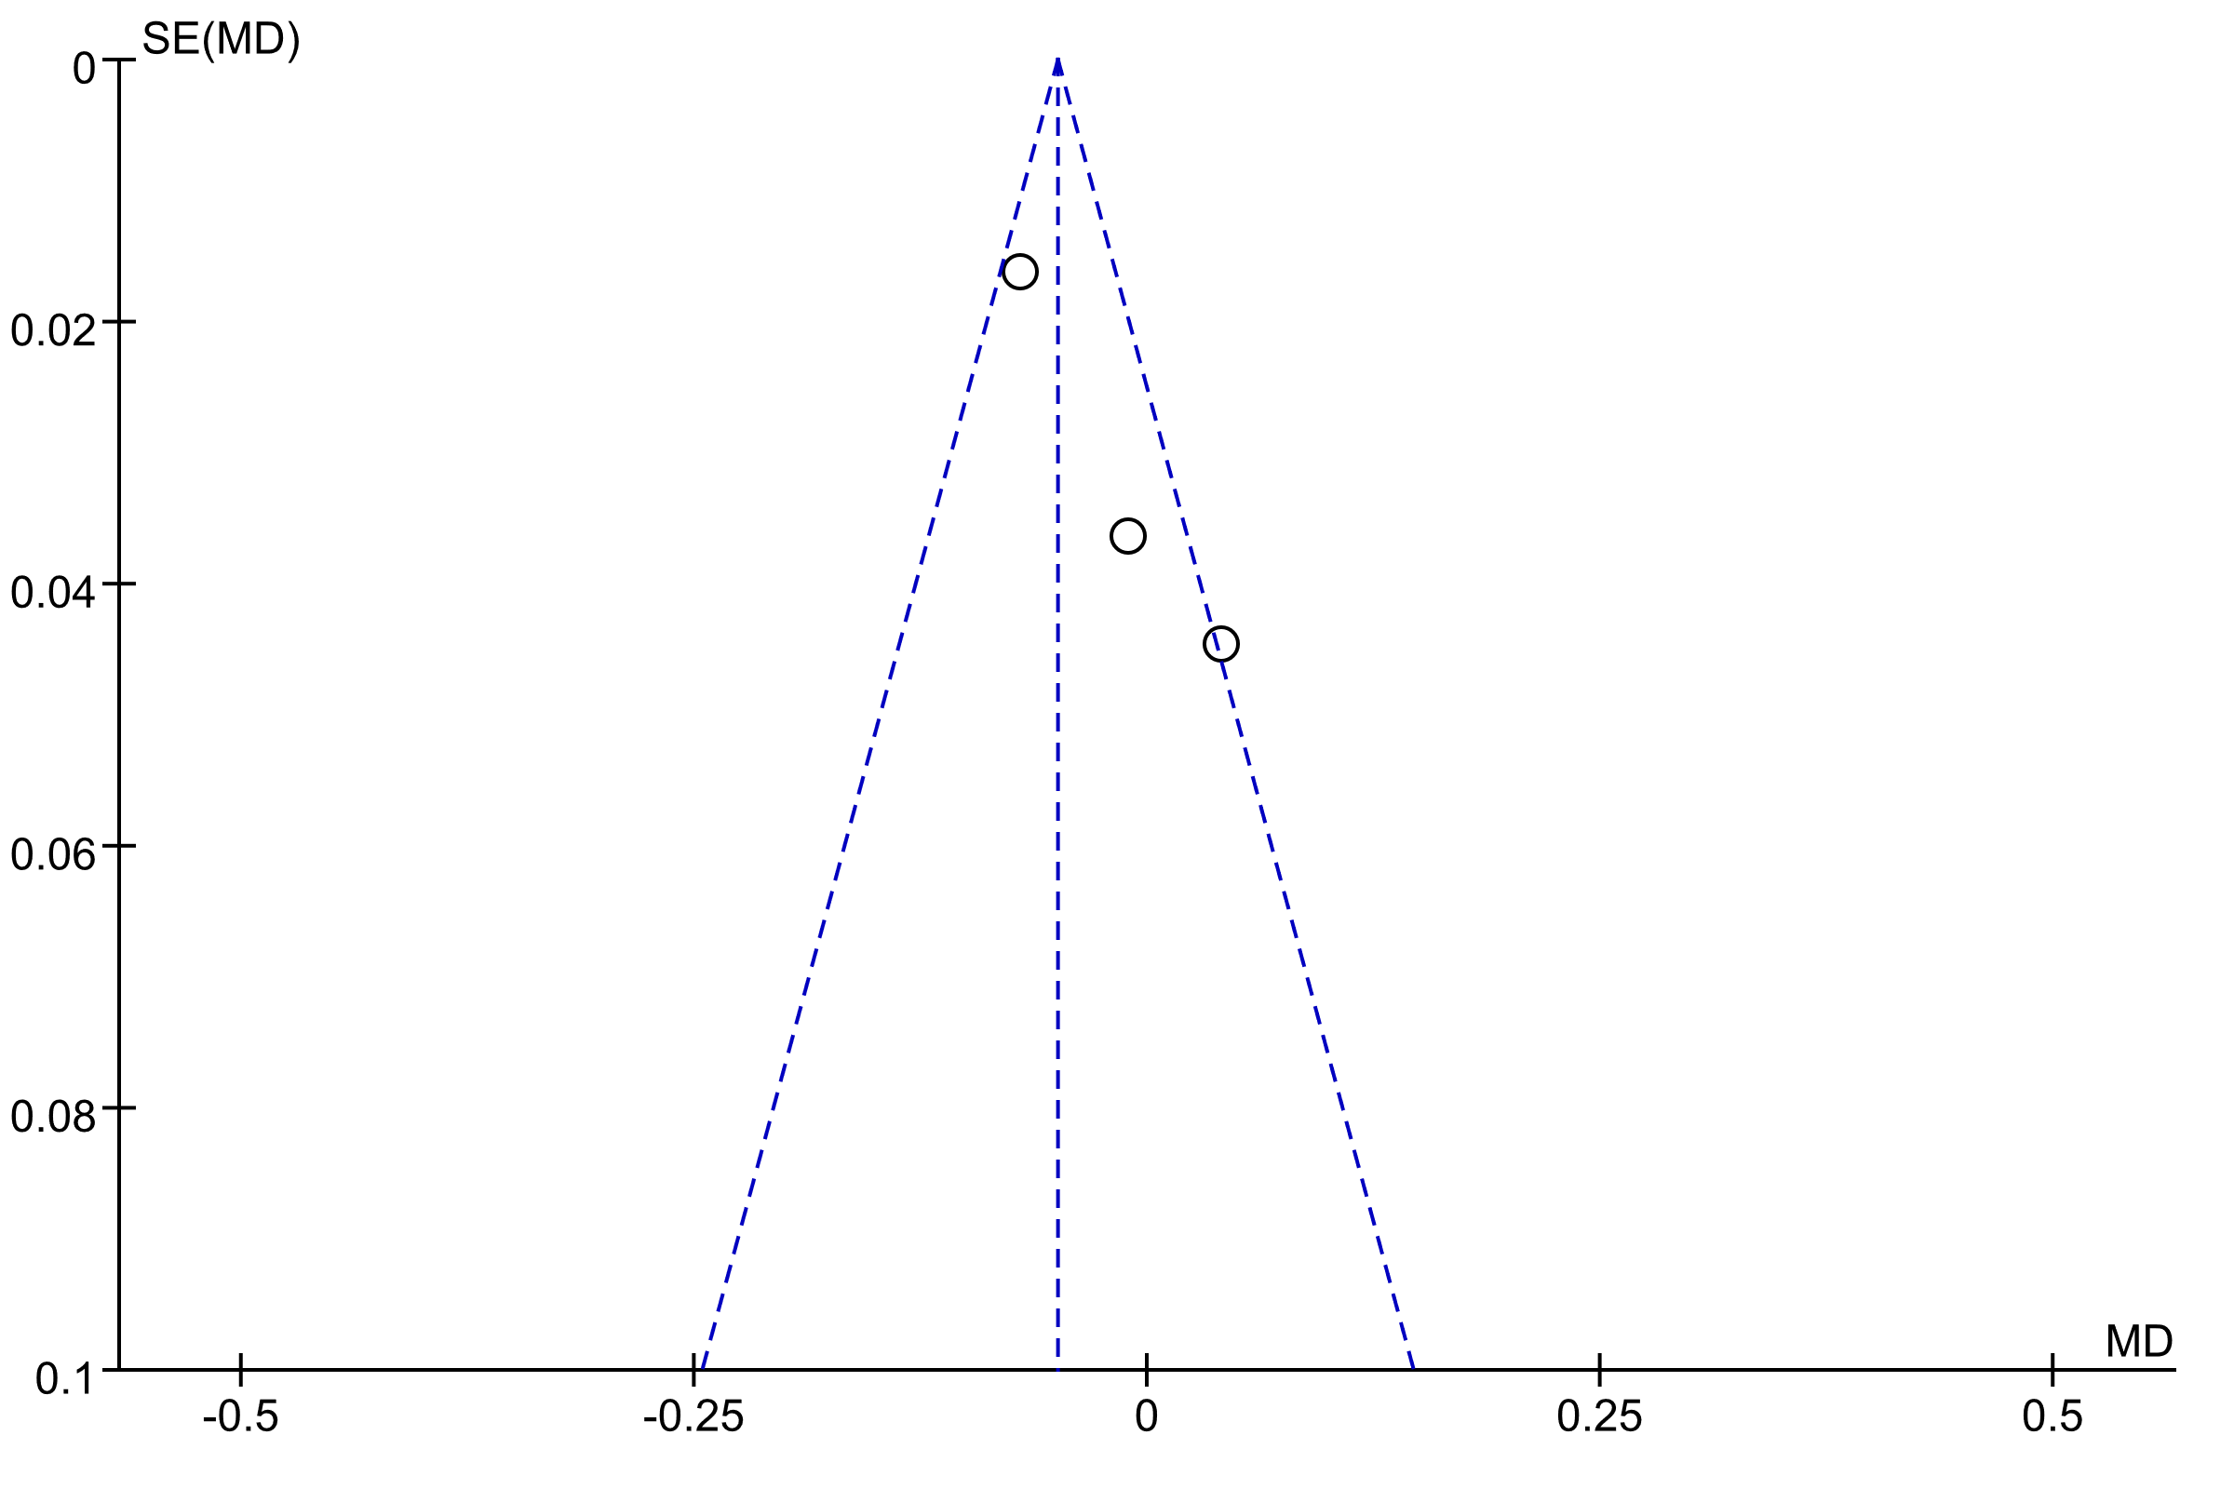
Supplementary Figure 19. Funnel plot of the effects of intermittent fasting (IF) versus control diet (CON) on Waist-to-Hip Ratio.

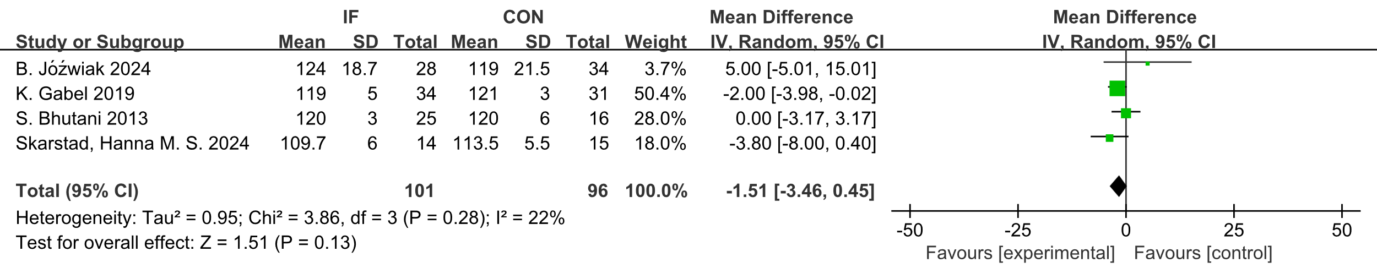
Supplementary Figure 20. Forest plot of the effects of intermittent fasting (IF) versus control diet (CON) on SBP.
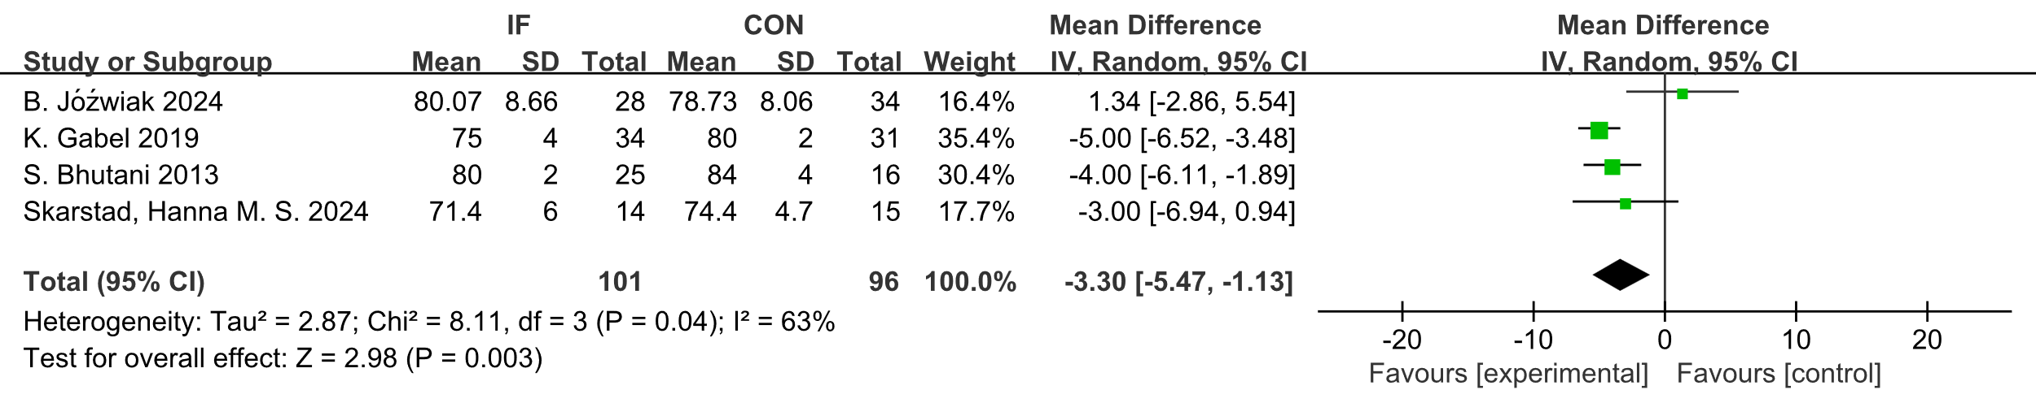
Supplementary Figure 21. Forest plot of the effects of intermittent fasting (IF) versus control diet (CON) on DBP.

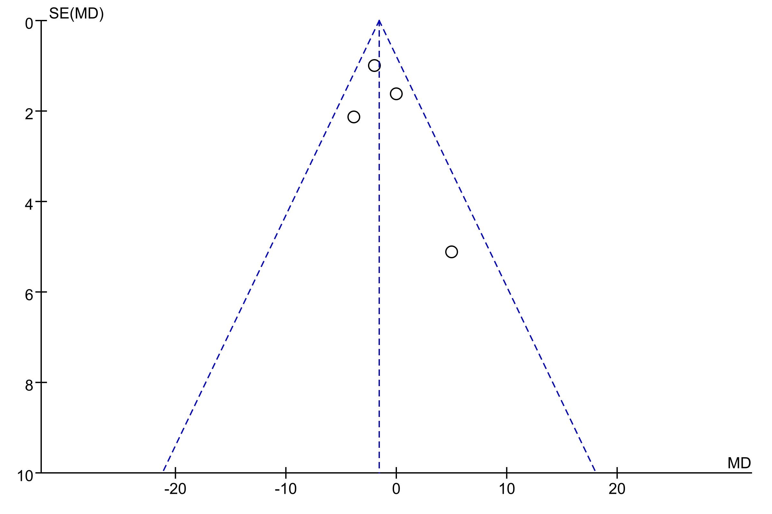
Supplementary Figure 22. Funnel plot of the effects of intermittent fasting (IF) versus control diet (CON) on systolic blood pressure.
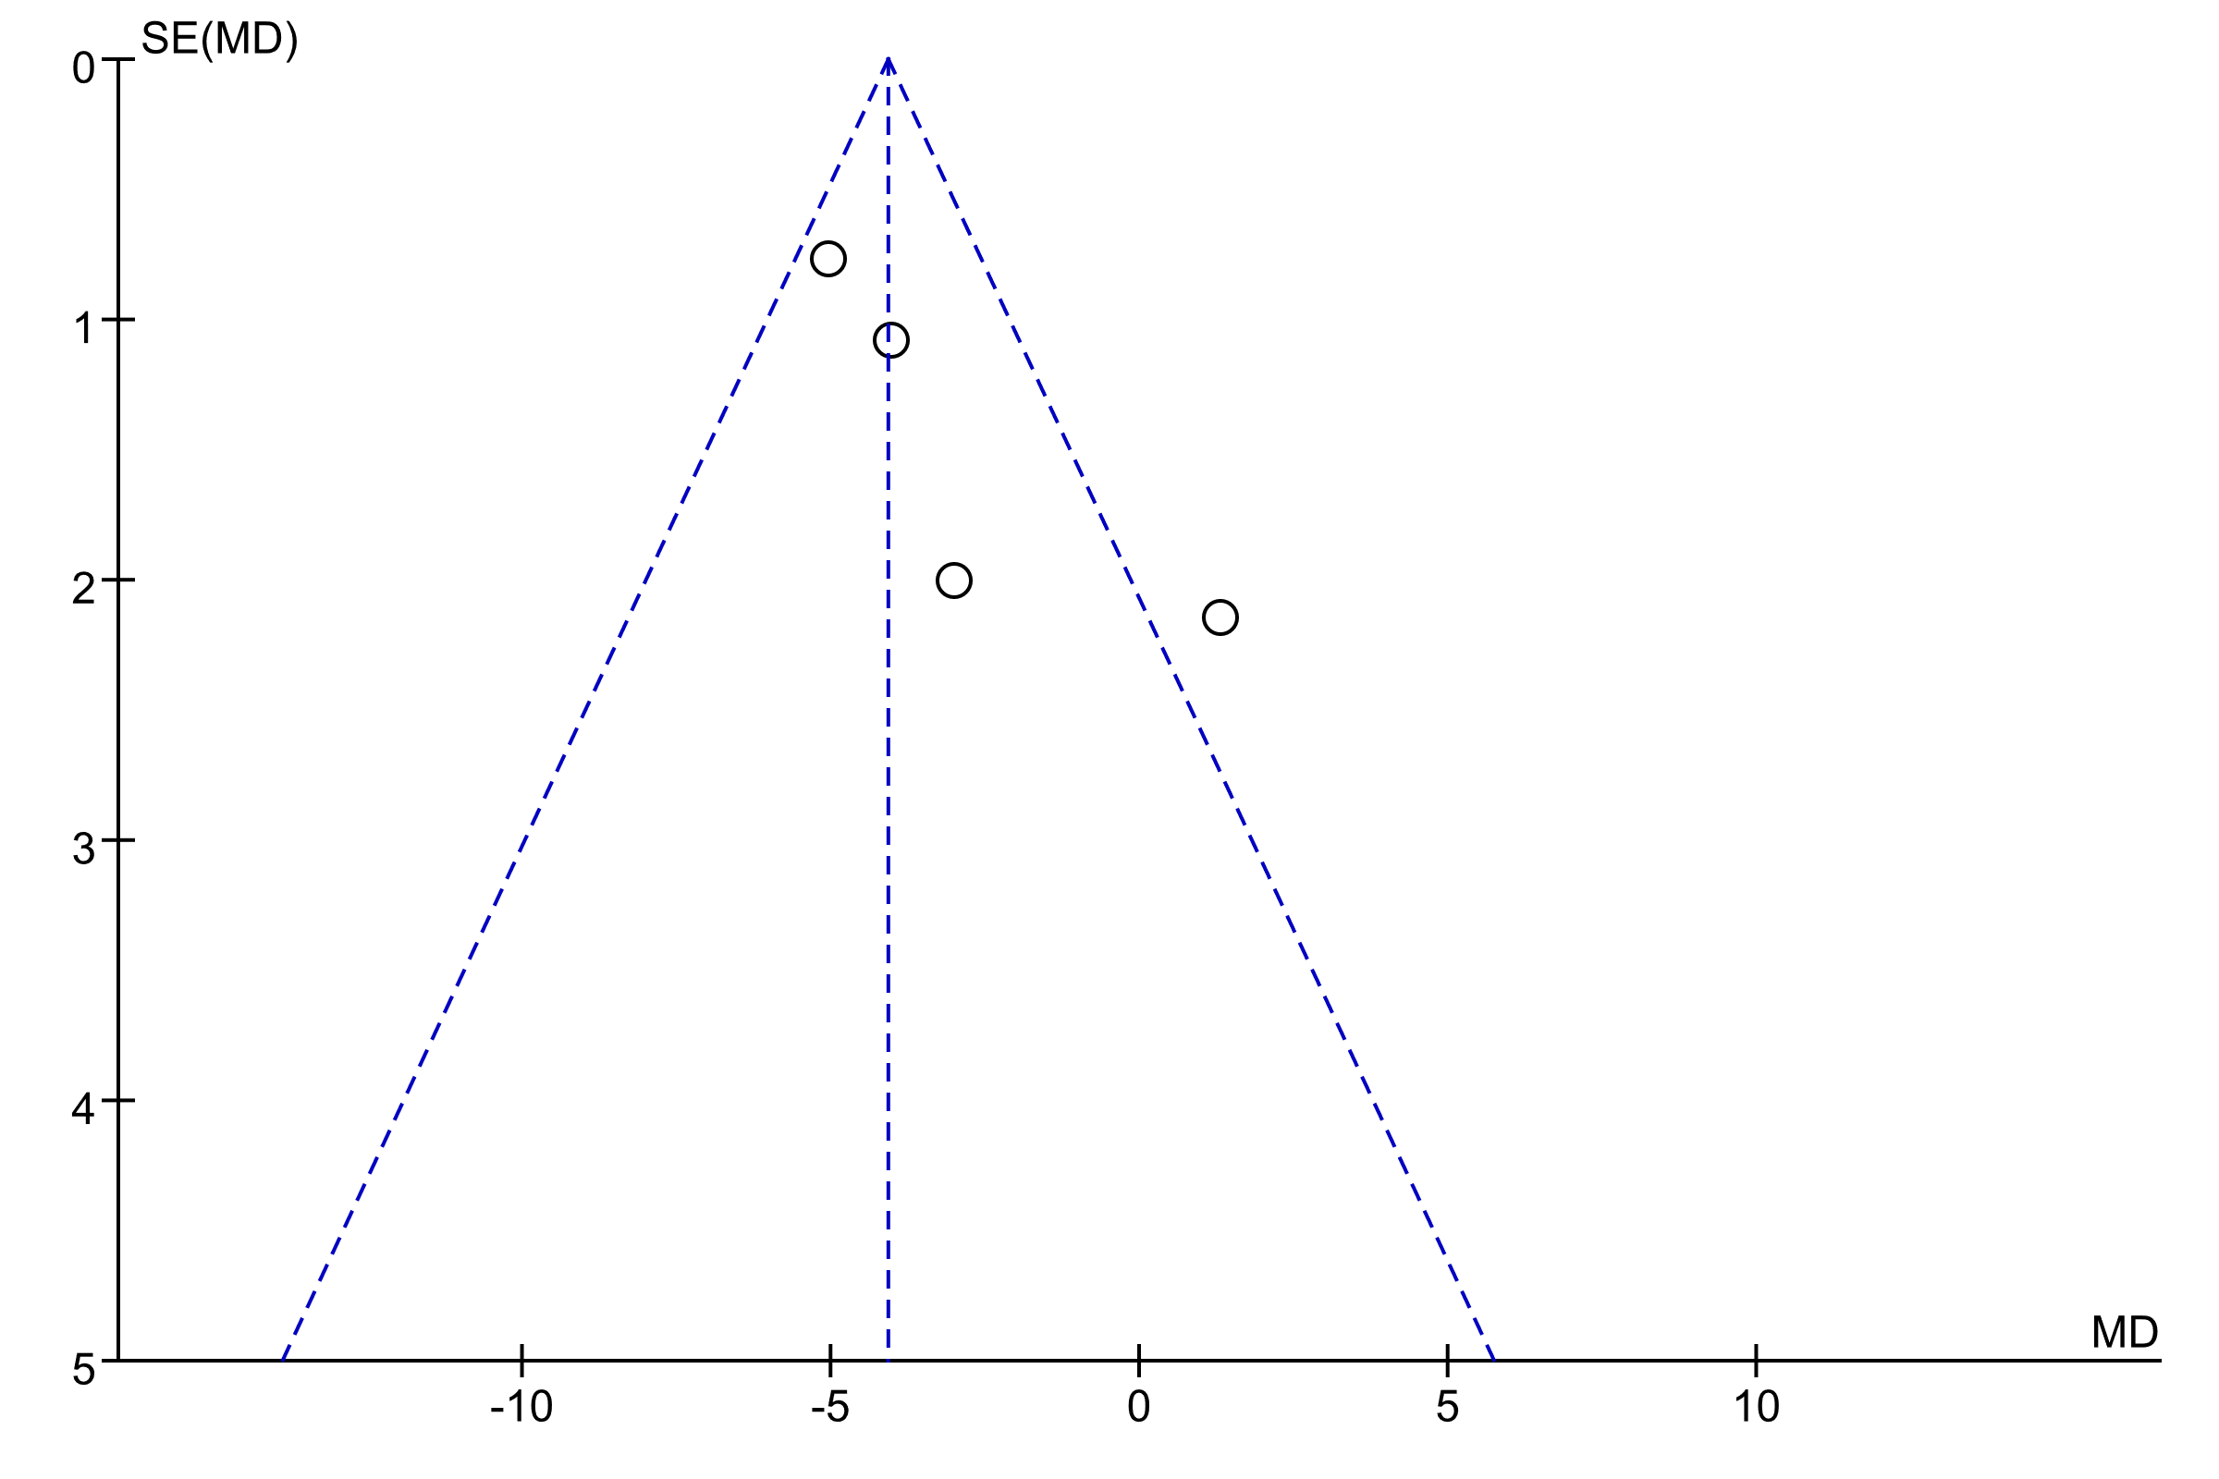
Supplementary Figure 23. Funnel plot of the effects of intermittent fasting (IF) versus control diet (CON) on diastolic blood pressure.
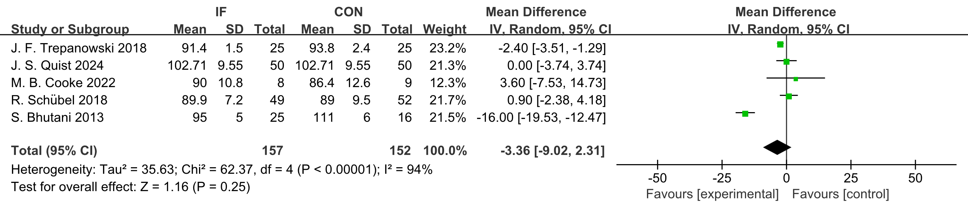
Supplementary Figure 24. Forest plot of the effects of intermittent fasting (IF) versus control diet (CON) on FPG.
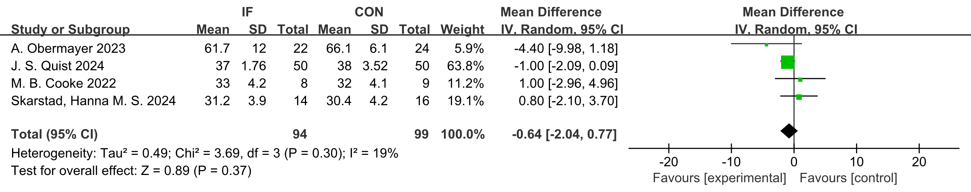
Supplementary Figure 25. Forest plot of the effects of intermittent fasting (IF) versus control diet (CON) on HbA1c.
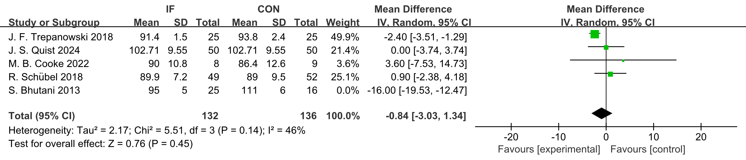
Supplementary Figure 26. Sensitivity – analysis forest plot of the effects of intermittent fasting (IF) versus control diet (CON) on FPG.

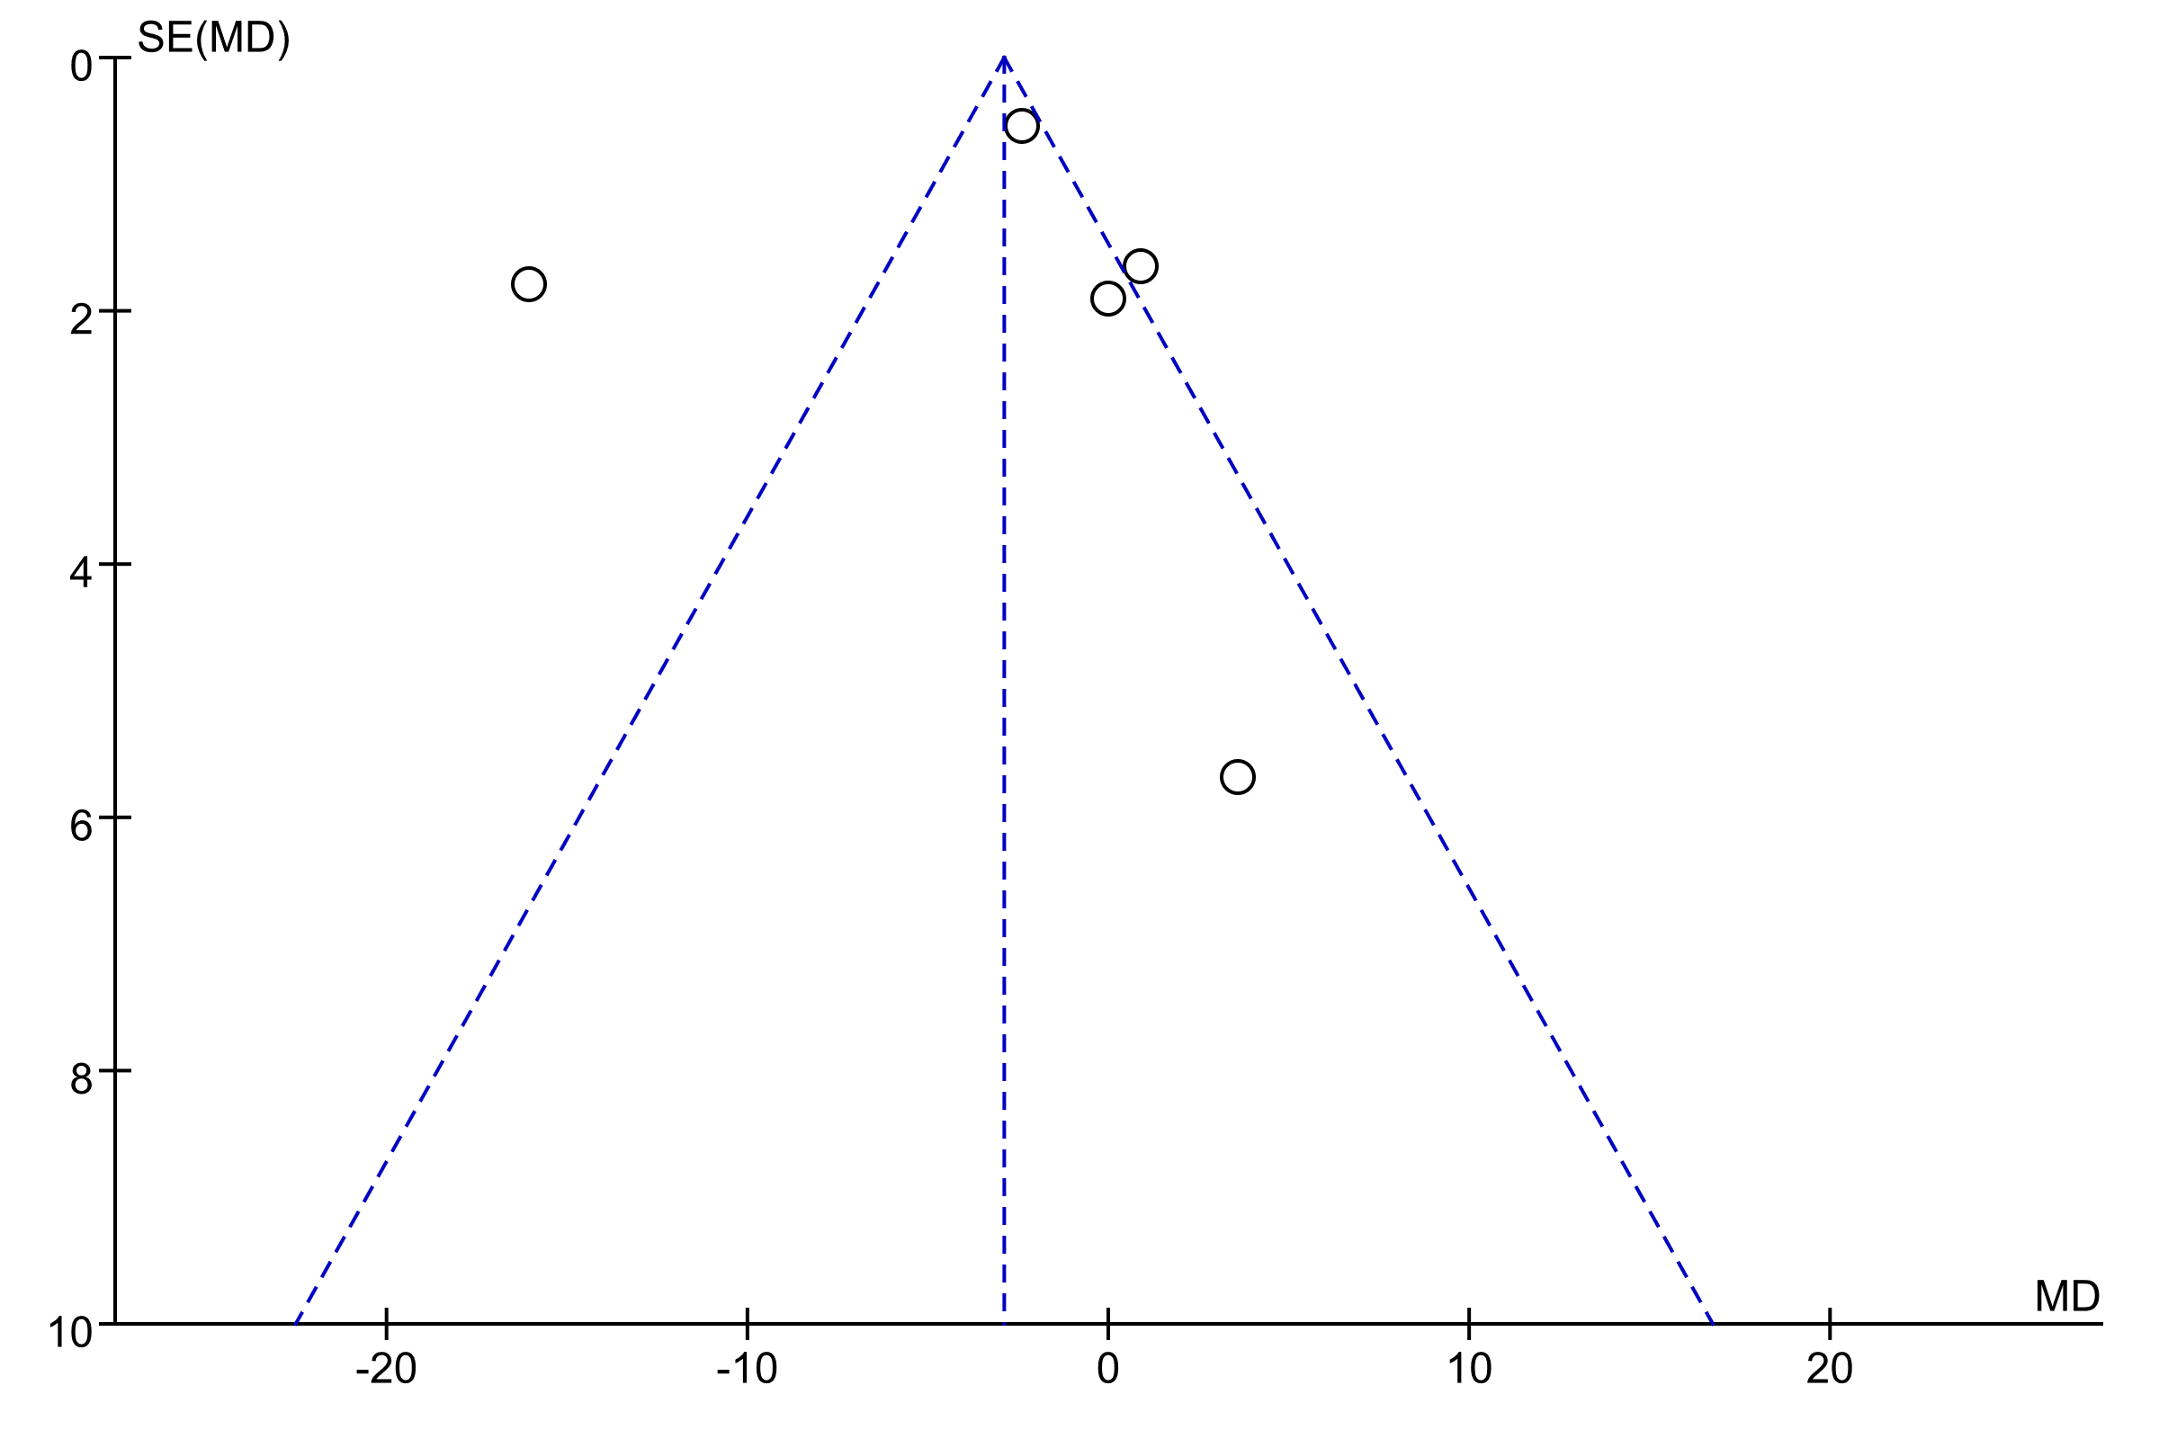
Supplementary Figure 27. Funnel plot of the effects of intermittent fasting (IF) versus control diet (CON) on fasting plasma glucose.
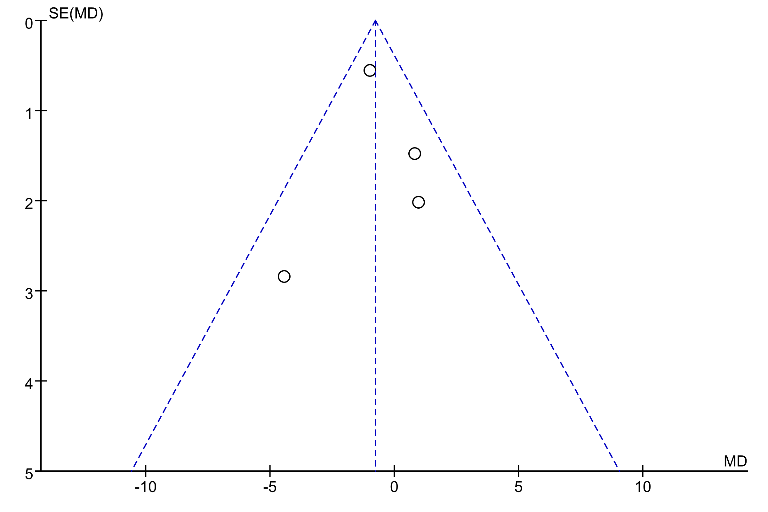
Supplementary Figure 28. Funnel plot of the effects of intermittent fasting (IF) versus control diet (CON) on Hemoglobin A1C.
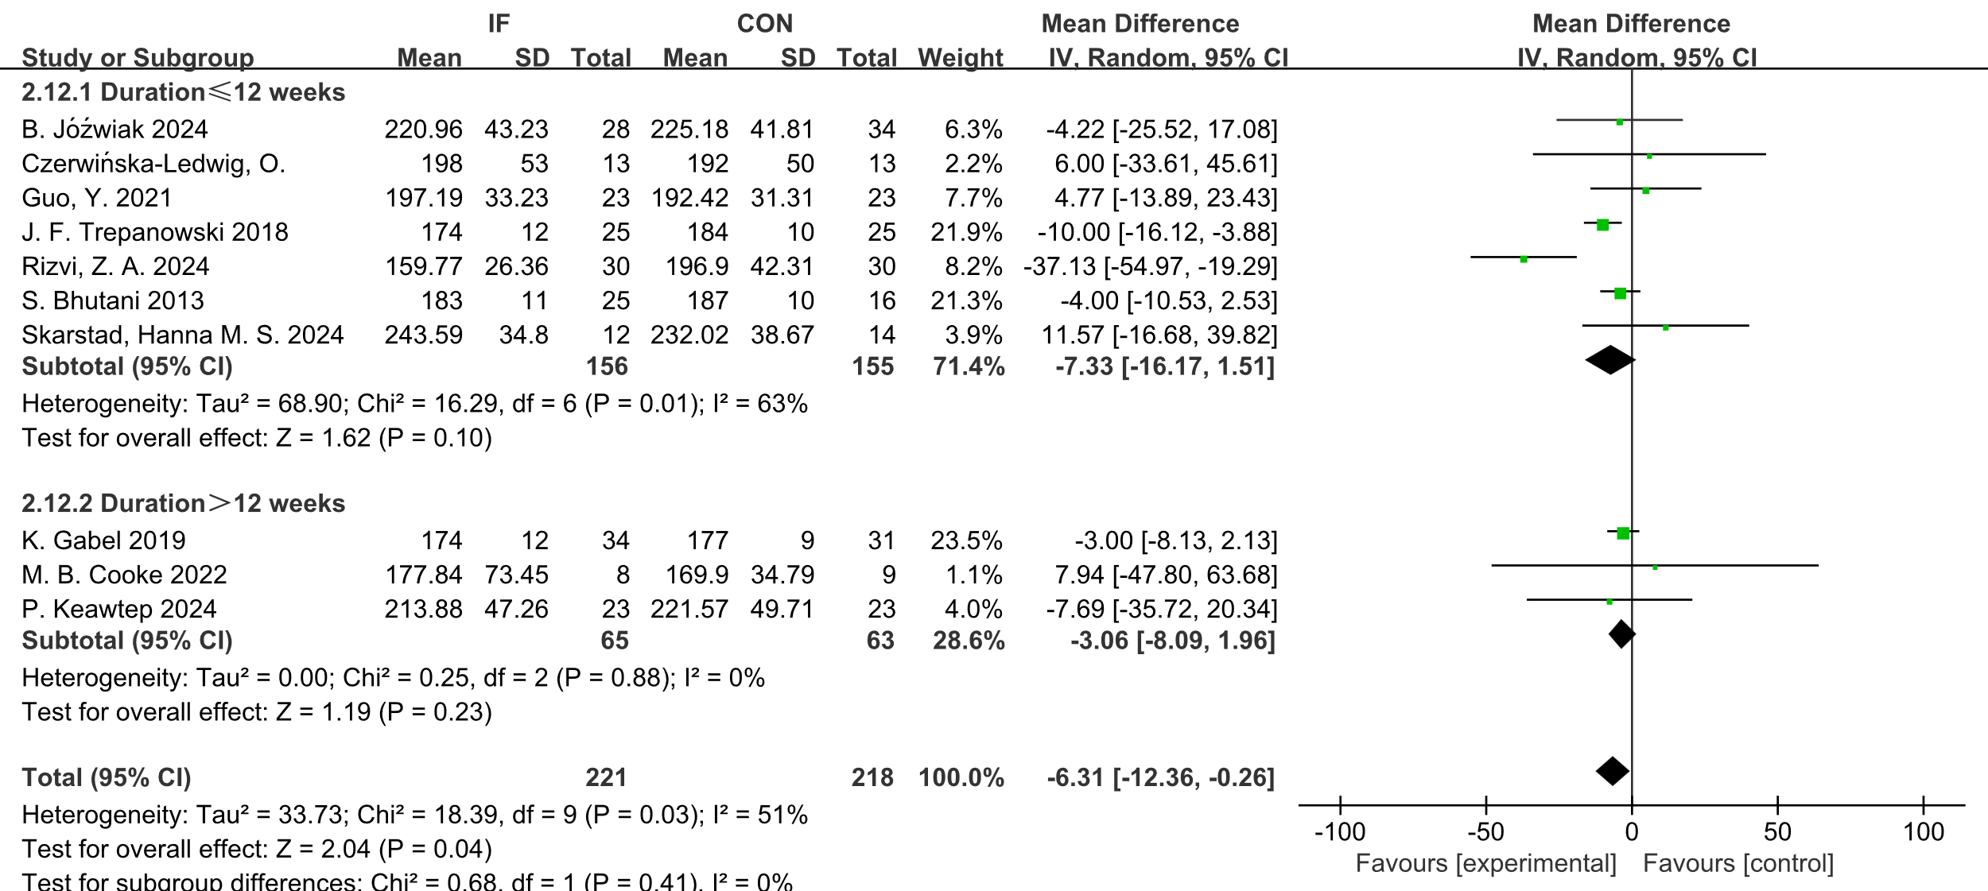
Supplementary Figure 29. Forest plot of the effect of intermittent fasting (IF) versus controlled diet (CON) on TC, stratified by duration (12 weeks).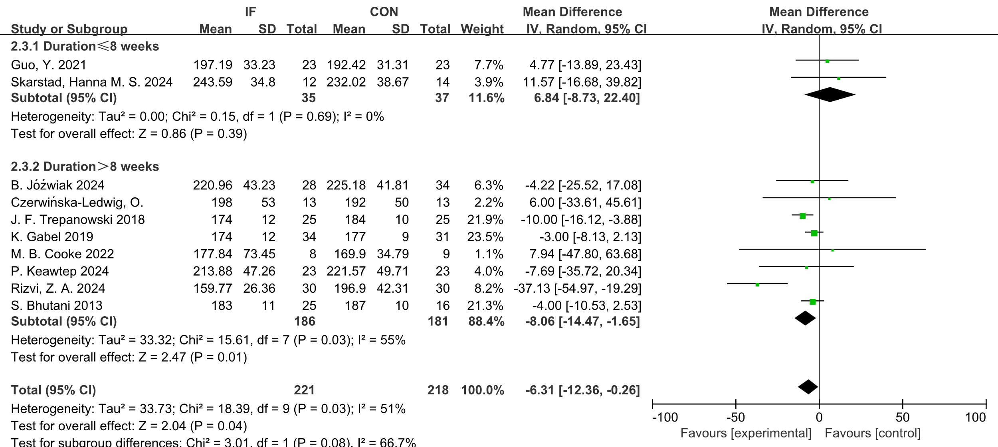

Supplementary Figure 30. Forest plot of the effects of intermittent fasting (IF) versus control diet (CON) on TC, stratified by duration (8 weeks).
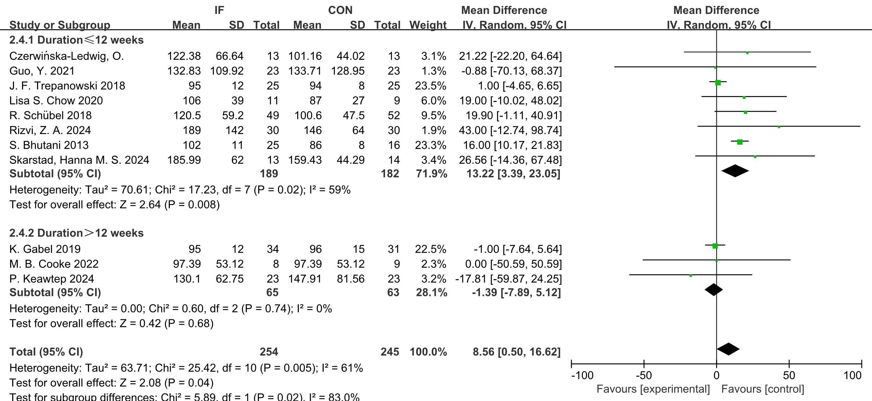
Supplementary Figure 31. Forest plot of the effects of intermittent fasting (IF) versus control diet (CON) on TG, stratified by duration.
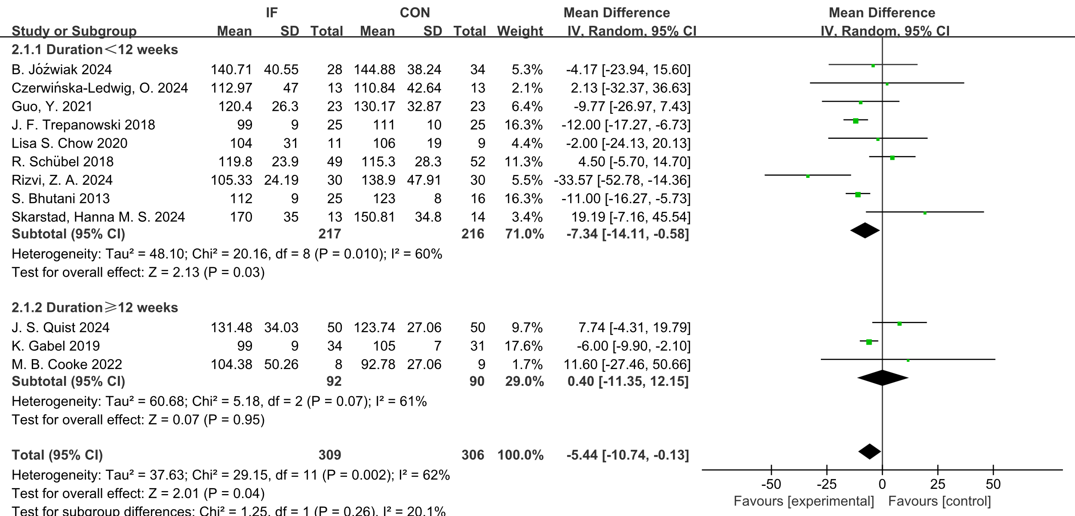

Supplementary Figure 32. Forest plot of the effects of intermittent fasting (IF) versus control diet (CON) on LDL, stratified by duration.
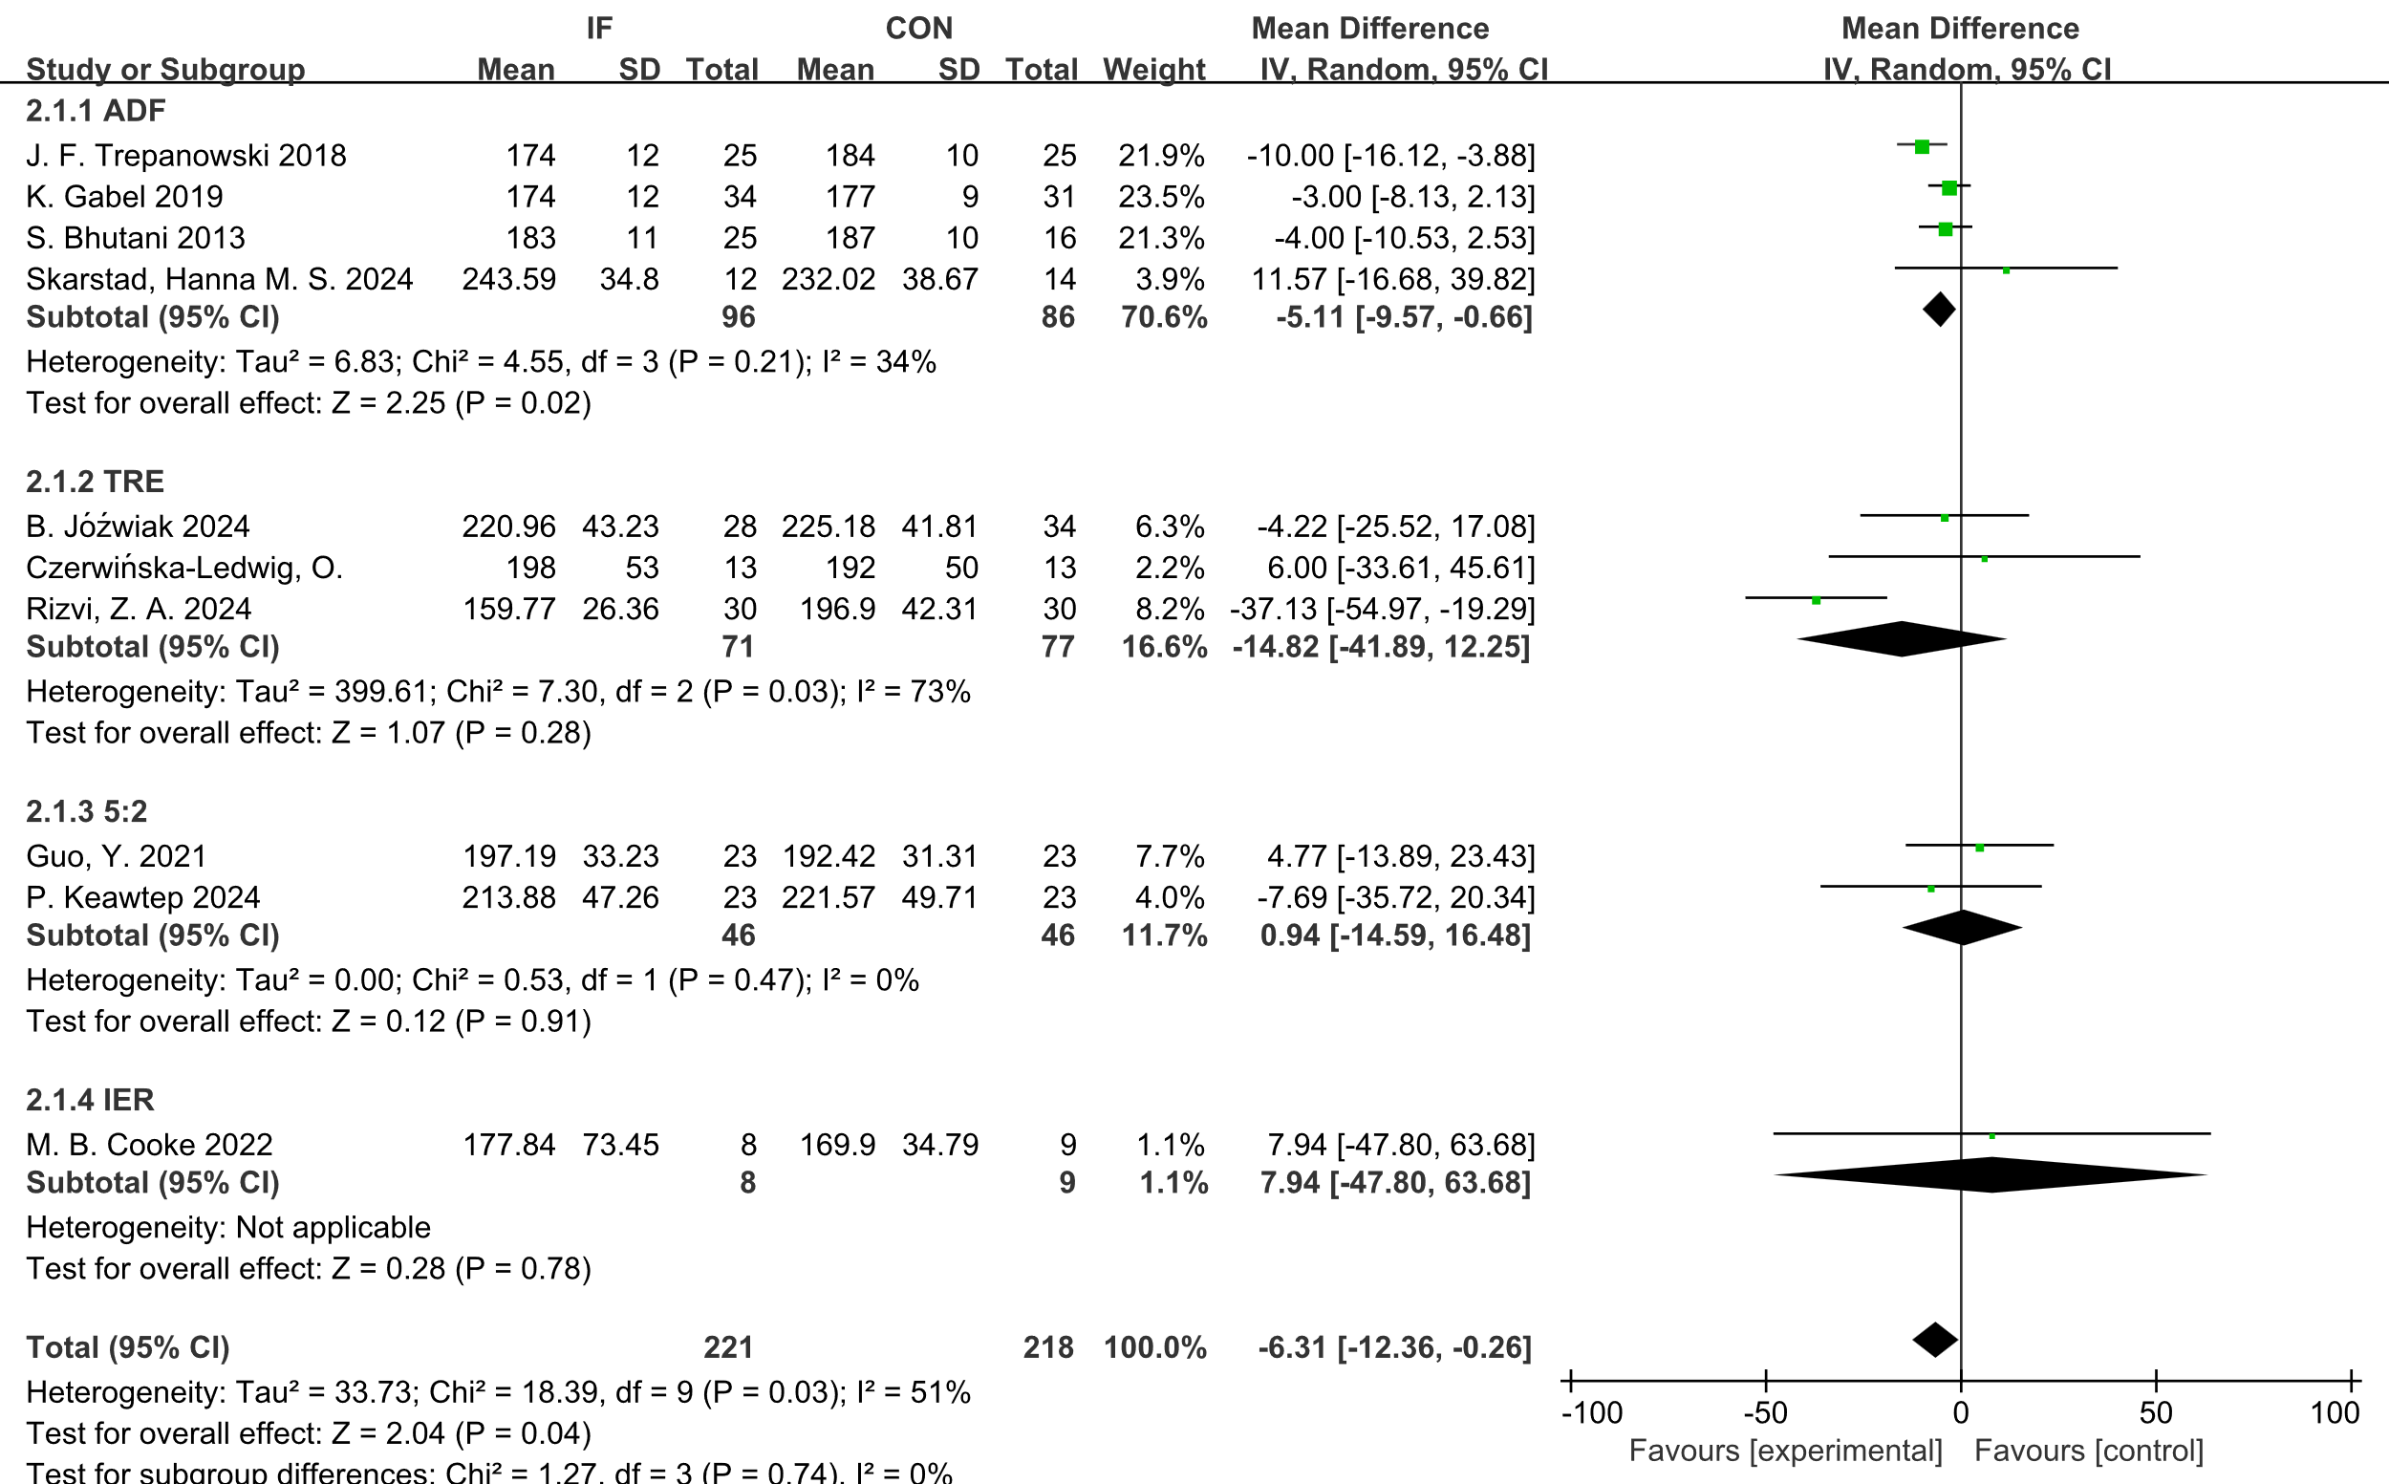
Supplementary Figure 33. Forest plot of the effects of intermittent fasting (IF) versus control diet (CON) on TC, stratified by IF form.
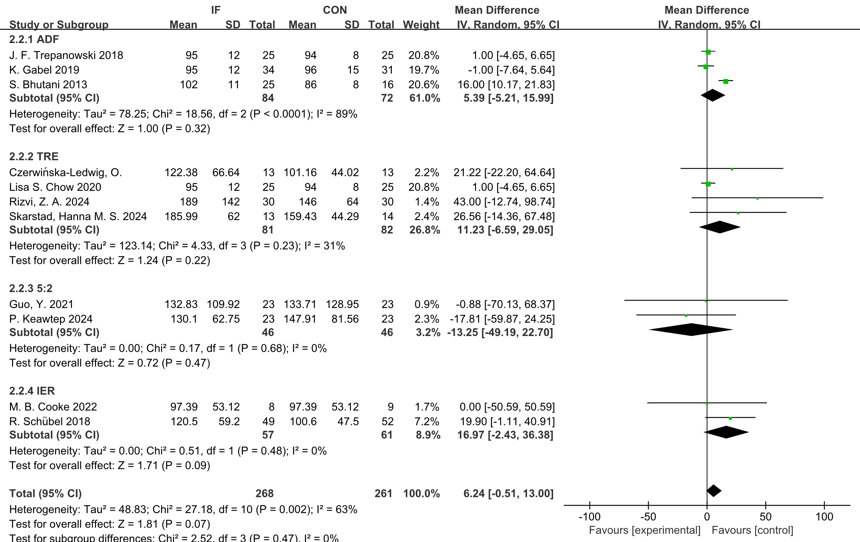
Supplementary Figure 34. Forest plot of the effects of intermittent fasting (IF) versus control diet (CON) on TG, stratified by IF form.
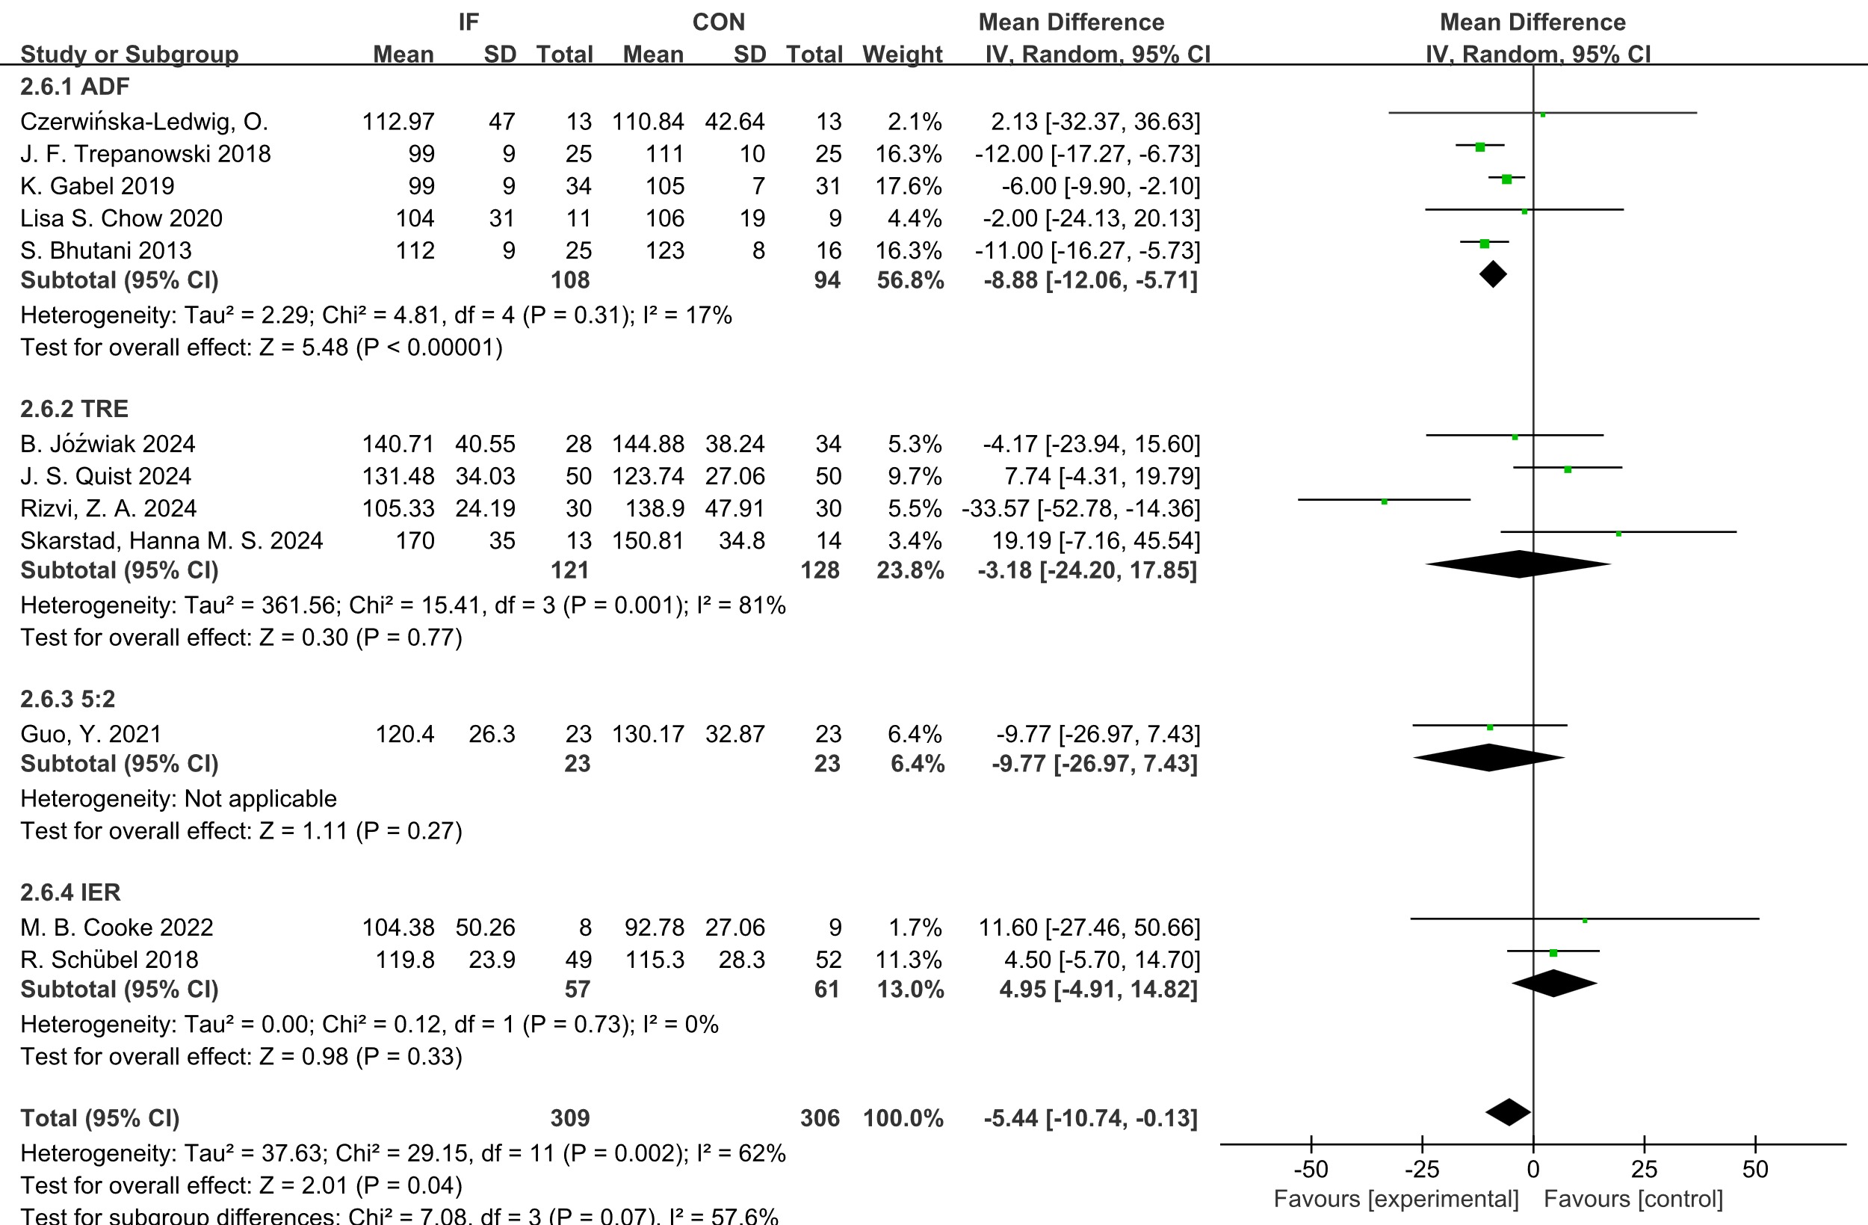
Supplementary Figure 35. Forest plot of the effects of intermittent fasting (IF) versus control diet (CON) on LDL, stratified by IF form.
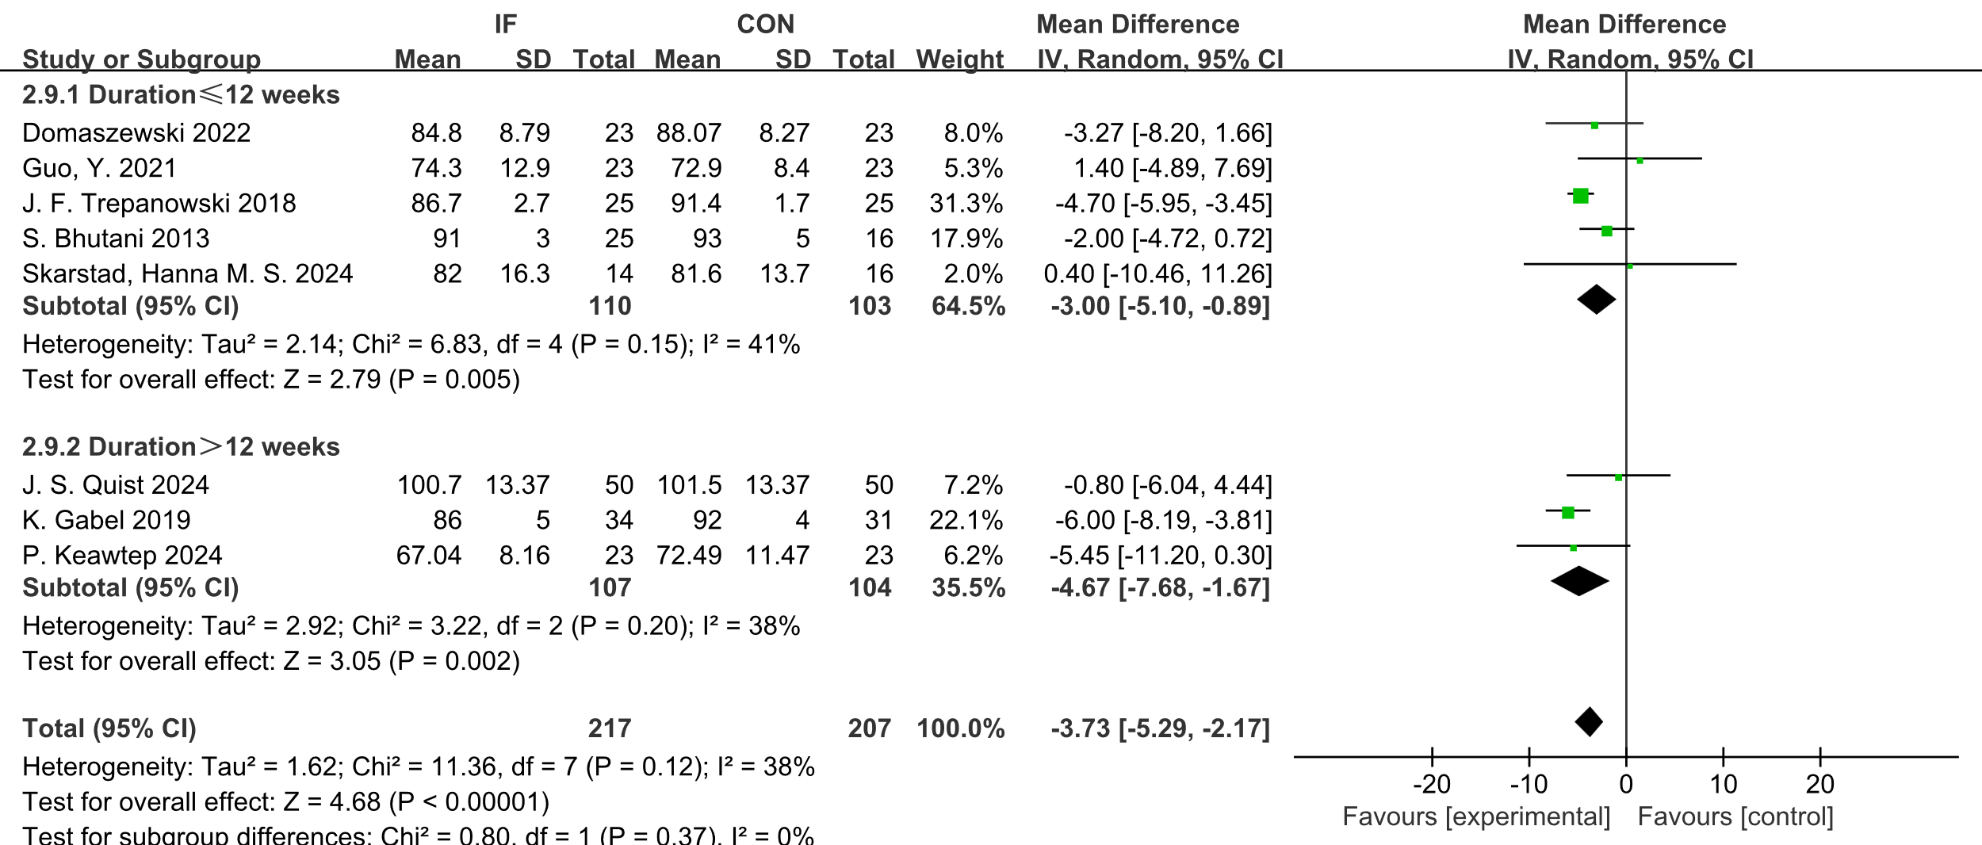
Supplementary Figure 36. Forest plot of the effects of intermittent fasting (IF) versus control diet (CON) on BW, stratified by duration.
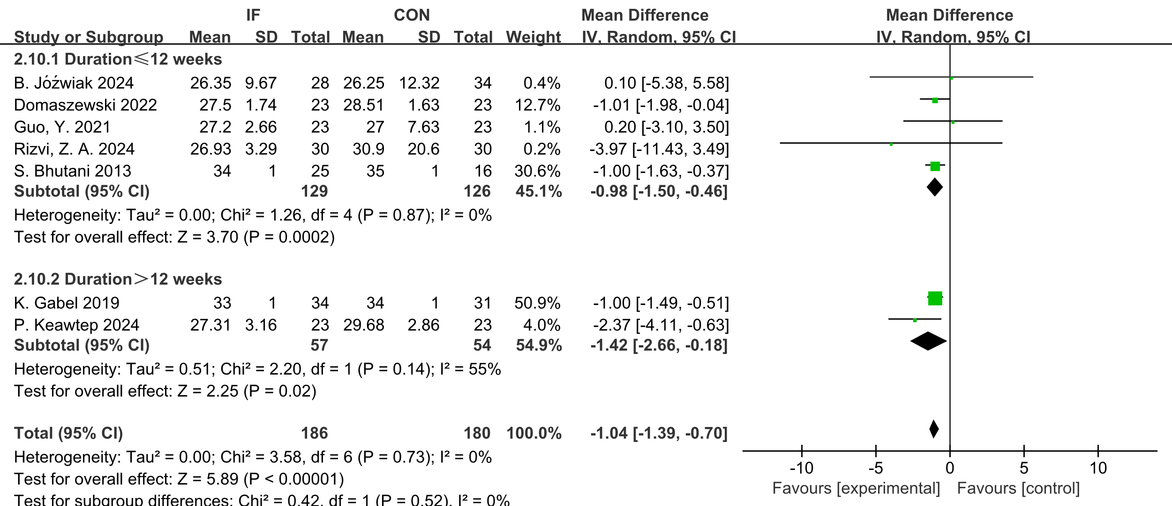
Supplementary Figure 37. Forest plot of the effects of intermittent fasting (IF) versus control diet (CON) on BMI, stratified by duration.
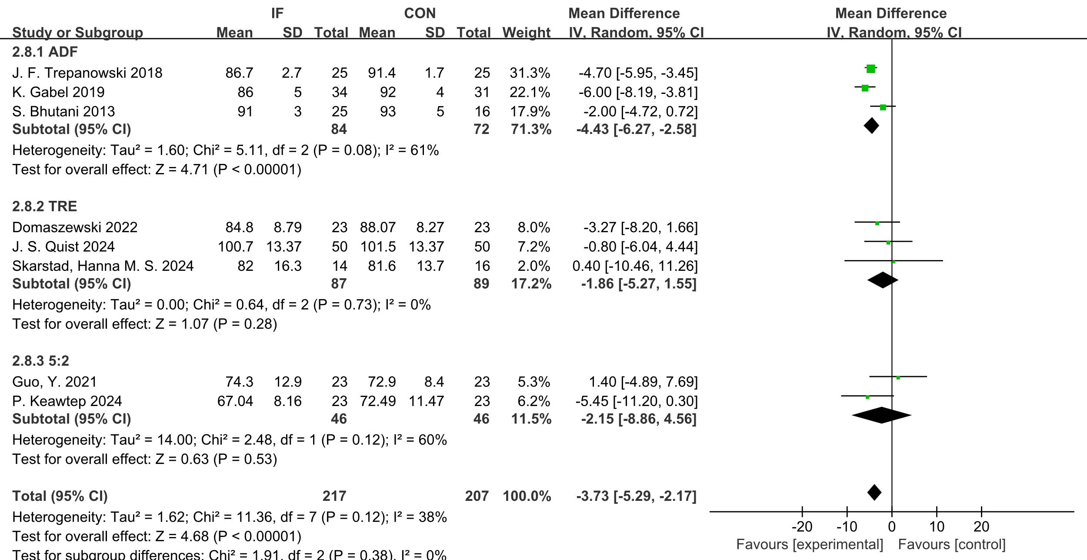
Supplementary Figure 38. Forest plot of the effects of intermittent fasting (IF) versus control diet (CON) on BW, stratified by IF form.

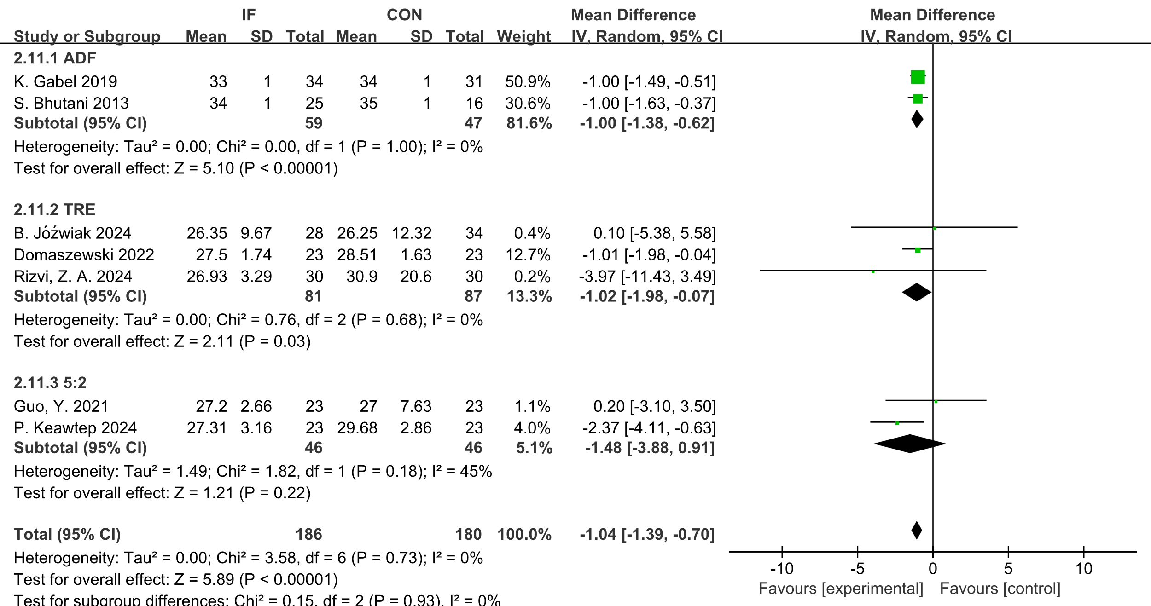
Supplementary Figure 39. Forest plot of the effects of intermittent fasting (IF) versus control diet (CON) on BMI, stratified by IF form.

Supplement Formula
TC (mg/dL) ≈ TC (mmol/L) × 38.67
FPG (mg/dL) ≈ FPG (mmol/L) × 18

