Online Supplementary Tables and Figures

Associations of a healthy beverage pattern with all-cause and cause-specific mortality among US Adults: a nationwide cohort study

Authors: Yu Feng, Haoming Wang, Kang Wang, Ziyue Li, Bohao Tan, Qirui Li, Fan Ouyang, Zhangling Chen

Page 2 | Supplementary Table 1. Scoring criteria for the HBS in the NHANES study
Page 3 | Supplementary Table 2. Beverage consumption across quartiles of the HBS in the NHANES study
Page 4-6 | Supplementary Table 3. Stratified hazard ratio (95% CI) of all-cause and CVD mortality according to the adherence to the HBS by risk factors
Page 7 | Supplementary Table 4. Hazard ratios (95% CIs) of all-cause and cause-specific mortality according to quartiles of the adherence to the HBS after excluding deaths who occurred within the first 2 years
Page 8 | Supplementary Table 5. Hazard ratios (95% CIs) of all-cause and cause-specific mortality according to quartiles of the adherence to the HBS with additional adjustment for HEI-2015
Page 9 | Supplementary Table 6. Hazard ratios (95% CIs) of all-cause and cause-specific mortality according to quartiles of the adherence to the HBS after excluding participants with baseline CVD
Page 10 | Supplementary Table 7. Hazard ratios (95% CIs) of more specific other mortality according to quartiles of the adherence to the HBS from the NHANES study
Page 11 | Supplementary Figure 1. Flow chart of participants selection
Page 12 | Supplementary Figure 2. Hazard ratios (95%CIs) for all-cause and CVD mortality according to per 1 point increase of modified HBS by excluding one component from HBS at a time

Supplementary Table 1. Scoring criteria for the HBS in the NHANES study.
Components | Score
Components | 1 | 2 | 3 | 4
Low-fat milk | No consumption | Tertile 1 | Tertile 2 | Tertile 3
Coffee and tea | No consumption | Tertile 1 | Tertile 2 | Tertile 3
Alcohol | Tertile 3 | Tertile 2 | Tertile 1 | No consumption
Whole-fat milk | Tertile 3 | Tertile 2 | Tertile 1 | No consumption
Fruit juice | Tertile 3 | Tertile 2 | Tertile 1 | No consumption
ASB | Tertile 3 | Tertile 2 | Tertile 1 | No consumption
SSB | Tertile 3 | Tertile 2 | Tertile 1 | No consumption
HBS, Healthy Beverage Score; ASB, artificially sweetened beverages; SSB, sugar-sweetened beverages.

Supplementary Table 2. Beverage consumption across quartiles of the HBS in the NHANES study.
HBS Components | Quartiles of HBS
HBS Components | Quartile 1  (n=3,344) | Quartile 2  (n=1,282) | Quartile 3  (n=2,467) | Quartile 4  (n=1,801)
Low-fat milk (g/d) | 2.6 (34.1) | 6.5 (46.5) | 15.5 (81.2) | 61.5 (175.6)
Coffee and tea (g/d) | 195.3 (445.1) | 360.6 (473.6) | 657.9 (743.5) | 1054.5 (875.1)
Whole-fat milk (g/d) | 73.6 (209.8) | 28.3 (129.1) | 22.4 (104.3) | 3.8 (25.2)
Fruit juice (cup/d) | 0.5 (0.8) | 0.3 (0.5) | 0.2 (0.5) | 0.0 (0.2)
ASB (g/d) | 21.0 (158.0) | 12.5 (99.1) | 5.9 (68.7) | 1.4 (23.9)
SSB (g/d) | 830.4 (767.8) | 447.2 (545.1) | 359.9 (505.9) | 130.6 (237.5)
Alcohol (g/d) | 19.0 (37.3) | 9.8 (21.9) | 5.9 (17.7) | 1.7 (6.8)
Values are means (SD) unless otherwise indicated.
HBS, Healthy Beverage Score; ASB, artificially sweetened beverages; SSB, sugar-sweetened beverages.

Supplementary Table 3. Stratified hazard ratio (95% CI) of all-cause and CVD mortality according to the adherence to the HBS by risk factors.
All-cause mortality
HBS | Quartile 1 | Quartile 2 | Quartile 3 | Quartile 4 | P for interaction
Age
<50y | 1 | 1.14 (0.81, 1.59) | 0.96 (0.63, 1.46) | 1.11 (0.64, 1.92) | 0.74
≥50y | 1 | 0.90 (0.76, 1.06) | 1.03 (0.87, 1.20) | 0.99 (0.84, 1.16) | 0.74
Sex
Female | 1 | 0.86 (0.69, 1.07) | 0.97 (0.83, 1.13) | 0.84 (0.69, 1.02) | 0.65
Male | 1 | 0.80 (0.66, 0.96) | 0.82 (0.65, 1.03) | 0.79 (0.65, 0.97) | 0.65
Smoking status
Current | 1 | 1.09 (0.76, 1.57) | 0.89 (0.65, 1.22) | 1.03 (0.75, 1.43) | 0.52
Former | 1 | 0.81 (0.62, 1.06) | 0.96 (0.76, 1.21) | 0.82 (0.64, 1.03) | 0.52
Never | 1 | 0.65 (0.50, 0.84) | 0.77 (0.62, 0.94) | 0.69 (0.54, 0.87) | 0.52
Dietary fiber consumption
≤Median | 1 | 0.84 (0.67, 1.05) | 0.92 (0.69, 1.21) | 0.87 (0.72, 1.06) | 0.96
>Median | 1 | 0.79 (0.63, 0.99) | 0.84 (0.74, 0.96) | 0.74 (0.61, 0.89) | 0.96
Daily energy intake
Q1 | 1 | 0.75 (0.57, 0.99) | 0.77 (0.60, 1.00) | 0.69 (0.52, 0.90) | 0.38
Q2 | 1 | 0.89 (0.66, 1.21) | 0.96 (0.69, 1.33) | 0.93 (0.73, 1.18) | 0.38
Q3 | 1 | 0.62 (0.44, 0.86) | 0.79 (0.59, 1.05) | 0.80 (0.58, 1.11) | 0.38
Q4 | 1 | 1.09 (0.72, 1.66) | 1.13 (0.84, 1.53) | 0.66 (0.39, 1.09) | 0.38
Hypertension
Yes | 1 | 0.90 (0.73, 1.10) | 0.89 (0.71, 1.11) | 0.82 (0.67, 1.02) | 0.41
No | 1 | 0.70 (0.52, 0.93) | 0.88 (0.70, 1.10) | 0.82 (0.67, 1.00) | 0.41
Hyperlipidemia
Yes | 1 | 0.84 (0.71, 0.99) | 0.91 (0.76, 1.10) | 0.85 (0.70, 1.02) | 0.74
No | 1 | 0.80 (0.55, 1.17) | 0.80 (0.59, 1.10) | 0.71 (0.53, 0.95) | 0.74
Healthy Eating Index-2015 |  |  |  |  | 0.52
≤Median | 1 | 0.91 (0.71, 1.17) | 0.89 (0.72, 1.10) | 0.89 (0.73, 1.10) | 0.52
>Median | 1 | 0.74 (0.60, 0.92) | 0.86 (0.72, 1.03) | 0.75 (0.60, 0.93) | 0.52
CVD mortality
HBS | Quartile 1 | Quartile 2 | Quartile 3 | Quartile 4 | P for interaction
Age
<50y | 1 | 2.94 (1.50, 5.75) | 0.88 (0.41, 1.86) | 1.04 (0.38, 2.79) | 0.06
≥50y | 1 | 0.85 (0.69, 1.05) | 0.94 (0.73, 1.21) | 0.98 (0.77, 1.25) | 0.06
Sex
Female | 1 | 1.21 (0.79, 1.84) | 0.99 (0.64, 1.55) | 1.13 (0.72, 1.77) | 0.17
Male | 1 | 0.76 (0.54, 1.09) | 0.80 (0.61, 1.06) | 0.63 (0.47, 0.84) | 0.17
Smoking status
Current | 1 | 1.50 (0.82, 2.73) | 0.51 (0.30, 0.85) | 0.87 (0.45, 1.71) | 0.02
Former | 1 | 0.77 (0.51, 1.15) | 0.92 (0.64, 1.33) | 0.63 (0.43, 0.92) | 0.02
Never | 1 | 0.78 (0.50, 1.23) | 0.96 (0.64, 1.43) | 0.99 (0.75, 1.31) | 0.02
Dietary fiber consumption
≤Median | 1 | 0.91 (0.66, 1.25) | 0.81 (0.61, 1.08) | 0.78 (0.61, 1.01) | 1.00
>Median | 1 | 0.86 (0.52, 1.42) | 0.83 (0.58, 1.19) | 0.74 (0.52, 1.08) | 1.00
Daily energy intake
Q1 | 1 | 0.76 (0.43, 1.33) | 0.65 (0.40, 1.06) | 0.74 (0.46, 1.18) | 0.08
Q2 | 1 | 0.86 (0.49, 1.50) | 0.92 (0.63, 1.33) | 0.87 (0.60, 1.25) | 0.08
Q3 | 1 | 0.91 (0.60, 1.36) | 0.86 (0.52, 1.44) | 0.90 (0.54, 1.51) | 0.08
Q4 | 1 | 1.27 (0.54, 3.01) | 1.15 (0.67, 1.96) | 0.29 (0.11, 0.80) | 0.08
Hypertension
Yes | 1 | 1.13 (0.83, 1.52) | 0.96 (0.71, 1.31) | 0.84 (0.64, 1.09) | 0.04
No | 1 | 0.51 (0.30, 0.87) | 0.62 (0.42, 0.92) | 0.80 (0.51, 1.25) | 0.04
Hyperlipidemia
Yes | 1 | 0.93 (0.71, 1.23) | 0.88 (0.66, 1.17) | 0.84 (0.67, 1.06) | 0.99
No | 1 | 0.83 (0.34, 2.03) | 0.77 (0.41, 1.44) | 0.68 (0.37, 1.25) | 0.99
Healthy Eating Index-2015 |  |  |  |  | 0.98
≤Median | 1 | 0.86 (0.59, 1.27) | 0.80 (0.58, 1.11) | 0.77 (0.55, 1.09) | 0.98
>Median | 1 | 0.90 (0.60, 1.35) | 0.84 (0.57, 1.24) | 0.78 (0.56, 1.11) | 0.98
Data are HRs and 95%CIs.
Multivariable analyses were adjusted for age (years), sex (male, female), race (non-Hispanic Black, non-Hispanic White, Mexican American, other Hispanic, other Races), smoking status (current, former, never smoker), PIR (continuous), education level (Junior middle school and below, High school or equivalent, College or above), BMI (kg/m²; <18.5, 18.5–19.9, 20.0–24.9, 25.0–29.9 and ≥30.0), hypertension (yes/no), hyperlipidemia (yes/no), number of medicines (number), daily energy intake (kcal/day; quartiles), dietary fiber consumption (g/day; ≤median, >median), fruit consumption (serving/day; ≤median, >median), vegetable consumption (serving/day; ≤median, >median), meat consumption (ounce/day; ≤median, >median), physical activity (MET-minutes/week). P for interaction was calculated by adding interaction terms of risk factors in the models. Given the potential for multiple testing, we set the statistical level for significance for these interactions at 0.006 (0.05/8 comparisons).
HBS, Healthy Beverage Score; PIR, income-poverty-ratio; BMI, body mass index; CVD, cardiovascular disease; MET, metabolic equivalents of task.

Supplementary Table 4. Hazard ratios (95% CIs) of all-cause and cause-specific mortality according to quartiles of the adherence to the HBS after excluding deaths who occurred within the first 2 years.
 | Quartiles of HBS |  |  |  | P for trend
 | Quartile 1 | Quartile 2 | Quartile 3 | Quartile 4 | P for trend
All-cause mortality | 1 (ref) | 0.78 (0.68, 0.91) | 0.86 (0.75, 1.00) | 0.80 (0.68, 0.93) | 0.02
CVD mortality | 1 (ref) | 0.85 (0.67, 1.07) | 0.86 (0.69, 1.06) | 0.79 (0.62, 0.99) | 0.06
Cancer mortality | 1 (ref) | 0.73 (0.47, 1.13) | 1.06 (0.68, 1.63) | 0.93 (0.68, 1.29) | 0.84
Other mortality | 1 (ref) | 0.76 (0.59, 0.98) | 0.79 (0.59, 1.07) | 0.74 (0.56, 0.98) | 0.07
Data are HRs and 95%CIs.
Multivariable analyses were adjusted for age (years), sex (male, female), race (non-Hispanic Black, non-Hispanic White, Mexican American, other Hispanic, other Races), smoking status (current, former, never smoker), PIR (continuous), education level (Junior middle school and below, High school or equivalent, College or above), BMI (kg/m²; <18.5, 18.5–19.9, 20.0–24.9, 25.0–29.9 and ≥30.0), hypertension (yes/no), hyperlipidemia (yes/no), number of medicines (number), daily energy intake (kcal/day; quartiles), dietary fiber consumption (g/day; ≤median, >median), fruit consumption (serving/day; ≤median, >median), vegetable consumption (serving/day; ≤median, >median), meat consumption (ounce/day; ≤median, >median), physical activity (MET-minutes/week).
HBS, Healthy Beverage Score; PIR, income-poverty-ratio; BMI, body mass index; CVD, cardiovascular disease; MET, metabolic equivalents of task.

Supplementary Table 5. Hazard ratios (95% CIs) of all-cause and cause-specific mortality according to quartiles of the adherence to the HBS with additional adjustment for HEI-2015.
 | Quartiles of HBS |  |  |  | P for trend
 | Quartile 1 | Quartile 2 | Quartile 3 | Quartile 4 | P for trend
All-cause mortality | 1 (ref) | 0.78 (0.67, 0.91) | 0.87 (0.75, 1.00) | 0.80 (0.69, 0.94) | 0.03
CVD mortality | 1 (ref) | 0.85 (0.67, 1.08) | 0.86 (0.69, 1.07) | 0.80 (0.65, 0.99) | 0.05
Cancer mortality | 1 (ref) | 0.74 (0.48, 1.14) | 1.07 (0.70, 1.63) | 0.96 (0.71, 1.30) | 0.95
Other mortality | 1 (ref) | 0.75 (0.59, 0.97) | 0.79 (0.60, 1.05) | 0.74 (0.57, 0.97) | 0.06
Data are HRs and 95%CIs.
Multivariable analyses were adjusted for age (years), sex (male, female), race (non-Hispanic Black, non-Hispanic White, Mexican American, other Hispanic, other Races), smoking status (current, former, never smoker), PIR (continuous), education level (Junior middle school and below, High school or equivalent, College or above), BMI (kg/m²; <18.5, 18.5–19.9, 20.0–24.9, 25.0–29.9 and ≥30.0), hypertension (yes/no), hyperlipidemia (yes/no), number of medicines (number), daily energy intake (kcal/day; quartiles), HEI-2015 (continuous), physical activity (MET-minutes/week).
HBS, Healthy Beverage Score; HEI-2015, Healthy Eating Index-2015; PIR, income-poverty-ratio; BMI, body mass index; CVD, cardiovascular disease; MET, metabolic equivalents of task.

Supplementary Table 6. Hazard ratios (95% CIs) of all-cause and cause-specific mortality according to quartiles of the adherence to the HBS after excluding participants with baseline CVD.
 | Quartiles of HBS |  |  |  | P for trend
 | Quartile 1 | Quartile 2 | Quartile 3 | Quartile 4 | P for trend
All-cause mortality | 1 (ref) | 0.80 (0.67, 0.95) | 0.82 (0.68, 0.98) | 0.84 (0.72, 0.98) | 0.05
CVD mortality | 1 (ref) | 0.82 (0.60, 1.13) | 0.68 (0.51, 0.91) | 0.81 (0.57, 1.16) | 0.18
Cancer mortality | 1 (ref) | 0.86 (0.52, 1.43) | 0.97 (0.66, 1.43) | 0.93 (0.65, 1.31) | 0.78
Other mortality | 1 (ref) | 0.76 (0.56, 1.05) | 0.83 (0.60, 1.16) | 0.81 (0.61, 1.07) | 0.20
Data are HRs and 95%CIs.
Multivariable analyses were adjusted for age (years), sex (male, female), race (non-Hispanic Black, non-Hispanic White, Mexican American, other Hispanic, other Races), smoking status (current, former, never smoker), PIR (continuous), education level (Junior middle school and below, High school or equivalent, College or above), BMI (kg/m²; <18.5, 18.5–19.9, 20.0–24.9, 25.0–29.9 and ≥30.0), hypertension (yes/no), hyperlipidemia (yes/no), number of medicines (number), daily energy intake (kcal/day; quartiles), dietary fiber consumption (g/day; ≤median, >median), fruit consumption (serving/day; ≤median, >median), vegetable consumption (serving/day; ≤median, >median), meat consumption (ounce/day; ≤median, >median), physical activity (MET-minutes/week).
HBS, Healthy Beverage Score; PIR, income-poverty-ratio; BMI, body mass index; CVD, cardiovascular disease; MET, metabolic equivalents of task.

Supplementary Table 7. Hazard ratios (95% CIs) of more specific other mortality according to quartiles of the adherence to the HBS from the NHANES study.
 | Quartiles of HBS |  |  |  | P for trend
 | Quartile 1 | Quartile 2 | Quartile 3 | Quartile 4 | P for trend
Kidney disease mortality | 1 (ref) | 1.25 (0.55, 2.84) | 1.63 (0.78, 3.38) | 1.60 (0.53, 4.81) | 0.44
Neurodegenerative disease mortality | 1 (ref) | 0.35 (0.20, 0.61) | 0.53 (0.27, 1.03) | 0.29 (0.11, 0.76) | 0.03
Diabetes mortality | 1 (ref) | 0.12 (0.04, 0.38) | 0.66 (0.29, 1.54) | 0.67 (0.22, 2.07) | 0.72
Respiration disease mortality | 1 (ref) | 1.17 (0.68, 2.00) | 1.00 (0.62, 1.61) | 1.05 (0.66, 1.67) | 0.92
Data are HRs and 95%CIs.
Multivariable analyses were adjusted for age (years), sex (male, female), race (non-Hispanic Black, non-Hispanic White, Mexican American, other Hispanic, other Races), smoking status (current, former, never smoker), PIR (continuous), education level (Junior middle school and below, High school or equivalent, College or above), BMI (kg/m²; <18.5, 18.5–19.9, 20.0–24.9, 25.0–29.9 and ≥30.0), hypertension (yes/no), hyperlipidemia (yes/no), number of medicines (number), daily energy intake (kcal/day; quartiles), dietary fiber consumption (g/day; ≤median, >median), fruit consumption (serving/day; ≤median, >median), vegetable consumption (serving/day; ≤median, >median), meat consumption (ounce/day; ≤median, >median), physical activity (MET-minutes/week).
HBS, Healthy Beverage Score; PIR, income-poverty-ratio; BMI, body mass index; MET, metabolic equivalents of task.

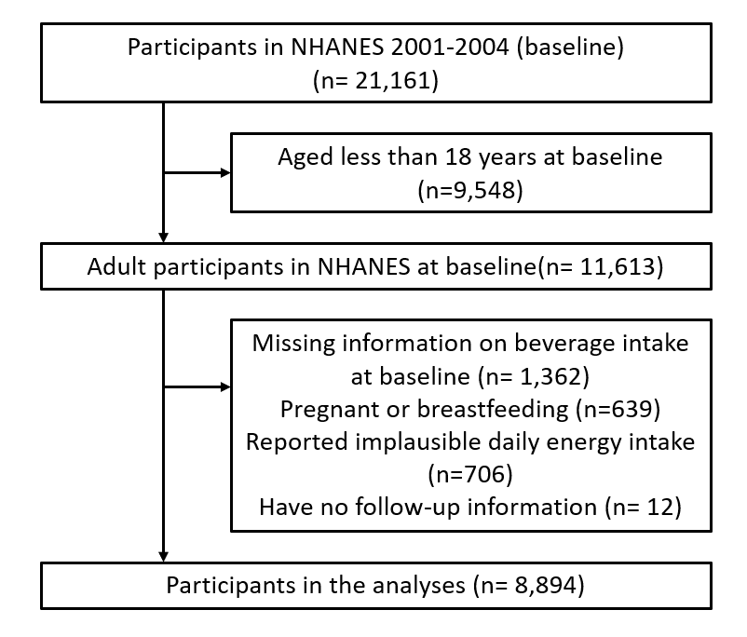

Supplementary Figure 1. Flow chart of participants selection.

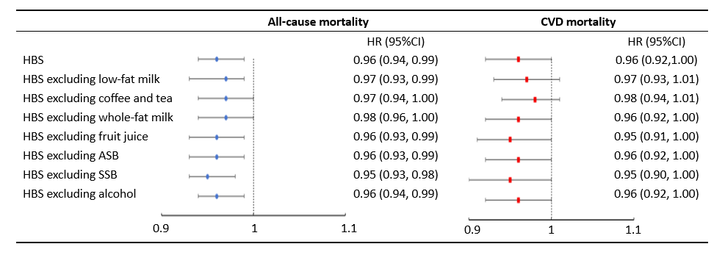
Supplementary Figure 2. Hazard ratios (95%CIs) for all-cause and CVD mortality according to per 1 point increase of modified HBS by excluding one component from HBS at a time.
Multivariable analyses were adjusted for age (years), sex (male, female), race (non-Hispanic Black, non-Hispanic White, Mexican American, other Hispanic, other Races), smoking status (current, former, never smoker), PIR (continuous), education level (Junior middle school and below, High school or equivalent, College or above), BMI (kg/m²; <18.5, 18.5–19.9, 20.0–24.9, 25.0–29.9 and ≥30.0), hypertension (yes/no), hyperlipidemia (yes/no), number of medicines (number), daily energy intake (kcal/day; quartiles), dietary fiber consumption (g/day; ≤median, >median), fruit consumption (serving/day; ≤median, >median), vegetable consumption (serving/day; ≤median, >median), meat consumption (ounce/day; ≤median, >median), physical activity (MET-minutes/week).
HBS, Healthy Beverage Score; ASB, artificially sweetened beverages; SSB, sugar-sweetened beverages; PIR, income-poverty-ratio; BMI, body mass index; CVD, cardiovascular disease; MET, metabolic equivalents of task; HR, hazard ratio; CI, confidence interval.

