Consumption of ultra-processed foods and risk of all-cause and cause-specific mortality: the Singapore Chinese Health Study
Yue Li et al.
Online Supplementary Material

Supplementary Table 1. Food products considered as ultra-processed foods according to the NOVA classification.
Ultra-processed food groupª | Examples of food
Sweetened beverages | Soft drinks, Milo, Ovaltine, and Horlicks
Dairy based products | Yakult, Vitagen, ice cream, and frozen yogurt
Cereals and starchy foods | Hot oats or other hot cereals, cornflakes or other cold cereals, white sliced bread, and hotcake
Sugary products | Crackers and biscuits, western cakes, and coconut desserts
Savory snacks | Hamburger and cheeseburger, French fries, sandwiches, pizza, and baked buns with processed meat
Meat, fish, and eggs | Deep-fried chicken, sausage, ham, hot dogs, luncheon meat, deep-fried fish, and preserved eggs
Spread and sweetener | Margarine, peanut butter, and artificial sweetener
ª Since hard liquor is classified as UPFs, but alcohol is a well-investigated risk factor for mortality, we did not consider hard liquor in UPFs in our primary analysis. Since whole-wheat bread, which belongs to UPFs, has been associated with lower ischemic heart disease mortality in our study population, we did not include whole-wheat bread in our primary analysis.

Supplementary Table 2. Sensitivity analysis for associations of ultra-processed food intake with mortality in the Singapore Chinese Health Study.ª
 | All-cause mortality |  | CVD mortality |  | Cancer mortality |  | Respiratory disease mortality
Ultra-processed food subgroups | HR (95% CI)^{b} |  | HR (95% CI)^{b} |  | HR (95% CI)^{b} |  | HR (95% CI)^{b}
Exclusion of within 2 years of follow up | 1.03 (1.01-1.04) |  | 1.03 (1.01-1.06) |  | 0.99 (0.97-1.02) |  | 1.06 (1.03-1.09)
Exclusion of within 3 years of follow up | 1.03 (1.01-1.04) |  | 1.03 (1.01-1.06) |  | 0.99 (0.97-1.02) |  | 1.05 (1.02-1.09)
Exclusion of prevalent CVD or cancer at baseline | 1.02 (1.01-1.04) |  | 1.03 (1.00-1.05) |  | 0.99 (0.96-1.01) |  | 1.06 (1.03-1.10)
Include whole-wheat bread in the total UPF definition | 1.03 (1.02-1.05) |  | 1.04 (1.02-1.07) |  | 1.00 (0.97-1.03) |  | 1.06 (1.03-1.09)
Include hard liquor in the total UPF definition | 1.04 (1.02-1.05) |  | 1.05 (1.02-1.07) |  | 1.00 (0.98-1.03) |  | 1.06 (1.03-1.09)
Include whole-wheat bread and hard liquor in the total UPF definition | 1.03 (1.02-1.05) |  | 1.04 (1.02-1.07) |  | 1.00 (0.97-1.03) |  | 1.06 (1.02-1.09)
HR: hazard ratio; CI: confidence intervals; CVD: cardiovascular disease; UPF: ultra-processed food.
ª All model was adjusted for age (continuous), sex (male or female), total energy intake (continuous), dialect group (Cantonese or Hokkien), educational level (no formal education, primary school, or secondary school or higher), body mass index (<18.5, 18.5-22.9, 23.0-27.4, 27.5+ kg/m²), smoking status (never, former, or current), alcohol frequency (none, monthly, weekly, or daily), physical activity (<0.5 h/wk, 0.5-3.9 h/wk, or ≥4 h/wk), sleep duration (<6 h/d, 6-8 h/d, or >8 h/d), history of hypertension (yes/no), history of diabetes (yes/no), history of cardiovascular disease (yes/no), and history of cancer (yes/no).
^{b} Hazard ratio for per increase of 10% in the proportion of ultra-processed food intake.

Supplementary Table 3. Hazard ratios (95% confidence intervals) for associations of ultra-processed food intake (quintiles based on whole cohort) with mortality in the Singapore Chinese Health Study.
 | Quintiles of ultra-processed food weight, %
 | Q1 | Q2 | Q3 | Q4 | Q5 | P trend
Median (IQR) | 1.1 (0.5-1.6) | 3.3 (2.7-3.9) | 6.1 (5.3-7.0) | 11.0 (9.5-12.9) | 20.3 (17.3-24.8)
All-cause mortality
Cases/person-years | 6385/267563 | 5788/275102 | 5565/276460 | 5554/274628 | 6180/265267
Full adjusted Modelª | 1 (ref) | 0.97 (0.94-1.01) | 1.00 (0.96-1.03) | 1.03 (1.00-1.07) | 1.06 (1.02-1.10) | <0.001
CVD mortality
Cases/person-years | 1974/267563 | 1840/275102 | 1712/276460 | 1782/274628 | 2014/265267
Full adjusted Modelª | 1 (ref) | 0.98 (0.92-1.05) | 0.97 (0.91-1.04) | 1.06 (0.99-1.13) | 1.08 (1.01-1.15) | <0.001
Cancer mortality
Cases/person-years | 2105/267563 | 1847/275102 | 1802/276460 | 1698/274628 | 1807/265267
Full adjusted Modelª | 1 (ref) | 0.96 (0.90-1.02) | 1.00 (0.94-1.06) | 0.96 (0.90-1.03) | 1.00 (0.94-1.07) | 0.78
Respiratory disease mortality
Cases/person-years | 1351/267563 | 1257/275102 | 1219/276460 | 1262/274628 | 1363/265267
Full adjusted Modelª | 1 (ref) | 1.00 (0.93-1.08) | 1.04 (0.96-1.12) | 1.13 (1.04-1.22) | 1.08 (1.00-1.17) | 0.006
IQR: interquartile range; CVD: cardiovascular disease.
ª Adjusted for age (continuous), sex (male or female), total energy intake (continuous), dialect group (Cantonese or Hokkien), educational level (no formal education, primary school, or secondary school or higher), body mass index (<18.5, 18.5-22.9, 23.0-27.4, 27.5+ kg/m²), smoking status (never, former, or current), alcohol frequency (none, monthly, weekly, or daily), physical activity (<0.5 h/wk, 0.5-3.9 h/wk, or ≥4 h/wk), sleep duration (<6 h/d, 6-8 h/d, or >8 h/d), history of hypertension (yes/no), history of diabetes (yes/no), history of cardiovascular disease (yes/no), and history of cancer (yes/no)
Supplementary Table 4. Hazard ratios (95% confidence intervals) for associations of ultra-processed food by weight with mortality in the Singapore Chinese Health Study.
 | Sex-specific quintiles of ultra-processed food weight, g/d
 | Q1 | Q2 | Q3 | Q4 | Q5 | P trend | Continuousª
Median (IQR) | 18.0 (7.9-26.2) | 54.7 (44.9-63.2) | 103.7 (89.3-120.0) | 204.2 (166.5-253.7) | 350.7 (310.6-453.1)
All-cause mortality
Cases/person-years | 6287/268367 | 5968/272796 | 5539/276192 | 5697/272586 | 5981/269080
Full adjusted Model^{b} | 1 (ref) | 1.01 (0.97-1.04) | 0.99 (0.95-1.02) | 1.04 (1.00-1.07) | 1.07 (1.03-1.11) | <0.001 | 1.03 (1.02-1.04)
CVD mortality
Cases/person-years | 1999/268367 | 1876/272796 | 1734/276192 | 1781/272586 | 1932/269080
Full adjusted Model^{b} | 1 (ref) | 0.98 (0.92-1.05) | 0.97 (0.91-1.03) | 1.01 (0.95-1.08) | 1.08 (1.01-1.15) | 0.004 | 1.04 (1.02-1.06)
Cancer mortality
Cases/person-years | 1993/268367 | 1890/272796 | 1800/276192 | 1762/272586 | 1814/269080
Full adjusted Model^{b} | 1 (ref) | 1.00 (0.94-1.07) | 1.00 (0.94-1.07) | 1.00 (0.94-1.07) | 1.02 (0.96-1.10) | 0.49 | 1.00 (0.98-1.02)
Respiratory disease mortality
Cases/person-years | 1330/268367 | 1318/272796 | 1193/276192 | 1291/272586 | 1320/269080
Full adjusted Model^{b} | 1 (ref) | 1.04 (0.96-1.12) | 0.99 (0.92-1.08) | 1.11 (1.02-1.20) | 1.10 (1.01-1.19) | 0.007 | 1.04 (1.02-1.07)
IQR: interquartile range; CVD: cardiovascular disease.
ª Calculated per standard deviation increment in ultra-processed foods.
^{b} Adjusted for age (continuous), sex (male or female), total energy intake (continuous), dialect group (Cantonese or Hokkien), educational level (no formal education, primary school, or secondary school or higher), body mass index (<18.5, 18.5-22.9, 23.0-27.4, 27.5+ kg/m²), smoking status (never, former, or current), alcohol frequency (none, monthly, weekly, or daily), physical activity (<0.5 h/wk, 0.5-3.9 h/wk, or ≥4 h/wk), sleep duration (<6 h/d, 6-8 h/d, or >8 h/d), history of hypertension (yes/no), history of diabetes (yes/no), history of cardiovascular disease (yes/no), and history of cancer (yes/no).
Participants recruited at baseline with FFQ (n= 63257)

Extreme energy intake (male: total energy<700; >3700 kcal/day; female: total energy<600; >3000 kcal/day); (n = 1060)

Participants with reasonable energy intake (n = 62197)

Supplementary Figure 1. Selection of study participants.

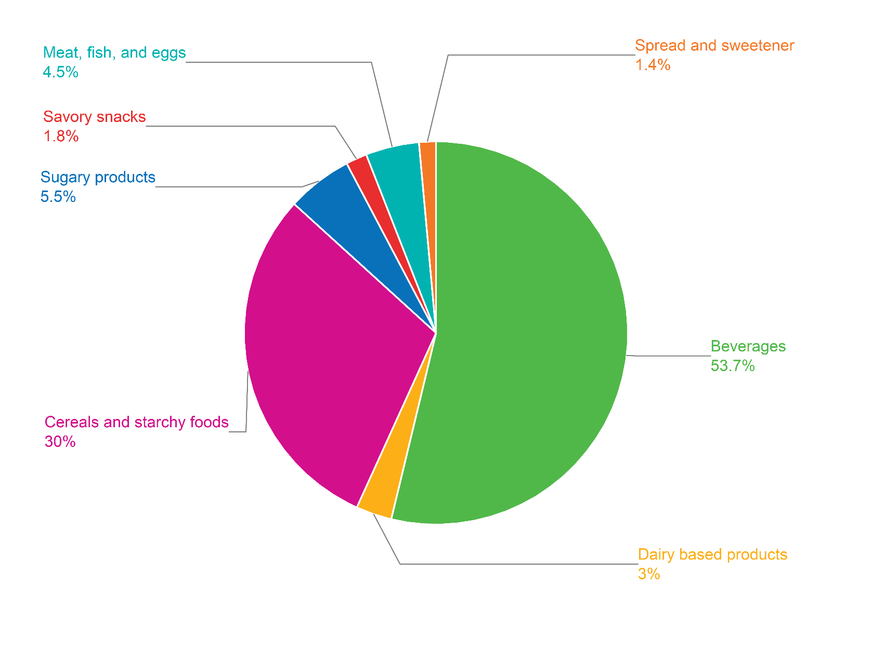
Supplementary Figure 2. Relative contribution (%) of each food subgroup to consumption of ultra-processed foods in the diet.

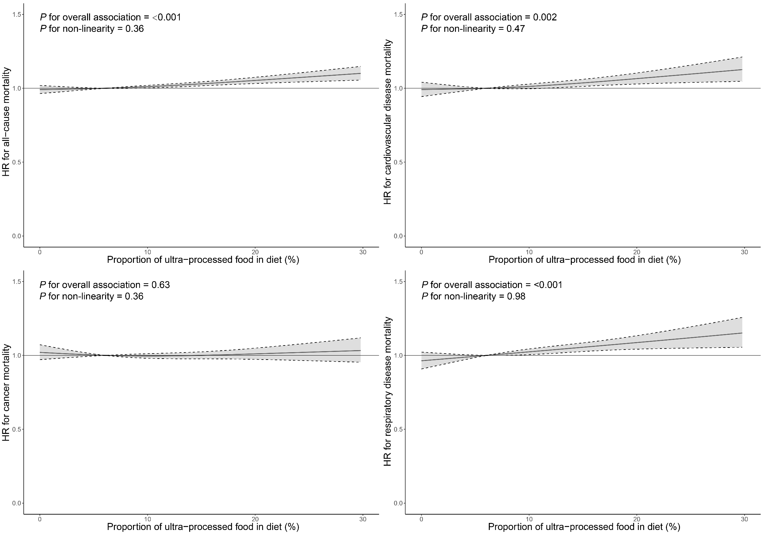
Supplementary Figure 3. Restricted cubic spline analysis of ultra-processed food consumption with all-cause mortality, cardiovascular disease mortality, cancer mortality, and respiratory disease mortality in the Singapore Chinese Health Study.
HRs with 95% confidence intervals (CIs) were calculated based on the multivariable model adjusted for age (continuous), sex (male or female), total energy intake (continuous), dialect group (Cantonese or Hokkien), educational level (no formal education, primary school, or secondary school or higher), body mass index (<18.5, 18.5-22.9, 23.0-27.4, 27.5+ kg/m²), smoking status (never, former, or current), alcohol frequency (none, monthly, weekly, or daily), physical activity (<0.5 h/wk, 0.5-3.9 h/wk, or ≥4 h/wk), sleep duration (<6 h/d, 6-8 h/d, or >8 h/d), history of hypertension (yes/no), history of diabetes (yes/no), history of cardiovascular disease (yes/no), and history of cancer (yes/no). The reference values for HRs were set as 6.1% (the median value of the proportion of ultra-processed food intake). Three knots were located at the 10th, 50th, and 90th percentiles of the exposure. The gray zones indicated 95% CIs.

