Supplemental Content
Supplementary Methods
Supplementary Table S1. Methods for evaluating each CKM stage.
Supplementary Table S2. Baseline Characteristics of Participants According to CKM Syndrome Stages.
Supplementary Table S3. Data Distribution Characteristics of Dietary Patterns Derived from DII and HEI Cluster Analysis.
Supplementary Figure S1. Flow Chart of the Study Population.
Supplementary Figure S2. Determination of the Optimal Number of Clusters (k) using the Elbow Method.
Supplementary Figure S3. Forest Plots for the Subgroup Analysis of the Associations Between DII, HEI, and Advanced CKM Syndrome Stage.
Supplementary Figure S4. Kaplan-Meier Survival Curves for All-Cause Mortality Outcomes Across Dietary Patterns in Advanced CKM Syndrome Stages.
Supplementary Figure S5. Forest Plots for the Subgroup Analysis of the Associations Between DII, HEI, and All-Cause Mortality in Advanced CKM Syndrome Stages.
Supplementary Figure S6. Mediation Effects of Inflammatory Markers on the Associations of DII, HEI with Advanced CKM Syndrome Stage.
Supplementary Figure S7. Mediation Effects of Inflammatory Markers on the Associations of DII, HEI with All-Cause Mortality in Advanced CKM Syndrome Stages.

Supplementary Methods
Survey Design and Weighting Strategy
All weighted analyses were performed using the survey package in R software (version 4.3.2) to appropriately account for the complex survey design of the NHANES, ensuring the findings are nationally representative.
The survey design elements defined for the analysis included strata, identified by the sdmvstra variable, and primary sampling units (PSUs), identified by the sdmvpsu variable. Following the NHANES analytical guidelines for combining multiple survey cycles, the final composite weight for this analysis was constructed. As the primary exposures in this study (DII and HEI) are derived from dietary data, the 2-year dietary interview weight (wtdrd1) was selected as the base weight. For the analysis spanning 11 survey cycles (1999–2020), an eleven-cycle composite weight was constructed for subsequent analyses. The design also accounted for the nested structure of strata across survey cycles.

Supplementary Table S1. Methods for evaluating each CKM stage.
Stage 0 | - Normal BMI (<23 kg/m² for Asians; <25 kg/m² for other groups)  - Normal waist circumference (<80 cm for Asian women; <90 cm for Asian men; <88 cm for other women; <102 cm for other men)  - No criteria met for other stages
Stage 1 | Individuals with any of the following:  - Elevated BMI (≥23 kg/m² for Asians; ≥25 kg/m² for others)  - Elevated waist circumference (≥80 cm for Asian women; ≥90 cm for Asian men; ≥88 cm for other women; ≥102 cm for other men)  - Prediabetes (glycohemoglobin 5.7%–6.4% or fasting glucose 100–125 mg/dL)
Stage 2 | Individuals with moderate-to-high-risk CKD (per KDIGO criteria) or metabolic risk factors.  Metabolic risk factors include elevated fasting triglycerides (≥135 mg/dL), hypertension, diabetes, or metabolic syndrome (≥3 of the following: elevated waist circumference, low HDL [<40 mg/dL for men, <50 mg/dL for women], fasting triglycerides ≥150 mg/dL, elevated blood pressure [systolic ≥130 mmHg, diastolic ≥80 mmHg, or antihypertensive use], or prediabetes).
Stage 3 | Individuals with:  - Very-high-risk CKD (per KDIGO criteria)  - High-predicted 10-year cardiovascular risk (≥20%), estimated using the AHA PREVENT equations:
Stage 4 | Individuals with self-reported, established cardiovascular disease, including any of the following: coronary heart disease, angina, heart attack, heart failure, or stroke.
Note: BMI, body mass index; CKD, chronic kidney disease; HDL, high-density lipoprotein cholesterol; AHA, American Heart Association.

Supplementary Table S2. Baseline Characteristics of Participants According to CKM Syndrome Stages.
Characteristics | Stage 0 | Stage 1 | Stage 2 | Stage 3 | Stage 4 | P
No. of participants | 1665 | 4539 | 9135 | 1833 | 2570
Age,years | 43.00(36.00,53.00) | 46.00(37.00,57.00) | 51.00(42.00,60.00) | 78.00(73.00,80.00) | 66.00(57.00,75.00) | <.001
Sex, n(%) |  |  |  |  |  | <.001
Female | 1058 (63.54) | 2299 (50.65) | 4637 (50.76) | 834 (45.50) | 1086 (42.26)
Male | 607 (36.46) | 2240 (49.35) | 4498 (49.24) | 999 (54.50) | 1484 (57.74)
Race, n(%) |  |  |  |  |  | <.001
Mexican American | 153 (9.19) | 760 (16.74) | 1788 (19.57) | 244 (13.31) | 283 (11.01)
Non-Hispanic Black | 261 (15.68) | 1030 (22.69) | 1754 (19.20) | 365 (19.91) | 543 (21.13)
Non-Hispanic White | 914 (54.89) | 1867 (41.13) | 3838 (42.01) | 1000 (54.56) | 1420 (55.25)
Other Hispanic | 105 (6.31) | 423 (9.32) | 904 (9.90) | 124 (6.76) | 176 (6.85)
Other Race | 232 (13.93) | 459 (10.11) | 851 (9.32) | 100 (5.46) | 148 (5.76)
BMI,kg/m² | 22.35(20.70,23.60) | 27.00(25.10,30.00) | 30.10(26.70,34.40) | 27.90(24.67,31.60) | 29.00(25.49,33.64) | <.001
WC,cm | 80.40(75.80, 85.20) | 95.00(88.20,102.00) | 103.80(94.90,113.70) | 101.70(93.10,111.70) | 103.70(94.40,115.00) | <.001
Education n(%) |  |  |  |  |  | <.001
Less than high school | 193 (12.13) | 738 (17.09) | 1736 (20.69) | 385 (24.62) | 614 (26.59)
More than high school | 1398 (87.87) | 3581 (82.91) | 6655 (79.31) | 1179 (75.38) | 1695 (73.41)
Marital, n(%) |  |  |  |  |  | <.001
Married/Living with Partner | 1132 (68.81) | 3055 (67.72) | 6024 (66.58) | 962 (52.92) | 1497 (58.57)
Never married/Widowed/Divorced/Separated | 513 (31.19) | 1456 (32.28) | 3024 (33.42) | 856 (47.08) | 1059 (41.43)
PIR, n(%) |  |  |  |  |  | <.001
Low | 183 (11.99) | 659 (15.95) | 1530 (18.39) | 324 (19.73) | 473 (20.21)
Middle | 705 (46.20) | 2060 (49.87) | 4433 (53.29) | 1019 (62.06) | 1395 (59.59)
High | 638 (41.81) | 1412 (34.18) | 2356 (28.32) | 299 (18.21) | 473 (20.21)
Smoking, n(%) |  |  |  |  |  | <.001
Never | 949 (57.00) | 2625 (57.83) | 4786 (52.39) | 875 (47.74) | 974 (37.90)
Former | 304 (18.26) | 1048 (23.09) | 2430 (26.60) | 731 (39.88) | 1043 (40.58)
Now | 412 (24.74) | 866 (19.08) | 1919 (21.01) | 227 (12.38) | 553 (21.52)
Drinking, n(%) |  |  |  |  |  | <.001
Never | 163 (10.60) | 482 (11.50) | 1095 (13.11) | 337 (20.51) | 302 (13.33)
Former | 155 (10.08) | 513 (12.24) | 1348 (16.13) | 468 (28.48) | 655 (28.92)
Mild | 650 (42.26) | 1659 (39.59) | 2907 (34.79) | 645 (39.26) | 832 (36.73)
Moderate | 297 (19.31) | 767 (18.31) | 1306 (15.63) | 103 (6.27) | 214 (9.45)
Heavy | 273 (17.75) | 769 (18.35) | 1699 (20.34) | 90 (5.48) | 262 (11.57)
Hypertension, n(%) |  |  |  |  |  | <.001
No | 1388 (83.36) | 3428 (75.52) | 4622 (50.60) | 396 (21.60) | 610 (23.74)
Yes | 277 (16.64) | 1111 (24.48) | 4513 (49.40) | 1437 (78.40) | 1960 (76.26)
DM, n(%) |  |  |  |  |  | <.001
No | 1665 (100.00) | 4539 (100.00) | 6618 (72.45) | 1018 (55.54) | 1471 (57.24)
Yes | 0 (0.00) | 0 (0.00) | 2517 (27.55) | 815 (44.46) | 1099 (42.76)
CVD, n(%) |  |  |  |  |  | <.001
No | 1665 (100.00) | 4539 (100.00) | 9135 (100.00) | 1833 (100.00) | 0 (0.00)
Yes | 0 (0.00) | 0 (0.00) | 0 (0.00) | 0 (0.00) | 2570 (100.00)
Malignancy, n(%)
No | 1546(91.43) | 4223(91.31) | 8362(90.44) | 1394(72.92) | 2047(79.09)
Yes | 118( 8.57) | 316( 8.69) | 765( 9.56) | 437(27.08) | 517(20.91)
Energy intake,kcal | 976.00(1508.00,2570.00) | 2076.00(1581.00,2740.00) | 2052.00(1507.00,2672.00) | 1683.00(1241.00,2184.00) | 1801.00(1328.00,2333.00) | <.001
PA,MET-min/week | 1020.13(360.00,2940.00) | 1680.00(504.00,4320.00) | 1225.00(472.50,3600.00) | 960.00(360.00,3024.00) | 1225.00(480.00,3360.00) | <.001
SBP,mmHg | 114.00(106.00,124.00) | 120.00(112.00,128.00) | 126.00(118.00,138.00) | 144.00(130.00,162.00) | 132.00(118.00,145.00) | <.001
DBP,mmHg | 70.00(66.00,78.00) | 74.00(68.00,78.00) | 78.00(70.00,84.00) | 68.00(60.00,78.00) | 72.00(63.00,80.00) | <.001
Glucose,mg/dl | 91.00(86.30, 95.00) | 98.00(92.00,104.00) | 104.00(96.90,114.00) | 110.00(99.00,130.00) | 107.00(97.00,126.00) | <.001
HbA1c | 5.20(5.00,5.40) | 5.40(5.10,5.60) | 5.60(5.30,5.90) | 5.80(5.50,6.50) | 5.70(5.40,6.30) | <.001
TC,mg/dl | 189.00(167.00,212.00) | 195.00(171.00,220.00) | 204.00(177.00,234.00) | 186.00(161.00,215.00) | 180.00(153.00,211.00) | <.001
TG,mg/dl | 71.00( 54.00, 91.00) | 83.00( 63.00,105.00) | 151.00(106.00,202.00) | 121.00( 86.00,167.00) | 123.00( 86.00,182.00) | <.001
HDL,mg/dl | 65.00(54.00,76.00) | 57.00(49.00,67.00) | 46.00(39.00,56.00) | 50.00(42.00,62.00) | 48.00(40.00,59.00) | <.001
Creatinine,mg/dl | 0.80(0.70,0.90) | 0.84(0.70,0.98) | 0.82(0.70,0.99) | 0.99(0.80,1.20) | 0.94(0.80,1.12) | <.001
eGFR,ml/min/1.73m² | 101.18(89.09,112.04) | 98.29(86.58,109.77) | 97.58(84.24,108.14) | 69.22(54.78, 85.10) | 81.64(63.04, 95.29) | <.001
UACR,mg/g | 5.74(4.08, 8.79) | 5.28(3.82, 7.87) | 6.63(4.44,12.64) | 19.77(9.39,58.08) | 10.35(5.85,26.64) | <.001
DII | 1.22(-0.24,2.54) | 1.37(-0.24,2.75) | 1.65( 0.10,2.91) | 1.83( 0.44,3.05) | 1.92( 0.49,3.15) | <.001
HEI | 52.94(43.11,62.85) | 51.25(41.79,61.23) | 49.30(40.52,59.08) | 53.21(43.72,63.30) | 50.16(40.37,60.87) | <.001
Note: CKM, cardiovascular-kidney-metabolic; BMI, body mass index; WC, waist circumference; PIR, poverty income ratio; DM, diabetes mellitus; CVD, cardiovascular disease; PA, physical activity; SBP, systolic blood pressure; DBP, diastolic blood pressure; TC, total cholesterol; TG, triglycerides; HDL, high-density lipoprotein cholesterol; eGFR, estimated glomerular filtration rate; UACR, urine albumin-to-creatinine ratio; DII, dietary inflammatory index; HEI, healthy eating index.

Supplementary Table S3. Data Distribution Characteristics of Dietary Patterns Derived from DII and HEI Cluster Analysis.
Dietary Pattern | Statistic | DII | HEI
A: Anti-inflammatory High-Quality Diet | N | 3673 | 3673
 | Mean | -0.88 | 69.11
 | SD | 1.21 | 8.27
 | Min | -4.68 | 50.81
 | Max | 2.08 | 95.89
 | Median | -0.76 | 67.94
 | P25 | -1.72 | 62.53
 | P75 | 0.05 | 74.61
 | IQR | 1.77 | 12.08
 | SE | 0.02 | 0.14
 | 95% CI | -0.92 - -0.84 | 68.85 - 69.38
B: Balanced Mid-Quality Diet | N | 4270 | 4270
 | Mean | 0.16 | 47.18
 | SD | 0.99 | 6.95
 | Min | -3.78 | 20.67
 | Max | 1.84 | 60.11
 | Median | 0.33 | 47.86
 | P25 | -0.44 | 42.9
 | P75 | 0.89 | 52.49
 | IQR | 1.33 | 9.6
 | SE | 0.01 | 0.11
 | 95% CI | 0.13 - 0.19 | 46.97 - 47.38
C: Pro-inflammatory Mid-Quality Diet | N | 5335 | 5335
 | Mean | 2.28 | 58.23
 | SD | 0.85 | 7.16
 | Min | 0.5 | 46.22
 | Max | 4.69 | 88.55
 | Median | 2.22 | 56.98
 | P25 | 1.64 | 52.63
 | P75 | 2.87 | 62.6
 | IQR | 1.24 | 9.96
 | SE | 0.01 | 0.1
 | 95% CI | 2.25 - 2.30 | 58.03 - 58.42
D: Pro-inflammatory Low-Quality Diet | N | 6464 | 6464
 | Mean | 3.14 | 37.83
 | SD | 0.84 | 7.05
 | Min | 0.69 | 0
 | Max | 5.47 | 51.92
 | Median | 3.17 | 38.64
 | P25 | 2.51 | 33.06
 | P75 | 3.79 | 43.38
 | IQR | 1.28 | 10.32
 | SE | 0.01 | 0.09
 | 95% CI | 3.12 - 3.16 | 37.66 - 38.00

Supplementary Figure S1. Flow Chart of the Study Population.
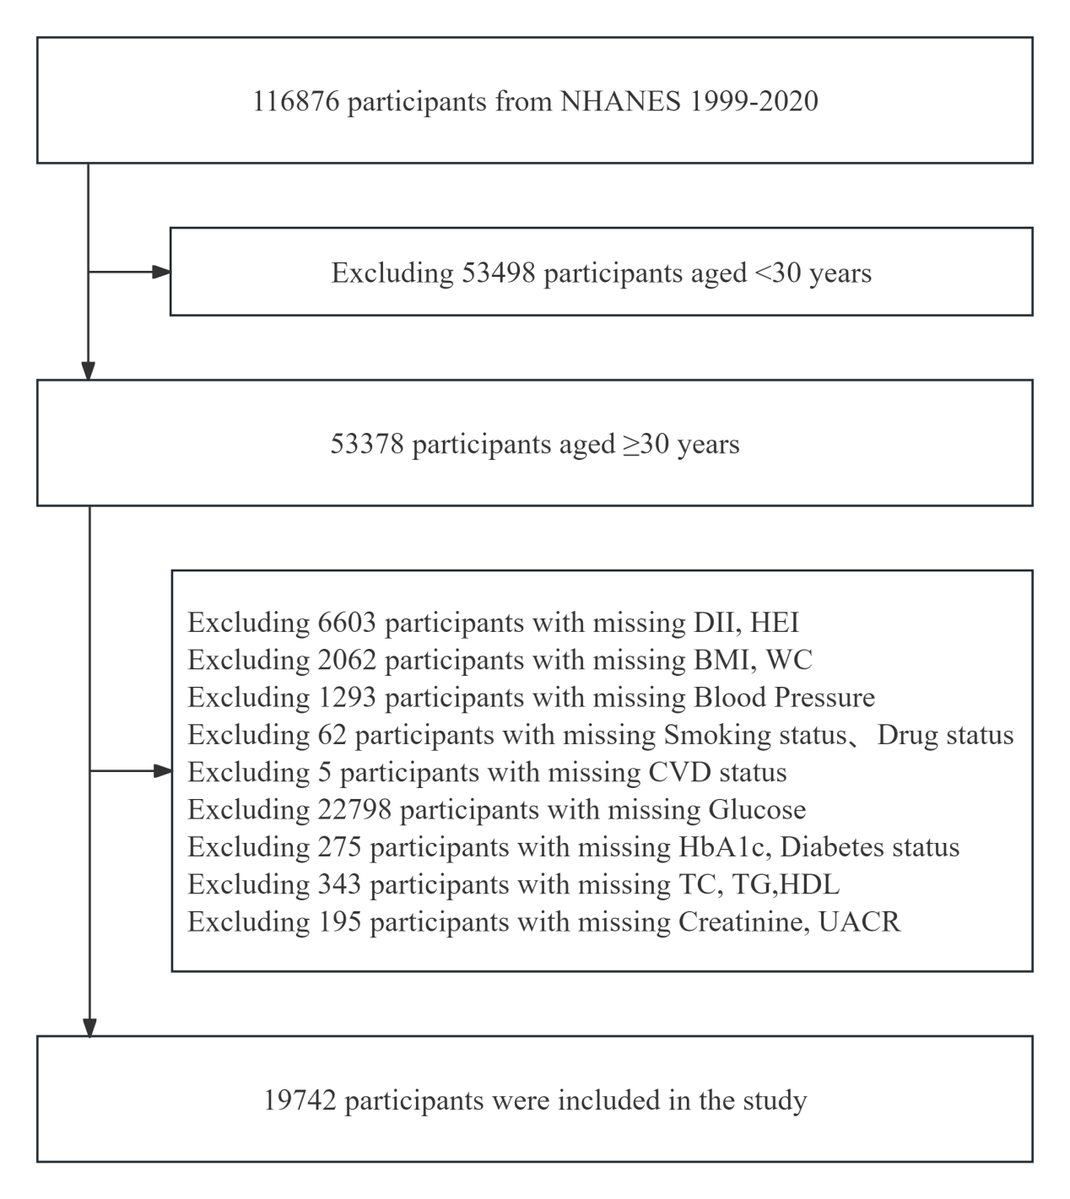
Note: BMI, body mass index; WC, waist circumference; CVD, cardiovascular disease; TC, total cholesterol; TG, triglycerides; HDL, high-density lipoprotein cholesterol; UACR, urine albumin-to-creatinine ratio; DII, dietary inflammatory index; HEI, healthy eating index.

Supplementary Figure S2. Determination of the Optimal Number of Clusters (k) using the Elbow Method.
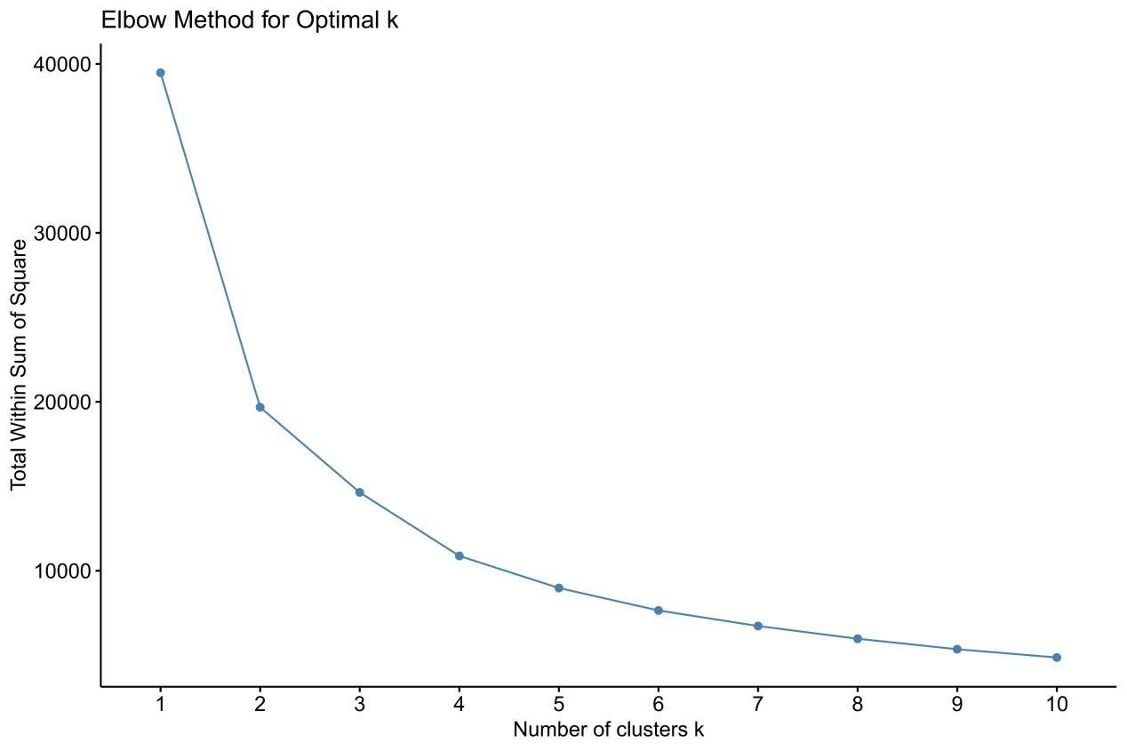
Supplementary Figure S3. Forest Plots for the Subgroup Analysis of the Associations Between DII, HEI, and Advanced CKM Syndrome Stage.
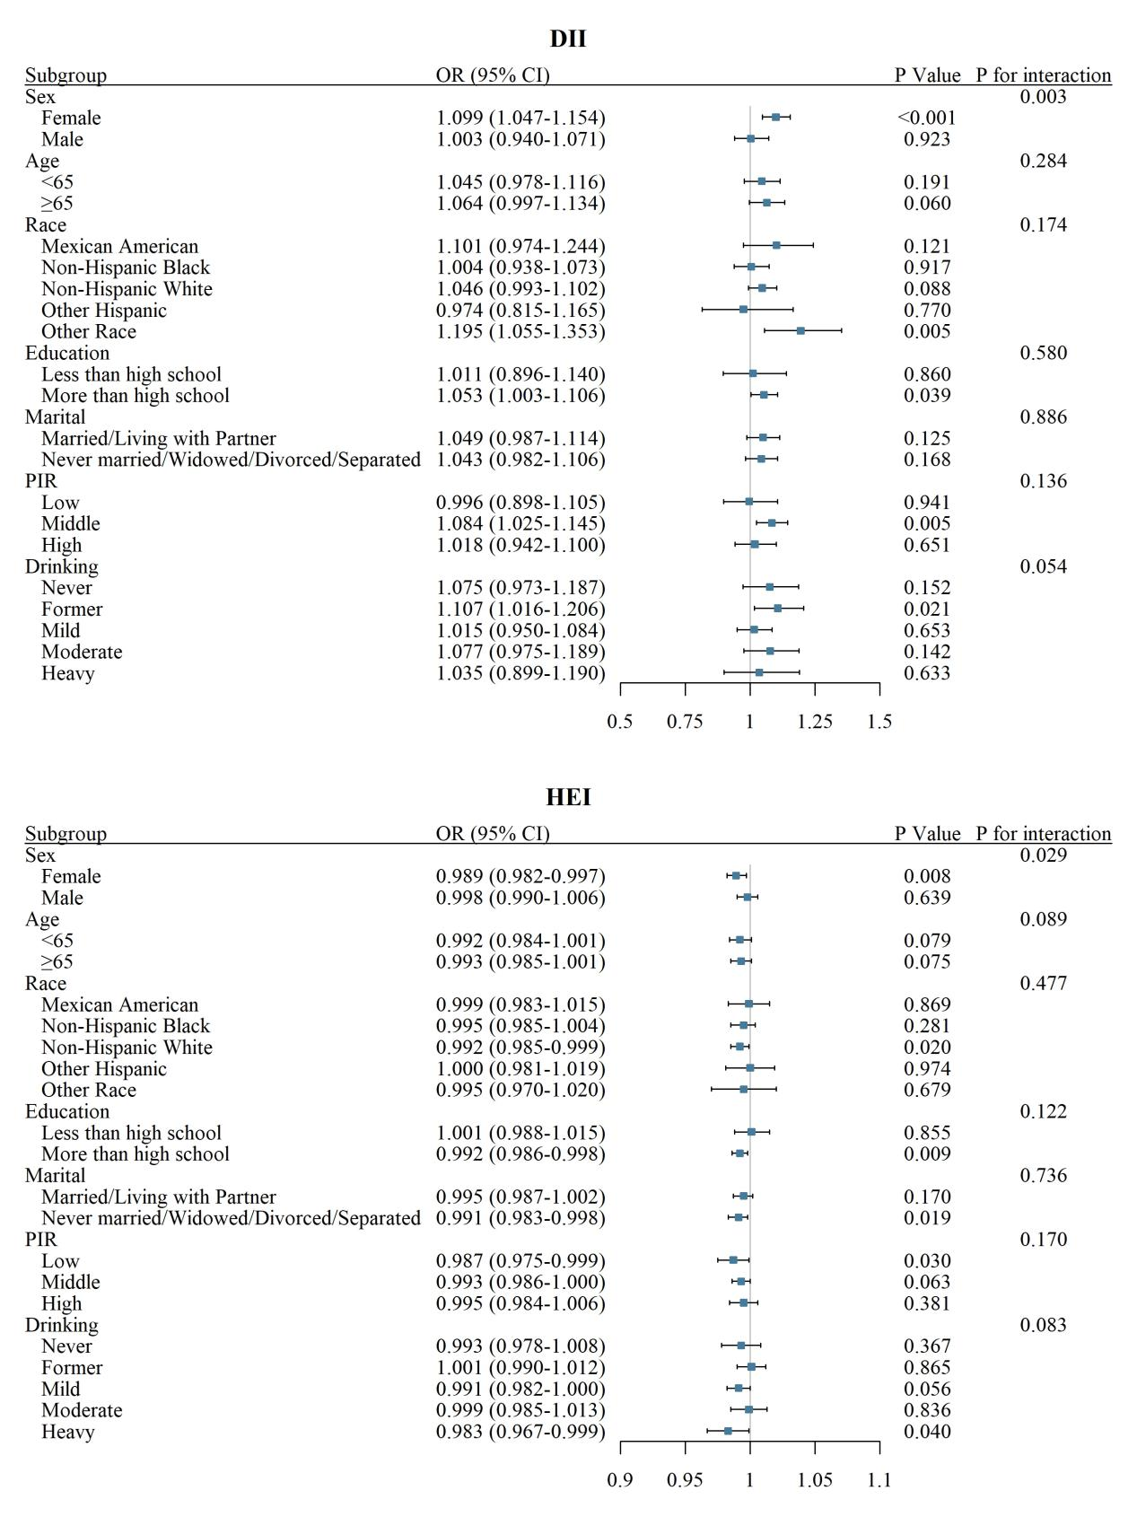
Note: The blue squares represent the ORs, and the horizontal lines indicate the 95% CIs. A reference line (OR = 1) is included for comparison. The arrows indicate that the 95%CIs exceed the plot limit.

Supplementary Figure S4. Kaplan-Meier Survival Curves for All-Cause Mortality Outcomes Across Dietary Patterns in Advanced CKM Syndrome Stages.
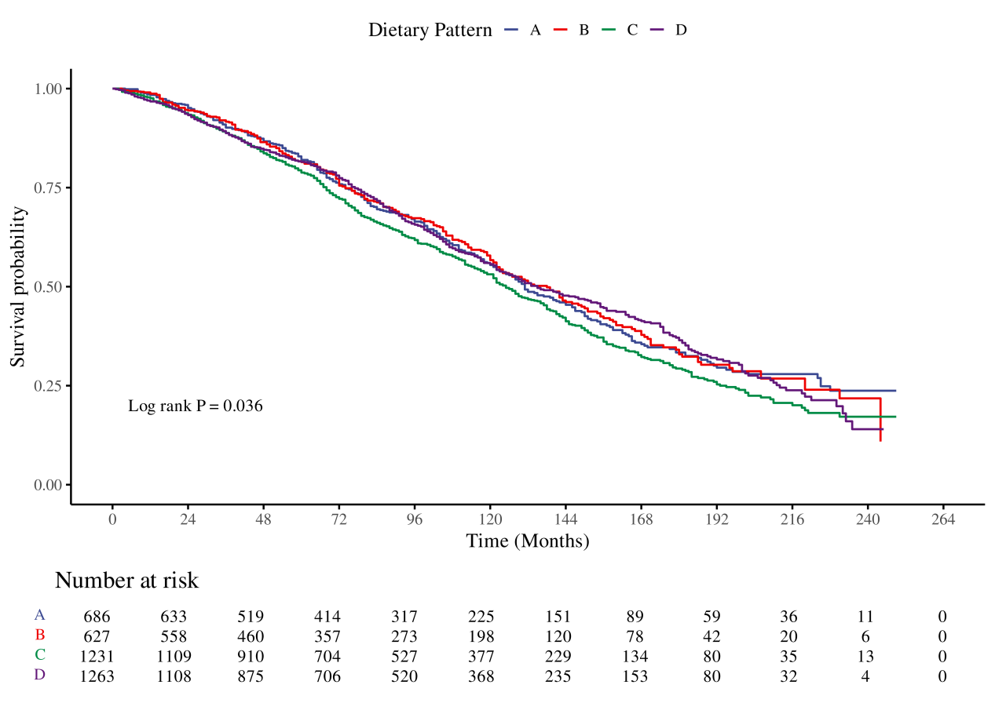

Supplementary Figure S5. Forest Plots for the Subgroup Analysis of the Associations Between DII, HEI, and All-Cause Mortality in Advanced CKM Syndrome Stages.
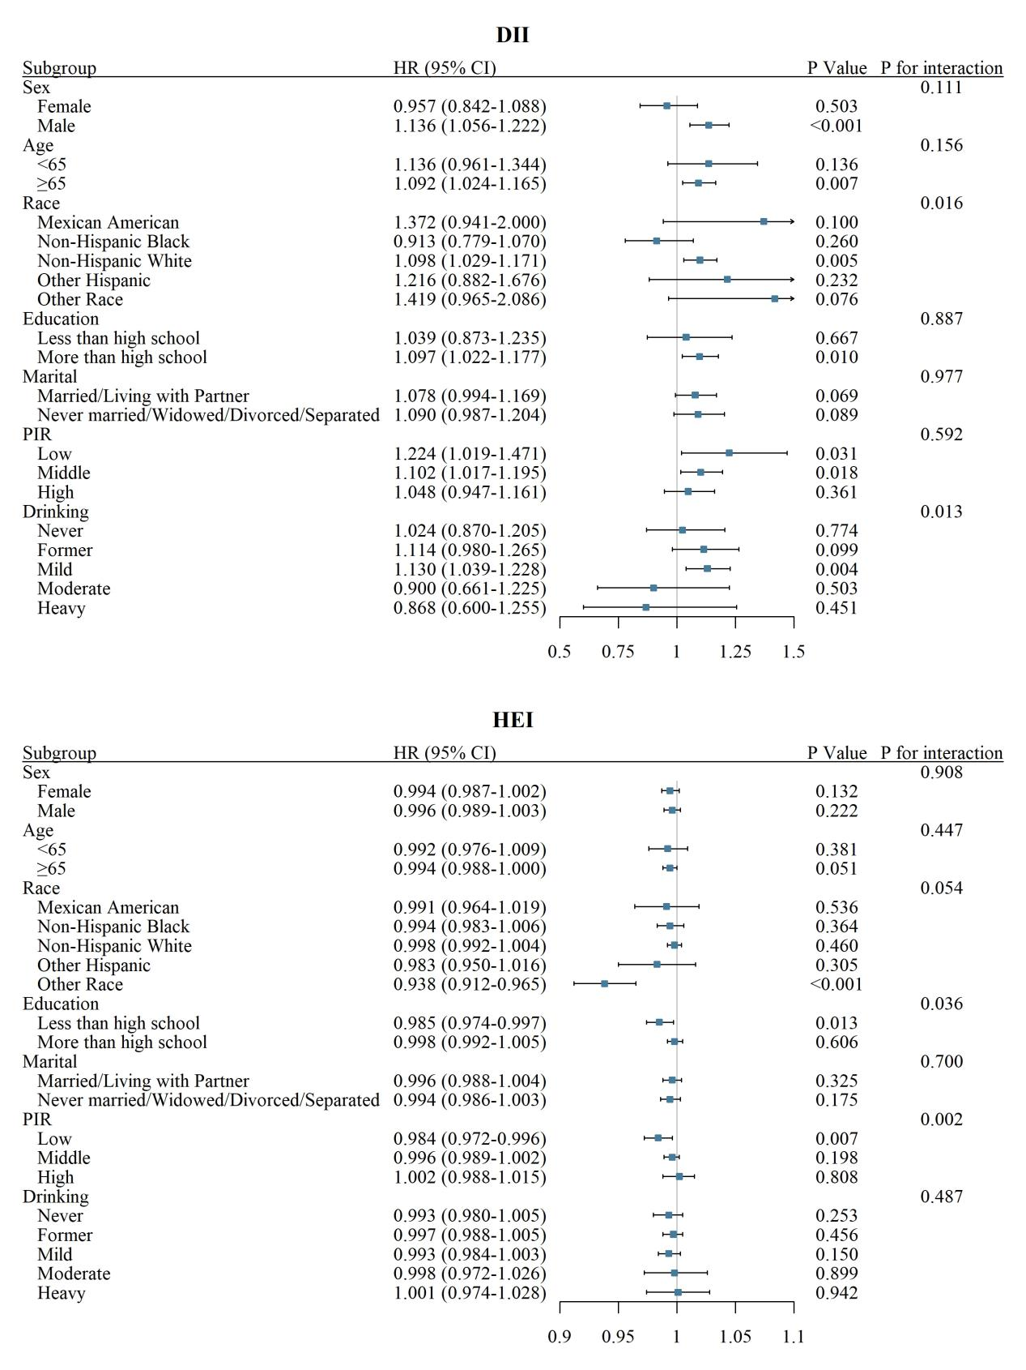
Note: The blue squares represent the HRs, and the horizontal lines indicate the 95% CIs. A reference line (HR = 1) is included for comparison. The arrows indicate that the 95%CIs exceed the plot limit.

Supplementary Figure S6. Mediation Effects of Inflammatory Markers on the Associations of DII, HEI with Advanced CKM Syndrome Stage.
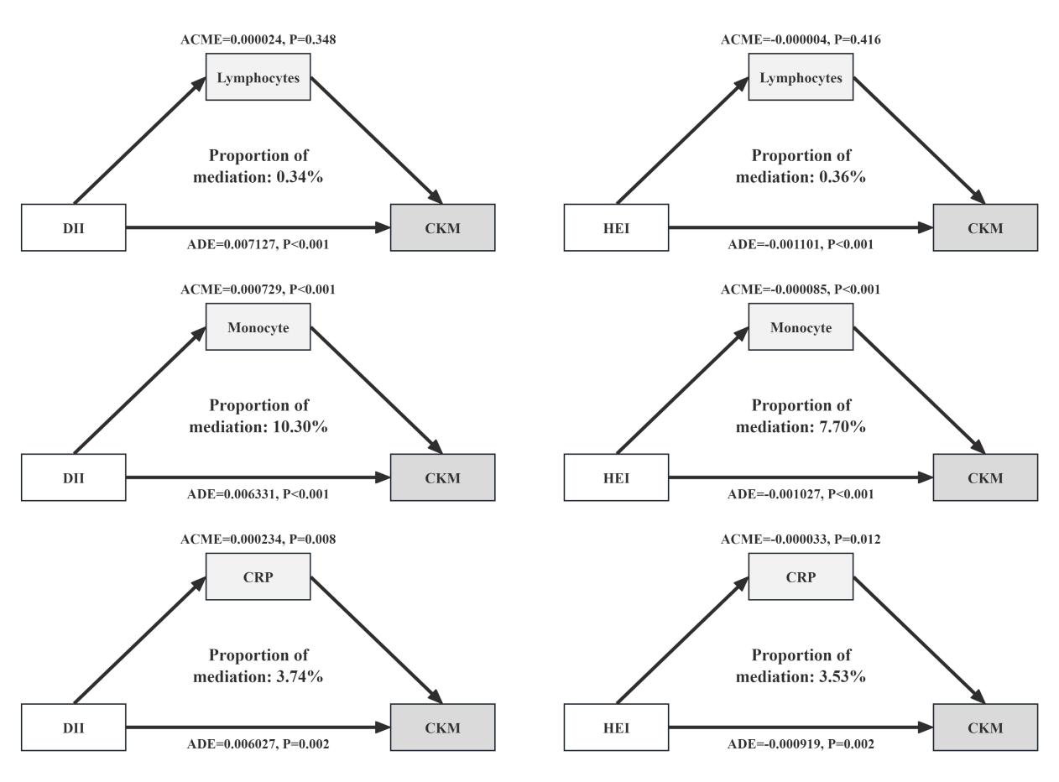
Note: Arrows indicate the direction of effects, and mediation is represented by the proportion of the total effect explained by the mediator. ACME represents the average causal mediation effects, and ADE represents the average direct effects.

Supplementary Figure S7. Mediation Effects of Inflammatory Markers on the Associations of DII, HEI with All-Cause Mortality in Advanced CKM Syndrome Stages.
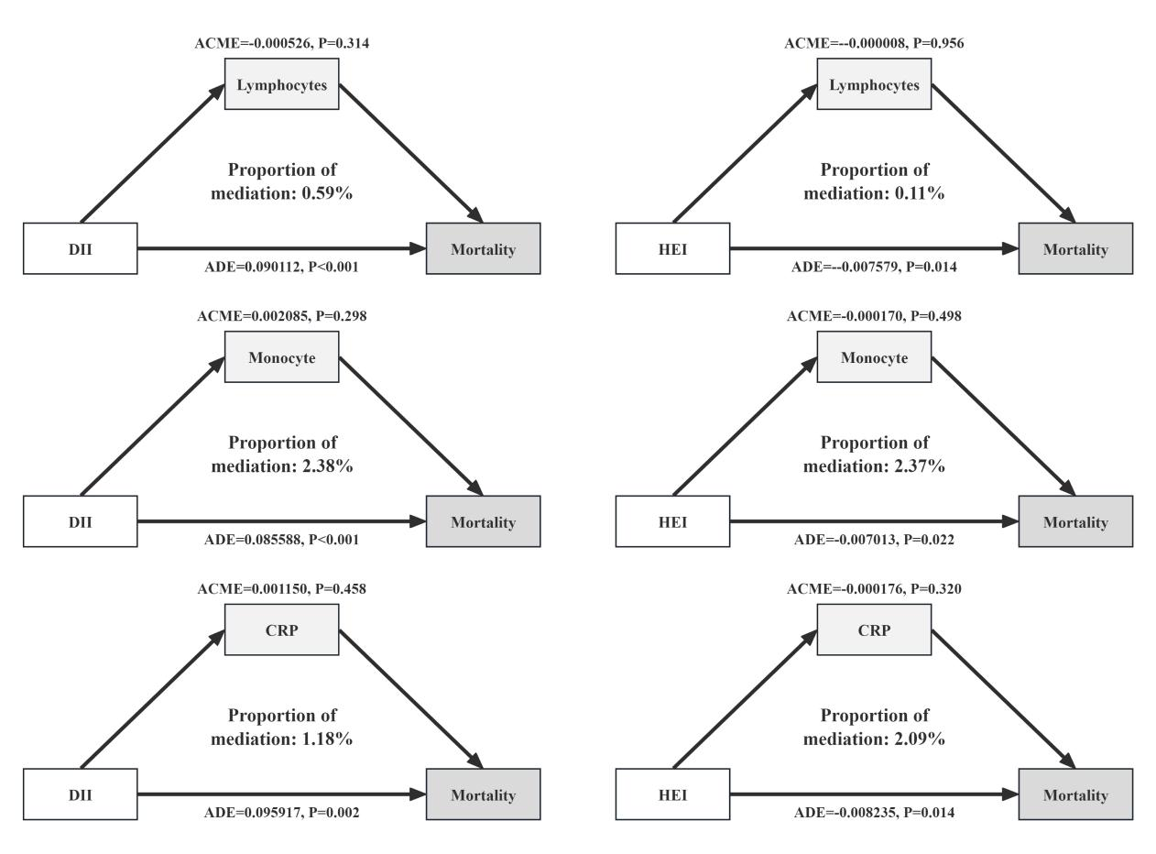
Note: Arrows indicate the direction of effects, and mediation is represented by the proportion of the total effect explained by the mediator. ACME represents the average causal mediation effects, and ADE represents the average direct effects.

