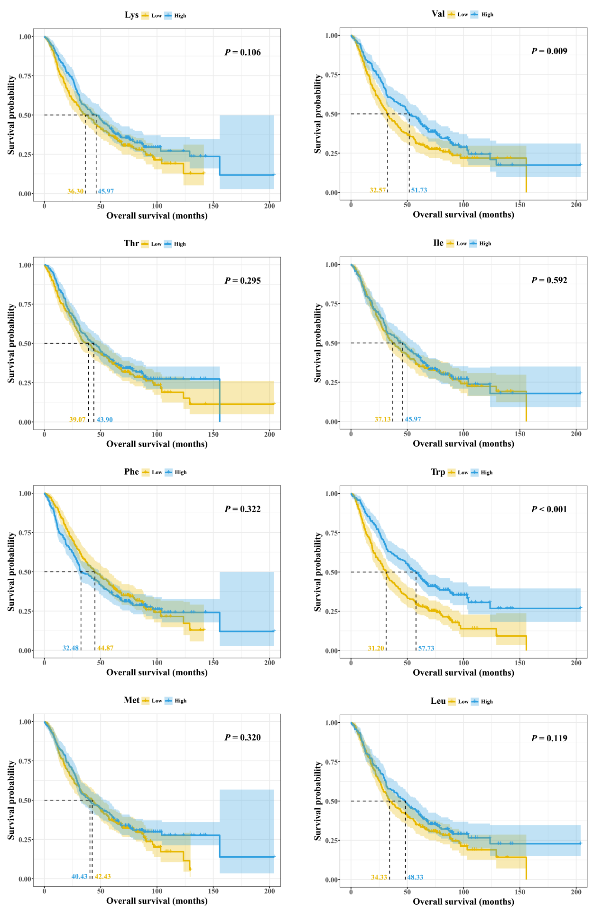
Figure S1. Kaplan-Meier survival analyses of OS for NSCLC patients with different levels of EAAs.

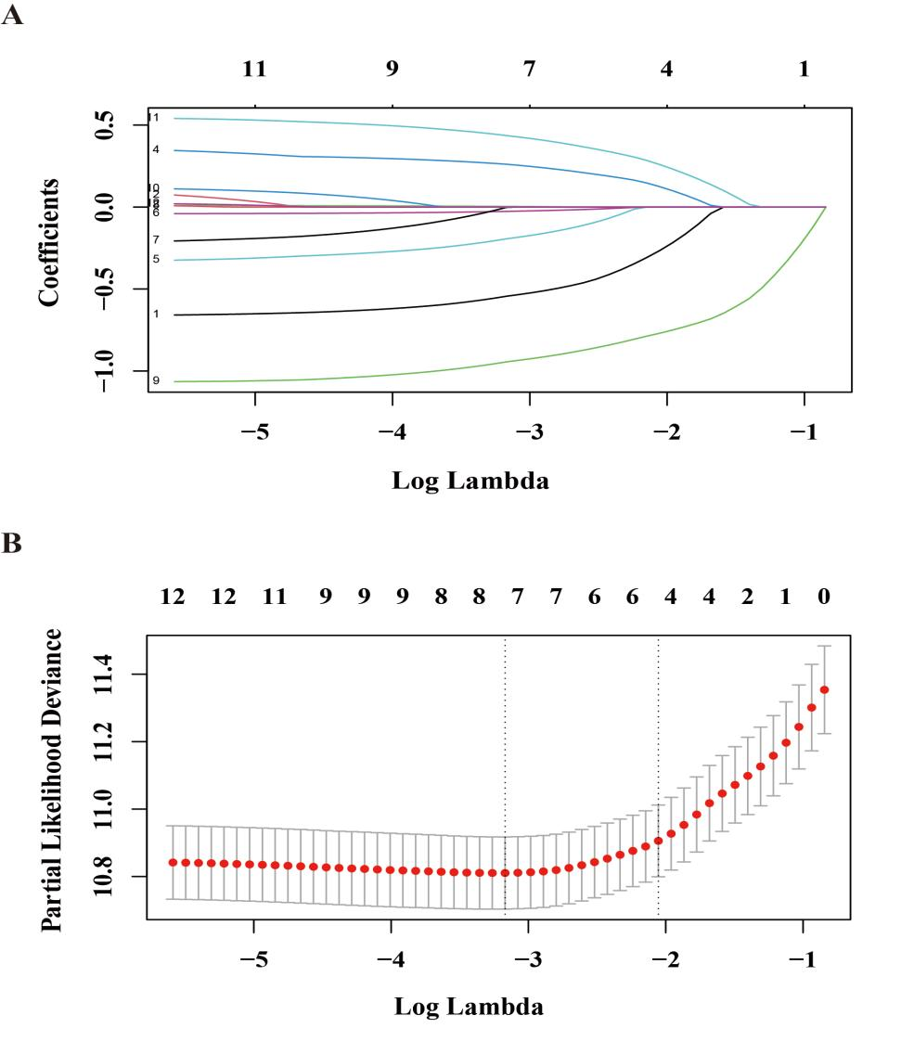
Figure S2. Presentation of the results of the LASSO regression analysis: (A) LASSO regression model screening variable trajectories; (B) LASSO regression model factor selection: left dashed line represents the optimal lambda value (lambda·min), while the right dashed line marks the lambda value within one standard error of the optimal (lambda.1se)

Table S1. EAA levels of patients with different survival outcomes (alive or dead).
EAAs | Total | Alive | Dead | P value
Lys | 182.79±44.06 | 188.00±40.40 | 180.67±45.36 | 0.0301
Val | 235.29±58.72 | 245.58±48.70 | 231.10±61.92 | 0.0018
Thr | 110.06±32.14 | 113.36±32.56 | 108.72±31.93 | 0.1860
Ile | 72.83±19.30 | 72.43±15.89 | 72.99±20.54 | 0.8789
Phe | 66.44±17.37 | 65.25±12.84 | 66.92±18.90 | 0.6826
Trp | 45.55±10.31 | 49.24±8.39 | 44.05±10.65 | <0.0001
Met | 25.71±8.72 | 26.12±6.63 | 25.54±9.44 | 0.1161
Leu | 126.80±31.93 | 129.68±25.65 | 125.63±34.12 | 0.0530
Total EAAs | 865.47±175.43 | 889.66±141.74 | 855.63±186.72 | 0.0090
P values were calculated using Wilcoxon tests.

Table S2. Association between EAA levels and the risk of death from NSCLC with all the EAAs included.
EAAs | HR (95%CI)
EAAs | Quartile 1 | Quartile 2 | Quartile 3 | Quartile 4 | Per SD increase
Lys | Ref | 0.94 (0.65-1.36) | 0.96 (0.65-1.40) | 0.74 (0.46-1.21) | 0.97 (0.81-1.16)
Val | Ref | 0.59 (0.37-0.93) | 0.66 (0.37-1.17) | 0.56 (0.29-1.09) | 0.89 (0.68-1.16)
Thr | Ref | 0.96 (0.68-1.36) | 0.86 (0.59-1.25) | 0.70 (0.46-1.06) | 0.92 (0.78-1.07)
Ile | Ref | 1.29 (0.85-1.95) | 1.43 (0.87-2.36) | 1.97 (1.12-3.50) | 1.38 (1.08-1.76)
Phe | Ref | 1.02 (0.69-1.50) | 1.37 (0.90-2.10) | 1.89 (1.15-3.08) | 1.35 (1.12-1.62)
Trp | Ref | 0.80 (0.57-1.13) | 0.86 (0.59-1.26) | 0.53 (0.34-0.81) | 0.74 (0.64-0.86)
Met | Ref | 0.75 (0.52-1.09) | 0.79 (0.53-1.18) | 0.84 (0.51-1.38) | 0.91 (0.73-1.15)
Leu | Ref | 1.00 (0.64-1.56) | 0.94 (0.53-1.67) | 0.75 (0.36-1.55) | 0.77 (0.56-1.07)
Models were adjusted for all essential amino acids, age, sex, BMI, family history of cancer, smoking status, drinking status, tumor type, cancer stage, and treatment (surgery, chemotherapy and radiotherapy).
The levels of all EAAs were transformed using a natural logarithmic scale before the analysis.
Abbreviation: BMI, body mass index; CI, confidence interval; EAAs, essential amino acids; HR, hazard ratio; NSCLC, non-small cell lung cancer.

Table S3. Association between Kyn levels and the risk of death in NSCLC patients.
Kyn | HR (95%CI)
Kyn | Quartile 1 | Quartile 2 | Quartile 3 | Quartile 4 | Per SD increase
Overall | Ref | 1.00 (0.71-1.41) | 1.10 (0.78-1.56) | 1.17 (0.84-1.63) | 1.10 (0.97-1.25)
Ⅰ-Ⅲ | Ref | 0.50 (0.25-1.00) | 0.64 (0.32-1.27) | 1.04 (0.54-2.01) | 1.06 (0.83-1.36)
Ⅳ | Ref | 1.24 (0.82-1.88) | 1.30 (0.84-1.98) | 1.44 (0.95-2.19) | 1.20 (1.01-1.41)
Models were adjusted for age, sex, BMI, family history of cancer, smoking status, drinking status, tumor type, cancer stage, and treatment (surgery, chemotherapy and radiotherapy).
The levels of the Kyn were transformed using a natural logarithmic scale before the analysis.
Abbreviation: BMI, body mass index; CI, confidence interval; EAA, essential amino acid; HR, hazard ratio; Kyn, kynurenine; NSCLC, non-small cell lung cancer.

Table S4. Association between the Trp/Kyn Ratio and the risk of death in NSCLC patients.
Trp/Kyn | HR (95%CI)
Trp/Kyn | Quartile 1 | Quartile 2 | Quartile 3 | Quartile 4 | Per SD increase
Overall | Ref | 0.77 (0.56-1.05) | 0.63 (0.45-0.87) | 0.51 (0.36-0.72) | 0.75 (0.66-0.84)
Ⅰ-Ⅲ | Ref | 0.38 (0.19-0.76) | 0.70 (0.38-1.29) | 0.52 (0.25-1.08) | 0.81 (0.63-1.04)
Ⅳ | Ref | 0.70 (0.48-1.03) | 0.69 (0.46-1.02) | 0.35 (0.23-0.55) | 0.68 (0.59-0.80)
Models were adjusted for age, sex, BMI, family history of cancer, smoking status, drinking status, tumor type, cancer stage, and treatment (surgery, chemotherapy and radiotherapy).
The levels of the Trp/Kyn ratio were transformed using a natural logarithmic scale before the analysis.
Abbreviation: BMI, body mass index; CI, confidence interval; EAA, essential amino acid; HR, hazard ratio; Kyn, kynurenine; NSCLC, non-small cell lung cancer; Trp, tryptophan.

