Association between varying fermentation levels of tea and bone health in a community-based population

Supplementary material
Content
Table S1 Distribution of tea consumption types and frequencies by bone health status 1
Table S2 Distribution of missing data for variables included in logistic regression 2
Table S3 Baseline characteristics of the study participants according to sex* 3
Table S4 Sensitivity analysis of tea type and bone health by using full sample after multiple imputation (n=9,942) 6
Table S5 Sensitivity analysis of tea consumption frequency and bone health† by using full sample after multiple imputation (n=9,942) 7
Table S6 Association between tea consumption frequency and bone health† stratified by age group 9
Table S7 Association between tea consumption frequency and bone health† stratified by sex 10
Figure S1 Distribution of study sites across Guangdong province in the DLCC 12
Figure S2 Flow diagram indicating derivation of final analyzed study sample 13

Table S1 Distribution of tea consumption types and frequencies by bone health status
Variables | Bone health
Variables | Normal | Osteopenia | Osteoporosis
Tea type, n(%)
Green tea | 989 (30.5) | 18 (22.5) | 216 (26.9)
Oolong tea | 1579 (48.7) | 35 (43.8) | 414 (51.6)
Black tea | 409 (12.6) | 22 (27.5) | 111 (13.8)
Dark tea | 266 (8.2) | 5 (6.2) | 61 (7.6)
Frequency of green tea consumption, n(%)
5-7 days/week | 698 (70.6) | 11 (61.1) | 156 (72.2)
3-4 days/week | 125 (12.6) | 1 (5.6) | 21 (9.7)
1-2 days/week | 106 (10.7) | 2 (11.1) | 24 (11.1)
≤3 days/month | 60 (6.1) | 4 (22.2) | 15 (6.9)
Frequency of oolong tea consumption, n(%)
5-7 days/week | 1284 (81.3) | 28 (80.0) | 345 (83.3)
3-4 days/week | 166 (10.5) | 3 (8.6) | 42 (10.1)
1-2 days/week | 112 (7.1) | 4 (11.4) | 22 (5.3)
≤3 days/month | 17 (1.1) | 0 (0.0) | 5 (1.2)
Frequency of black tea consumption, n(%)
5-7 days/week | 240 (58.7) | 13 (59.1) | 63 (56.8)
3-4 days/week | 49 (12.0) | 5 (22.7) | 22 (19.8)
1-2 days/week | 78 (19.1) | 2 (9.1) | 21 (18.9)
≤3 days/month | 42 (10.3) | 2 (9.1) | 5 (4.5)
Frequency of dark tea consumption, n(%)
5-7 days/week | 153 (57.5) | 1 (20.0) | 43 (70.5)
3-4 days/week | 33 (12.4) | 4 (80.0) | 7 (11.5)
1-2 days/week | 44 (16.5) | 0 (0.0) | 9 (14.8)
≤3 days/month | 36 (13.5) | 0 (0.0) | 2 (3.3)

Table S2 Distribution of missing data for variables included in logistic regression
Missing variabales |  | Missing number of participants, n(%)
Marital status |  | 22(0.2)
Education |  | 22(0.2)
Body mass index |  | 79(0.8)
Diabetes |  | 1112(11.2)
History of fracture |  | 115(1.2)
Chronic kidney disease |  | 27(0.3)
Smoking status |  | 1(0.0)
Drinking status |  | 4(0.04)
Frequency of meat comsunption |  | 1(0.0)
Frequnency of dairy comsunption |  | 47(0.5)
Frequnency of vegetable comsunption |  | 4(0.04)
Frequnency of fruit comsunption |  | 12(0.1)
Work intensity |  | 6(0.06)

Table S3 Baseline characteristics of the study participants according to sex*
Variables | Men | Women | P-value
Variables | (N=2444) | (N=6046) | P-value
Age, year | 53.0 ± 13.2 | 50.8 ± 12.5 | <0.001
Marital status, no.(%) |  |  | <0.001
Unmarried | 132 (5.4) | 279 (4.6)
Married | 2227 (91.1) | 5136 (84.9)
Divorced or widowed | 85 (3.5) | 631 (10.4)
Education, no.(%) |  |  | <0.001
No formal school | 79 (3.2) | 720 (11.9)
Primary or middle school | 1068 (43.7) | 2751 (45.5)
High school | 586 (24.0) | 1171 (19.4)
College or above | 711 (29.1) | 1404 (23.2)
Hypertension, no.(%) | 503 (20.7) | 944 (15.6) | <0.001
Diabetes, no.(%) | 226 (9.2) | 417 (6.9) | <0.001
Chronic kidney disease | 140 (5.7) | 132 (2.2) | <0.001
History of fracture, no.(%) | 413 (16.9) | 662 (10.9) | <0.001
History of tumor, no.(%) | 30 (1.2) | 200 (3.3) | <0.001
Body mass index | 24.1 ± 3.3 | 23.7 ± 3.5 | <0.001
Body mass index, no.(%) |  |  | <0.001
Normal weight/low weight | 934 (38.2) | 2717 (44.9)
Overweight | 1160 (47.5) | 2504 (41.4)
Obesity | 350 (14.3) | 825 (13.6)
Bone health, no.(%) |  |  | <0.001
Normal | 1756 (71.8) | 4922 (81.4)
Osteopenia | 59 (2.4) | 175 (2.9)
Osteoporosis | 629 (25.7) | 949 (15.7)
Smoking status, no.(%) |  |  | <0.001
Never | 1014 (41.5) | 6009 (99.4)
Ever | 295 (12.1) | 11 (0.2)
Current | 1135 (46.4) | 26 (0.4)
Drinking status, no.(%) |  |  | <0.001
Never | 1233 (50.5) | 5677 (93.9)
Ever | 172 (7.0) | 39 (0.6)
Current | 1039 (42.5) | 330 (5.5)
Frequency of meat consumption, no.(%) |  |  | 0.018
5-7 days/week | 2130 (87.2) | 5152 (85.2)
3-4 days/ week | 219 (9.0) | 553 (9.1)
1-2 days/ week | 79 (3.2) | 278 (4.6)
≤3 days/month | 13 (0.5) | 45 (0.7)
Never | 3 (0.1) | 18 (0.3)
Frequency of dairy products consumption, no.(%) |  |  | <0.001
5-7 days/week | 411 (16.8) | 1215 (20.1)
3-4 days/ week | 265 (10.8) | 797 (13.2)
1-2 days/ week | 469 (19.2) | 1220 (20.2)
≤3 days/month | 733 (30.0) | 1687 (27.9)
Never | 566 (23.2) | 1127 (18.6)
Frequency of vegetables consumption, no.(%) |  |  | 0.005
5-7 days/week | 2381 (97.4) | 5935 (98.2)
3-4 days/ week | 35 (1.4) | 75 (1.2)
1-2 days/ week | 19 (0.8) | 33 (0.5)
≤3 days/month | 7 (0.3) | 2 (0.0)
Never | 2 (0.1) | 1 (0.0)
Frequency of fruits consumption, no.(%) |  |  | <0.001
5-7 days/week | 1035 (42.3) | 3188 (52.7)
3-4 days/ week | 432 (17.7) | 1086 (18.0)
1-2 days/ week | 597 (24.4) | 1130 (18.7)
≤3 days/month | 329 (13.5) | 569 (9.4)
Never | 51 (2.1) | 73 (1.2)
Work intensity, no.(%) |  |  | <0.001
Sedentary or mild physical activity | 1787 (73.2) | 5320 (88.0)
Moderate physical activity | 326 (13.3) | 341 (5.6)
Heavy physical work | 329 (13.5) | 384 (6.4)
Tea consumption, no.(%) |  |  | <0.001
No tea | 810 (33.1) | 3555 (58.8)
Green tea | 566 (23.2) | 657 (10.9)
Oolong tea | 661 (27.0) | 1367 (22.6)
Black tea | 231 (9.5) | 311 (5.1)
Dark tea | 176 (7.2) | 156 (2.6)
Years of tea drinking, year | 29.9 ± 14.7 | 27.7 ± 13.7 | <0.001
Hemoglobin, g/L | 153.9 ± 13.2 | 134.9 ± 12.8 | <0.001
Alanine transaminase, U/L | 22.7 ± 16.6 | 16.7 ± 12.3 | <0.001
Alanine aminotransferase, U/L | 27.2 ± 19.6 | 23.6 ± 11.9 | <0.001
Serum creatinine, umol/L | 87.1 ± 17.4 | 62.4 ± 18.1 | <0.001
Serum creatinine, mg/dl | 1.0 ± 0.2 | 0.7 ± 0.2 | <0.001
eGFR, ml/(min×1.73m²) | 88.2 ± 16.9 | 98.1 ± 16.6 | <0.001
Blood sugar, mmol/L | 6.0 ± 1.9 | 5.8 ± 1.5 | <0.001
*Data are expressed as mean ± SD and number (%). eGFR: estimated glomerular filtration rate.

Table S4 Sensitivity analysis of tea type and bone health by using full sample after multiple imputation (n=9,942)
Variables | Model 1 |  | Model 2 |  | Model 3
Variables | OR(95% CI) | P-value | OR(95% CI) | P-value | OR(95% CI) | P-value
Osteopenia
Tea consumption
No | Ref. |  | Ref. |  | Ref.
Yes | 0.53(0.42, 0.68) | <0.001 | 0.54(0.42, 0.70) | <0.001 | 0.58(0.45, 0.76) | <0.001
Tea type
No tea | Ref. |  | Ref. |  | Ref.
Black tea/dark tea | 0.73(0.48, 1.11) | 0.139 | 0.83(0.54, 1.10) | 0.4 | 0.92(0.60, 1.42) | 0.713
Oolong tea | 0.49(0.35, 0.69) | <0.001 | 0.48(0.33, 0.69) | <0.001 | 0.52(0.36, 0.76) | 0.001
Green tea | 0.43(0.27, 0.67) | <0.001 | 0.41(0.25, 0.66) | <0.001 | 0.43(0.26, 0.71) | 0.001
P for trend | <0.001 |  | 0.003 |  | 0.021
Osteoporosis
Tea consumption
No | Ref. |  | Ref. |  | Ref.
Yes | 0.89(0.81, 0.99) | 0.027 | 0.89(0.79, 0.99) | 0.03 | 0.89(0.79, 0.99) | 0.047
Tea type
No tea | Ref. |  | Ref. |  | Ref.
Dark tea | 0.80(0.60, 1.05) | 0.107 | 0.89(0.64, 1.20) | 0.45 | 0.9(0.67, 1.21) | 0.494
Black tea | 1.03(0.83, 1.27) | 0.794 | 1.03(0.80, 1.29) | 0.815 | 1.04(0.83, 1.31) | 0.725
Oolong tea | 0.93(0.81, 1.06) | 0.271 | 0.91(0.82, 1.05) | 0.207 | 0.91(0.79, 1.05) | 0.184
Green tea | 0.78(0.67, 0.92) | 0.003 | 0.77(0.67, 0.91) | 0.003 | 0.78(0.66, 0.93) | 0.006
P for trend | 0.014 |  | 0.008 |  | 0.012
Model 1 was adjusted for age, sex, marital status and education; Model 2 further adjusted for body mass index, chronic kidney disease, diabetes, history of fracture and tumor; Model 3 further adjusted for smoking, alcohol drinking, work intensity, and frequency of dietary (vegetable/fruit/dairy product/meat) intake.

Table S5 Sensitivity analysis of tea consumption frequency and bone health† by using full sample after multiple imputation (n=9,942)
Frequency of tea intake | Model 1 |  | Model 2 |  | Model 3
Frequency of tea intake | OR(95% CI) | P-value | OR(95% CI) | P-value | OR(95% CI) | P-value
Green tea
Never | Ref. |  | Ref. |  | Ref.
Occasional | 0.92 (0.72, 1.18) | 0.524 | 0.91 (0.69, 1.12) | 0.483 | 0.91 (0.69, 1.18) | 0.647
Regular | 0.75 (0.65, 0.86) | <0.001 | 0.68 (0.63, 0.86) | <0.001 | 0.74 (0.63, 0.86) | 0.006
P for trend | <0.001 |  | <0.001 |  | 0.006
Oolong tea
Never | Ref. |  | Ref. |  | Ref.
Occasional | 1.00 (0.73, 1.33) | 0.976 | 0.86 (0.61, 1.19) | 0.371 | 0.86 (0.60, 1.20) | 0.379
Regular | 0.84 (0.75, 0.95) | 0.004 | 0.83 (0.73, 0.95) | 0.005 | 0.83 (0.72, 0.95) | 0.006
P for trend | 0.005 |  | 0.005 |  | 0.005
Black tea
Never | Ref. |  | Ref. |  | Ref.
Occasional | 0.81 (0.61, 1.06) | 0.117 | 0.77 (0.57, 1.02) | 0.07 | 1.05 (0.60, 1.09) | 0.176
Regular | 0.98 (0.83, 1.15) | 0.764 | 1.10 (0.80, 1.13) | 0.6 | 1.04 (0.86, 1.25) | 0.685
P for trend | 0.570 |  | 0.406 |  | 0.873
Dark tea
Never | Ref. |  | Ref. |  | Ref.
Occasional | 0.73 (0.51, 1.01) | 0.062 | 0.70 (0.48, 1.00) | 0.06 | 0.75 (0.51, 1.07) | 0.118
Regular | 0.89 (0.72, 1.09) | 0.274 | 0.91 (0.73, 1.13) | 0.406 | 0.98 (0.78, 1.23) | 0.868
P for trend | 0.144 |  | 0.224 |  | 0.627
†Due to the limited number of individuals with osteopenia across tea consumption frequency subgroups (Table S1), bone health was collapsed into two categories (normal bone mass vs. osteopenia/osteoporosis). Model 1 was adjusted for age, sex, marital status and education; Model 2 further adjusted for body mass index, chronic kidney disease, diabetes, history of fracture and tumor; Model 3 further adjusted for smoking status, drinking status, work intensity, and frequency of dietary (vegetable/fruit/dairy product/meat) intake.

Table S6 Association between tea consumption frequency and bone health† stratified by age group
Frequency of tea intake | Age<60 | Age≥60 | P for interaction
Frequency of tea intake | OR(95% CI) | OR(95% CI) | P for interaction
Green tea
Never | Ref. | Ref. | 0.666
Occasional | 1.03(0.75, 1.40) | 0.87(0.67, 1.04) | 0.666
Regular | 0.81(0.66, 0.98) | 0.68(0.42, 0.99) | 0.666
P for trend | 0.151 | <0.001 | 0.666
Oolong tea
Never | Ref. | Ref. | 0.805
Occasional | 0.82(0.69, 1.10) | 0.89(0.71, 1.11) | 0.805
Regular | 0.86(0.63, 1.00) | 0.72(0.43, 0.98) | 0.805
P for trend | 0.986 | <0.001 | 0.805
Black tea
Never | Ref. | Ref. | 0.122
Occasional | 0.88(0.63, 1.21) | 0.72(0.34, 1.39) | 0.122
Regular | 1.17(0.94, 1.46) | 0.96(0.70, 1.31) | 0.122
P for trend | 0.117 | 0.430 | 0.122
Dark tea
Never | Ref. | Ref. | 0.547
Occasional | 0.73(0.47, 1.10) | 0.92(0.42, 1.91) | 0.547
Regular | 1.06(0.80, 1.39) | 0.98(0.65, 1.48) | 0.547
P for trend | 0.131 | 0.884 | 0.547
†Bone health was collapsed into two categories (normal bone mass vs. osteopenia/osteoporosis). Model was adjusted for sex, marital status, education, body mass index, chronic kidney disease, diabetes, history of fracture, tumor, smoking status, drinking status, work intensity, and frequency of dietary (vegetable/fruit/dairy product/meat) intake.

Table S7 Association between tea consumption frequency and bone health† stratified by sex
Frequency of tea intake | Men | Women | P for interaction
Frequency of tea intake | OR(95% CI) | OR(95% CI) | P for interaction
Green tea
Never | Ref. | Ref. | 0.939
Occasional | 0.90(0.56, 1.40) | 0.91(0.64, 1.27) | 0.939
Regular | 0.73(0.57, 0.93) | 0.80(0.64, 0.99) | 0.939
P for trend | 0.013 | 0.039 | 0.939
Oolong tea
Never | Ref. | Ref. | 0.36
Occasional | 1.19(0.80, 1.52) | 0.80(0.53, 1.18) | 0.36
Regular | 0.87(0.68, 0.99) | 0.76(0.64, 0.89) | 0.36
P for trend | 0.707 | <0.001 | 0.36
Black tea
Never | Ref. | Ref. | 0.531
Occasional | 1.04(0.66, 1.61) | 0.70(0.45, 1.04) | 0.531
Regular | 1.15(0.88, 1.50) | 0.94(0.72, 1.21) | 0.531
P for trend | 0.540 | 0.210 | 0.531
Dark tea
Never | Ref. | Ref. | <0.001
Occasional | 0.95(0.54, 1.60) | 0.79(0.52, 1.26) | <0.001
Regular | 1.27(0.93, 1.72) | 0.87(0.62, 1.12) | <0.001
P for trend | 0.315 | 0.736 | <0.001
†Bone health was collapsed into two categories (normal bone mass vs. osteopenia/osteoporosis). Model was adjusted for age, marital status, education, body mass index, chronic kidney disease, diabetes, history of fracture, tumor, smoking status, drinking status, work intensity, and frequency of dietary (vegetable/fruit/dairy product/meat) intake.

Figure S1 Distribution of study sites across Guangdong province in the DLCC

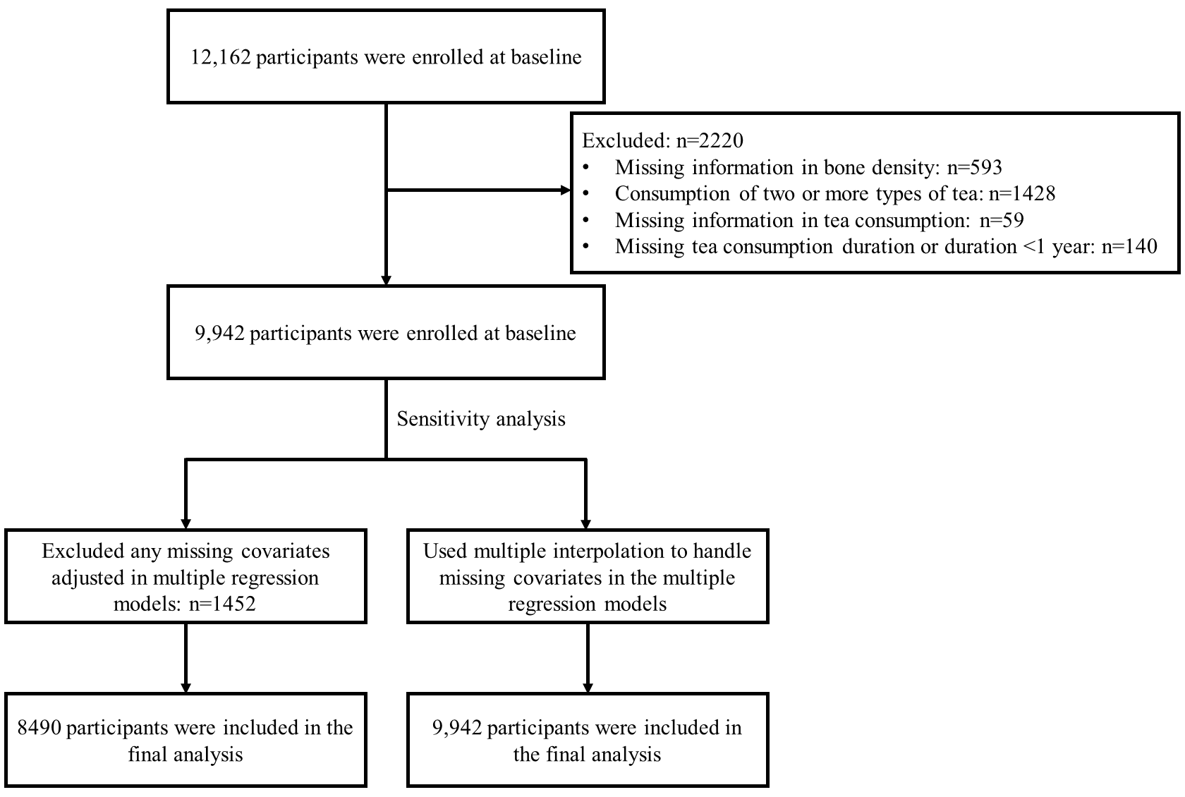

Figure S2 Flow diagram indicating derivation of final analyzed study sample

