Supplementary Table 1. Search strategy for each database or search engine. 24/11/2024
Database or search engine | Search strategy
Medline | (“Dairy products” [MeSH] OR “Dairy products” [TIAB] OR “Dairy product” [TIAB] OR “Dairy” [MeSH] OR “Dairy” [TIAB] OR “Dairies” [MeSH] OR “Dairies” [TIAB] OR “Milk” [MeSH] OR “Milk” [TIAB] OR “Yogurt” [MeSH] OR “Yogurt” [TIAB] OR “Cheese” [MeSH] OR “Cheese” [TIAB] OR “Kefir” [MeSH] OR “Kefir” [TIAB] OR “Margarine” [MeSH] OR “Margarine” [TIAB] OR “Ghee” [MeSH] OR “Ghee” [TIAB] OR “Koumiss” [MeSH] OR “Koumiss” [TIAB] OR “Ice Cream” [MeSH] OR “Ice Cream” [TIAB] OR “Buttermilk” [MeSH] OR “Buttermilk” [TIAB] OR “Butter” [MeSH] OR “Butter” [TIAB] OR “Whey” [MeSH] OR “Whey” [TIAB] OR “Cultured Milk Products” [MeSH] OR “Cultured Milk Products” [TIAB] OR “Cultured Milk Product” [TIAB] OR “yoghurt” [TIAB] OR “Kumis” [TIAB] OR “Sour milk” [TIAB] OR “dried yogurt” [TIAB] OR “dried yoghurt” [TIAB] OR “Nagorno Qrvt” [TIAB]) AND (“sleep” [MeSH] OR “sleep” [TIAB] OR “insomnia” [TIAB] )
Scopus | (TITLE-ABS-KEY (“Dairy products”) OR TITLE-ABS-KEY (“Dairy product”) OR TITLE-ABS-KEY (“Dairy”) OR TITLE-ABS-KEY (“Dairies”) OR TITLE-ABS-KEY (“Milk”) OR TITLE-ABS-KEY (“Yogurt”) OR TITLE-ABS-KEY (“yoghurt”) OR TITLE-ABS-KEY (“Cheese”) OR TITLE-ABS-KEY (“Ghee”) OR TITLE-ABS-KEY (“Kefir”) OR TITLE-ABS-KEY (“Margarine”) OR TITLE-ABS-KEY (“Koumiss”) OR TITLE-ABS-KEY (“Kumis”) OR TITLE-ABS-KEY (“Ice Cream”) OR TITLE-ABS-KEY (“Buttermilk”) OR TITLE-ABS-KEY (“Butter”) OR TITLE-ABS-KEY (“Whey”) OR TITLE-ABS-KEY (“Cultured Milk Products”) OR TITLE-ABS-KEY (“Cultured Milk Product”) OR TITLE-ABS-KEY (“Sour milk”) OR TITLE-ABS-KEY (“dried yogurt”) OR TITLE-ABS-KEY (“dried yoghurt”) OR TITLE-ABS-KEY (“Nagorno Qrvt”)) AND (TITLE-ABS-KEY (“sleep”) OR TITLE-ABS-KEY (“insomnia”))
Web of Science | (TS=(“Dairy products”) OR TS=(“Dairy product”) OR TS=(“Dairy”) OR TS=(“ Dairies”) OR TS=(“Milk”) OR TS=(“Yogurt”) OR TS=(“yoghurt”) OR TS=(“Cheese”) OR TS=(“Ghee”) OR TS=(“Kefir”) OR TS=(“Margarine”) OR TS=(“ Koumiss”) OR TS=(“Kumis”) OR TS=(“Ice Cream”) OR TS=(“Buttermilk”) OR TS=(“Butter”) OR TS=(“Whey”) OR TS=(“Cultured Milk Products”) OR TS=(“Cultured Milk Product”) OR TS=(“Sour milk”) OR TS=(“dried yogurt”) OR TS=(“dried yoghurt”) OR TS=(“Allocated”) OR TS=(“Nagorno Qrvt”)) AND (TS=(“sleep”) OR TS=(“insomnia”))
Google Scholar | allintitle: (“Dairy products” OR “Dairy product” OR “Dairy” OR “Dairies” OR “Milk” OR “Yogurt” OR “yoghurt” OR “Cheese” OR “Ghee” OR “Kefir” OR “Margarine” OR “ Koumiss” OR “ Kumis” OR “ Ice Cream” OR “ Buttermilk” OR “Butter” OR “Whey” OR “Cultured Milk Products” OR “Cultured Milk Product” OR “Sour milk” OR “dried yogurt” OR “dried yoghurt” OR “Allocated” OR “Nagorno Qrvt”) AND (“sleep” OR “insomnia”)

Supplementary Table 2. Quality assessment based on Newcastle-Ottawa scale for cross-sectional studies examining the association between dairy intake and sleep

First author (publication year) | Representativeness of the sample | Sample size | Non-respondents | Ascertainment of exposure | Comparability of outcome groups | Assessment of outcome | Statistical test | Score | Overall  quality
Al-Hazzaa (2013) | * | * | - | * | ** | * | * | 7 | High
Bhurosy (2019) | * | * | - | * | ** | * | * | 7 | High
Börnhorst (2015) | * | * | - | * | ** | * | * | 7 | High
Hamulka (2024) | * | * | - | ** | - | * | * | 6 | Low
Hong (2017) | * | * | - | * | ** | * | * | 7 | High
Kang (2018) | * | * | - | * | ** | * | * | 7 | High
Kitano (2014) | * | * | - | * | ** | * | * | 7 | High
Knowlden (2016) | - | - | - | ** | - | * | * | 4 | Low
Mangal (2018) | * | * | - | * | - | * | - | 4 | Low
McDonald (2023) | - | - | - | ** | ** | * | * | 6 | Low
Min (2018) | * | * | - | * | ** | * | * | 7 | High
Mozaffarian (2020) | * | * | - | ** | ** | * | * | 8 | High
Nachvak (2016) | - | - | - | ** | ** | * | * | 6 | Low
Nisar (2019) | - | * | - | * | - | * | * | 4 | Low
Oliveira (2023) | * | * | - | ** | ** | * | * | 8 | High
Ordóñez (2024) | * | * | - | ** | ** | * | * | 8 | High
Ramón-Arbués (2022) | - | - | - | ** | ** | * | * | 6 | Low
Sato (2024) | * | * | - | ** | ** | * | * | 8 | High
Tambalis (2022) | * | * | - | ** | ** | * | * | 8 | High
Xu (2023) | - | * | - | ** | ** | * | * | 7 | High
Yasuda (2019) | * | * | - | * | ** | * | * | 7 | High
Supplementary Table 3. Quality assessment based on Newcastle-Ottawa scale for cohort studies examining the association between dairy intake and sleep
First author (publication year) | Representativeness of the exposed | Selection of non-exposed | Ascertainment of exposure | Lack of outcome in start of study | Comparability of outcome groups | Assessment of outcome | Follow up enough time | Adequacy of follow up | Score | Overall  quality
Inoue (2022) | * | * | - | * | ** | - | * | * | 7 | High
Jansen (2022) | * | * | * | * | ** | - | * | * | 8 | High
Wirth (2024) | * | * | - | - | ** | - | * | * | 6 | Low

Supplementary Table 4. Risk of bias assessment for the included randomized controlled trials examining the association between dairy intake and sleep
First author (publication year) | Bias arising from the randomization process | Bias due to deviations from intended interventions | Bias due to missing outcome data | Bias in the measurement of the outcome | Bias in the selection of the reported result | Overall  risk of bias
Fakhr-Movahedi (2018) | ? | ? | + | ? | ? | _
Kawada (2016) | ? | ? | + | ? | ? | _
Keser (2024) | + | ? | + | + | ? | ?
O’Connor (2022) | + | + | + | + | ? | ?
Rajabi (2019) | _ | ? | + | ? | ? | _
Symbols: , low risk of bias; , some concerns; , high risk of bias.
+
?
_

Supplementary Table 5. Certainty assessment using the GRADE approach
Certainty assessment |  |  |  |  |  |  |  | Certainty
№ of studies | Study design | Risk of bias | Inconsistency | Indirectness | Imprecision | Other considerations
Milk & Sleep Duration
8 | Observational studies | Not serious | Not serious | Not serious | Not serious | Dose-response gradient | ⨁⨁⨁◯  Moderate
Yogurt & Sleep Duration
3 | Observational studies | Not serious | Not serious | Not serious | Not serious | None | ⨁⨁◯◯  Low
Cheese & Sleep Duration
3 | Observational studies | Not serious | Serious ª | Not serious | Not serious | None | ⨁◯◯◯  Very low
Dairy & Sleep Duration
3 | Observational studies | Not serious | Serious ª | Not serious | Not serious | None | ⨁◯◯◯  Very low
Milk & Sleep Quality
5 | Observational studies | Not serious | Not serious | Not serious | Not serious | Dose-response gradient | ⨁⨁⨁◯  Moderate
Dairy & Sleep Quality
11 | Observational studies | Not serious | Serious ª | Not serious | Not serious | Dose-response gradient | ⨁⨁◯◯  Low
Dairy & Sleep Quality
4 | RCTs | Serious ^{b} | Not serious | Not serious | Not serious | Dose-response gradient | ⨁⨁⨁⨁  High

a. High heterogeneity across studies (variation in the size and direction of the effects)
b. Most RCTs indicated a high risk of bias

Abbreviations: RCTs: randomized controlled trials.

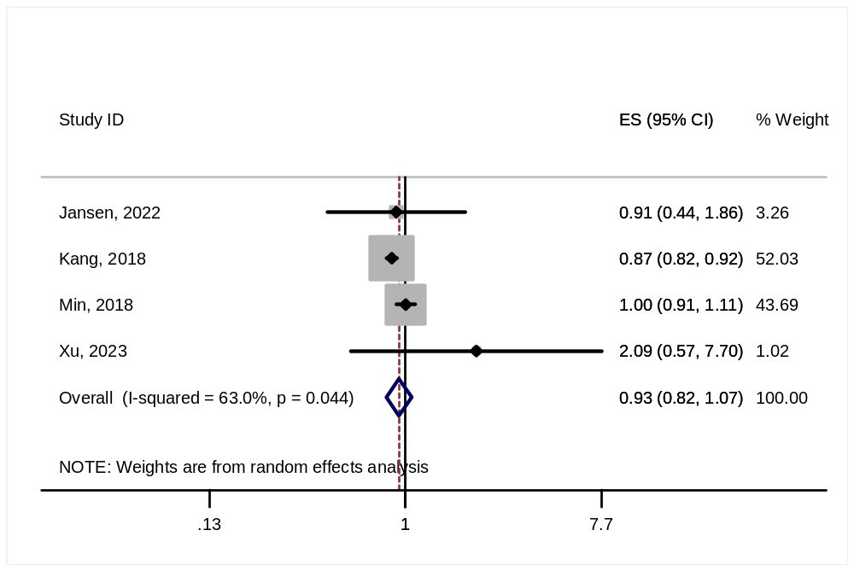
Supplementary Figure 1- Estimated risk of short sleep duration for each serving increase in milk consumption

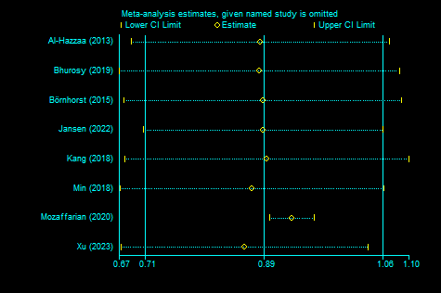

Supplementary Figure 2- Sensitivity analysis for observational studies examining the association between milk consumption and sleep duration

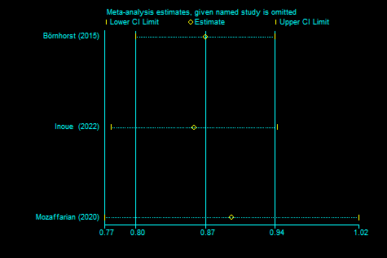
Supplementary Figure 3- Sensitivity analysis for observational studies examining the association between yogurt consumption and sleep duration

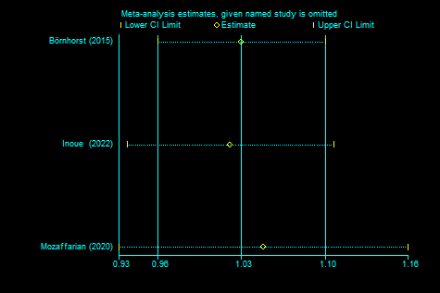
Supplementary Figure 4- Sensitivity analysis for observational studies examining the association between cheese consumption and sleep duration

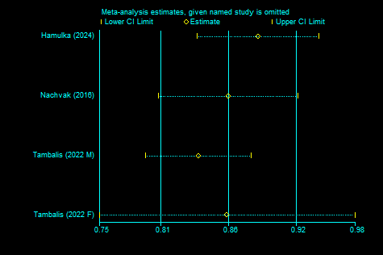
Supplementary Figure 5- Sensitivity analysis for observational studies examining the association between dairy consumption and sleep duration.

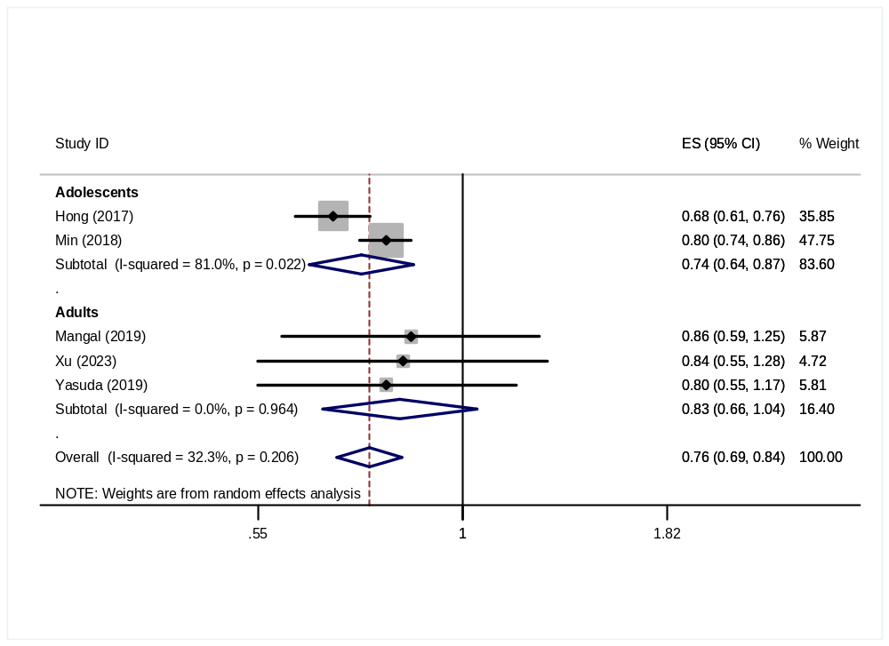
Supplementary Figure 6- Subgroup analysis based on age for the association of milk consumption and poor sleep quality.
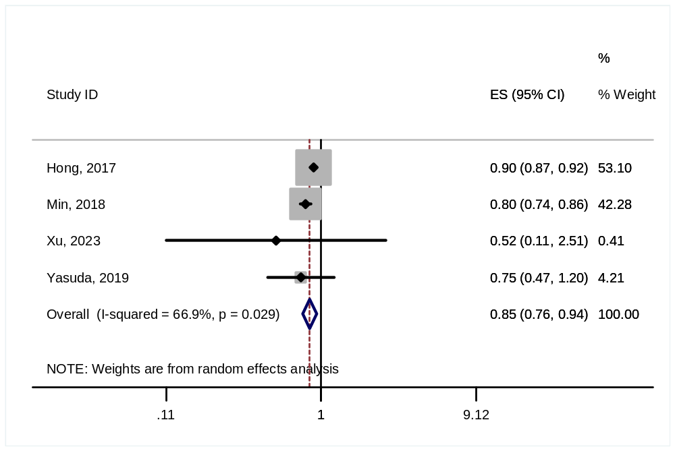
Supplementary Figure 7- Estimated risk of poor sleep quality for each serving increase in milk consumption

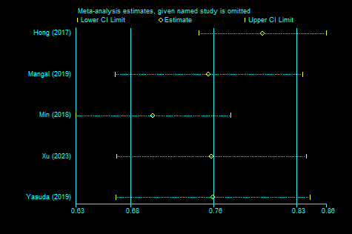
Supplementary Figure 8- Sensitivity analysis for observational studies examining the association between milk consumption and sleep quality.

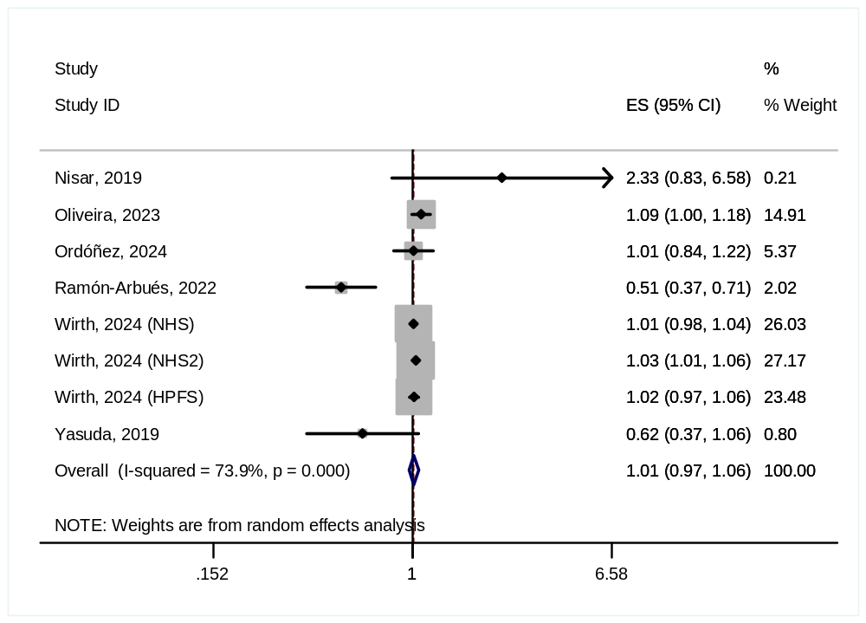
Supplementary Figure 9- Estimated risk of poor sleep quality for each serving increase in dairy consumption

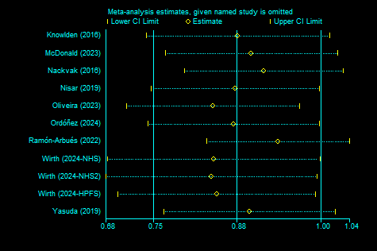
Supplementary Figure 10- Sensitivity analysis for observational studies examining the association between dairy consumption and sleep quality.

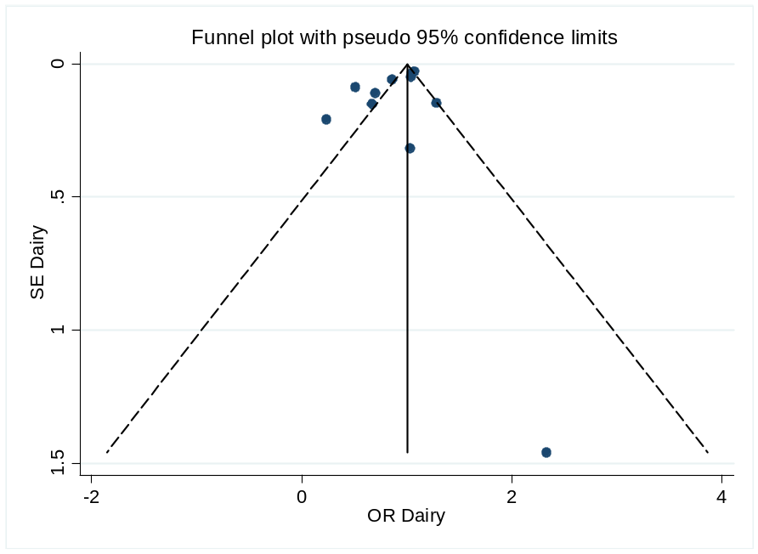
Supplementary Figure 11- Publication bias funnel plots for Association between dairy consumption and poor sleep quality in observational studies,
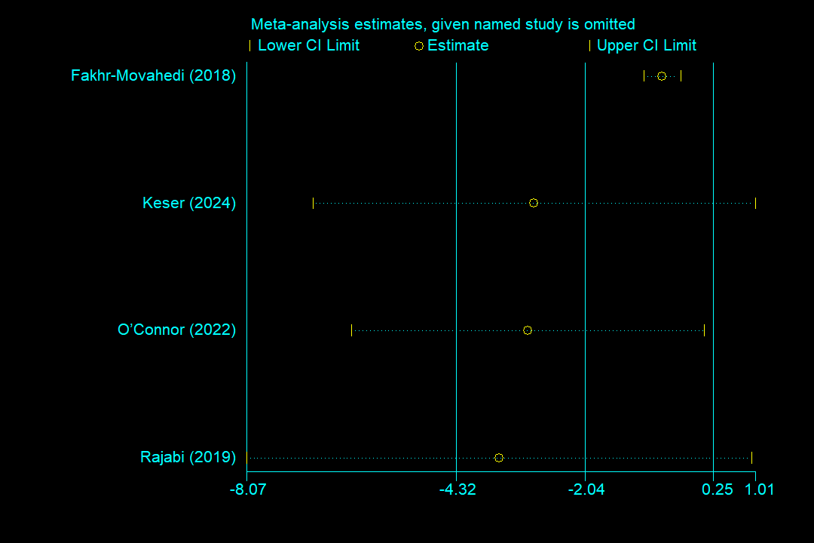
Supplementary Figure 12- Sensitivity analysis for the randomized controlled trials examining the effect of dairy consumption on sleep quality.

