Supplementary Material
Risk factor control and type 2 diabetes event risks in people with high genetic susceptibility to diabetes
Figure S1. Flowchart of the study participants.
Figure S2. The log-minus-log survival curve.
Figure S3. The relative importance of optimally controlled risk factors for T2D stratified by genetic risk and prediabetic status.
Figure S4. Association between the number of optimally controlled risk factors and T2D events in high genetic risk participants compared with those with low genetic risk after excluding participants with missing covariates.
Figure S5. Association between the number of optimally controlled risk factors and T2D events in high genetic risk participants compared with those with low genetic risk after missing covariates imputed by multiple imputation.
Figure S6. Association between the number of optimally controlled risk factors and T2D events in participants with family history of diabetes compared with those without family history of diabetes.
Figure S7. Association between the number of optimally controlled risk factors and T2D events in high genetic risk participants compared with those with low genetic risk after restricting the sample to participants of European ancestry.
Figure S8. Association between the number of optimally controlled risk factors and T2D events in high genetic risk participants compared with those with low genetic risk using updated hypertension definition.
Figure S9. Association between the number of optimally controlled risk factors (4 risk factors) and T2D events in high genetic risk participants compared with those with low genetic risk.

Table S1. Hazard ratios for association between the number of optimally controlled risk factors and T2D stratified by genetic risk groups.
Table S2. Association between genetic risk and T2D risk within each category of risk factor control.

Table S3. Hazard ratios for association between the number of optimally controlled risk factors and T2D stratified by genetic risk groups after excluding participants with missing covariates.
Table S4. Hazard ratios for association between the number of optimally controlled risk factors and T2D stratified by genetic risk groups after missing covariates imputed by multiple imputation.
Table S5. Hazard ratios for association between the number of optimally controlled risk factors and T2D stratified by family history of diabetes.
Table S6. Hazard ratios for association between the number of optimally controlled risk factors and T2D stratified by genetic risk groups after restricting the sample to participants of European ancestry.
Table S7. Hazard ratios for association of degree of joint risk factors control with T2D stratified by genetic risk groups: using participants with 3 risk factors as the reference group.
Table S8. Hazard ratios for association of degree of joint risk factors control with T2D stratified by genetic risk groups: updated hypertension definition.
Table S9. Hazard ratios for association of degree of joint risk factors (4 risk factors) control with T2D.

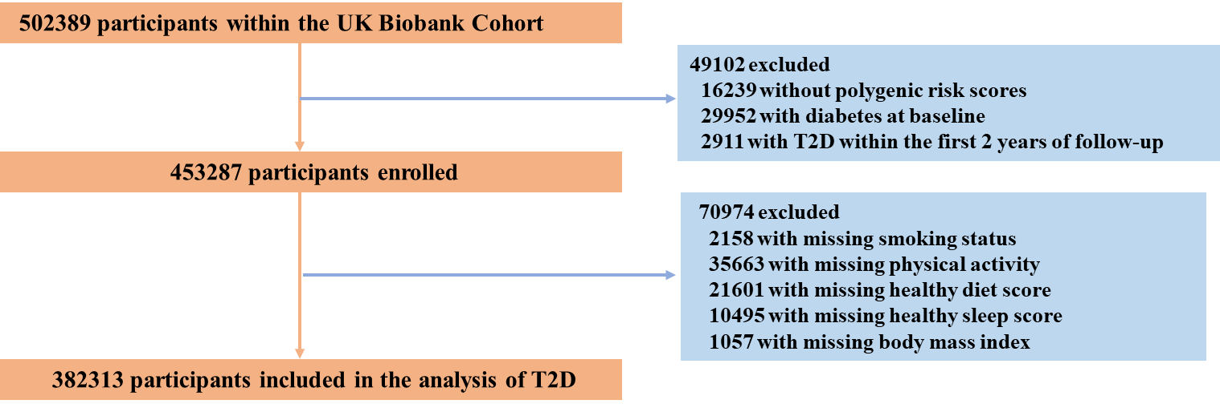
Figure S1. Flowchart of the study participants.
Abbreviations: T2D, type 2 diabetes.

Figure S2. The log-minus-log survival curve.
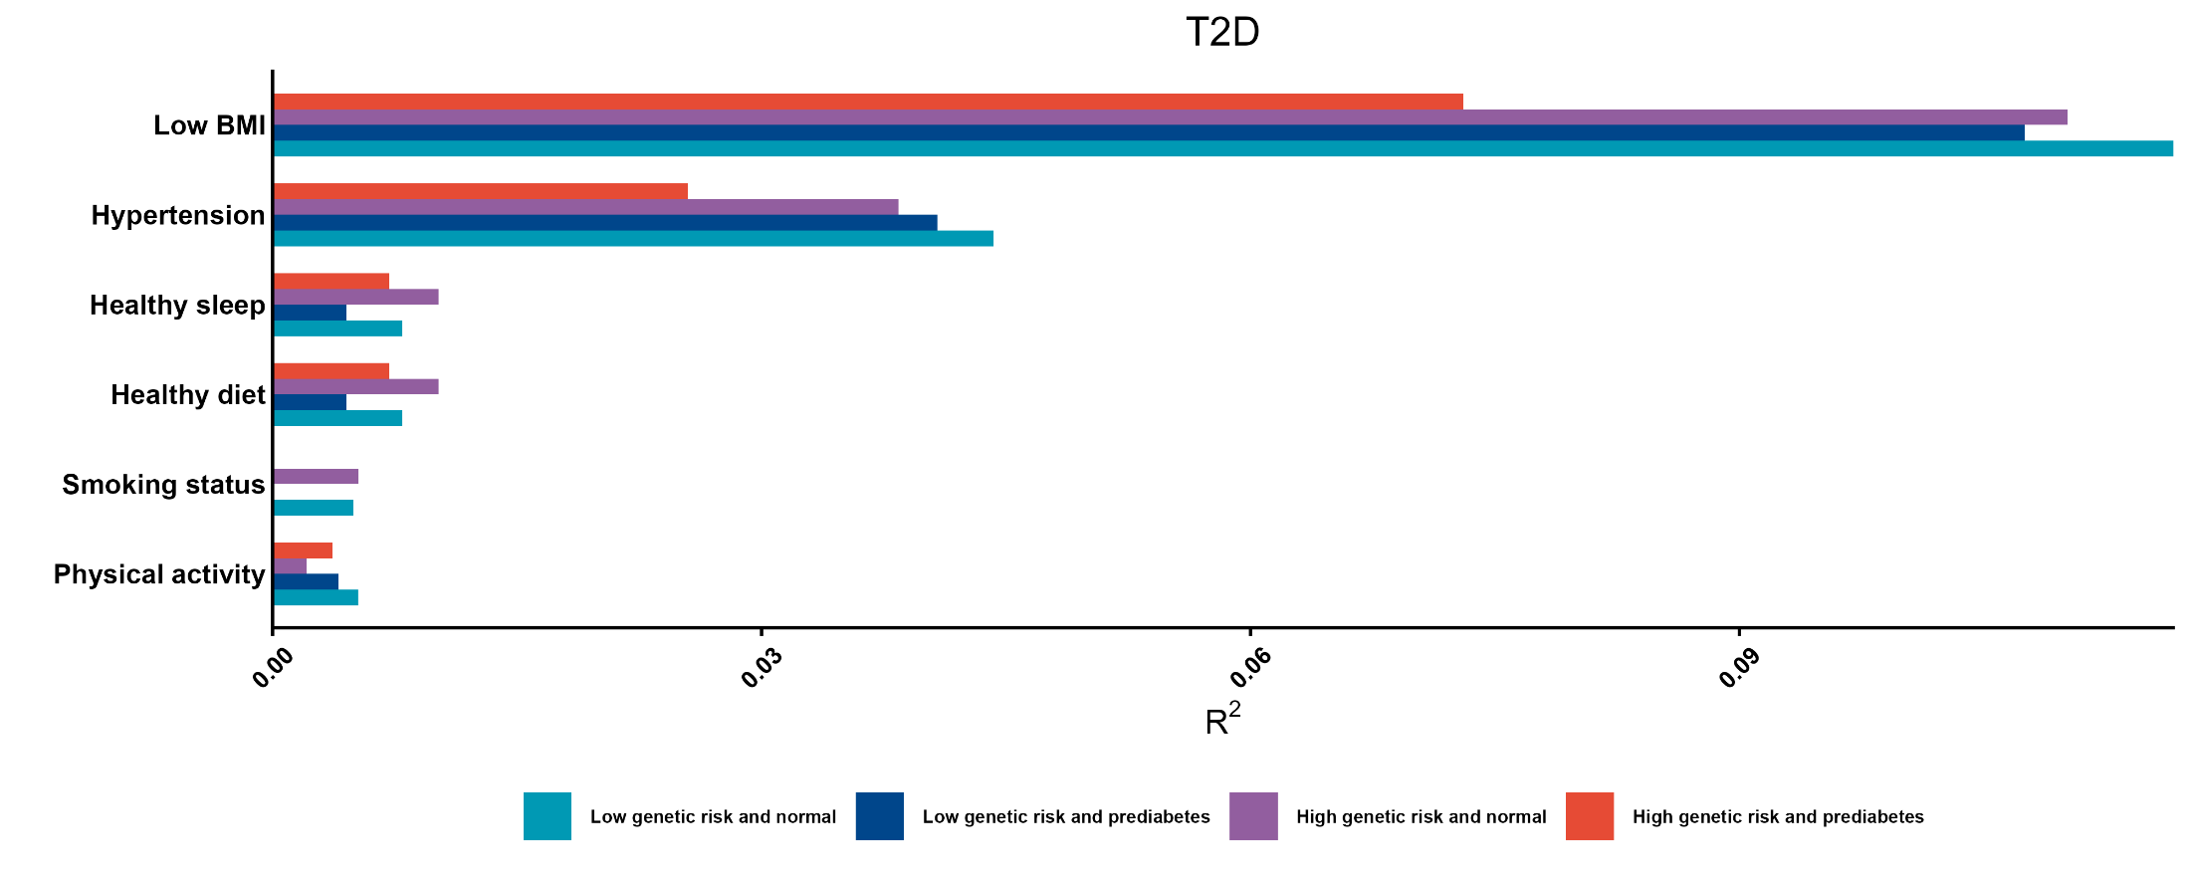
Figure S3. The relative importance of optimally controlled risk factors for T2D stratified by genetic risk and prediabetic status.
Adjusted for age, sex, ethnicity, Townsend deprivation index, education level, income, alcohol intake frequency, Charlson Comorbidity Index and hyperlipidemia.
Abbreviations: T2D, type 2 diabetes.

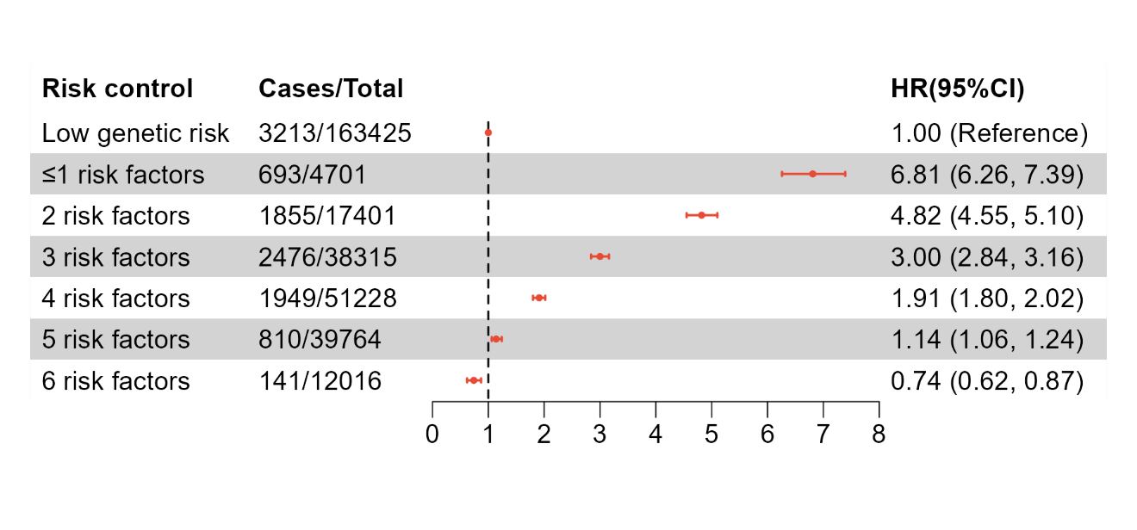
Figure S4. Association between the number of optimally controlled risk factors and T2D events in high genetic risk participants compared with those with low genetic risk after excluding participants with missing covariates. Adjusted for age, sex, ethnicity, Townsend deprivation index, education level, income, alcohol intake frequency, Charlson Comorbidity Index, and hyperlipidemia. All associations remained significant after Bonferroni correction.
Abbreviations: T2D, type 2 diabetes.
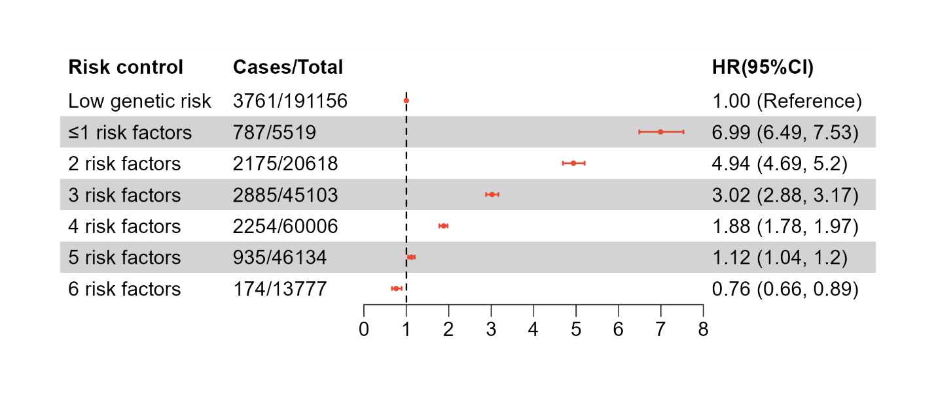
Figure S5. Association between the number of optimally controlled risk factors and T2D events in high genetic risk participants compared with those with low genetic risk after missing covariates imputed by multiple imputation. Adjusted for age, sex, ethnicity, Townsend deprivation index, education level, income, alcohol intake frequency, Charlson Comorbidity Index, and hyperlipidemia. All associations remained significant after Bonferroni correction.
Abbreviations: T2D, type 2 diabetes.
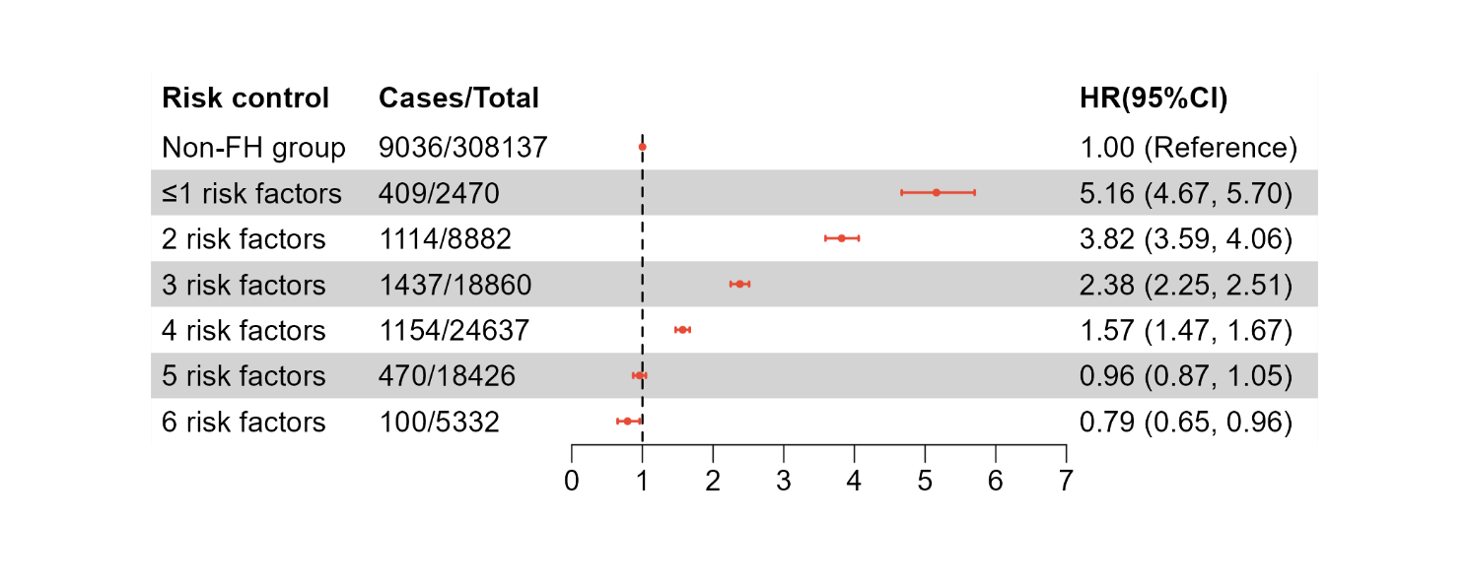
Figure S6. Association between the number of optimally controlled risk factors and T2D events in participants with family history of diabetes compared with those without family history of diabetes. Adjusted for age, sex, ethnicity, Townsend deprivation index, education level, income, alcohol intake frequency, Charlson Comorbidity Index, and hyperlipidemia. All associations remained significant after Bonferroni correction. Non-FH group refers to those without family history of diabetes.
Abbreviations: FH, family history; T2D, type 2 diabetes.
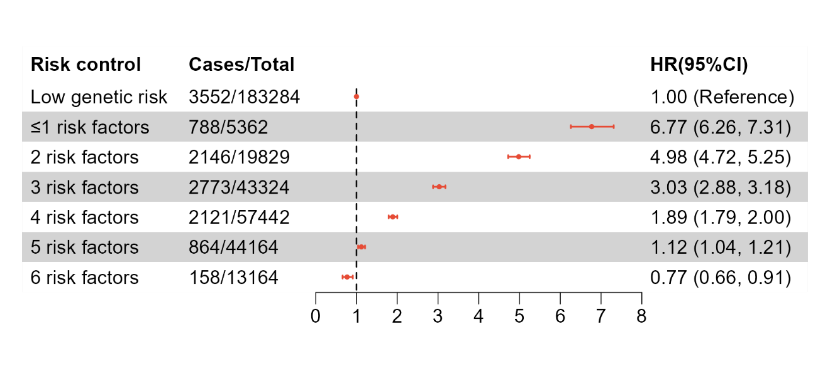
Figure S7. Association between the number of optimally controlled risk factors and T2D events in high genetic risk participants compared with those with low genetic risk after restricting the sample to participants of European ancestry. Adjusted for age, sex, ethnicity, Townsend deprivation index, education level, income, alcohol intake frequency, Charlson Comorbidity Index, and hyperlipidemia. All associations remained significant after Bonferroni correction.
Abbreviations: T2D, type 2 diabetes.
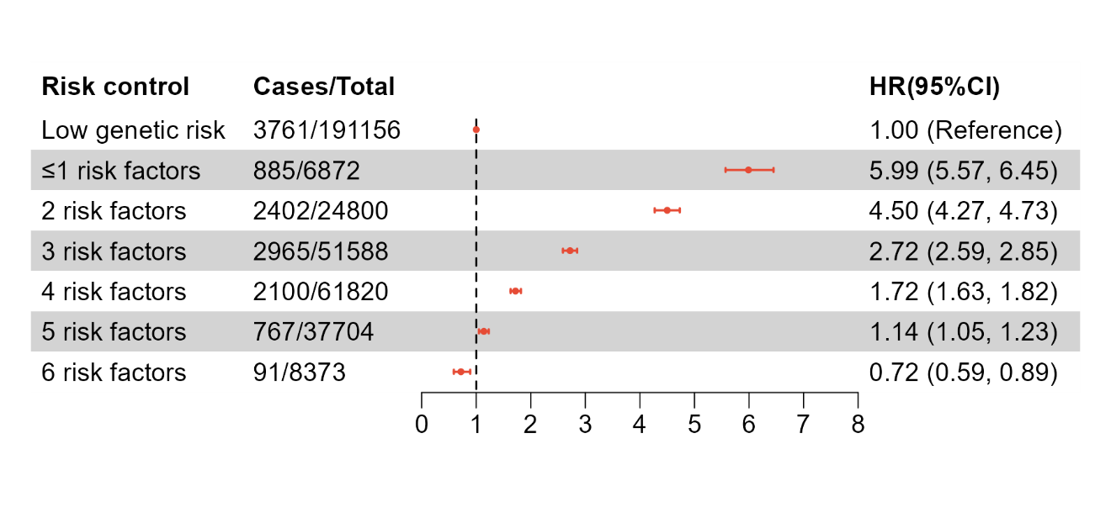
Figure S8. Association between the number of optimally controlled risk factors and T2D events in high genetic risk participants compared with those with low genetic risk using updated hypertension definition. Adjusted for age, sex, ethnicity, Townsend deprivation index, education level, income, alcohol intake frequency, Charlson Comorbidity Index, and hyperlipidemia. All associations remained significant after Bonferroni correction.
Abbreviations: T2D, type 2 diabetes.
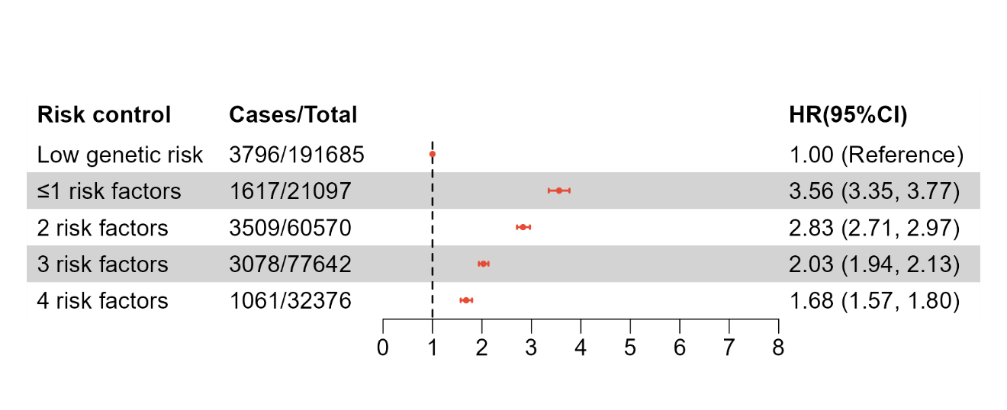
Figure S9. Association between the number of optimally controlled risk factors (4 risk factors) and T2D events in high genetic risk participants compared with those with low genetic risk. Adjusted for age, sex, ethnicity, Townsend deprivation index, education level, income, alcohol intake frequency, Charlson Comorbidity Index, and hyperlipidemia. All associations remained significant after Bonferroni correction.
Abbreviations: T2D, type 2 diabetes.

Table S1. Hazard ratios for association between the number of optimally controlled risk factors and T2D stratified by genetic risk and prediabetes status
 | ≤1 risk factor | 2 risk factors | 3 risk factors | 4 risk factors | 5 risk factors | 6 risk factors | P-trend
High genetic risk
Prediabetes
Cases, n | 483 (1607) | 1344 (5107) | 1669 (8485) | 1223 (8612) | 490 (5097) | 91 (1217)
Model 1 | 1.00(Reference) | 0.83 (0.75, 0.93) | 0.59 (0.53, 0.65) | 0.41 (0.37, 0.46) | 0.28 (0.24, 0.32) | 0.22 (0.18, 0.28) | <0.001
Model 2 | 1.00(Reference) | 0.86 (0.77, 0.95) | 0.62 (0.56, 0.69) | 0.45 (0.40, 0.50) | 0.31 (0.27, 0.35) | 0.25 (0.20, 0.32) | <0.001
Non-prediabetes
Cases, n | 328 (3724) | 841 (14715) | 1200 (34797) | 1004 (48807) | 432 (38824) | 82 (11901)
Model 1 | 1.00(Reference) | 0.61 (0.53, 0.69) | 0.36 (0.32, 0.41) | 0.22 (0.19, 0.25) | 0.12 (0.11, 0.14) | 0.08 (0.06, 0.10) | <0.001
Model 2 | 1.00(Reference) | 0.65 (0.57, 0.74) | 0.40 (0.36, 0.46) | 0.26 (0.23, 0.29) | 0.15 (0.13, 0.18) | 0.10 (0.08, 0.13) | <0.001
Low genetic risk
Prediabetes
Cases, n | 209 (914) | 486 (2755) | 611 (4901) | 448 (5320) | 130 (3294) | 21 (864)
Model 1 | 1.00(Reference) | 0.72 (0.61, 0.85) | 0.48 (0.41, 0.57) | 0.33 (0.28, 0.39) | 0.15 (0.12, 0.19) | 0.10 (0.06, 0.16) | <0.001
Model 2 | 1.00(Reference) | 0.75 (0.64, 0.88) | 0.52 (0.44, 0.61) | 0.37 (0.31, 0.44) | 0.18 (0.15, 0.23) | 0.12 (0.08, 0.19) | <0.001
Non-prediabetes
Cases, n | 161 (3337) | 430 (14054) | 537 (35332) | 437 (53560) | 212 (44722) | 46 (13840)
Model 1 | 1.00(Reference) | 0.60 (0.50, 0.72) | 0.29 (0.24, 0.35) | 0.16 (0.13, 0.19) | 0.10 (0.08, 0.13) | 0.08 (0.06, 0.11) | <0.001
Model 2 | 1.00(Reference) | 0.63 (0.53, 0.76) | 0.33 (0.28, 0.39) | 0.20 (0.16, 0.24) | 0.13 (0.11, 0.16) | 0.10 (0.07, 0.14) | <0.001
Model 1 was adjusted for age, sex, and ethnicity. Model 2 was further adjusted for Townsend deprivation index, education level, income, alcohol frequency, Charlson Comorbidity Index, and hyperlipidemia. All associations remained significant after Bonferroni correction. P for interaction <0.001.
Subgroup | Low genetic risk group | High genetic risk group
Non-smoker | 1.00 (Reference) | 2.54 (2.44, 2.65)
High level of physical activity | 1.00 (Reference) | 2.58 (2.47, 2.69)
Healthy diet | 1.00 (Reference) | 2.58 (2.41, 2.76)
Healthy sleep | 1.00 (Reference) | 2.61 (2.46, 2.76)
Low BMI | 1.00 (Reference) | 2.75 (2.60, 2.90)
Non-hypertension | 1.00 (Reference) | 2.98 (2.75, 3.22)
Table S2. Association between genetic risk and T2D risk within each category of
risk factor control
Model was adjusted for age, sex, genotyping batch, and the first 10 genetic principal components.

Table S3. Hazard ratios for association between the number of optimally controlled risk factors and T2D stratified by genetic risk groups after excluding participants with missing covariates
 | ≤1 risk factor | 2 risk factors | 3 risk factors | 4 risk factors | 5 risk factors | 6 risk factors | P-trend
High genetic risk
Cases, n | 693 (4701) | 1855 (17401) | 2476 (38315) | 1949 (51228) | 810 (39764) | 141 (12016)
Model 1 | 1.00(Reference) | 0.67 (0.61, 0.73) | 0.39 (0.36, 0.42) | 0.23 (0.21, 0.25) | 0.13 (0.12, 0.15) | 0.08 (0.07, 0.10) | <0.001
Model 2 | 1.00(Reference) | 0.70 (0.64, 0.77) | 0.43 (0.40, 0.47) | 0.27 (0.25, 0.30) | 0.16 (0.14, 0.18) | 0.10 (0.08, 0.12) | <0.001
Low genetic risk
Cases, n | 330 (3742) | 746 (14635) | 1015 (35720) | 767 (52489) | 300 (43453) | 55 (13386)
Model 1 | 1.00(Reference) | 0.53 (0.47, 0.61) | 0.29 (0.26, 0.33) | 0.15 (0.14, 0.18) | 0.08 (0.07, 0.09) | 0.05 (0.04, 0.07) | <0.001
Model 2 | 1.00(Reference) | 0.57 (0.50, 0.64) | 0.33 (0.29, 0.37) | 0.19 (0.16, 0.21) | 0.10 (0.09, 0.12) | 0.07 (0.05, 0.09) | <0.001
Model 1 was adjusted for age, sex, and ethnicity. Model 2 was further adjusted for Townsend deprivation index, education level, alcohol frequency, income, Charlson Comorbidity Index, and hyperlipidemia. All associations remained significant after Bonferroni correction. P for interaction <0.001

Table S4. Hazard ratios for association between the number of optimally controlled risk factors and T2D stratified by genetic risk groups after missing covariates imputed by multiple imputation
 | ≤1 risk factor | 2 risk factors | 3 risk factors | 4 risk factors | 5 risk factors | 6 risk factors | P-trend
High risk group
Cases, n | 787 (5519) | 2175 (20618) | 2885 (45103) | 2254 (60006) | 935 (46134) | 174 (13777)
Model 1 | 1.00(Reference) | 0.68 (0.63, 0.73) | 0.39 (0.36, 0.42) | 0.23 (0.21, 0.25) | 0.13 (0.12, 0.14) | 0.09 (0.07, 0.10) | <0.001
Model 2 | 1.00(Reference) | 0.72 (0.67, 0.78) | 0.44 (0.41, 0.48) | 0.27 (0.25, 0.30) | 0.16 (0.15, 0.18) | 0.11 (0.09, 0.13) | <0.001
Low risk group
Cases, n | 365 (4385) | 913 (17465) | 1174 (42063) | 901 (61558) | 342 (50291) | 66 (15394)
Model 1 | 1.00(Reference) | 0.58 (0.51, 0.65) | 0.3 (0.27, 0.33) | 0.16 (0.15, 0.19) | 0.08 (0.07, 0.10) | 0.06 (0.05, 0.07) | <0.001
Model 2 | 1.00(Reference) | 0.62 (0.55, 0.69) | 0.34 (0.31, 0.38) | 0.2 (0.18, 0.23) | 0.11 (0.09, 0.13) | 0.08 (0.06, 0.10) | <0.001
Model 1 was adjusted for age, sex, and ethnicity. Model 2 was further adjusted for Townsend deprivation index, education level, alcohol frequency, income, Charlson Comorbidity Index, and hyperlipidemia. All associations remained significant after Bonferroni correction. P for interaction <0.001.

Table S5. Hazard ratios for association between the number of optimally controlled risk factors and T2D stratified by family history of diabetes
 | ≤1 risk factor | 2 risk factors | 3 risk factors | 4 risk factors | 5 risk factors | 6 risk factors | P-trend
Family history of diabetes
Cases, n | 409 (2470) | 1114 (8882) | 1437 (18860) | 1154 (24637) | 470 (18426) | 100 (5332)
Model 1 | 1.00(Reference) | 0.69 (0.62, 0.78) | 0.40 (0.36, 0.45) | 0.25 (0.22, 0.27) | 0.14 (0.12, 0.16) | 0.11 (0.09, 0.13) | <0.001
Model 2 | 1.00(Reference) | 0.74 (0.66, 0.83) | 0.45 (0.41, 0.51) | 0.29 (0.26, 0.33) | 0.18 (0.15, 0.20) | 0.14 (0.11, 0.18) | <0.001
Non-family history of diabetes
Cases, n | 814 (7617) | 2153 (29769) | 2855 (69413) | 2173 (98234) | 885 (78979) | 156 (24125)
Model 1 | 1.00(Reference) | 0.63 (0.58, 0.68) | 0.35 (0.32, 0.37) | 0.19 (0.18, 0.21) | 0.11 (0.10, 0.12) | 0.07 (0.06, 0.08) | <0.001
Model 2 | 1.00(Reference) | 0.67 (0.62, 0.73) | 0.39 (0.36, 0.42) | 0.23 (0.21, 0.25) | 0.13 (0.12, 0.14) | 0.08 (0.07, 0.10) | <0.001
Model 1 was adjusted for age, sex, and ethnicity. Model 2 was further adjusted for Townsend deprivation index, education level, alcohol frequency, income, Charlson Comorbidity Index, and hyperlipidemia. All associations remained significant after Bonferroni correction. P for interaction <0.001.

Table S6. Hazard ratios for association between the number of optimally controlled risk factors control and T2D stratified by genetic risk groups after restricting the sample to participants of European ancestry
 | ≤1 risk factor | 2 risk factors | 3 risk factors | 4 risk factors | 5 risk factors | 6 risk factors | P-trend
High genetic risk
Case, n | 788 (5362) | 2146 (19829) | 2773 (43324) | 2121 (57442) | 864 (44164) | 158 (13164)
Model 1 | 1.00(Reference) | 0.68 (0.63, 0.74) | 0.39 (0.36, 0.42) | 0.23 (0.21, 0.25) | 0.13 (0.11, 0.14) | 0.08 (0.07, 0.10) | <0.001
Model 2 | 1.00(Reference) | 0.73 (0.67, 0.79) | 0.44 (0.41, 0.48) | 0.27 (0.25, 0.29) | 0.16 (0.14, 0.17) | 0.11 (0.09, 0.13) | <0.001
Low genetic risk
Case, n | 362 (4234) | 870 (16712) | 1103 (40365) | 837 (58983) | 318 (48241) | 62 (14749)
Model 1 | 1.00(Reference) | 0.57 (0.50, 0.64) | 0.29 (0.26, 0.32) | 0.15 (0.14, 0.18) | 0.08 (0.07, 0.09) | 0.05 (0.04, 0.07) | <0.001
Model 2 | 1.00(Reference) | 0.61 (0.54, 0.68) | 0.33 (0.29, 0.37) | 0.19 (0.17, 0.22) | 0.10 (0.09, 0.12) | 0.07 (0.06, 0.09) | <0.001
Model 1 was adjusted for age, sex and ethnicity. Model 2 was further adjusted for Townsend deprivation index, education level, alcohol frequency, income, Charlson Comorbidity Index, and hyperlipidemia. All associations remained significant after Bonferroni correction. P for interaction <0.001.
 | 3 risk factors | ≤1 risk factor | 2 risk factors | 4 risk factors | 5 risk factors | 6 risk factors | P-trend
High genetic risk
Case, n | 2885 (45103) | 709 (5102) | 2175 (20618) | 2254 (60006) | 935 (46134) | 174 (13777)
Model 1 | 1.00(Reference) | 2.42 (2.23, 2.63) | 1.71 (1.61, 1.80) | 0.59 (0.56, 0.63) | 0.34 (0.31, 0.36) | 0.22 (0.19, 0.26) | <0.001
Model 2 | 1.00(Reference) | 2.18 (2.00, 2.36) | 1.62 (1.53, 1.71) | 0.62 (0.59, 0.66) | 0.37 (0.34, 0.40) | 0.25 (0.22, 0.30) | <0.001
Low genetic risk
Case, n | 1174 (42063) | 334 (4076) | 913 (17465) | 901 (61558) | 342 (50291) | 66 (15394)
Model 1 | 1.00(Reference) | 3.22 (2.85, 3.63) | 1.92 (1.76, 2.10) | 0.54 (0.50, 0.59) | 0.28 (0.25, 0.31) | 0.19 (0.15, 0.24) | <0.001
Model 2 | 1.00(Reference) | 2.83 (2.51, 3.20) | 1.79 (1.64, 1.95) | 0.58 (0.53, 0.64) | 0.31 (0.28, 0.35) | 0.22 (0.17, 0.28) | <0.001
Table S7. Hazard ratios for association between degree of joint risk factors control with T2D stratified by genetic risk groups: using participants with 3 risk factors as the reference group
Model 1 was adjusted for age, sex and ethnicity. Model 2 was further adjusted for Townsend deprivation index, education level, alcohol frequency, income, Charlson Comorbidity Index, and hyperlipidemia. All associations remained significant after Bonferroni correction.
 | ≤1 risk factor | 2risk factors | 3 risk factors | 4 risk factors | 5 risk factors | 6 risk factors | P-trend
High genetic risk
Case, n | 885 (6872) | 2402 (24800) | 2965 (51588) | 2100 (61820) | 767 (37704) | 91 (8373)
Model 1 | 1.00(Reference) | 0.69 (0.64, 0.75) | 0.39 (0.36, 0.42) | 0.23 (0.22, 0.25) | 0.15 (0.13, 0.16) | 0.09 (0.07, 0.11) | <0.001
Model 2 | 1.00(Reference) | 0.74 (0.69, 0.80) | 0.45 (0.41, 0.48) | 0.28 (0.26, 0.30) | 0.18 (0.16, 0.20) | 0.11 (0.09, 0.14) | <0.001
Low genetic risk
Case, n | 330 (3742) | 746 (14635) | 1015 (35720) | 767 (52489) | 300 (43453) | 55 (13386)
Model 1 | 1.00(Reference) | 0.53 (0.47, 0.61) | 0.29 (0.26, 0.33) | 0.15 (0.14, 0.18) | 0.08 (0.07, 0.09) | 0.05 (0.04, 0.07) | <0.001
Model 2 | 1.00(Reference) | 0.57 (0.50, 0.64) | 0.33 (0.29, 0.37) | 0.19 (0.16, 0.21) | 0.10 (0.09, 0.12) | 0.07 (0.05, 0.09) | <0.001
Table S8. Hazard ratios for association of degree of joint risk factors control with T2D stratified by genetic risk groups: updated hypertension definition
Model 1 was adjusted for age, sex and ethnicity. Model 2 was further adjusted for Townsend deprivation index, education level, alcohol frequency, income, Charlson Comorbidity Index, and hyperlipidemia. All associations remained significant after Bonferroni correction.

Table S9. Hazard ratios for association of degree of joint risk factors (4 risk factors) control with T2D
 | ≤1 risk factor | 2 risk factors | 3 risk factors | 4 risk factors | P-trend
High genetic risk
Case, n | 1617 (21097) | 3509 (60570) | 3078 (77642) | 1061 (32376)
Model 1 | 1.00(Reference) | 0.71 (0.67, 0.76) | 0.49 (0.46, 0.52) | 0.40 (0.37, 0.43) | <0.001
Model 2 | 1.00(Reference) | 0.79 (0.74, 0.84) | 0.56 (0.53, 0.60) | 0.46 (0.43, 0.50) | <0.001
Low genetic risk
Case, n | 698 (20158) | 1435 (60027) | 1275 (78890) | 388 (32610)
Model 1 | 1.00(Reference) | 0.65 (0.60, 0.72) | 0.45 (0.41, 0.49) | 0.33 (0.29, 0.37) | <0.001
Model 2 | 1.00(Reference) | 0.73 (0.67, 0.80) | 0.53 (0.48, 0.58) | 0.39 (0.34, 0.44) | <0.001
stratified by genetic risk groups

Model 1 was adjusted for age, sex and ethnicity. Model 2 was further adjusted for Townsend deprivation index, education level, alcohol frequency, income, Charlson Comorbidity Index, and hyperlipidemia. All associations remained significant after Bonferroni correction.

