A.Association between the mean difference of HDL-C and mean age of the participants
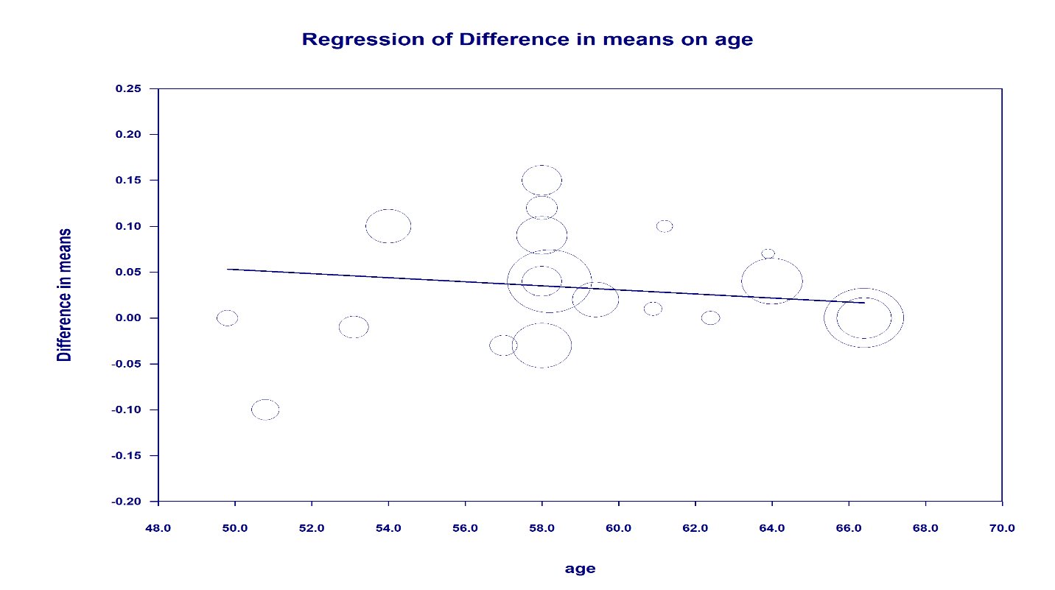 B. Association between the mean difference of HDL-C and mean BMI of the participants
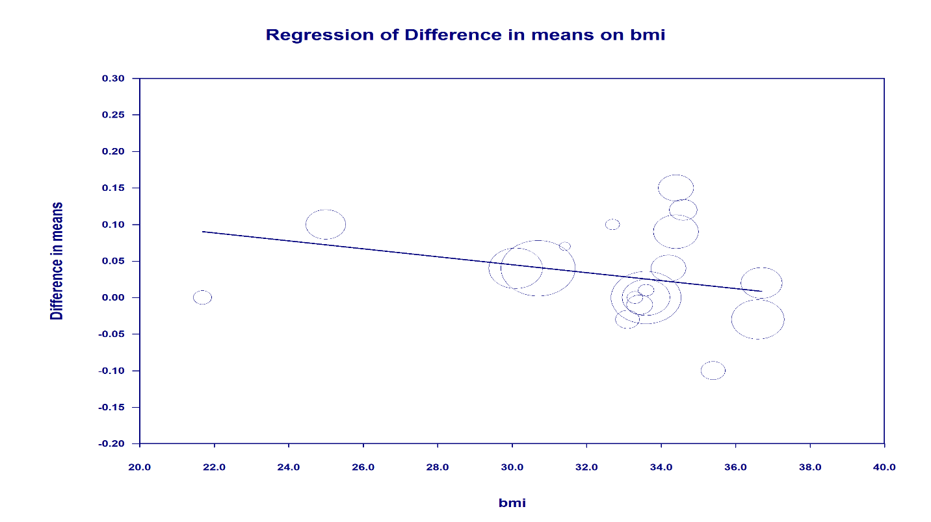 C. Association between the mean difference of HDL-C and mean Duration of the studies
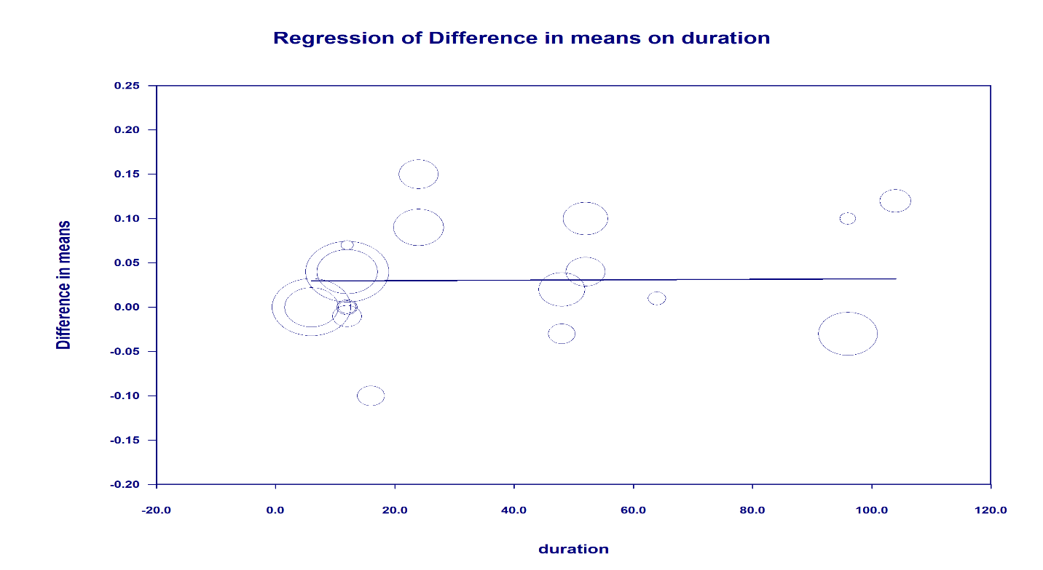 D. Association between the mean difference of HDL-C and mean Sample size of the studies
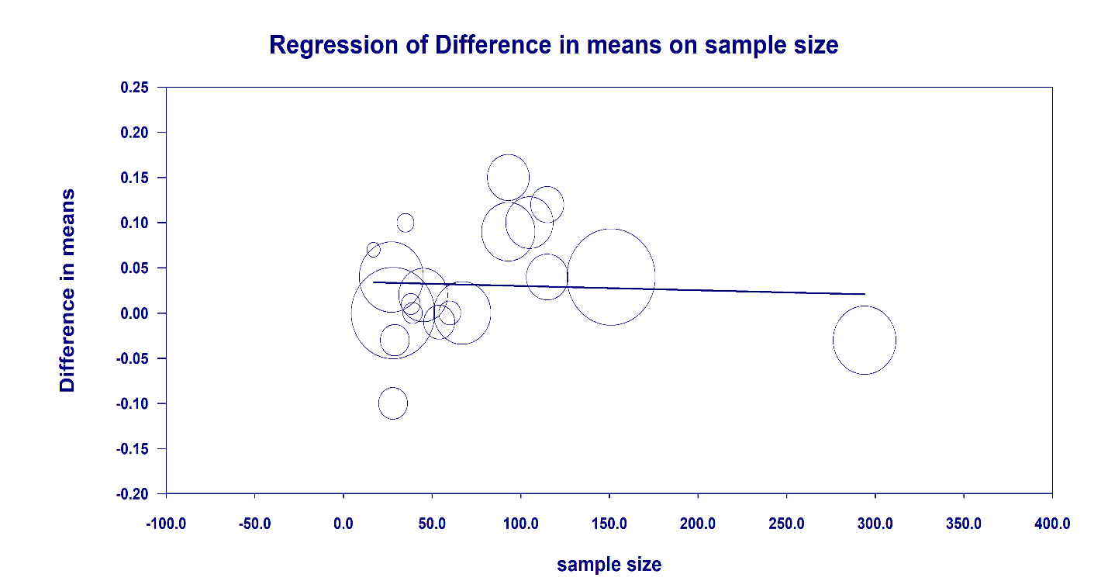 E. Association between the mean difference of HDL-C and baseline values of HDL-C in the intervention group
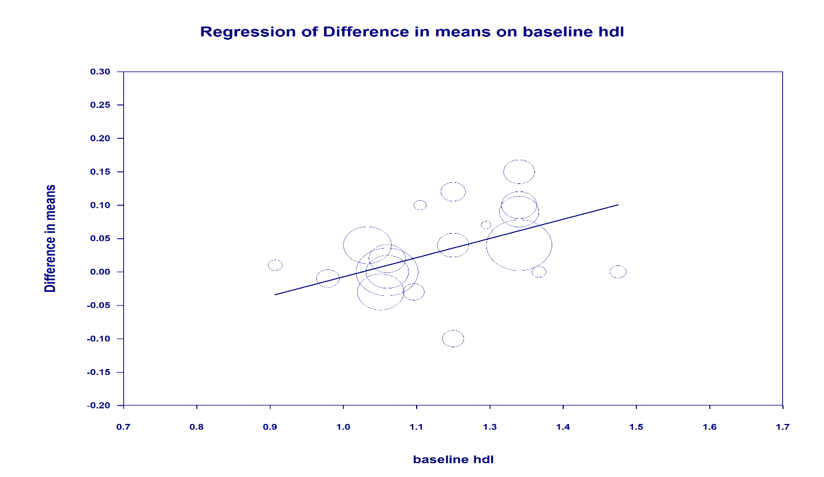 FigureS1. Bubble plots of univariate meta-regression analyses for the effect of higher-protein dietary interventions on high-density lipoprotein cholesterol (HDL-C). Bubble size is proportional to study weight (inverse variance). (A) Age (beta coefficient = -0.002, 95% CI: -0.007 to 0.003, P=0.370); (B) BMI (beta coefficient = -0.005, 95% CI: -0.012 to 0.002, P=0.130); (C) Intervention duration (beta coefficient = 0.000, 95% CI: -0.001 to 0.001, P=0.944); (D) Sample size (beta coefficient = 0.000, 95% CI: -0.0003 to 0.0002, P=0.731); (E) Baseline HDL-C (beta coefficient = 0.259, 95% CI: 0.058 to 0.460, P=0.011). Baseline HDL-C was the only significant moderator.

A.Association between the mean difference of LDL-C and mean age of the participants
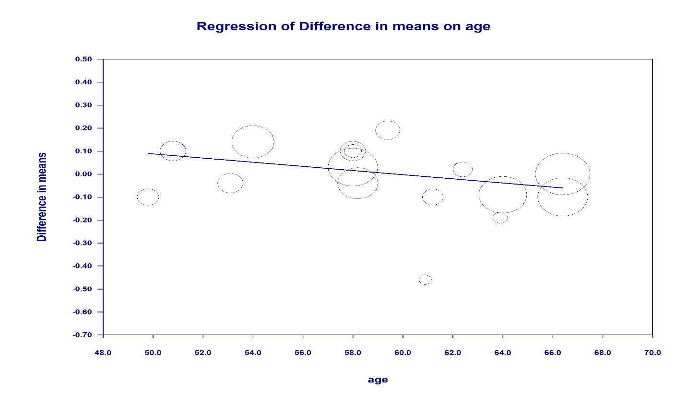 B. Association between the mean difference of LDL-C and mean BMI of the participants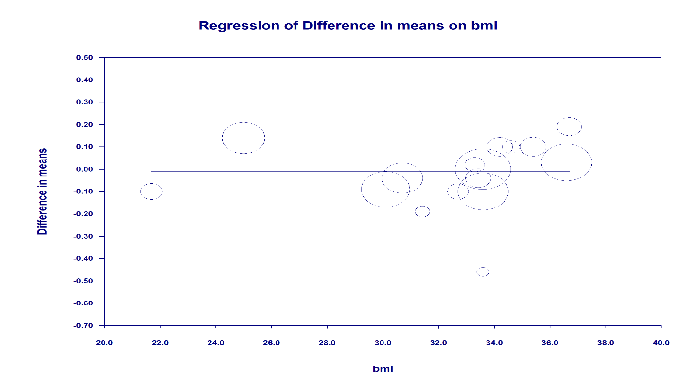 C. Association between the mean difference of LDL-C and mean Duration of the studies
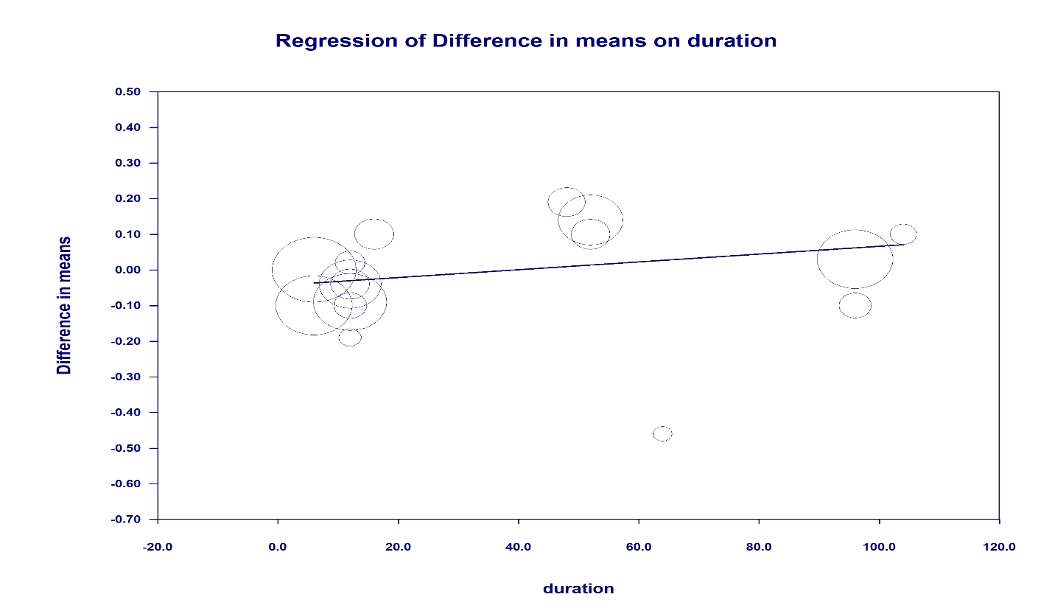 D. Association between the mean difference of LDL-C and mean Sample size of the studies
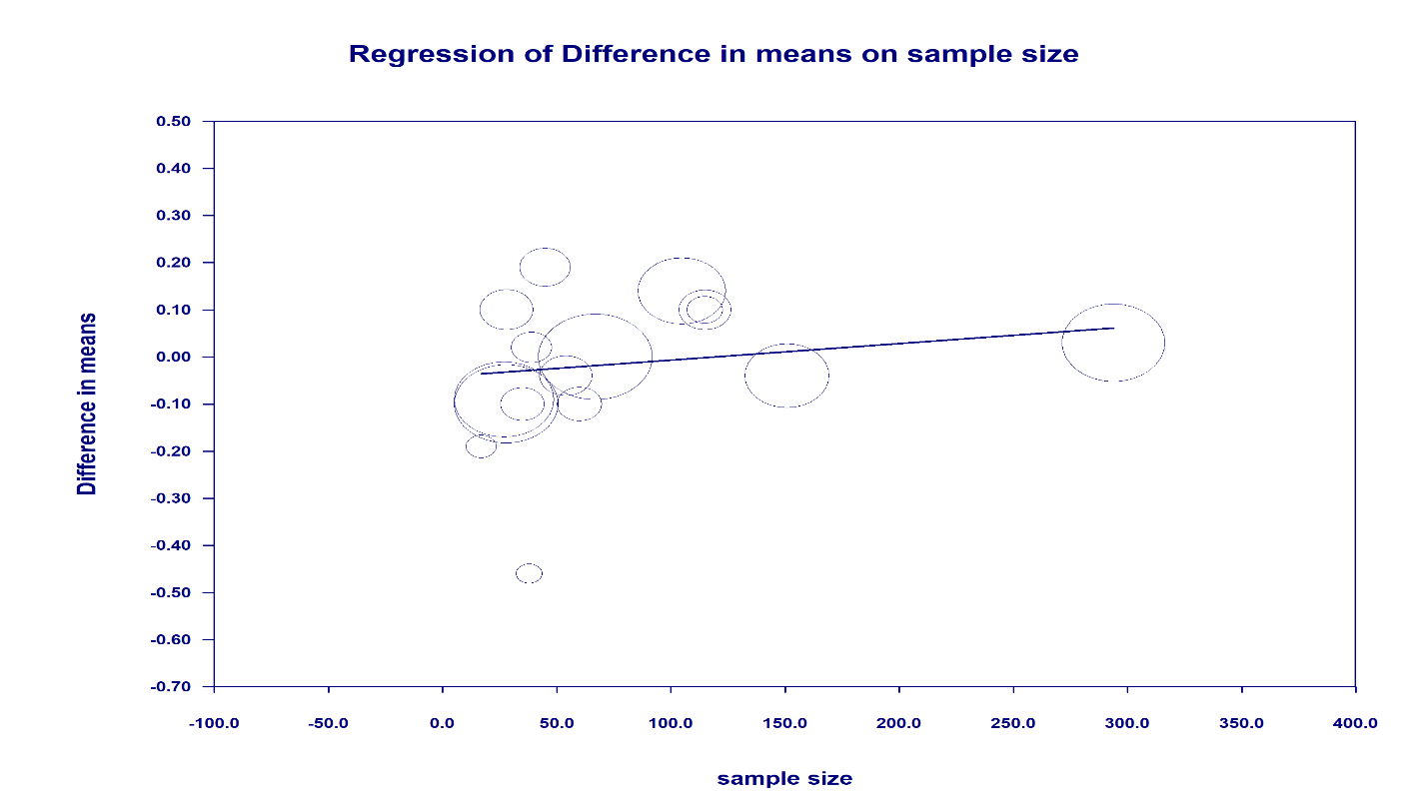 E. Association between the mean difference of LDL-C and baseline values of LDL-C in the intervention group
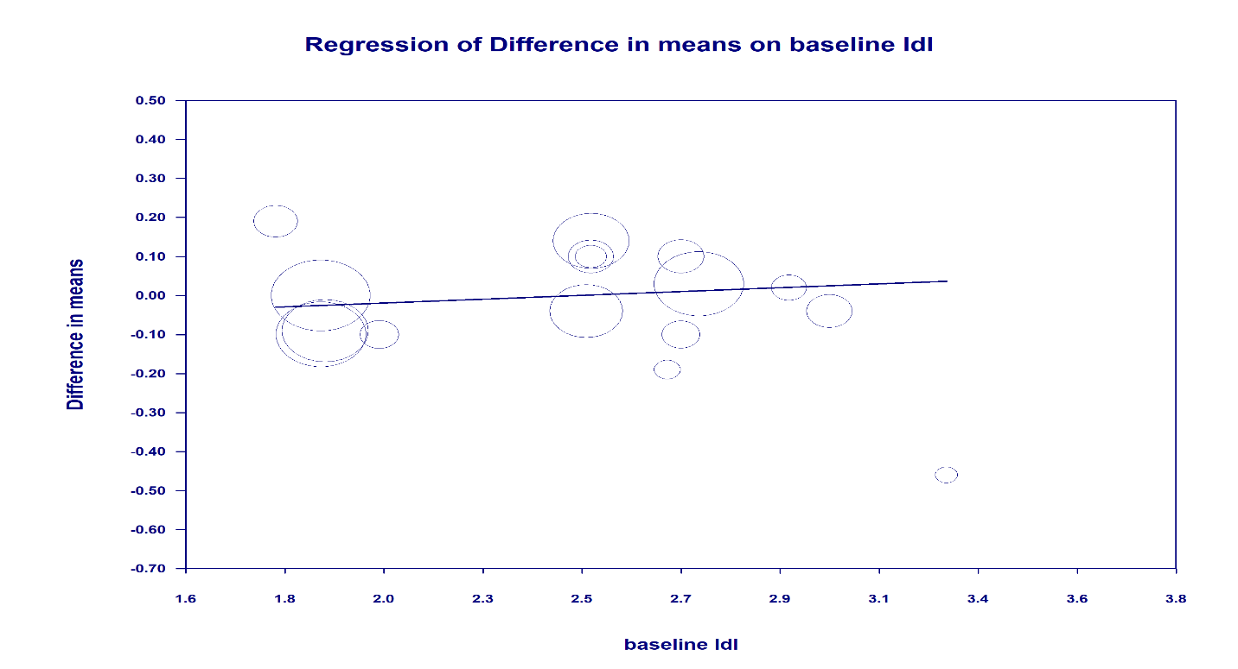 FigureS2. Bubble plots of univariate meta-regression analyses for the effect of higher-protein dietary interventions on low-density lipoprotein cholesterol (LDL-C). Bubble size is proportional to study weight (inverse variance). (A) Age (beta coefficient = -0.009, 95% CI: -0.024 to 0.006, P=0.241); (B) BMI (beta coefficient = 0.0001, 95% CI: -0.021 to 0.021, P=0.996); (C) Intervention duration (beta coefficient = 0.001, 95% CI: -0.001 to 0.003, P=0.348); (D) Sample size (beta coefficient = 0.0004, 95% CI: -0.0005 to 0.0012, P=0.440); (E) Baseline LDL-C (beta coefficient = 0.045, 95% CI: -0.149 to 0.239, P=0.650). No significant moderators were identified for LDL-C.

A.Association between the mean difference of TC and mean age of the participants
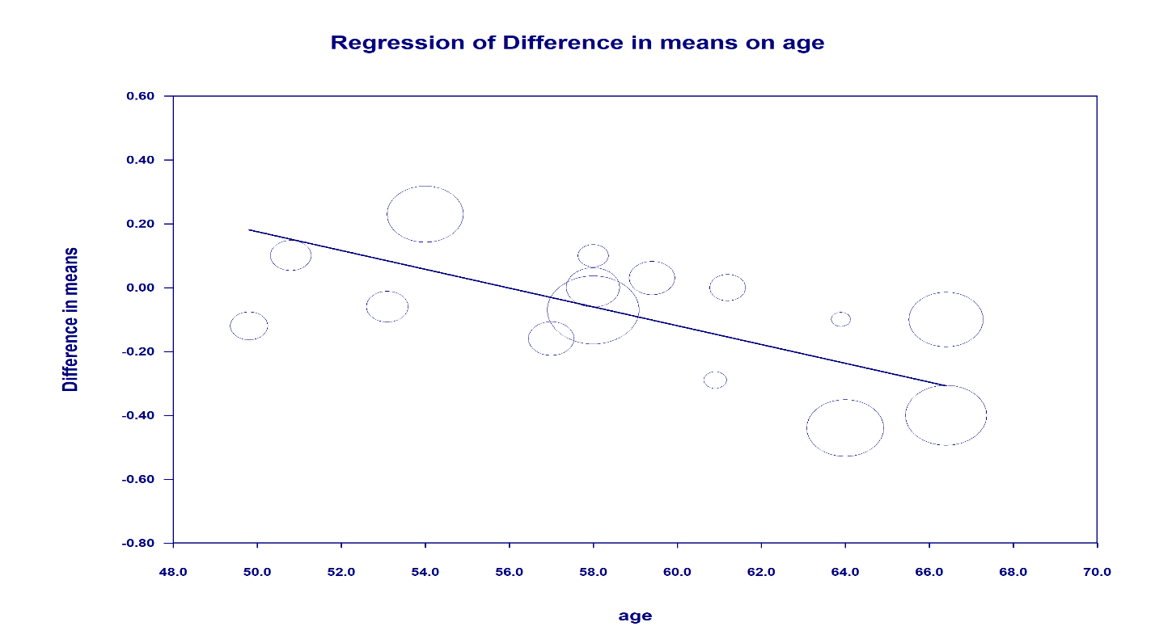 B. Association between the mean difference of TC and mean BMI of the participants
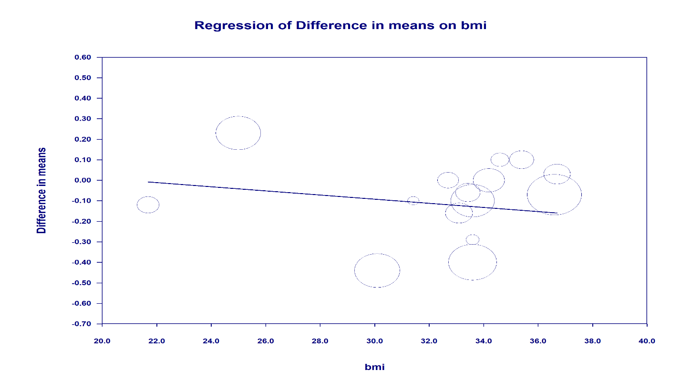 C. Association between the mean difference of TC and mean Duration of the studies
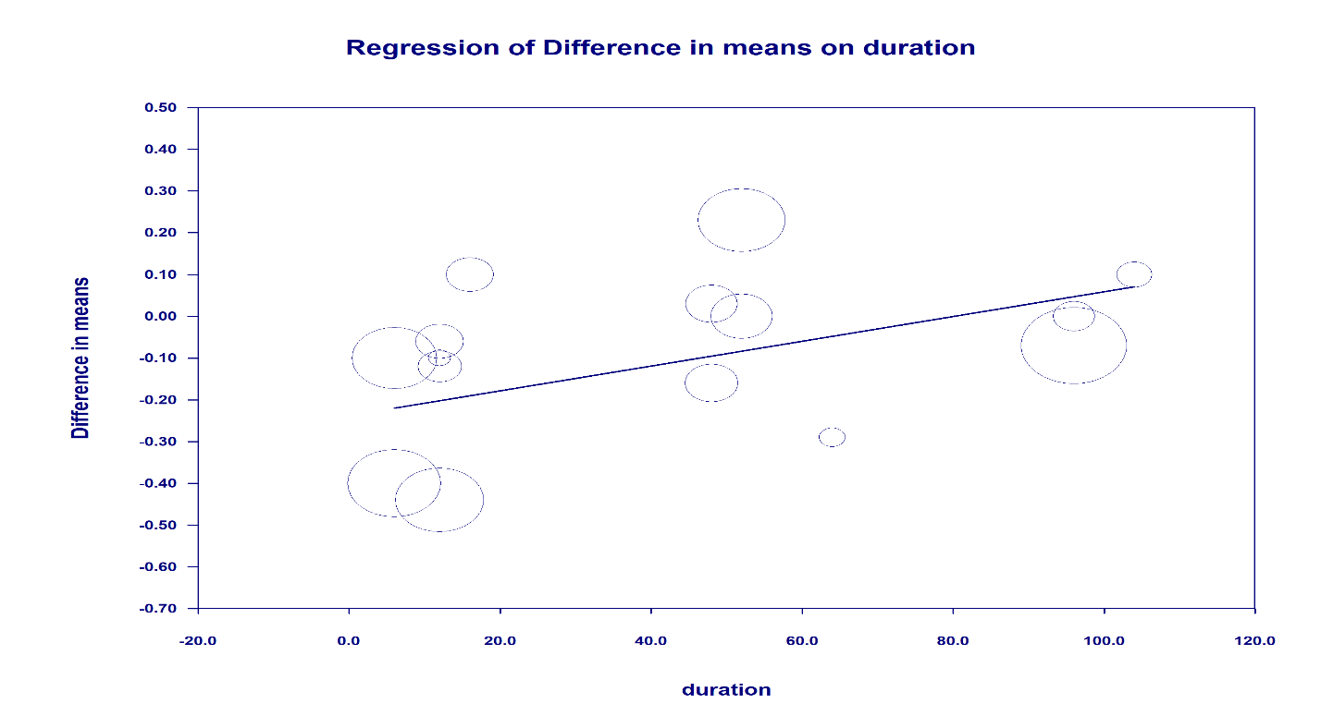 D. Association between the mean difference of TC and mean Sample size of the studies
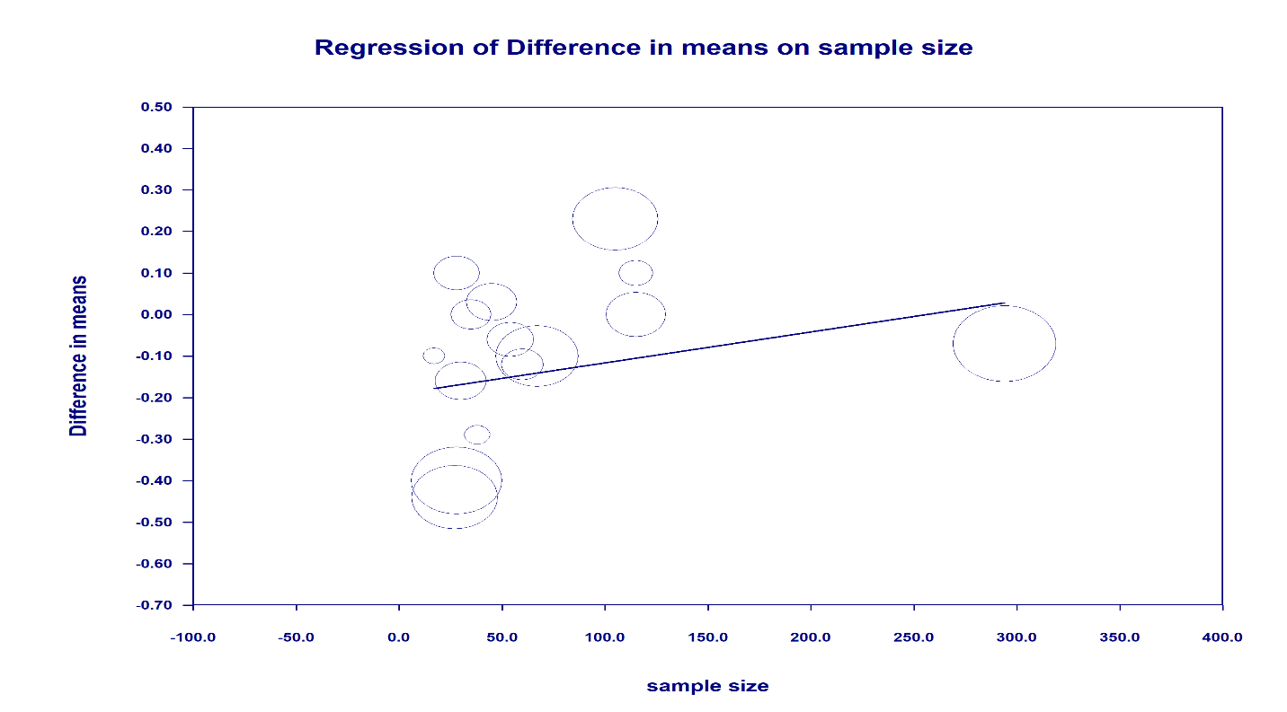 E. Association between the mean difference of TC and baseline values of TC in the intervention group
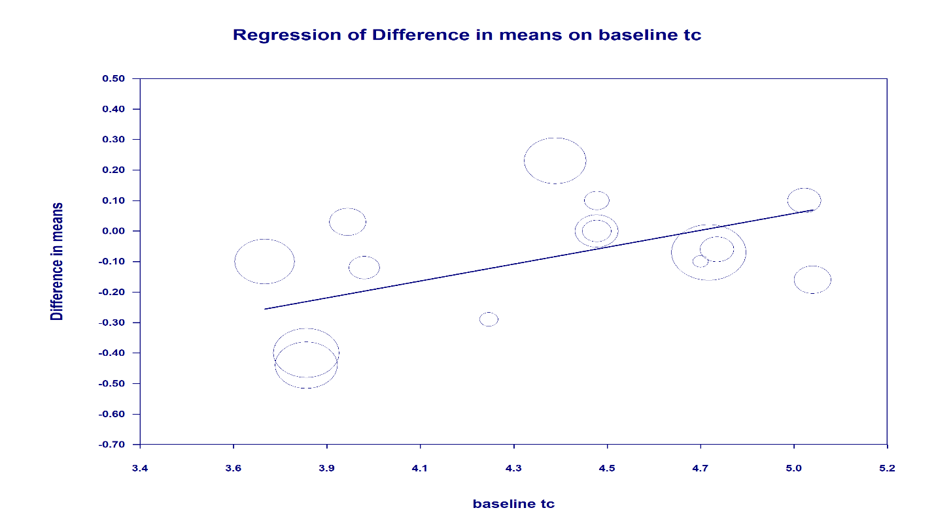 FigureS3. Bubble plots of univariate meta-regression analyses for the effect of higher-protein dietary interventions on total cholesterol (TC). Bubble size is proportional to study weight (inverse variance). (A) Age (beta coefficient = -0.029, 95% CI: -0.049 to -0.010, P=0.002); (B) BMI (beta coefficient = -0.010, 95% CI: -0.035 to 0.015, P=0.421); (C) Intervention duration (beta coefficient = 0.003, 95% CI: 0.0002 to 0.006, P=0.037); (D) Sample size (beta coefficient = 0.001, 95% CI: -0.0003 to 0.002, P=0.156); (E) Baseline TC (beta coefficient = 0.246, 95% CI: 0.034 to 0.458, P=0.023). Age, intervention duration, and baseline TC were significant moderators; older age and higher baseline TC were associated with greater reductions in TC.
A.Association between the mean difference of TG and mean age of the participants
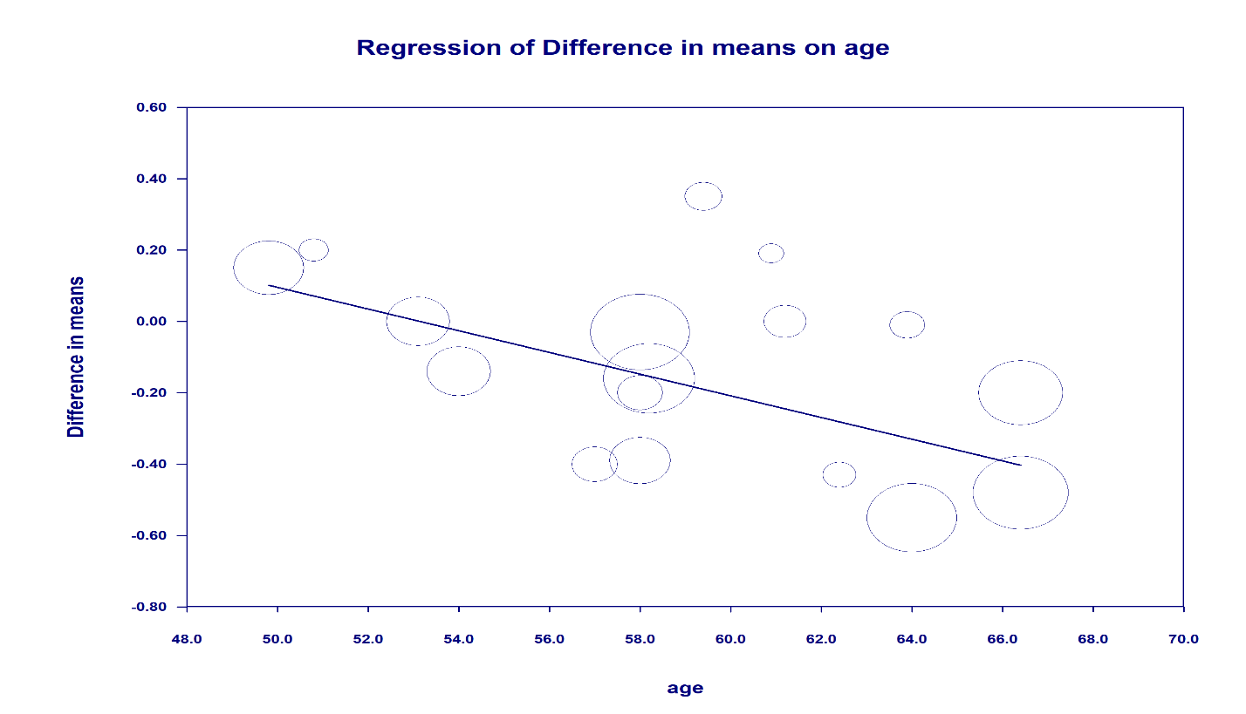 B. Association between the mean difference of TG and mean BMI of the participants
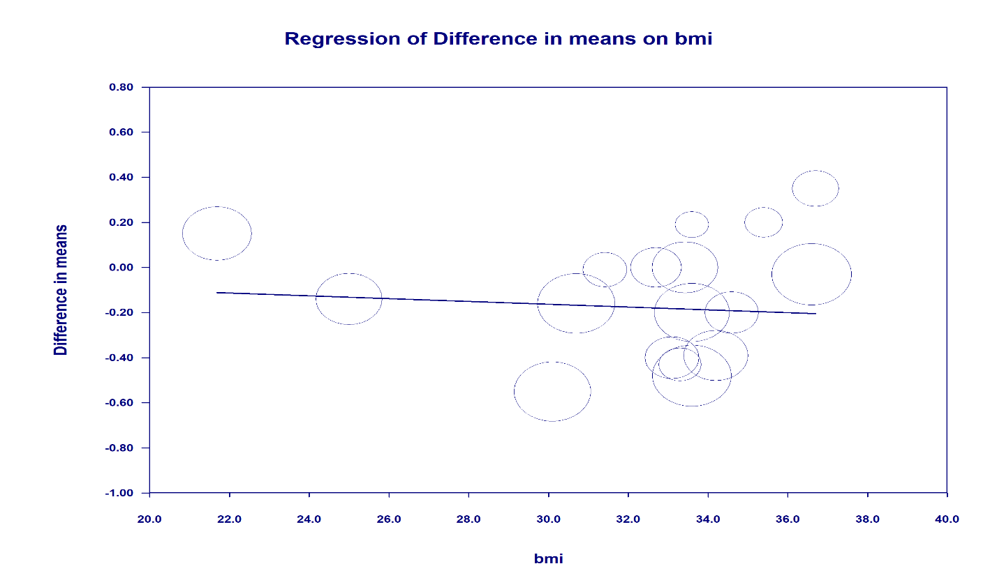 C. Association between the mean difference of TG and mean Duration of the studies
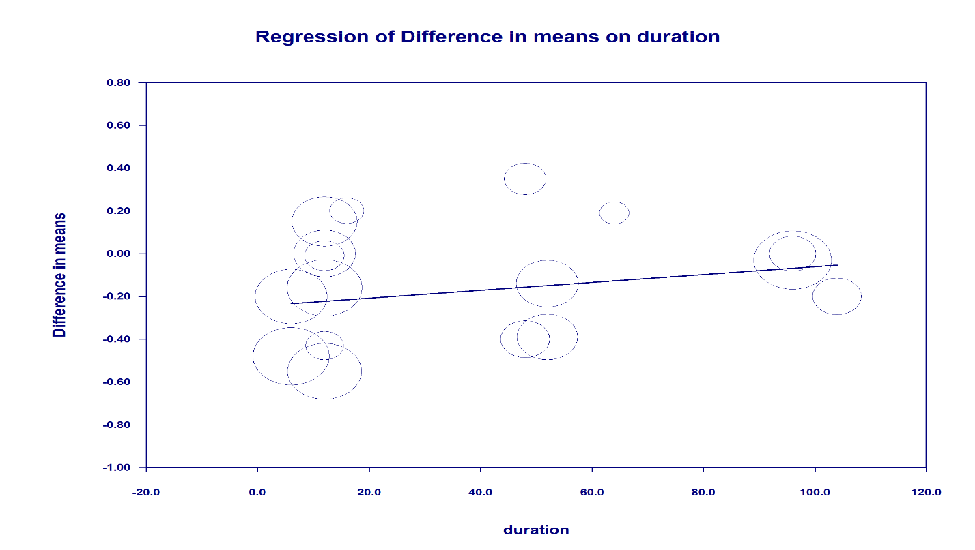 D. Association between the mean difference of TG and mean Sample size of the studies
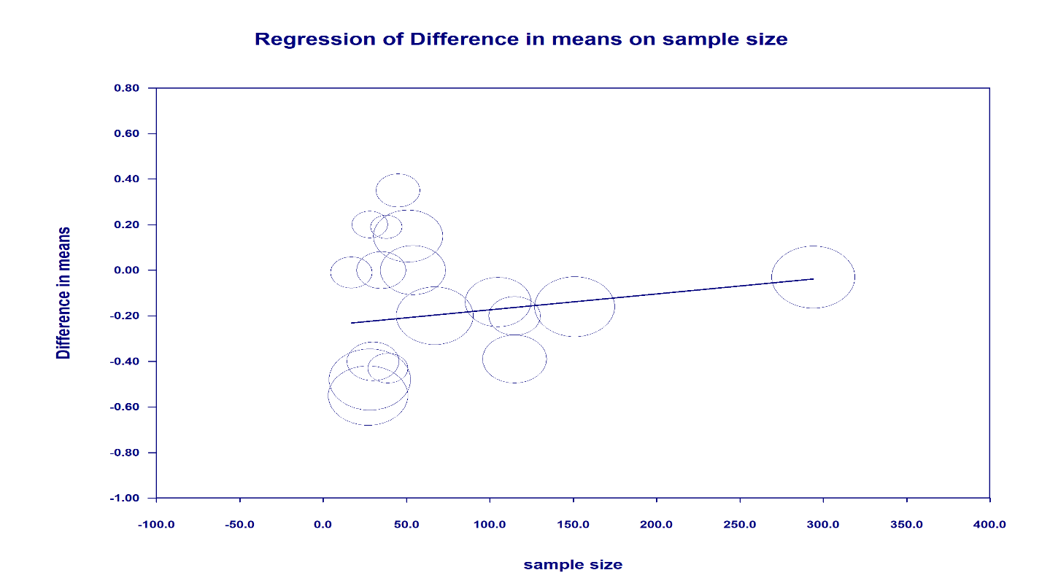 E. Association between the mean difference of TG and baseline values of TG in the intervention group
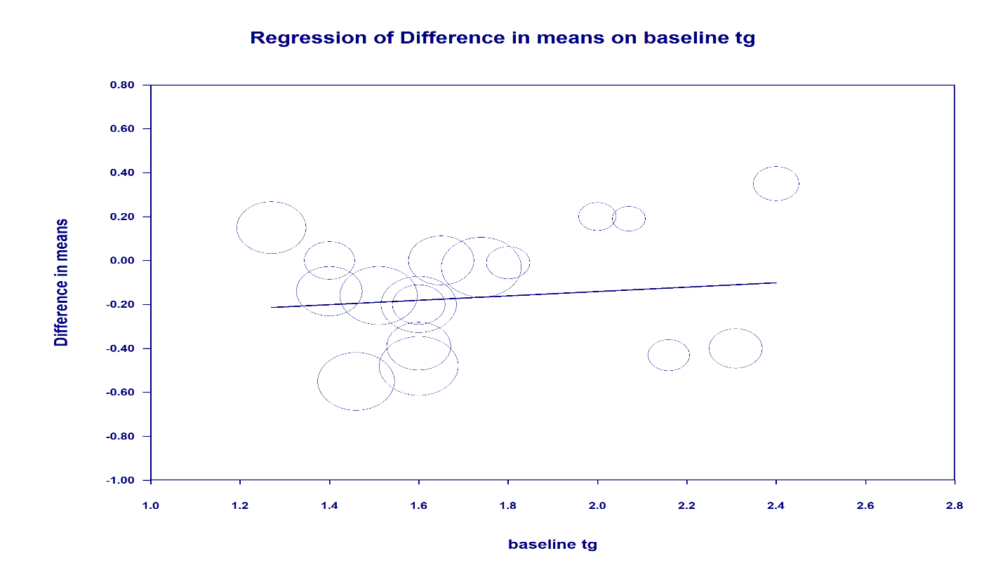 FigureS4. Bubble plots of univariate meta-regression analyses for the effect of higher-protein dietary interventions on triglycerides (TG). Bubble size is proportional to study weight (inverse variance). (A) Age (beta coefficient = -0.030, 95% CI: -0.048 to -0.013, P<0.001); (B) BMI (beta coefficient = -0.006, 95% CI: -0.039 to 0.027, P=0.714); (C) Intervention duration (beta coefficient = 0.002, 95% CI: -0.002 to 0.005, P=0.318); (D) Sample size (beta coefficient = 0.001, 95% CI: -0.001 to 0.002, P=0.364); (E) Baseline TG (beta coefficient = 0.100, 95% CI: -0.375 to 0.574, P=0.681). Age was the only significant moderator (R² analog = 0.79), with older age associated with a greater reduction in TG.
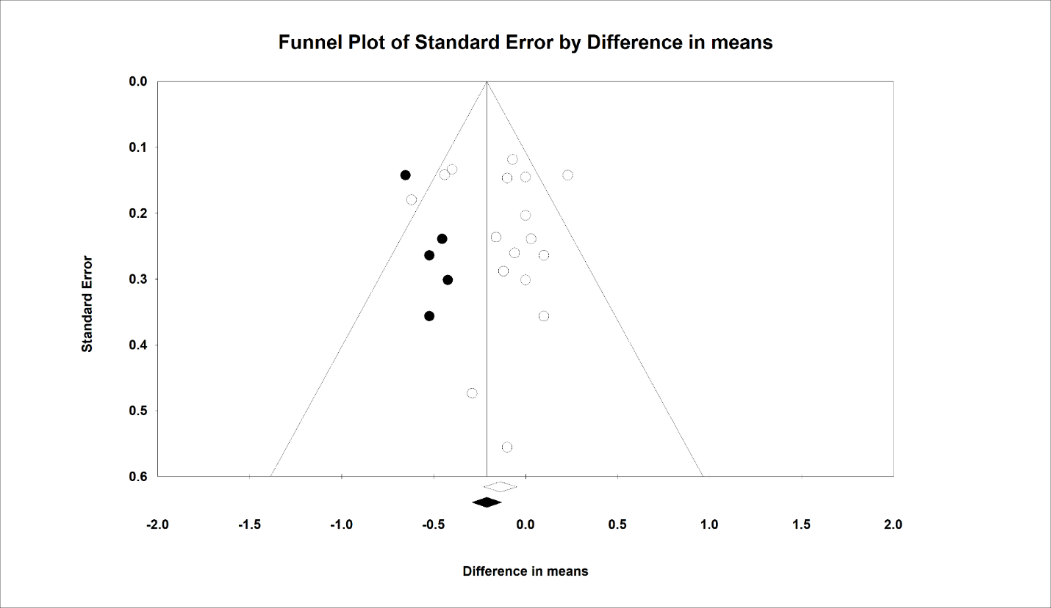 Figure S5. Funnel plot of standard error by weighted mean difference for total cholesterol (TC), assessing publication bias across the 17 included studies. Open circles represent observed studies; filled circles represent studies imputed by the Duval and Tweedie trim-and-fill procedure (n=5 imputed studies). Neither Begg's rank correlation test (Kendall's Tau = -0.02, z=0.12, P=0.90) nor Egger's linear regression test (intercept=0.42, 95% CI: -1.39 to 2.24, t=0.49, df=15, P=0.62) indicated significant publication bias; the fail-safe N was 12.
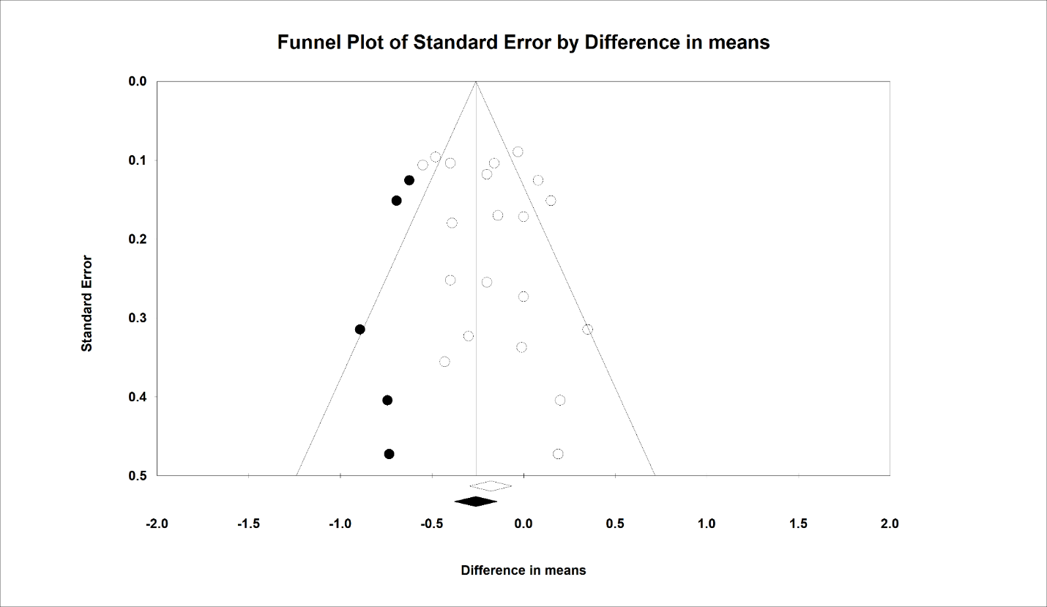 Figure S6. Funnel plot of standard error by weighted mean difference for triglycerides (TG), assessing publication bias across the 20 included studies. Open circles represent observed studies; filled circles represent studies imputed by the Duval and Tweedie trim-and-fill procedure (n=5 imputed studies). Neither Begg's rank correlation test (Kendall's Tau = 0.12, z=0.74, P=0.45) nor Egger's linear regression test (intercept=0.95, 95% CI: -0.68 to 2.58, t=1.21, df=18, P=0.23) indicated significant publication bias; the fail-safe N was 101.
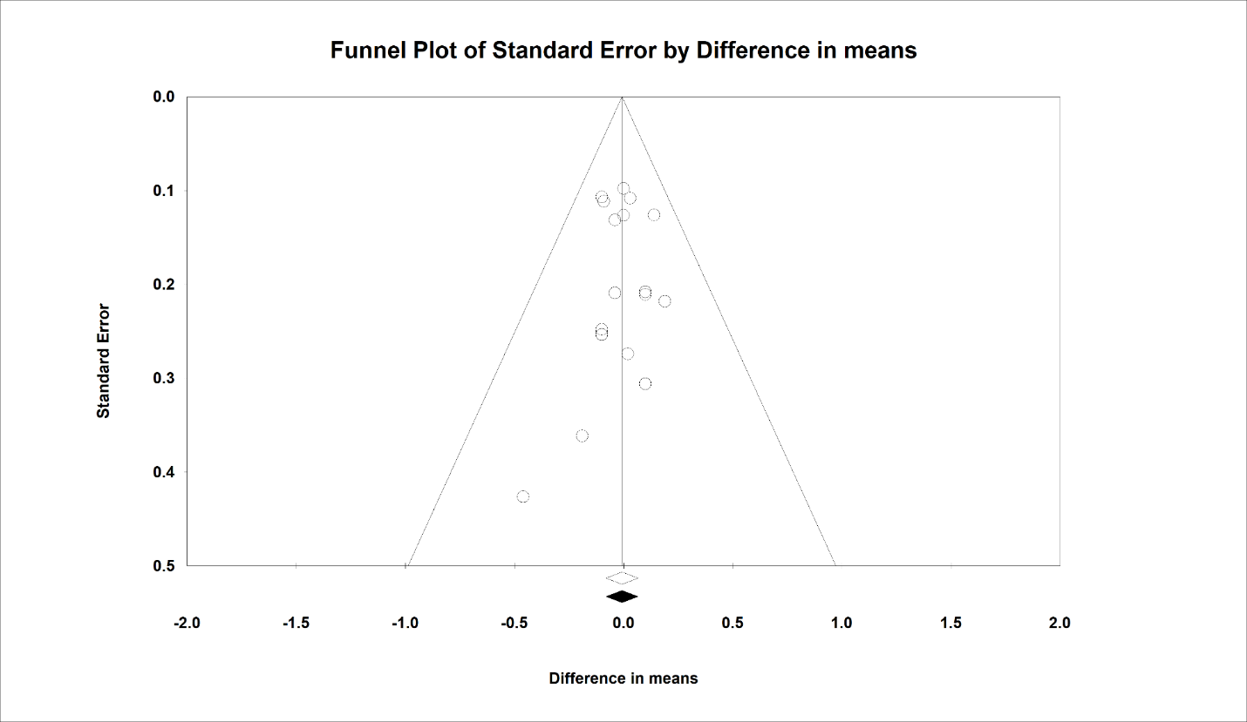 Figure S7. Funnel plot of standard error by weighted mean difference for low-density lipoprotein cholesterol (LDL-C), assessing publication bias across the 17 included studies. Open circles represent observed studies; no studies were imputed by the Duval and Tweedie trim-and-fill procedure. Neither Begg's rank correlation test (Kendall's Tau = -0.11, z=0.61, P=0.53) nor Egger's linear regression test (intercept=-0.11, 95% CI: -0.93 to 0.71, t=0.28, df=15, P=0.77) indicated significant publication bias; fail-safe N analysis was not applicable as the pooled effect was already non-significant.
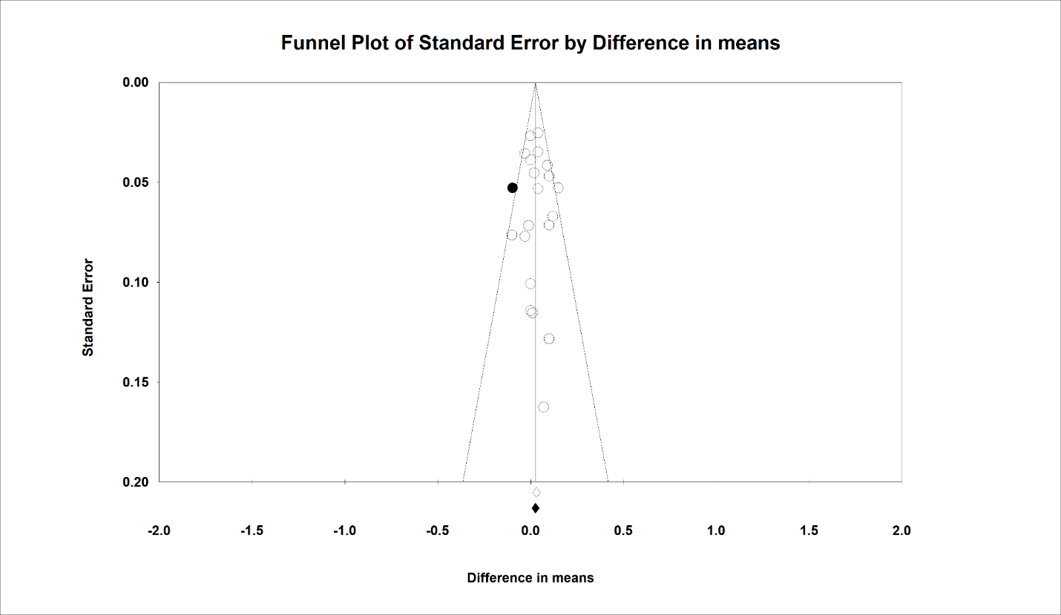 Figure S8. Funnel plot of standard error by weighted mean difference for high-density lipoprotein cholesterol (HDL-C), assessing publication bias across the 19 included studies. Open circles represent observed studies; filled circles represent studies imputed by the Duval and Tweedie trim-and-fill procedure (n=1 imputed study). Neither Begg's rank correlation test (Kendall's Tau = 0.02, z=0.16, P=0.87) nor Egger's linear regression test (intercept=0.24, 95% CI: -0.90 to 1.38, t=0.44, df=18, P=0.66) indicated significant publication bias; the fail-safe N was 24.

