Table S1. Adjusted mean (SE) of each Korean Healthy Eating Index component and energy consumption across alcohol drinking levels.^{1,2,3}
 | Score range | Never | Former | Light | Moderate | Heavy
Unweighted N |  | 1067 | 1840 | 5437 | 768 | 907
KHEI components
KHEI total score | 0-100 | 59.1 (0.52) | 59.7 (0.38) | 58.7 (0.25) | 56.8 (0.54) | 54.8 (0.47)
Adequacy (8 items) | 0-55 | 26.2 (0.38) | 26.7 (0.28) | 26.3 (0.18) | 25.5 (0.41) | 24.1 (0.35)
Have breakfast | 0-10 | 6.5 (0.14) | 6.4 (0.13) | 6.3 (0.09) | 6.0 (0.18) | 5.5 (0.19)
Mixed grains intake | 0-5 | 0.9 (0.08) | 1.0 (0.06) | 0.9 (0.03) | 0.9 (0.07) | 0.7 (0.06)
Total fruit intake | 0-5 | 1.8 (0.09) | 1.9 (0.07) | 1.8 (0.05) | 1.5 (0.09) | 1.3 (0.07)
Fresh fruit intake | 0-5 | 2.0 (0.10) | 2.3 (0.08) | 2.1 (0.05) | 1.7 (0.09) | 1.6 (0.09)
Total vegetable intake | 0-5 | 2.6 (0.07) | 2.6 (0.05) | 2.6 (0.03) | 2.7 (0.06) | 2.8 (0.06)
Vegetable intake, excluding Kimchi and pickled vegetables | 0-5 | 2.1 (0.07) | 2.1 (0.05) | 2.1 (0.04) | 2.1 (0.07) | 2.3 (0.07)
Meat, fish, eggs, and beans intake | 0-10 | 6.5 (0.14) | 6.7 (0.10) | 6.7 (0.06) | 7.1 (0.14) | 7.1 (0.12)
Milk and milk product intake | 0-10 | 3.9 (0.19) | 3.9 (0.15) | 4.1 (0.10) | 3.6 (0.20) | 3.0 (0.17)
Moderation (3 items) | 0-30 | 23.8 (0.19) | 23.4 (0.16) | 23.0 (0.11) | 22.2 (0.21) | 22.1 (0.20)
Percentage of energy from saturated fatty acids | 0-10 | 6.9 (0.16) | 6.5 (0.13) | 6.3 (0.09) | 5.8 (0.18) | 6.1 (0.19)
Sodium intake | 0-10 | 7.2 (0.10) | 7.3 (0.08) | 7.1 (0.05) | 6.6 (0.11) | 6.3 (0.11)
Percentage of energy from sweets and beverages | 0-10 | 9.7 (0.04) | 9.6 (0.04) | 9.6 (0.03) | 9.7 (0.06) | 9.6 (0.07)
Energy balance (3 items) | 0-15 | 9.1 (0.21) | 9.5 (0.14) | 9.3 (0.10) | 9.1 (0.21) | 8.7 (0.21)
Percentage of energy from carbohydrates | 0-5 | 2.6 (0.09) | 2.7 (0.07) | 2.7 (0.04) | 2.5 (0.11) | 2.4 (0.11)
Percentage of energy intake from fat | 0-5 | 3.5 (0.09) | 3.6 (0.06) | 3.6 (0.04) | 3.4 (0.10) | 3.4 (0.09)
Energy intake | 0-5 | 3.0 (0.10) | 3.2 (0.07) | 3.1 (0.04) | 3.1 (0.10) | 2.9 (0.10)
Energy consumption
Energy intake, including alcoholic beverages, kcal/day⁴ |  | 1766 (26.60) | 1782 (19.71) | 1791 (13.89) | 1895 (35.49) | 2007 (39.11)
Energy intake, excluding alcoholic beverages, kcal/day⁴ |  | 1739 (26.69) | 1769 (19.55) | 1750 (13.33) | 1705 (31.23) | 1658 (34.20)
Carbohydrate intake, g/day |  | 263.2 (2.09) | 260.8 (1.64) | 259.5 (1.23) | 251.1 (2.51) | 250.8 (2.57)
Protein intake, g/day |  | 68.1 (0.71) | 68.9 (0.61) | 69.7 (0.43) | 74.7 (0.89) | 76.3 (1.01)
Fat intake, g/day |  | 49.2 (0.81) | 50.0 (0.63) | 50.6 (0.44) | 53.7 (1.01) | 53.2 (0.97)
Percentage of energy from carbohydrates, %⁵
Using energy intake, including alcoholic beverages |  | 60.8 (0.47) | 59.3 (0.35) | 58.3 (0.26) | 53.7 (0.54) | 50.8 (0.68)
Using energy intake, excluding alcoholic beverages |  | 61.4 (0.45) | 59.8 (0.34) | 59.5 (0.24) | 57.8 (0.49) | 57.5 (0.55)
Percentage of energy from protein, %⁵
Using energy intake, including alcoholic beverages |  | 15.0 (0.16) | 15.4 (0.13) | 15.4 (0.09) | 15.5 (0.17) | 14.8 (0.20)
Using energy intake, excluding alcoholic beverages |  | 15.2 (0.17) | 15.5 (0.13) | 15.8 (0.09) | 17.0 (0.19) | 17.5 (0.23)
Percentage of energy from fat, %⁵
Using energy intake, including alcoholic beverages |  | 23.0 (0.37) | 24.5 (0.28) | 24.3 (0.18) | 23.7 (0.42) | 21.5 (0.43)
Using energy intake, excluding alcoholic beverages |  | 23.2 (0.38) | 24.5 (0.28) | 24.8 (0.19) | 26.3 (0.44) | 26.2 (0.45)
¹ The adjusted mean KHEI score for all participants was 58.3, with the adjusted mean scores for the adequacy, moderation, and energy balance components being 26.1, 23.0, and 9.3, respectively.
² Means (SEs) were adjusted for age (years), sex (females, males), total daily energy intake (kcal/day, excluding alcoholic beverages), BMI (kg/m²), education level (college graduate, non-graduate), household income (≥ the median, <the median), current smoking (current, past/never), aerobic physical activity (yes, no), marital status (living with a spouse, living without a spouse), residence (urban, rural), perceived stress (yes, no), hypertension (yes, no), diabetes (yes, no), and dyslipidemia (yes, no). Total daily energy intake excluding alcoholic beverages was not adjusted for when energy intake itself was the outcome.
³ Participants were categorised into never-drinkers (lifetime abstainers), former drinkers (no alcohol use in the past 12 months), light drinkers (women: <0.5 serving/d; men: <1.0 serving/d), moderate drinkers (women: 0.5–1.0 serving/d; men: 1.0–2.0 servings/d) and heavy drinkers (women: >1.0 servings/d; men: >2.0 servings/d).
⁴ Although individual values for “including” and “excluding” alcohol are identical in never and former drinkers subgroups, the adjusted mean estimates may differ slightly because they are derived from regression models with covariate adjustment.
⁵ Total energy intake, including or excluding that derived from alcoholic beverages, was used as the denominator; The sum of adjusted mean percentages may not equal 100% because each macronutrient model was estimated separately after covariate adjustment.
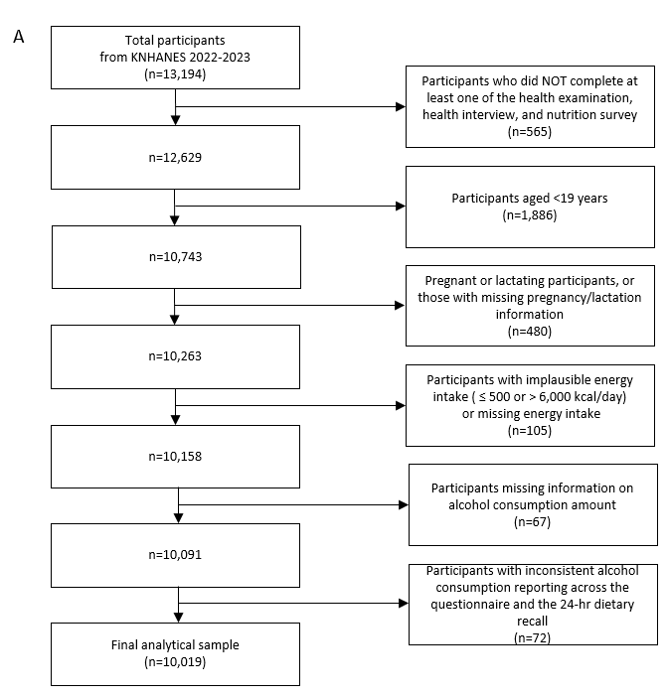 | 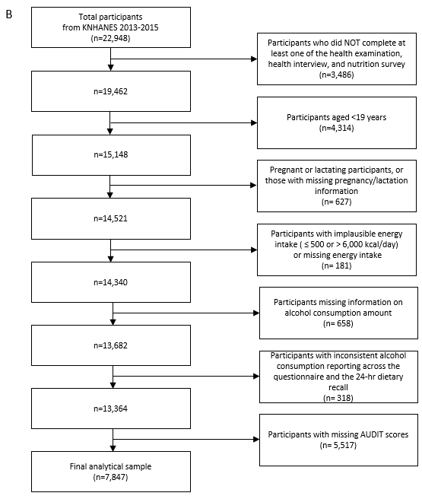
Figure S1. Flow diagrams of participant selection.

(A) Participant selection for the main analysis using data from KNHANES 2022–2023.
(B) Participant selection for the AUDIT analysis using data from KNHANES 2013–2015.

Table S2. Adjusted mean (SE) of source-specific macronutrient intake after excluding alcohol-derived energy across alcohol drinking levels.¹
 | Never | Former | Light | Moderate | Heavy
Carbohydrate intake from staple foods² (g/day) | 161.6 (3.59) | 158.6 (2.61) | 155.2 (1.54) | 153.8 (4.02) | 158.0 (3.96)
from fruits (g/day) | 17.5 (1.25) | 17.8 (0.96) | 16.8 (0.66) | 13.3 (1.00) | 11.2 (0.88)
Protein intake from meat (g/day) | 19.8 (0.73) | 18.9 (0.61) | 20.2 (0.47) | 25.0 (1.09) | 26.1 (1.20)
from fish (g/day) | 6.6 (0.41) | 7.5 (0.40) | 7.2 (0.24) | 8.3 (0.62) | 8.5 (0.66)
from egg (g/day) | 4.9 (0.28) | 5.4 (0.24) | 5.0 (0.13) | 4.9 (0.34) | 5.0 (0.28)
from beans (g/day) | 4.4 (0.33) | 4.5 (0.25) | 4.5 (0.14) | 4.2 (0.33) | 4.0 (0.26)
Fat intake from meat (g/day) | 14.7 (0.78) | 13.4 (0.56) | 15.1 (0.48) | 18.9 (1.03) | 19.6 (1.05)
from fish (g/day) | 1.1 (0.12) | 1.6 (0.13) | 1.5 (0.10) | 1.6 (0.18) | 1.3 (0.13)
from oils and fats (g/day) | 6.4 (0.27) | 6.6 (0.24) | 6.5 (0.15) | 7.0 (0.33) | 7.4 (0.39)
Alcohol consumed with meals (%) | -³ | -³ | 79.3 | 79.2 | 83.0
¹ Means (SEs) were adjusted for age (years), sex (females, males), total daily energy intake (kcal/day, excluding alcoholic beverages), BMI (kg/m²), education level (college graduate, non-graduate), household income (≥ the median, <the median), current smoking (current, past/never), aerobic physical activity (yes, no), marital status (living with a spouse, living without a spouse), residence (urban, rural), perceived stress (yes, no), hypertension (yes, no), diabetes (yes, no), and dyslipidemia (yes, no).
² Staple foods were defined as commonly consumed grain-based staples, including rice, noodles, barley, rice cakes, and bread.
³ Alcohol consumed with meals (%) was not applicable for never and former drinkers.

Table S3. Multivariate adjusted prevalence ratios and 95% confidence intervals for poor dietary quality across drinking levels.
 | Continuous¹ | Never | Former | Light | Moderate | Heavy
No. | 10,019 | 1,067 | 1,840 | 5,437 | 768 | 907
Prevalence ratio² | 1.12 (1.06, 1.19) | 1 (Ref) | 1.09 (0.82, 1.44) | 1.33 (1.03, 1.72) | 1.71 (1.28, 2.30) | 1.91 (1.44, 2.53)
Ref, Reference.
¹ Values for the continuous exposure represent PRs (95% CIs) for poor dietary quality per one standard drink increase.
² Prevalence ratios (95% CIs) were estimated using modified Poisson regression with robust variance estimation. The model was adjusted for age (years), sex (females, males), total daily energy intake (kcal/day, excluding alcoholic beverages), BMI (kg/m²), education level (college graduate, non-graduate), household income (≥ the median, <the median), current smoking (current, past/never), aerobic physical activity (yes, no), marital status (living with a spouse, living without a spouse), residence (urban, rural), perceived stress (yes, no), hypertension (yes, no), diabetes (yes, no), and dyslipidemia (yes, no).

Table S4. Association between continuous alcohol intake and continuous Korean Healthy Eating Index (KHEI) score.^{1,2}
Exposure | β (95% CI) | P value
Alcohol intake (per 1 serving/day) | −1.25 (−1.65, −0.85) | <0.001
¹ Values are β coefficients (95% confidence intervals) estimated using survey-weighted linear regression.
² The model was adjusted for age (years), sex (females, males), total daily energy intake (kcal/day, excluding alcoholic beverages), BMI (kg/m²), education level (college graduate, non-graduate), household income (≥ the median, <the median), current smoking (current, past/never), aerobic physical activity (yes, no), marital status (living with a spouse, living without a spouse), residence (urban, rural), perceived stress (yes, no), hypertension (yes, no), diabetes (yes, no), and dyslipidemia (yes, no).

Table S5. Sensitivity analysis: Additional adjustment for smoking intensity (cigarettes/day) in the association between alcohol drinking level and poor dietary quality.
 | Continuous¹ | Never | Former | Light | Moderate | Heavy
No. | 10,019 | 1,067 | 1,840 | 5,437 | 768 | 907
Model 3 (original)² | 1.23 (1.13, 1.34) | 1 (Ref) | 1.05 (0.74, 1.50) | 1.34 (0.98, 1.83) | 1.89 (1.26, 2.82) | 2.37 (1.64, 3.42)
Model 3 + smoking intensity | 1.23 (1.12, 1.34) | 1 (Ref) | 1.06 (0.74, 1.51) | 1.34 (0.98, 1.84) | 1.90 (1.26, 2.84) | 2.35 (1.62, 3.39)
Ref, Reference.
¹ Odds ratio (95% CI) for poor dietary quality per one standard drink (14 g ethanol) increase.
² Model 3: Adjusted for the variables in Model 2, and marital status (living with a spouse, living without a spouse), residence (urban, rural), perceived stress (yes, no), hypertension (yes, no), diabetes (yes, no), and dyslipidemia (yes, no).

