Additional file 1: Appendix A
Table S1. Coordinate points of eight muscles according to a previous study [1].
Muscle | Point | x [m] | y [m] | Reference frame
Iliopsoas* | Origin | 0.0075 | 0.1350 | Trunk
 | Via point | 0.0260 | 0.0293 | Trunk
 | Insertion | -0.0180 | 0.3351 | Thigh
Gluteus maximus* | Origin | -0.0578 | 0.0754 | Trunk
 | Via point | -0.0409 | -0.0455 | Trunk
 | Insertion | -0.0158 | 0.3519 | Thigh
Vastus | Origin | 0.0106 | 0.2026 | Thigh
 | Via point | -0.0005 | 0.4056 | Shank
 | Insertion | 0.0000 | 0.3700 | Shank
Rectus femoris* | Origin | 0.0326 | 0.0323 | Trunk
 | Via point | 0.0041 | 0.4084 | Shank
 | Insertion | 0.0000 | 0.3700 | Shank
Hamstrings* | Origin | -0.0409 | -0.0455 | Trunk
 | Insertion | -0.0508 | 0.3321 | Shank
Tibialis anterior | Origin | -0.0155 | 0.2175 | Shank
 | Via point | 0.0259 | 0.0257 | Shank
 | Insertion | 0.1850 | -0.0510 | Foot
Soleus | Origin | -0.0292 | 0.2467 | Shank
 | Insertion | -0.0365 | -0.0288 | Foot
Gastrocnemius | Origin | -0.0203 | 0.0071 | Thigh
 | Insertion | -0.0368 | -0.0289 | Foot
* The muscle lines were used to calculate hip joint contact force during sit-to-stand (STS) movements.

Additional file 1: Appendix B
Operation of the normalized maximum muscle forces
The change in the normalized muscle forces (i.e., $F_{N_L}$) affects the change in the normalized maximum force (i.e., $F_{N_MAX}$). The normalized muscle forces were changed using parameter “k” through the following equation:

${F'}_{N_L}({\tilde{L}}_{m}(t))=k_{m}\left(F_{N_L}({\tilde{L}}_{m}(t))-1\right)+1$,

where:
$${F'}_{N_L}: changed and normalized muscle force;$$
$$t: time;$$
$$k: random value \left(within 0.5–1.5\right);and$$
$$F_{N_L}: normalized muscle force.$$

$f_{ce}$ in Eq. (5) was replaced by ${F'}_{N_L}$ at the time step, such that a sensitivity analysis can be conducted.

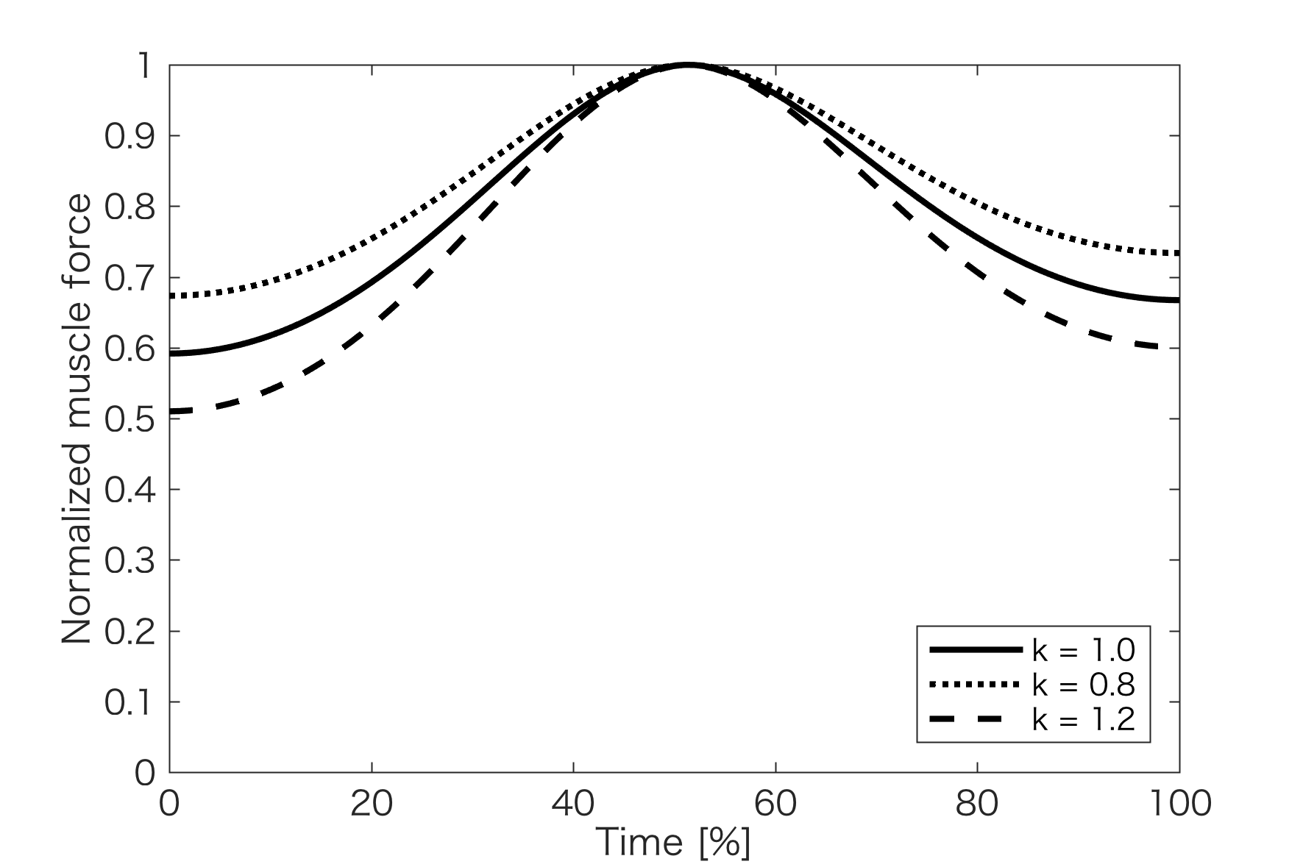
Figure S1. Typical examples of the changes in the normalized muscle force
The normalized muscle force is affected by the changing parameter “k.”

Additional file 1: Appendix C
Computer simulation using other muscle moment arm lengths
We tested the computer simulation using the muscle moment arm lengths reported by Yoshioka et al. [2]. The results are shown in the table below.

Table S2. Comparison of the peak muscle forces estimated using different muscle moment arm lengths during the STS movements.
 | A | B | C
Muscle forces (N/kg)
Gluteus maximus | 19.0 | 5.5 | 5.6
Hamstrings | 25.8 | 9.7 | 7.8
Sum of the peak hip and peak knee extensor muscle forces | 82.4 | 42.8 | 44.7
A: This study uses the muscle moment arm lengths in Table 1.
B: This study uses the muscle moment arm lengths reported by Yoshioka et al. [2].
C: Yoshioka et al. [2].

References
1. A musculoskeletal model of the human lower extremity: the effect of muscle, tendon, and moment arm on the moment-angle relationship of musculotendon actuators at the hip, knee, and ankle. J Biomech. 1990;23:157–69.
2. The minimum required muscle force for a sit-to-stand task. J Biomech. 2012;45:699–705.

