Additional File 1

Supplementary methods

Lumped parameter model (LPM)

The LPM consists of 13 compartments. Ten compartments describe the cardiovascular circulation – left and right atrium, left and right ventricle, aorta, system arterial and systemic venous circulation, pulmonary artery, pulmonary arterial and pulmonary venous circulation. In addition, the VAD is described by an inflow cannula, an outflow cannula and the pump compartment which creates a relationship between pressure head and pump flow.

Except for the cardiac chambers and the pump, all remaining compartments (8 compartments) were described with a resistance R and a hydraulic compliance C in a parallel circuit yielding the following ODEs (equation 1a and 1b):

$Q_{out}=\frac{p_{i}-p_{i+1}}{R_{i}}$ (1a)
$\frac{{dp}_{i}}{dt}=\frac{Q_{in}-Q_{out}}{C_{i}}$ (1b)

Q_{in} and Q_{out} are the incoming and outgoing flows into the compartment i (R_{i} and C_{i}); p_{i} and p_{i+1} are the pressures of the corresponding and the downstream compartment, respectively.

The ventricles (equation 2a) and atria (equation 2b) were modelled as time-varying elastances described by the following equations:

$p_{j}= V_{j}e_{v}\left(t\right)E_{max,j}+(1-e_{v}\left(t\right))(α_{j}e^{κ_{j}V_{j}}+β_{j})$ with j= LV or RV (2a)
$p_{k}=V_{k}(e_{a}\left(t\right)\left(E_{max,k}-E_{d,k}\right)+E_{d,k})$ with k =LA or RA (2b)
$\frac{{dV}_{i}}{dt}=Q_{in}-Q_{out}$ (3)

e_{v}(t) and e_{a}(t) are the ventricular and atrial activity functions (analytical formula in equation 4). E_{max} and E_{d} are the maximal systolic and diastolic elastances. α, β and κ are parameters quantifying end-diastolic ventricular elastance.

T_{s1,v/a} and T_{s2,v/a} are the respective time constants of the ventricular and atrial activity functions. T_{c} is the duration of the cardiac cycle (1 s).

$e_{v/a}=\left\{\begin{aligned}\frac{1-cos⁡(\frac{t}{T_{s1,v/a}}π)}{2}, 0≤t <T_{s1,v/a} \\ \frac{1+\cos\left(\frac{t-T_{s1,\frac{v}{a}}}{T_{s2,\frac{v}{a}}-T_{s1,\frac{v}{a}}}\right), T_{s1,v/a}≤t<T_{s2,v/a}}{2} \\ 0, T_{s2,v/a}≤t<T_{c}\end{aligned}\right.$ (4)

The valves (aortic, tricuspidal, mitral, pulmonary) were described as an ideal diode allowing only forward flow direction and an orifice with a quadratic pressure loss (loss coefficient CQ_{i}), see equation 5:
$Q_{out}=\sqrt{p_{i}-p_{i+1}}{CQ}_{i}$ (5)

Considering the pressure difference H across the LVAD, the according blood flow through the pump is shown in equation 6. The parameters a_{i} were fitted to an existing HVAD HQ curve. rpm is the rotational frequency of the VAD:

$Q_{VAD}=a_{0}+a_{1}rpm+a_{2}H+a_{3}H rpm+a_{4}H^{2}$ (6)

The system of ODEs was implemented in MATLAB and solved with an explicit Euler algorithm for a duration of 10 seconds and a timestep of 1e-4 s. After confirmation of a steady state, the last cycle was taken as an input for the CFD model, see Figure 1 in main text.

The parameters of the LPM are shown below. They are mostly taken from the work of Neidlin et al. (reference 27 in the main text) and were adjusted to model the desired behavior.

Table 1: Model parameters
Part | Parameter | Value
Systemic circulation | R_{aorta} [mmHg s/ml]  C_{aorta} [ml/mmHg]  R_{sart} [mmHg s/ml]  C_{sart} [ml/mmHg]  R_{svn} [mmHg s/ml]  C_{svn} [ml/mmHg] | 0.015  0.17  0.845  1.1  0.04  12
Pulmonary circulation | R_{pa} [mmHg s/ml]  C_{pa} [ml/mmHg]  R_{part} [mmHg s/ml]  C_{part} [ml/mmHg]  R_{pvn} [mmHg s/ml]  C_{pvn} [ml/mmHg] | 0.008  0.625  0.065  4.32  0.04  0.6
Right heart | CQ_{tri} [ml/s mmHg^{0.5}]  CQ_{pul} [ml/s mmHg^{0.5}]  E_{maxRA} [mmHg/ml]  E_{dRA} [mmHg/ml]  E_{maxRV} [mmHg/ml]  α_{RV} [mmHg/ml]  β_{RV} [mmHg/ml]  κ_{RV} [1/ml] | 400  350  0.2025  0.1575  0.342  0.047  4.27  0.028
Left heart | CQ_{mi} [ml/s mmHg^{0.5}]  CQao [ml/s mmHg^{0.5}]  E_{maxLA} [mmHg/ml]  E_{dLA} [mmHg/ml]  E_{maxLV} [mmHg/ml]  α_{LV} [mmHg/ml]  β_{LV} [mmHg/ml]  κ_{LV} [1/ml] | 400  350  0.45  0.2125  0.768  0.064  2.5  0.033
VAD | a₀  a₁  a₂  a₃  a₄  rpm | 28.1673  0.0738  -3.1436  6.75e-4  -0.0037  2600
Additional parameters | T_{c} [s]  T_{s1,v} [s]  T_{s2,v} [s]  T_{s1,a} [s]  T_{s2,a} [s] | 1  0.3  0.45  0.04  0.09

Supplementary results
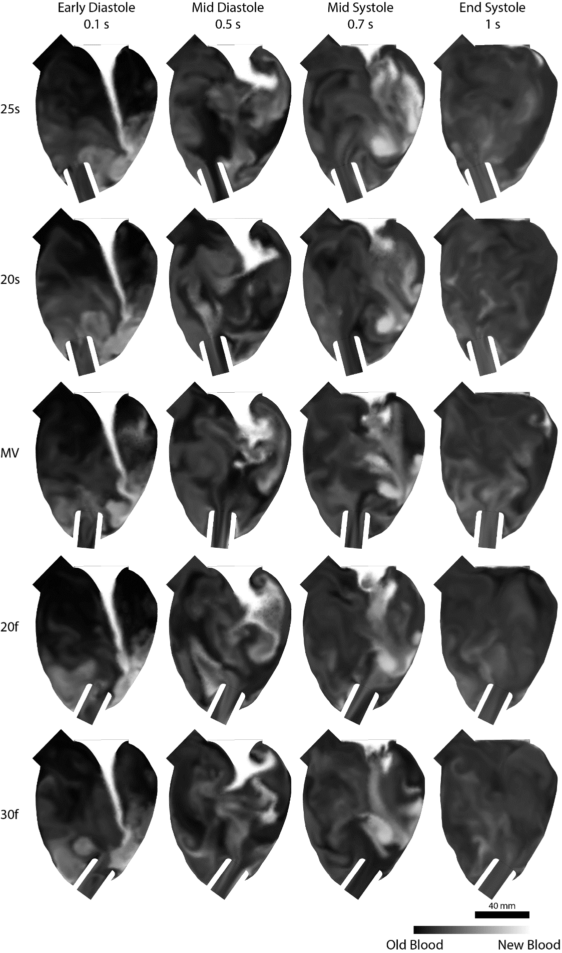
Fig. SI1 Flow path visualisation of new incoming blood to replace old blood with two severe cannulation angles towards the septum and free wall. Cannula angulation towards the free wall had better flow alignment towards the incoming blood, potentially increasing the risk of thrombosis

