Additional file 1

Mesh Dependency Study
In Table 1 we give an overview of the Grid Convergence Index (GCI) analysis for the two studied cases. We have based the analysis on mean WSS since WSS was the main study objective in this research. Three meshes, ith tetrahedral elements and prism layer close to the wall were created for each of the cases:
- Fine (mesh 1) - phantom (14.1 million), patient CoA (9.3 million)
- Medium (mesh 2) - phantom (7.0 million), patient CoA (4.7 million)
- Coarse (mesh 3) - phantom (3.6 million), patient CoA (2.3 million).
Both the Richardson extrapolation and the test whether the studied parameter lies in the asymptotic range show that the medium mesh is sufficient. Based on the analysis, we have proceeded with mesh 2 (medium), for all presented results.
The details of the final numerical meshes that were used for the two studied geometries are shown in Fig. 1.

Table 1: Mesh dependency analysis for phantom and patient, with wall shear stress for three different meshes (fine - 1, medium - 2, coarse - 3), refinement ratio r, Richardson extrapolation (fh=0), Grid Convergence Index (GCI1,2 - fine-medium, GCI2,3 - medium-coarse), and the test whether the studied variables lie in the asymptotic range
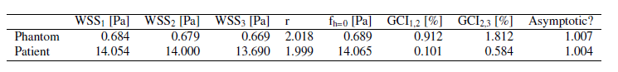

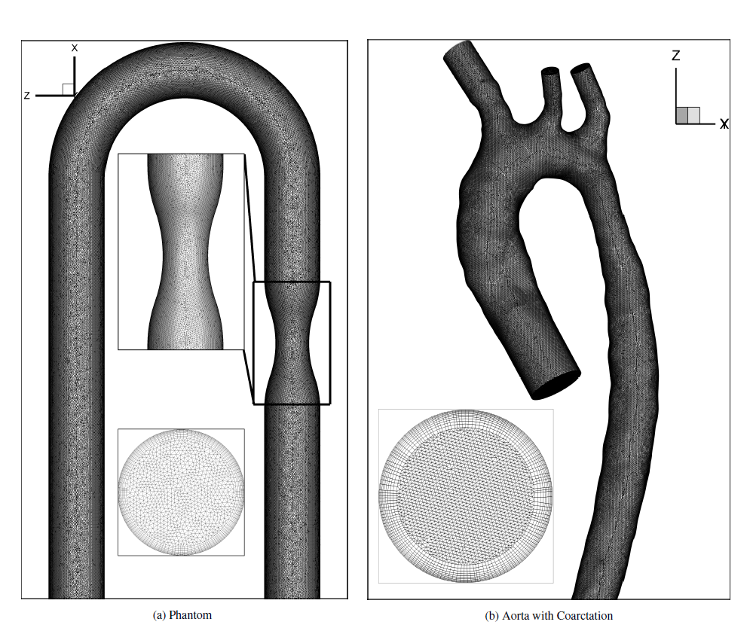
Figure 2: Tetrahedral mesh with details of inlet and stenosed region for phantom (a) and patient-specific aorta (b)

