Additional file

Wireless capsule endoscopy multiclass classification using three-dimensional deep convolutional neural network model

Mehrdokht Bordbar¹, Mohammad Sadegh Helfroush¹*, Habibollah Danyali¹ and Fardad Ejtehadi²

*Correspondence: ms_helfroush@sutech.ac.ir;
¹ Department of Electrical Engineering, Shiraz University of Technology, Shiraz, Iran
² Department of Internal Medicine, Gastroenterohepatology Research Center, School of Medicine, Shiraz University of Medical Sciences, Shiraz, Iran

BioMedical Engineering OnLine

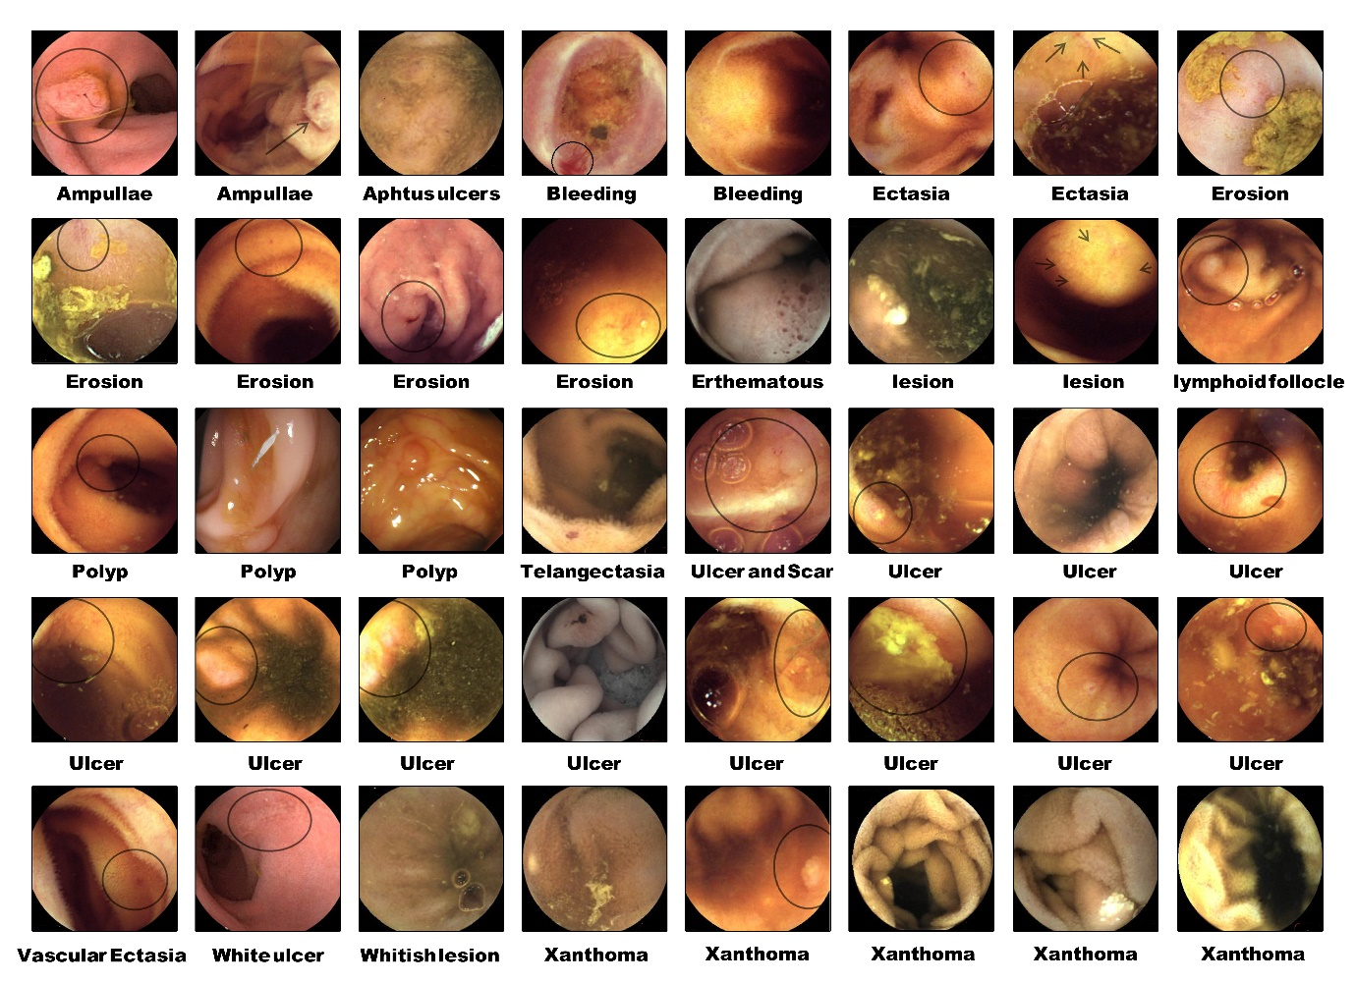
Figure S1. Samples of different types of lesions in the used dataset

Table S1. The comparisons of numerous studies in WCE video classification using deep networks
Year | Method | Task | Dataset | Validation method | Results
2016 [1] | 8 Layer CNN | Bleeding detection and classification | 10,000 frames  (Proprietary videos) | Cross validation, frame-based | F1 score: 99.5  Precision: 99.9  Recall: 99.2
2018 [2] | AlexNet | Ulcers and erosion detection and classification | 21,160 frames  (Proprietary videos) | Cross validation, frame-based | Accuracy: 95.0  Sensitivity: 95.2  Specificity: 95.7
2019 [3] | AlexNet, GooglNet | Ulcers detection and classification | 1,875 frames  (Proprietary videos) | Split dataset, frame-based | Accuracy: 100  Sensitivity: 100  Specificity: 100
2019 [4] | Single Shot Multi-Box  Detector | Angioectasia detection and classification | 2,237 frames  (Proprietary videos) | Split dataset, frame-based | Accuracy: 98.7  Sensitivity: 98.8  Specificity: 98.4
2019 [5] | Single Shot Multi-Box  Detector | Ulcers and erosion detection and classification | 1,580 frames  (Proprietary videos) | Split dataset, disease-based | Accuracy: 90.8  Sensitivity: 88.2  Specificity: 90.9
2020 [6] | Inception-ResNet-v2 | Significant frames classification | 210,100 frames  (Proprietary videos) | Cross validation, frame-based & disease-based | Accuracy: 98.3  Sensitivity: 96.0  Specificity: 99.5
2021 [7] | AlexNet + Triplet Network | Abnormality detection and classification | 5,306 frames  (Proprietary videos) | Split dataset, frame-based | Accuracy: 90.8  Sensitivity: 91.4  Specificity: 90.9
2021 [8] | MobileNet + CNN | Bleeding detection and classification | 1650 frames  (Proprietary videos) | Cross validation, frame-based | Accuracy: 99.3  Sensitivity: 99.4  Precision: 100
2021 [9] | Inception-Resnet-V2 | Multiple disease detection and classification | 400,000 frames  (Proprietary videos) | Split dataset, frame-based | Accuracy: 97.9  Sensitivity: 97.2  Specificity: 98.7
2021 [10] | Backbone networks + SVM (VGG19, InceptionV3, ResNet50) | Bleeding detection and classification | KID Dataset 2 [11] , MICAAI 2017 [12] | Cross validation, frame-based | Accuracy: 98.2, 95.7  Sensitivity: 98.7, 95.8  Specificity: 97.3, 95.5
2022 [13] | Backbone networks + Dense layers (Efficientnet, DenseNet, Xception) | Multiple disease detection and classification | Kvasir [14] | Split dataset, frame-based | Accuracy: 94.8
Table S2. Proposed 2D-CNN characteristics
Layers arrange and their specifications
1 | Image input | 224×224×3 images with “zerocenter” normalization
2 | Convolution | 32 3×3×3 convolutions with stride [1 1] and padding “same”
3 | Batch normalization | Batch normalization with 32 channels
4 | ReLU | ReLU activation function
5 | Max pooling | 2×2 max pooling with stride [2 2] and “zero” padding
6 | Dropout | Dropout with 0.4 rate
7 | Convolution | 64 3×3×32 convolutions with stride [1 1] and padding “same”
8 | Batch normalization | Batch normalization with 64 channels
9 | ReLU | ReLU activation function
10 | Max pooling | 2×2 max pooling with stride [2 2] and “zero” padding
11 | Dropout | Dropout with 0.4 rate
12 | Convolution | 128 3×3×64 convolutions with stride [1 1] and padding “same”
13 | Batch normalization | Batch normalization with 128 channels
14 | ReLU | ReLU activation function
15 | Max pooling | 2×2 max pooling with stride [2 2] and “zero” padding
16 | Dropout | Dropout with 0.4 rate
17 | Convolution | 256 3×3×128 convolutions with stride [1 1] and padding “same”
18 | Batch normalization | Batch normalization with 256 channels
19 | ReLU | ReLU activation function
20 | Max pooling | 2×2 max pooling with stride [2 2] and “zero” padding
21 | Dropout | Dropout with 0.4 rate
22 | Convolution | 512 3×3×256 convolutions with stride [1 1] and padding “same”
23 | Batch normalization | Batch normalization with 512 channels
24 | ReLU | ReLU activation function
25 | Max pooling | 2×2 max pooling with stride [2 2] and “zero” padding
26 | Dropout | Dropout with 0.4 rate
27 | Fully connected | 1 fully connected layer after the flatten filter
28 | Dropout | Dropout with 0.4 rate
29 | Softmax | Softmax layer with 3 output classes
Training options
 | Max epochs | 150
 | Batch size | 32
 | Learning rate | 0.0001
 | Decay rate | 0.0001
 | Solver for training network | Adam optimizer
 | Loss function | Cross-entropy
 | Total trainable parameters | 7,992,131

Table S3. Proposed 3D-CNN characteristics
Layers arrange and their specifications
1 | Image input | 224×224×3×16 images with “zerocenter” normalization
2 | Convolution | 32 3×3×3×3 convolutions with stride [1 1 1] and padding “same”
3 | Batch normalization | Batch normalization with 32 channels
4 | ReLU | ReLU activation function
5 | Max pooling | 2×2×1 max pooling with stride [2 2 2] and “zero” padding
6 | Dropout | Dropout with 0.4 rate
7 | Convolution | 64 3×3×3×32 convolutions with stride [1 1 1] and padding “same”
8 | Batch normalization | Batch normalization with 64 channels
9 | ReLU | ReLU activation function
10 | Max pooling | 2×2×2 max pooling with stride [2 2 2] and “zero” padding
11 | Dropout | Dropout with 0.4 rate
12 | Convolution | 128 3×3×3×64 convolutions with stride [1 1 1] and padding “same”
13 | Batch normalization | Batch normalization with 128 channels
14 | ReLU | ReLU activation function
15 | Max pooling | 2×2×2 max pooling with stride [2 2 2] and “zero” padding
16 | Dropout | Dropout with 0.4 rate
17 | Convolution | 256 3×3×3×128 convolutions with stride [1 1 1] and padding “same”
18 | Batch normalization | Batch normalization with 256 channels
19 | ReLU | ReLU activation function
20 | Max pooling | 2×2×2 max pooling with stride [2 2 2] and “zero” padding
21 | Dropout | Dropout with 0.4 rate
22 | Convolution | 512 3×3×3×256 convolutions with stride [1 1 1] and padding “same”
23 | Batch normalization | Batch normalization with 512 channels
24 | ReLU | ReLU activation function
25 | Max pooling | 2×2×2 max pooling with stride [2 2 2] and “zero” padding
26 | Dropout | Dropout with 0.4 rate
27 | Fully connected | 1 fully connected layer after the flatten filter
28 | Dropout | Dropout with 0.4 rate
29 | Softmax | Softmax layer with 3 output classes
Training options
 | Max epochs | 150
 | Batch size | 32
 | Learning rate | 0.0001
 | Decay rate | 0.0001
 | Solver for training network | Adam optimizer
 | Loss function | Cross-entropy
 | Total trainable Parameters | 49,722,593

References:
1. Jia, X. and M.Q.-H. Meng. A deep convolutional neural network for bleeding detection in wireless capsule endoscopy images. in 2016 38th Annual International Conference of the IEEE Engineering in Medicine and Biology Society (EMBC). 2016. IEEE.
2. Fan, S., et al., Computer-aided detection of small intestinal ulcer and erosion in wireless capsule endoscopy images. Physics in Medicine & Biology, 2018. 63(16): p. 165001.
3. Alaskar, H., et al., Application of convolutional neural networks for automated ulcer detection in wireless capsule endoscopy images. Sensors, 2019. 19(6): p. 1265.
4. Tsuboi, A. and S. Oka, Artificial intelligence using a convolutional neural network for automatic detection of small-bowel angioectasia in capsule endoscopy images. 2020. 32(3): p. 382-390.
5. Aoki, T., et al., Automatic detection of erosions and ulcerations in wireless capsule endoscopy images based on a deep convolutional neural network. Gastrointestinal endoscopy, 2019. 89(2): p. 357-363. e2.
6. Park, J., et al., Artificial intelligence that determines the clinical significance of capsule endoscopy images can increase the efficiency of reading. PLoS One, 2020. 15(10): p. e0241474.
7. Adewole, S., et al. Lesion2Vec: Deep Meta Learning for Few-Shot Lesion Recognition in Capsule Endoscopy Video. in Proceedings of the Future Technologies Conference (FTC) 2021, Volume 2. 2022. Cham: Springer International Publishing.
8. Rustam, F., et al., Wireless Capsule Endoscopy Bleeding Images Classification Using CNN Based Model. IEEE Access, 2021. 9: p. 33675-33688.
9. Kim, S.H., et al., Efficacy of a comprehensive binary classification model using a deep convolutional neural network for wireless capsule endoscopy. Scientific Reports, 2021. 11(1): p. 17479.
10. Caroppo, A., A. Leone, and P. Siciliano, Deep transfer learning approaches for bleeding detection in endoscopy images. Computerized Medical Imaging and Graphics, 2021. 88: p. 101852.
11. Koulaouzidis, A., et al., KID Project: an internet-based digital video atlas of capsule endoscopy for research purposes. Endoscopy international open, 2017. 5(06): p. E477-E483.
12. Coelho, P., et al. A Deep Learning Approach for Red Lesions Detection in Video Capsule Endoscopies. in Image Analysis and Recognition. 2018. Cham: Springer International Publishing.
13. Su, Q., et al., Deep convolutional neural networks with ensemble learning and transfer learning for automated detection of gastrointestinal diseases. Computers in Biology and Medicine, 2022. 150: p. 106054.
14. Pogorelov, K., et al. Kvasir: A multi-class image dataset for computer aided gastrointestinal disease detection. in Proceedings of the 8th ACM on Multimedia Systems Conference. 2017.

