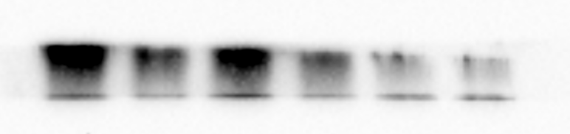
Col-I
β-actin
Strain strain strain control control control

Uncropped western blot image of Figure 2D

