Supplementary material
- Predicted LCL and MCL forces of the multibody model
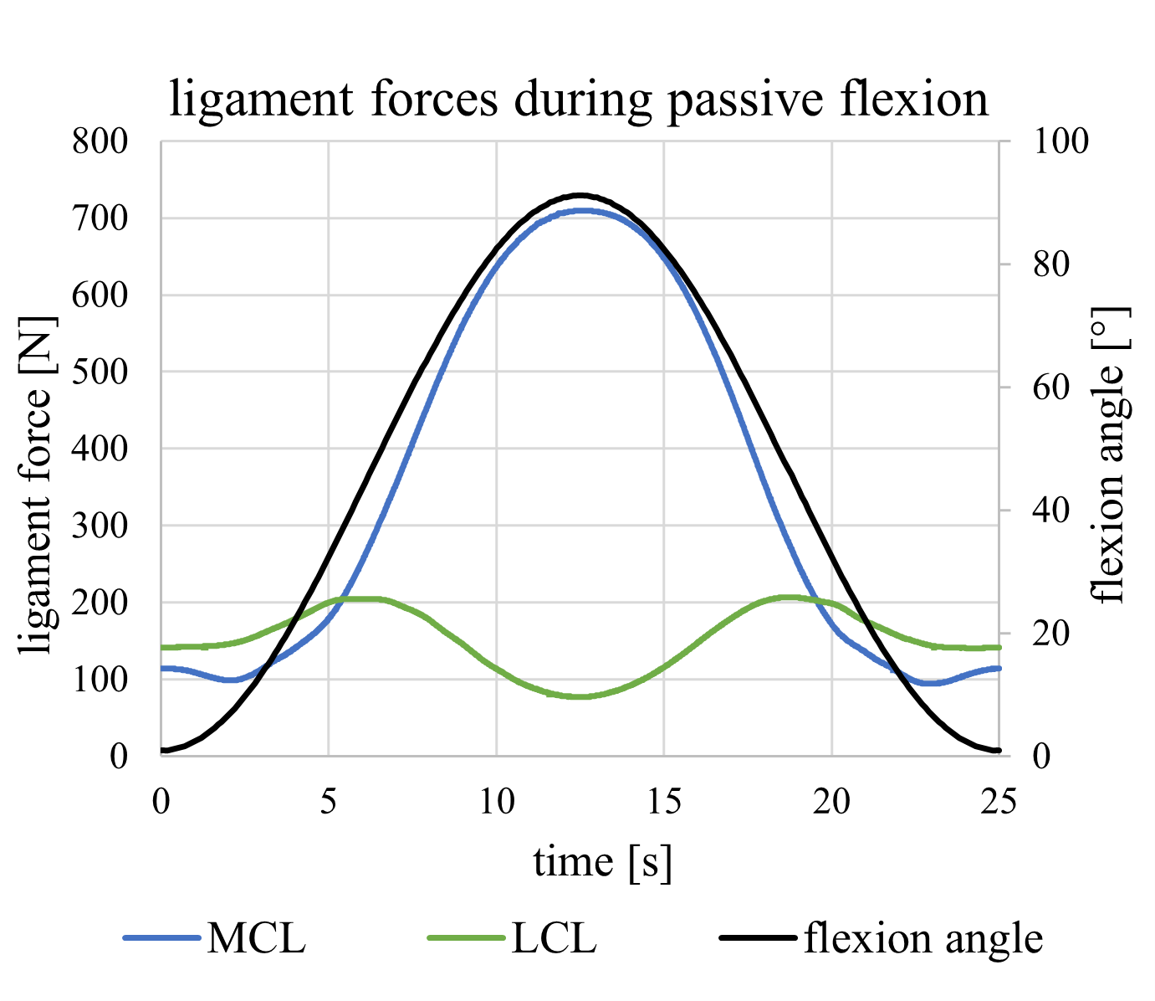
Fig. 1 shows the progression of the forces in the lateral and medial ligaments of the multibody model during passive flexion.
Figure 1: The calculated LCL and MCL ligament forces derived from the multibody model for the passive flexion over time

