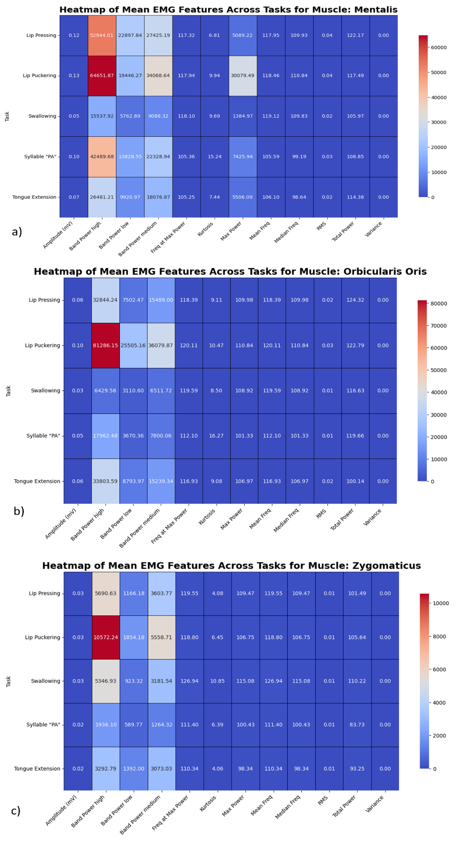
Fig S1. Heatmap describing the significance of different features during each task for: a) Musculus Mentalis; b) Musculus Orbicularis Oris; c) Musculus Zygomaticus Major.
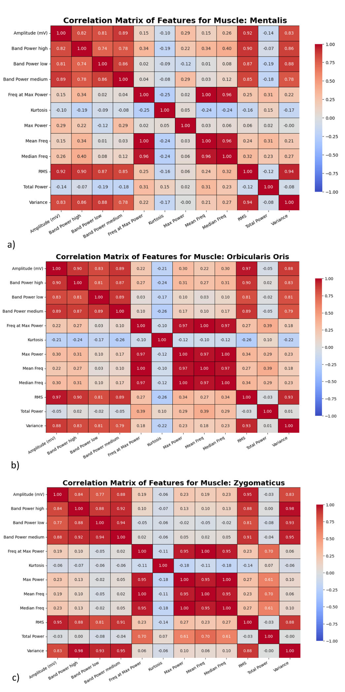
Fig S2. Heatmap describing the correlation matrix of different features for each muscle: a) Musculus Mentalis; b) Musculus Orbicularis Oris; c) Musculus Zygomaticus Major.

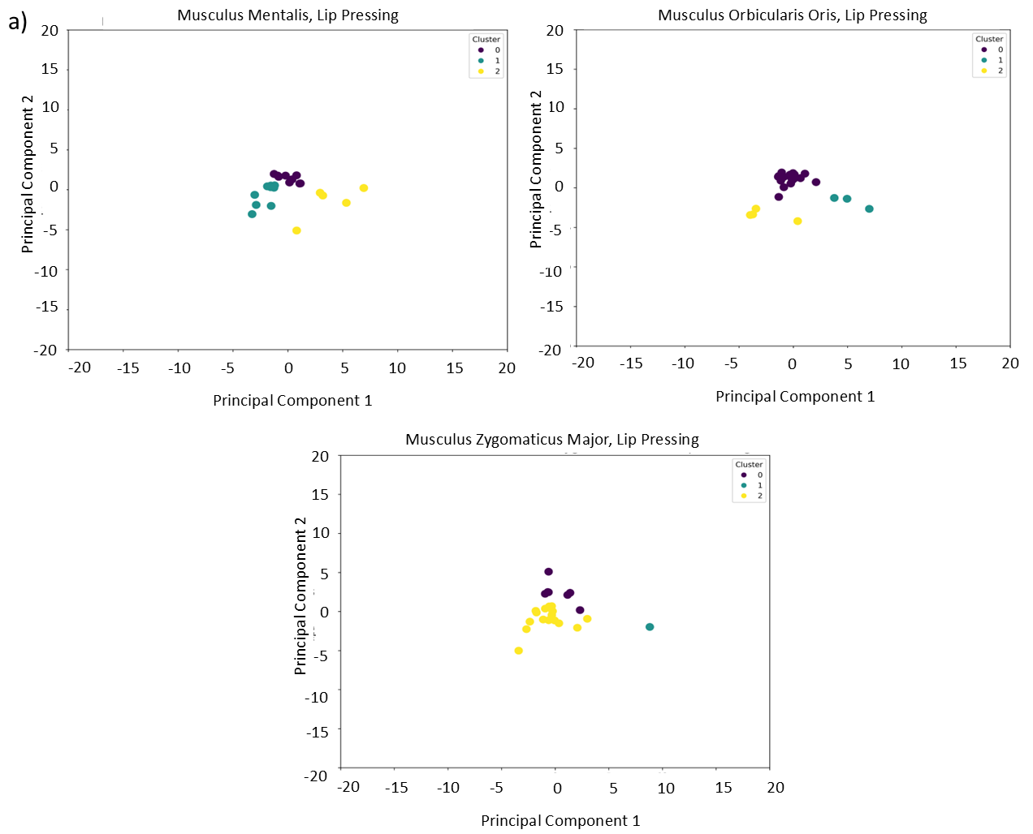
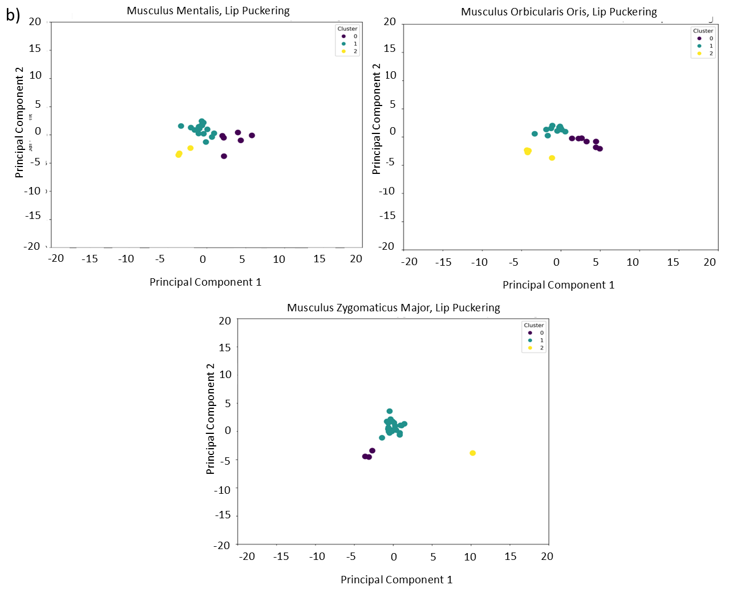
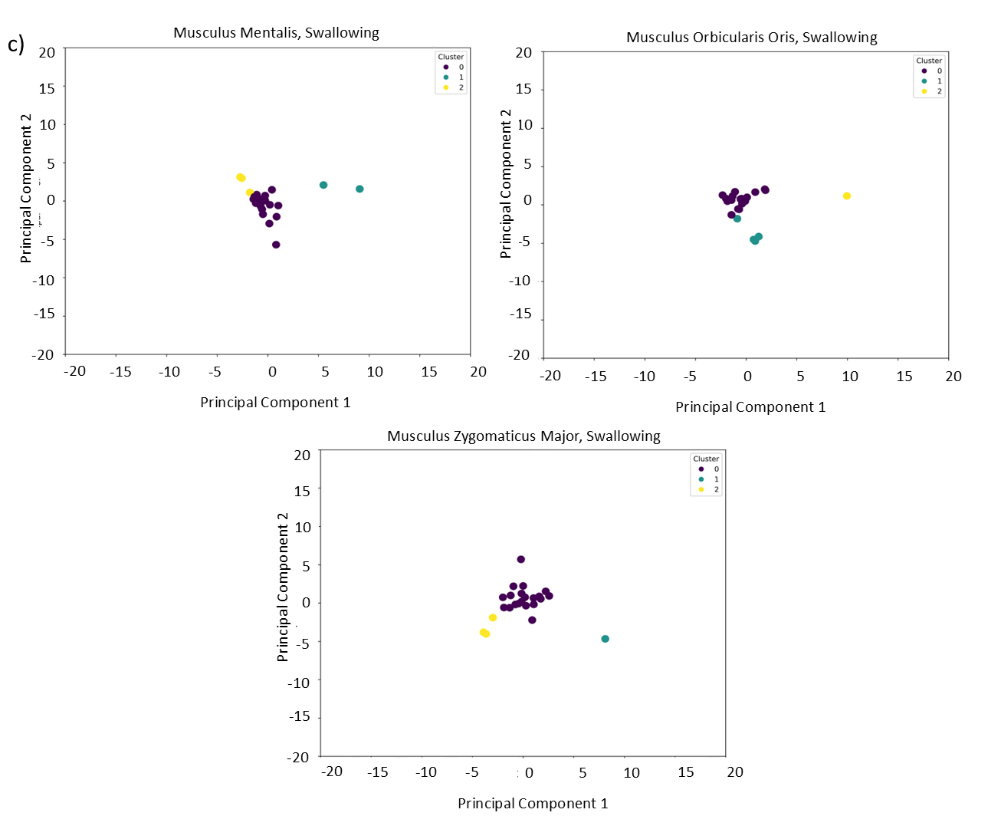
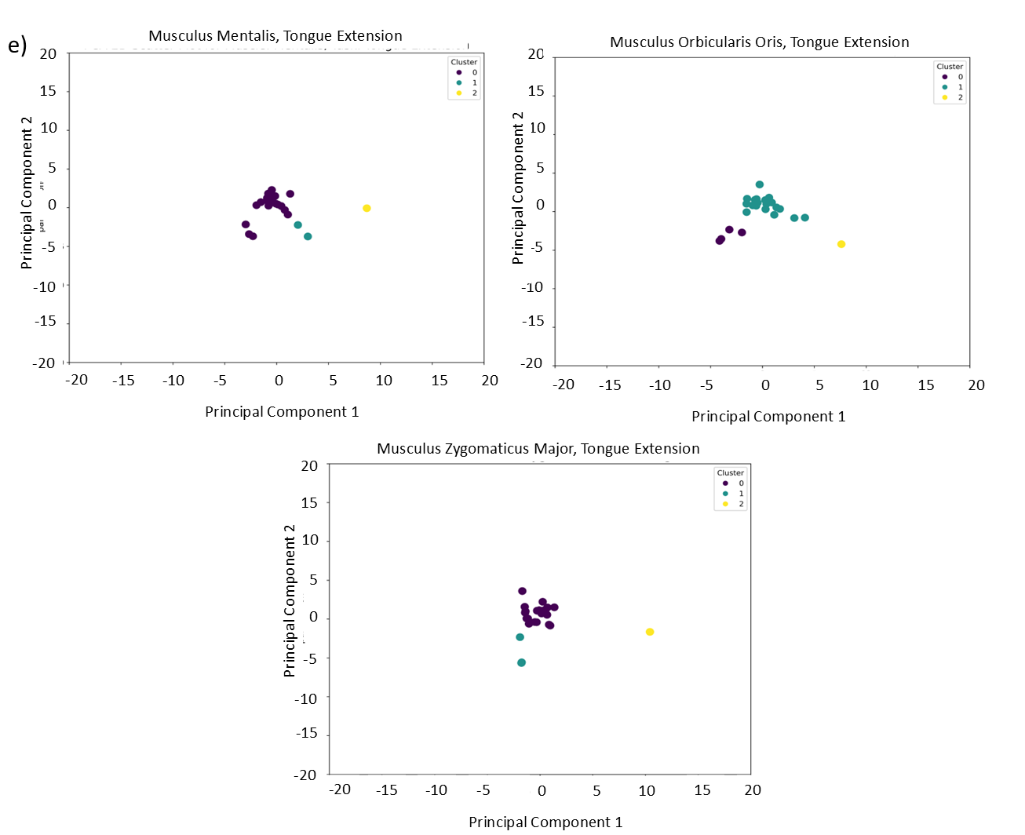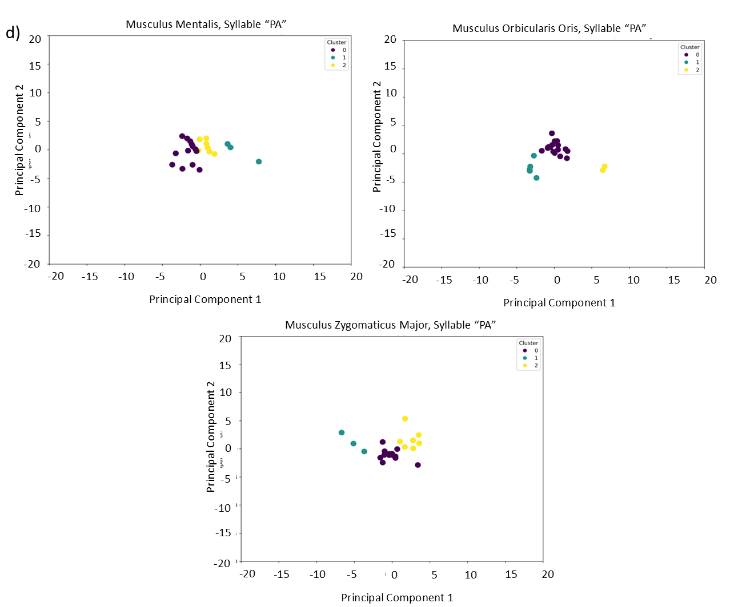

Fig S3. PCA scatter plot of each participant per task: a) Lip Pressing; b) Lip Puckering; c) Swallowing; d) Syllable “PA”, e) Tongue Extension. Each column represent one muscle: first column shows musculus mentalis; second shows musculus orbicularis oris and third column shows musculus zygomaticus major.

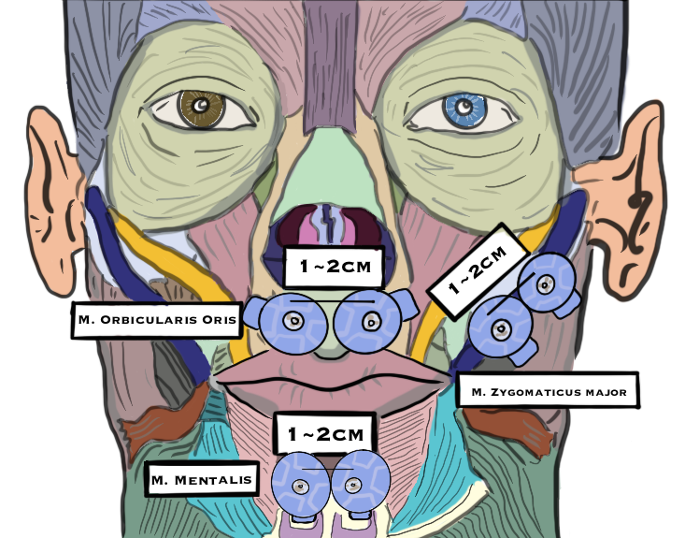
Fig S4. Electrode placement for each muscle, with inter-electrode distance.

