Competitive Flow Identification and Hemodynamic Analysis in Coronary Artery Bypass Grafting
Supplementary Materials

Supplementary Tables
Supplementary Table S1. LIMA continuous-cFFR multivariable linear regression.
Variable | β | 95% CI | P value
Preoperative cFFR (per 0.1) | 0.018 | 0.004–0.031 | 0.013
PI (per 1 unit) | 0.009 | −0.029–0.047 | 0.632
DF (per 1 percentage point) | −0.001 | −0.005–0.003 | 0.671
Graft length (per 1 cm) | −0.001 | −0.014–0.013 | 0.919
Stenosis length (per 1 cm) | −0.001 | −0.013–0.012 | 0.884
Adjusted R²=0.030; overall model P=0.203. HC3 robust standard errors were used.

Supplementary Table S2. SVG continuous-cFFR Gaussian GEE model.
Variable | β | 95% CI | P value
Preoperative cFFR (per 0.1) | 0.014 | −0.004–0.031 | 0.130
PI (per 1 unit) | −0.018 | −0.030–−0.005 | 0.006
DF (per 1 percentage point) | −0.004 | −0.007–−0.001 | 0.017
Graft length (per 1 cm) | 0.000 | −0.007–0.007 | 0.957
Stenosis length (per 1 cm) | −0.011 | −0.031–0.008 | 0.266
The exchangeable working-correlation structure was used for the primary analysis; independence produced materially similar estimates.

Supplementary Table S3. SVG cluster-adjusted univariable comparisons.
Variable | Difference (95% CI) | P value | Holm-adjusted P
Preoperative cFFR | 0.141 (0.032–0.249) | 0.011 | 0.033
DF (percentage points) | −7.132 (−12.534–−1.730) | 0.010 | 0.029
RRT | −0.192 (−8.178–7.794) | 0.962 | 1.000
WSS-mean | 0.878 (−3.712–5.467) | 0.708 | 1.000
WSSG | 2.672 (−9.814–15.159) | 0.675 | 1.000
OSI | −0.010 (−0.056–0.036) | 0.672 | 1.000
APS-mean | −74.668 (−255.350–106.014) | 0.418 | 1.000
PI | −0.115 (−1.095–0.864) | 0.818 | 1.000
Negative flow ratio | 0.006 (−0.025–0.037) | 0.700 | 1.000
Graft length | 0.358 (−3.399–4.116) | 0.852 | 0.852
Stenosis length | −0.823 (−1.775–0.130) | 0.090 | 0.181
Differences are competitive flow minus anastomotic stenosis. Holm correction was applied within prespecified variable families.

Supplementary Table S4. Bootstrap internal-validation metrics.
Metric | LIMA | SVG
Bootstrap resamples | 2,000 | 2,000
Successful fits | 2,000 | 1,357
Failed fits | 0 | 643
Fitting success rate | 100% | 67.85%
Apparent AUC | 0.721 | 0.772
Optimism-corrected AUC | 0.653 | 0.703
Apparent Brier score | 0.184 | 0.123
Optimism-corrected Brier score | 0.215 | 0.144
Apparent calibration intercept | 0.000 | 0.110
Corrected calibration intercept | 0.001 | 0.114
Apparent calibration slope | 1.000 | 1.126
Corrected calibration slope | 0.645 | 0.752
SVG validation used patient-cluster bootstrap resampling.

Supplementary Table S5. Model-diagnostic assessment.
Diagnostic domain | LIMA logistic model | SVG Firth-type PGEE model
Linearity: preoperative cFFR | Potential nonlinearity; P=0.003 | Not reliably assessable because of nonconvergence
Linearity: PI | No clear evidence; P=0.474 | No clear evidence
Linearity: DF | No clear evidence; P=0.895 | Extended model did not converge after 500 iterations
Linearity: graft length | No clear evidence; P=0.324 | Potential nonlinearity; P=0.031
Linearity: stenosis length | No clear evidence; P=0.130 | No clear evidence
Multicollinearity | All VIFs <1.3; max condition index 1.648 | All VIFs <1.5; max condition index 1.911
Influence analysis | Leave-one-observation-out | Leave-one-patient-out
Main influence finding | Preoperative cFFR coefficient remained positive and statistically significant in all refits. | Directions generally stable; some P values crossed 0.05
Hosmer–Lemeshow | χ²=6.153, df=8, P=0.630 | Not applied because of clustering and penalized PGEE
No observation or patient cluster was removed from the primary analysis on the basis of diagnostic findings.

Supplementary Table S6. SVG bootstrap coefficient-direction consistency.
Variable | Bootstrap coefficient-direction consistency
DF | 98.6%
Preoperative cFFR | 96.5%
PI | 87.2%
Stenosis length | 84.5%
Graft length | 48.2%
Percentages were calculated among successfully fitted SVG bootstrap models.

Supplementary Figures
Supplementary Figure S1. Distribution of postoperative cFFR in the 86 low-flow LIMA grafts.

Supplementary Figure S2. Distribution of postoperative cFFR in the 84 low-flow SVG grafts.

Supplementary Figure S3. Residual Q–Q plot for the LIMA continuous-cFFR multivariable model.

Supplementary Figure S4. Coefficient plot for the LIMA continuous-cFFR multivariable model.

Supplementary Figure S5. Coefficient plot for the SVG continuous-cFFR Gaussian GEE model.

Supplementary Figure S6. Distribution of the number of SVG grafts contributed per patient in the strict binary-analysis dataset.

Supplementary Figure S7. Within-patient composition of SVG binary phenotypes.

Supplementary Figure S8. Comparison of effect estimates across alternative SVG binary models.

Supplementary Figure S9. Graphical presentation of SVG cluster-adjusted univariable comparisons.

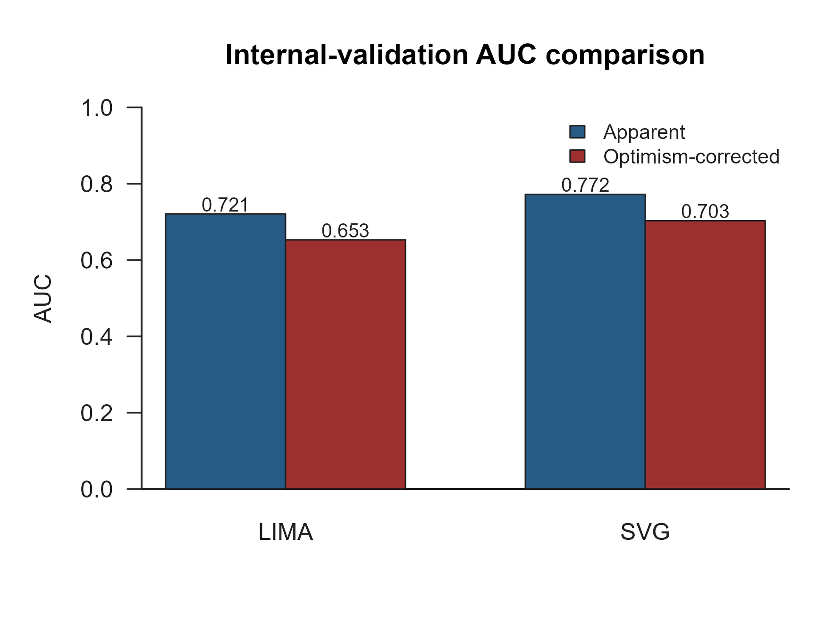
Supplementary Figure S10. Comparison of apparent and optimism-corrected AUCs for the LIMA and SVG models.

Supplementary Figure S11. LIMA ROC curve annotated with apparent and optimism-corrected AUC values. The marked cutoff represents the optimal model-predicted probability cutoff and does not represent a cFFR threshold.
Supplementary Figure S12. SVG ROC curve annotated with apparent and optimism-corrected AUC values. The marked cutoff represents the optimal model-predicted probability cutoff and does not represent a cFFR threshold.

