Supplementary material

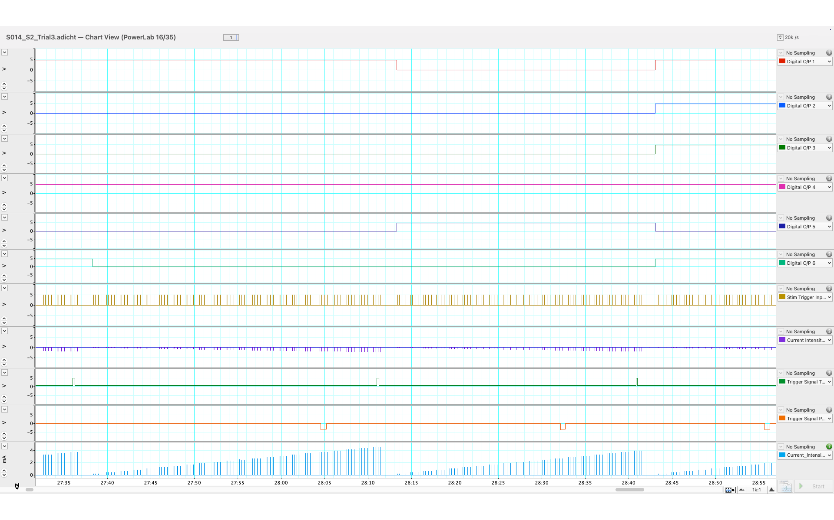
Figure S1. Representative LabChart 8 recordings during the multi-dermatome computer-controlled electrical perceptual threshold (multi-dermatome CCEPT) testing. Laptop B interfaced with the PowerLab 16/35 and controller module to record synchronized channel-index signals, the stimulation trigger, current-monitor voltage, participant-response trigger, examiner-verification trigger, and calculated stimulation current. The stimulation-current trace was derived from the current-monitor voltage using the LabChart 8 arithmetic function.

Table S2 Functions of key electrical components in the controller and current-monitoring pathway.
No | Component | Role in the system | Purpose / rationale
1 | FE180 stimulus isolator | Generates and delivers the programmed isolated constant-current pulses to the selected electrode pathway | Ensures that participant stimulation is supplied by a dedicated stimulus isolator
2 | DSCA49 signal isolator module | Electrically isolates and conditions the current-monitoring signal before it reaches the controller and data acquisition systems | Reduces ground-loop and electrical-interference risks between subsystems
3 | 500-Ω current-sensing resistor | Produces a voltage proportional to the delivered stimulation current according to Ohm’s law | Enables indirect monitoring of delivered current
4 | Voltage divider | Scales the isolated monitoring voltage to a range compatible with the Arduino analog input | Protects the microcontroller input from overvoltage
5 | Arduino Mega 2560 | Controls relay activation, button inputs, channel sequencing, display, buzzer, and maximum-current detection | Coordinates the automated testing workflow without generating stimulation current
6 | Relay module | Route the FE180 output and return pathways to the selected cathode and ipsilateral return electrode. | Enable computer-controlled selection of one stimulation pathway at a time
7 |  | Reads the isolated and scaled voltage derived from the current-sensing pathway. | Allows the controller to detect the delivered current and identify the 10 mA limit
  Arduino analog-monitoring input
Note. The Arduino Mega 2560 and relay modules controlled channel selection and monitoring logic only. Participant stimulation current was generated exclusively by the FE180 stimulus isolator.

Table S2: Region-specific cable bundles for bilateral sensory test-site coverage from C2 to S4/S5.
Cable | Dermatome Region | Dermatomes Covered | Color code
1 | Head and neck | C2–C5 (R), C2–C5 (L) | Brown
2 | Upper limbs-torso (R) | C6–T5 (R) | Red
3 | Mid torso and lower back (R) | T6–L1 (R) + return electrode (R) | Orange
4 | Lower body (R) | L2–S4/S5 (R) | Yellow
5 | Upper limbs/torso (L) | C6–T5 (L) | Green
6 | Mid torso and lower back (L) | T6–L1 (L) + return electrode (L) | Blue
7 | Lower body (L) | L2–S4/S5 (L) | White
Note. R = right; L = Left.

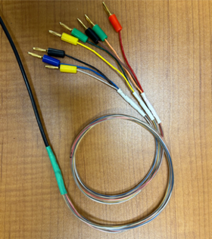

Figure S2. Representative region-specific cable bundle used in the multi-dermatome computer-controlled electrical perceptual threshold (multi-dermatome CCEPT) system. The cable bundle was used for pre-positioned surface-electrode connections and was color-coded by body region. The upper limb/torso (L) bundle shown here is described in Table A.

