Additional file: Maps of Smoothed standardized mortality ratios (sSMR) for specific cause of death in LMA and the probability that the sSMR is higher than 100

Smoothed standardized mortality ratios (sSMR) for Infectious and parasitic disease in LMA and the probability that the sSMR is higher than 100
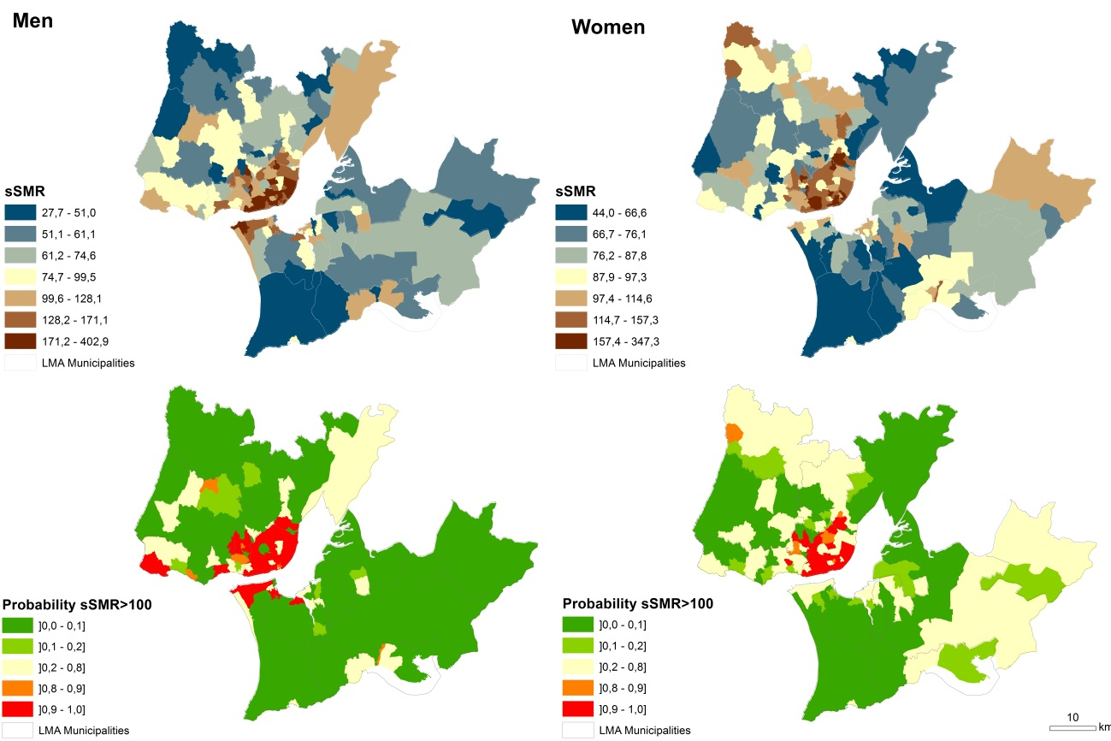
Source: based on Portuguese National Statistics Institute, 1995-2008.

Smoothed standardized mortality ratios (sSMR) for MN stomach in LMA and the probability that the sSMR is higher than 100
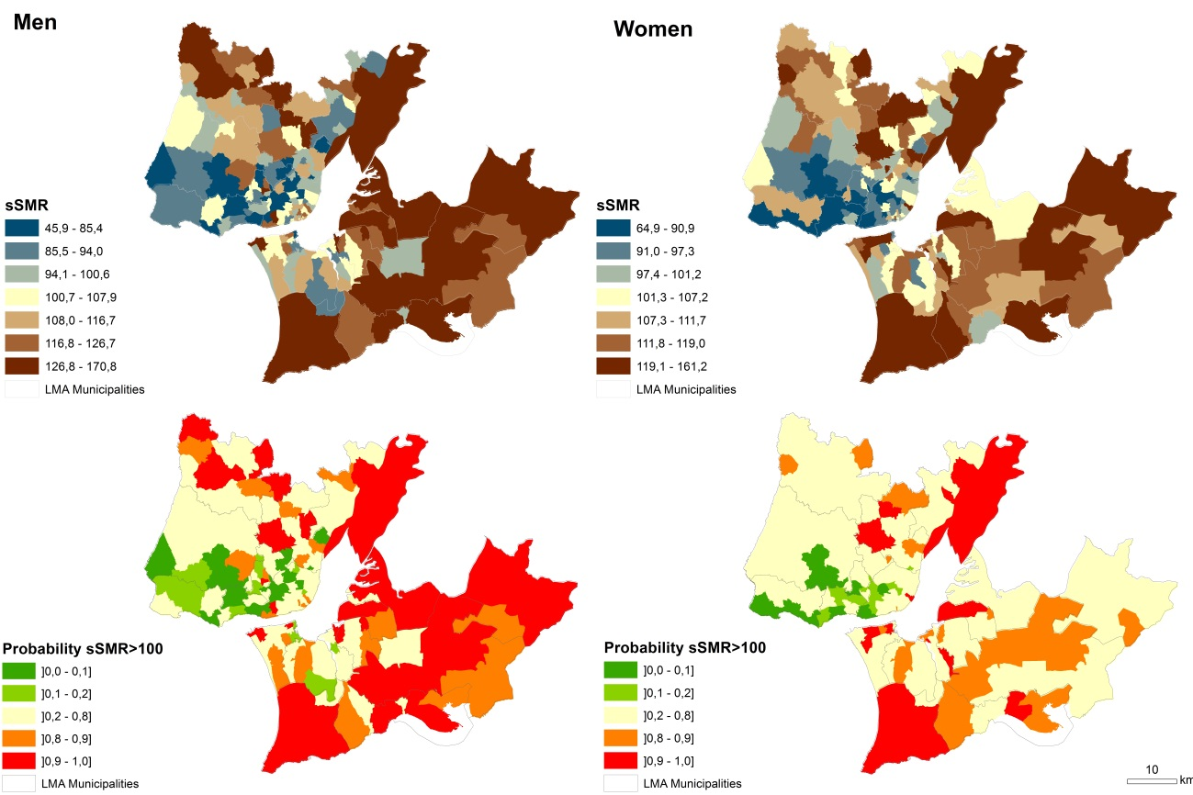
Source: based on Portuguese National Statistics Institute, 1995-2008.

Smoothed standardized mortality ratios (sSMR) for MN colon, rectum, anus and anal canal in LMA and the probability that the sSMR is higher than 100
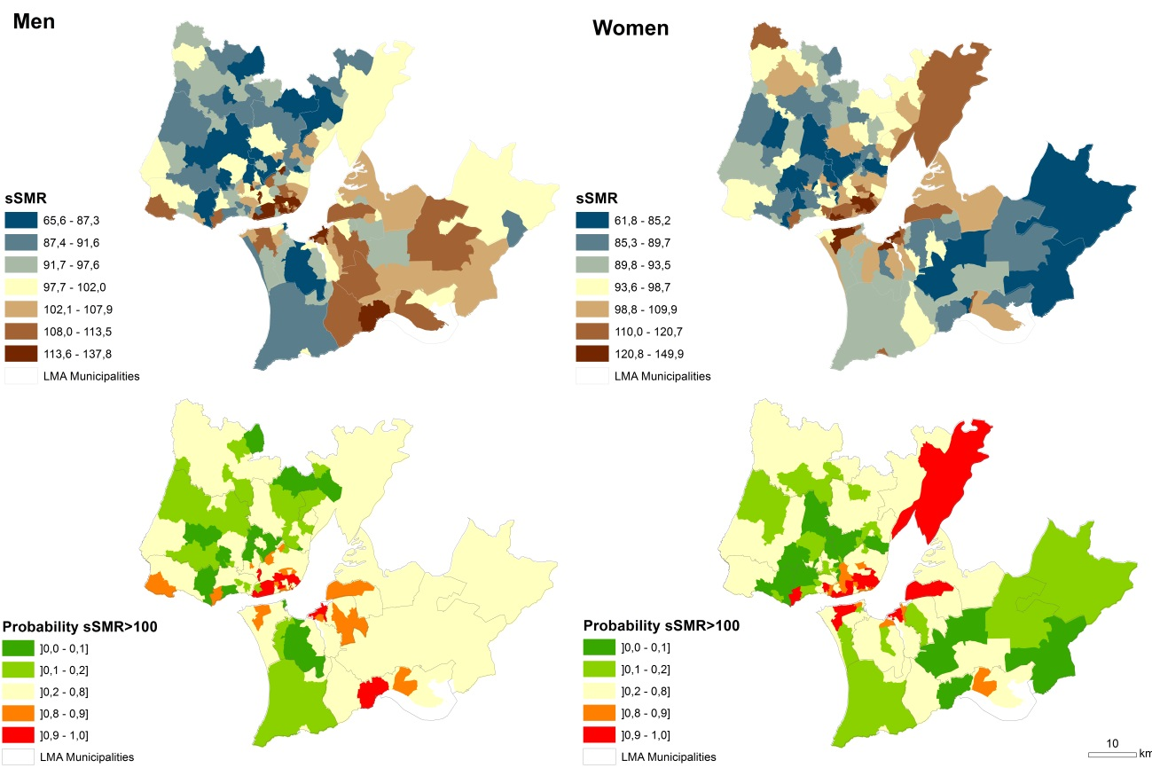
Source: based on Portuguese National Statistics Institute, 1995-2008.

Smoothed standardized mortality ratios (sSMR) for MN larynx, trachea, bronchus and lung in LMA and the probability that the sSMR is higher than 100
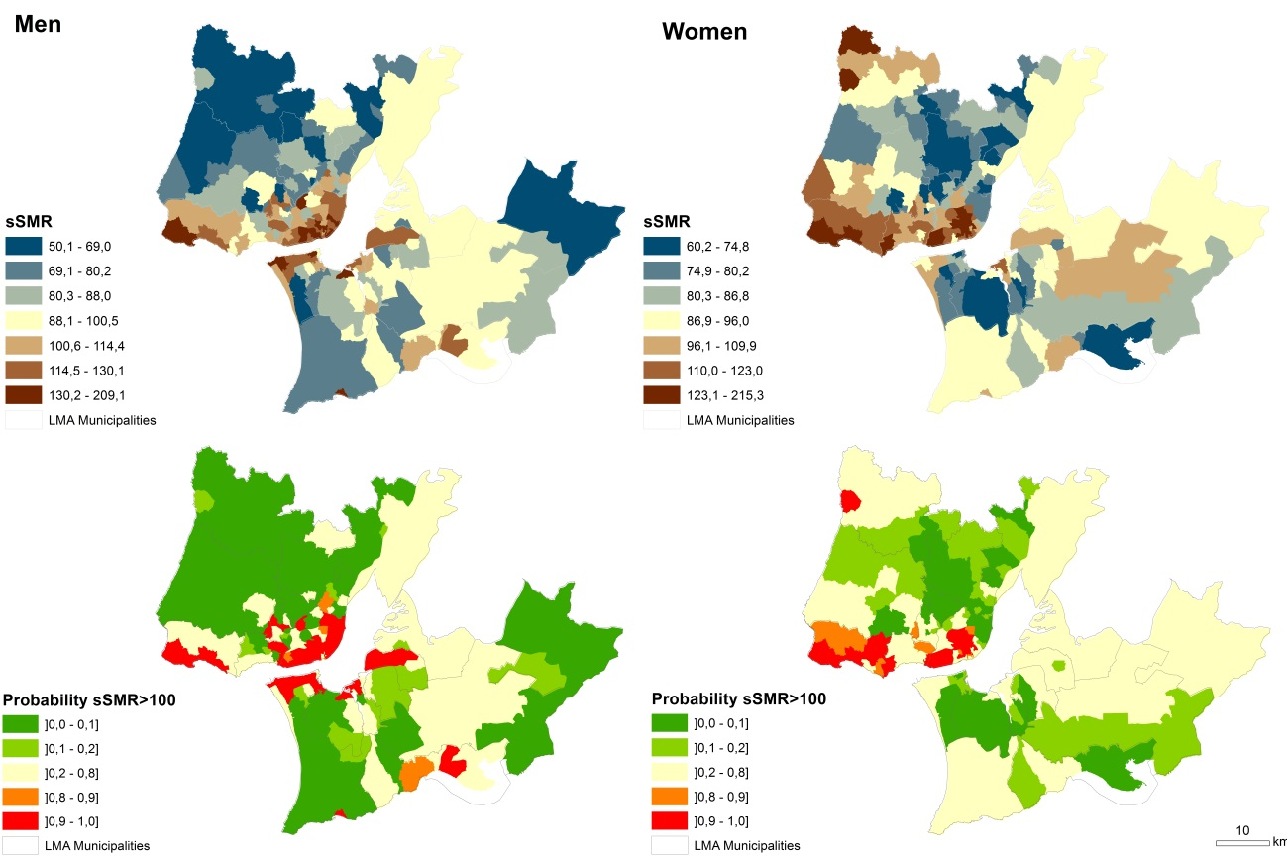
Source: based on Portuguese National Statistics Institute, 1995-2008.

Smoothed standardized mortality ratios (sSMR) for MN female breast (women) and MN prostate (men) in LMA and the probability that the sSMR is higher than 100
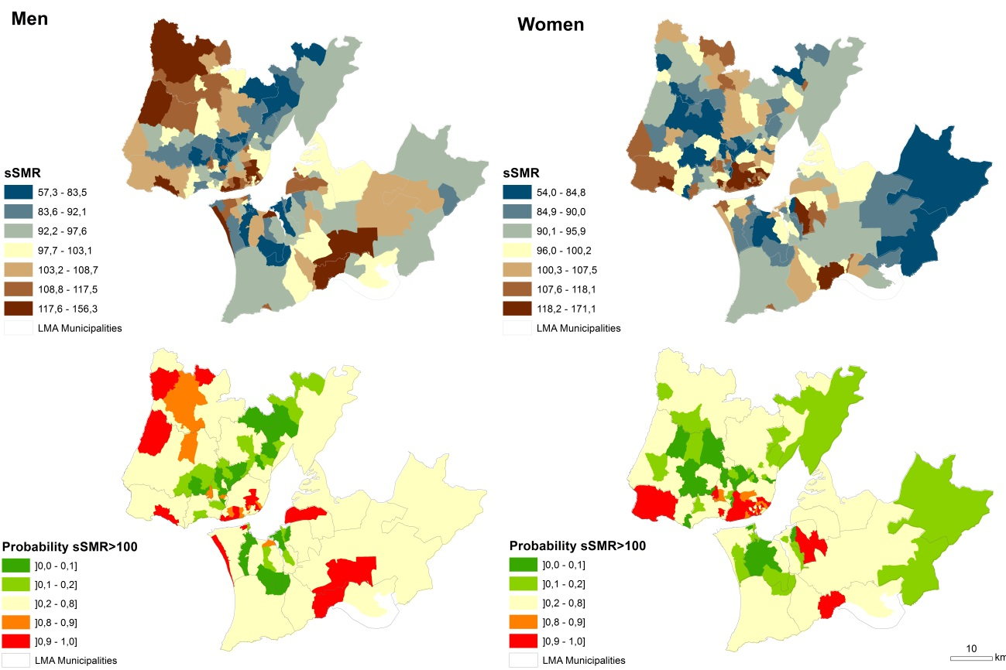
Source: based on Portuguese National Statistics Institute, 1995-2008.

Smoothed standardized mortality ratios (sSMR) for Diabetes mellitus in LMA and the probability that the sSMR is higher than 100
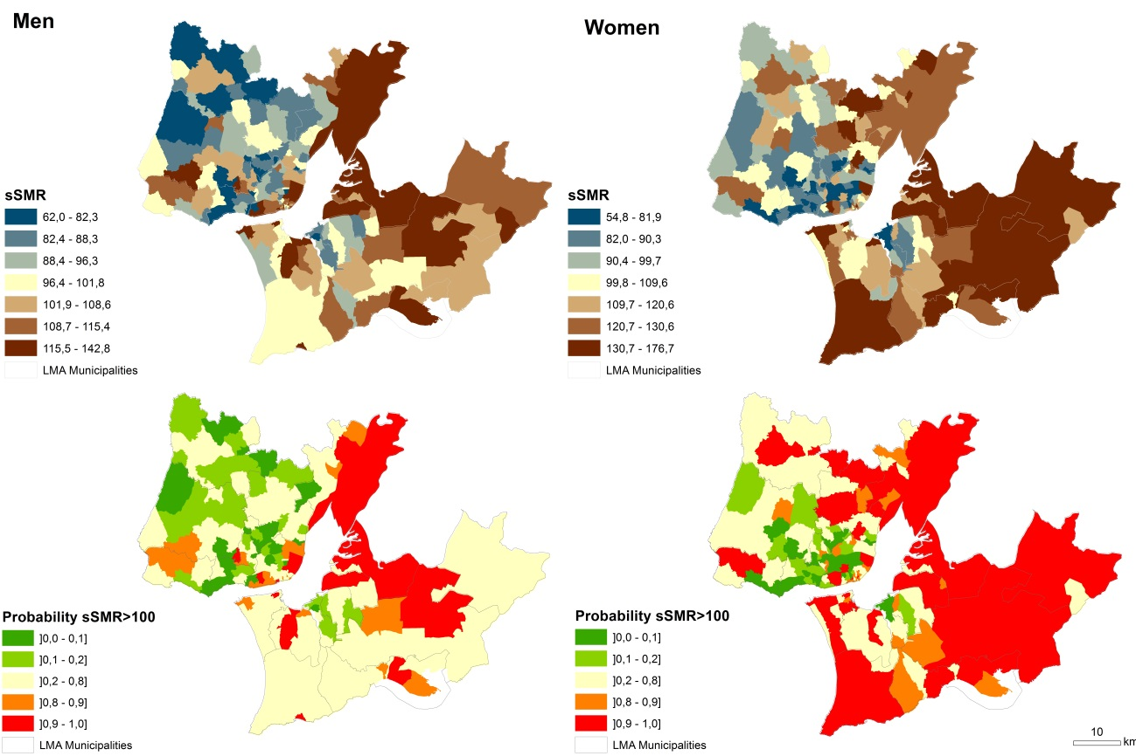
Source: based on Portuguese National Statistics Institute, 1995-2008.

Smoothed standardized mortality ratios (sSMR) for Dementias in LMA and the probability that the sSMR is higher than 100
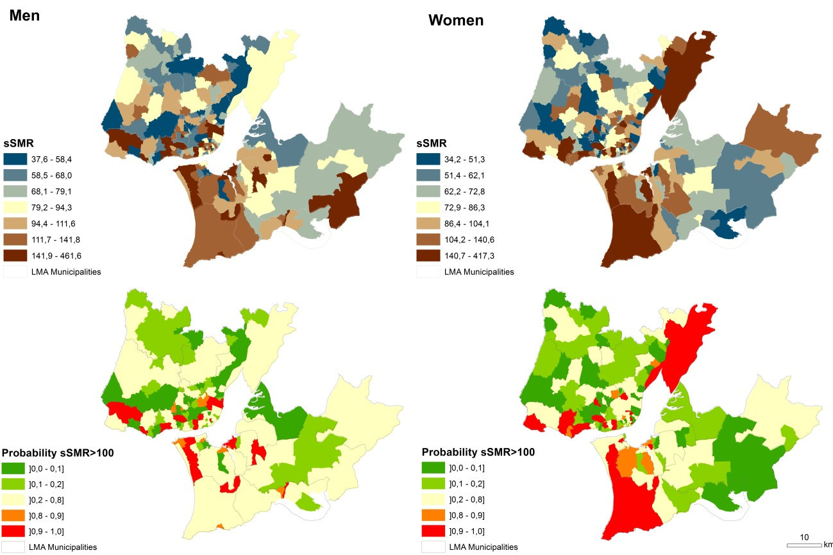
Source: based on Portuguese National Statistics Institute, 1995-2008.

Smoothed standardized mortality ratios (sSMR) for Ischemic heart disease in LMA and the probability that the sSMR is higher than 100
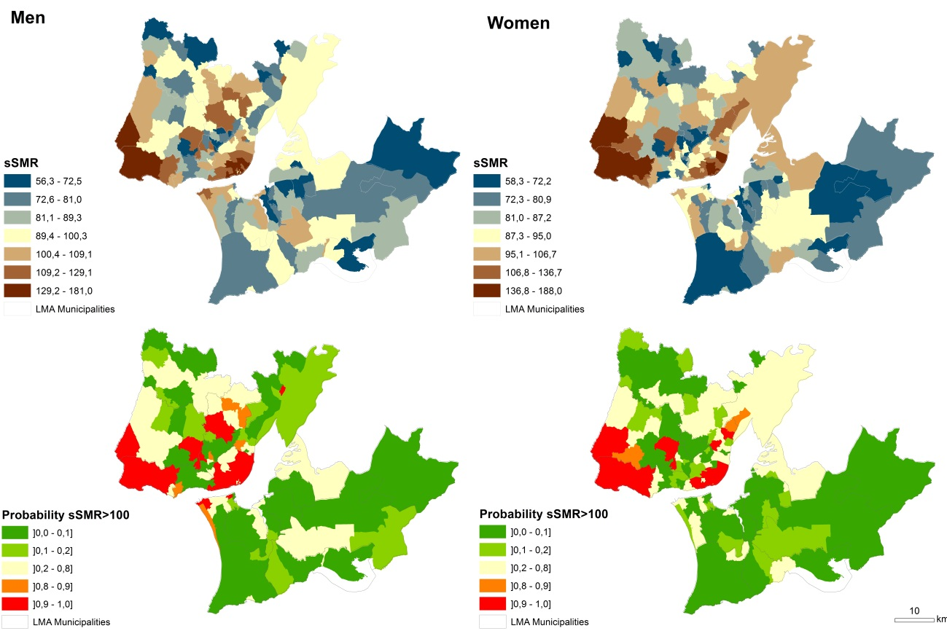
Source: based on Portuguese National Statistics Institute, 1995-2008.

Smoothed standardized mortality ratios (sSMR) for Cerebrovascular disease in LMA and the probability that the sSMR is higher than 100
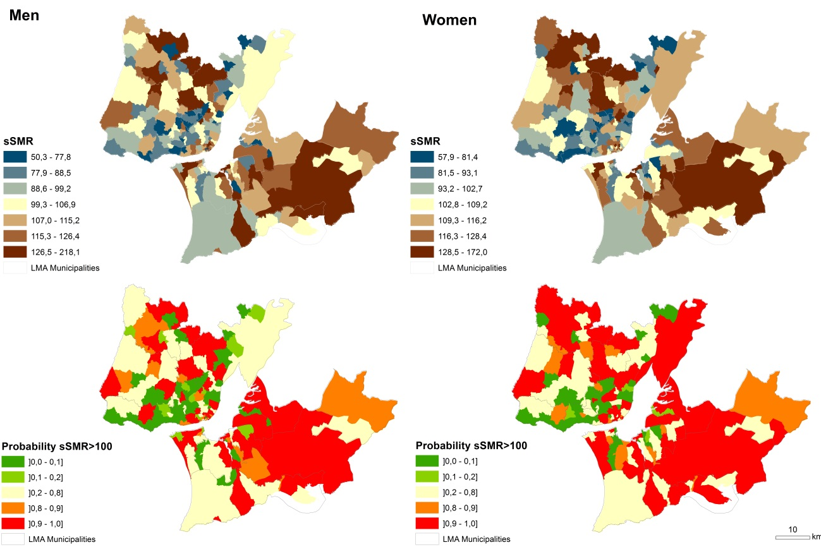
Source: based on Portuguese National Statistics Institute, 1995-2008.

Smoothed standardized mortality ratios (sSMR) for Chronic liver disease in LMA and the probability that the sSMR is higher than 100
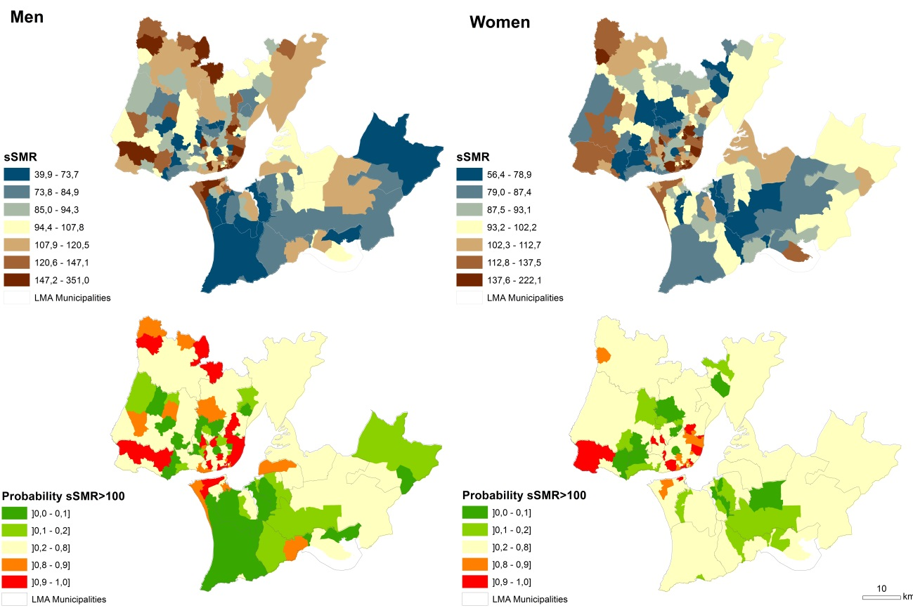
Source: based on Portuguese National Statistics Institute, 1995-2008.

Smoothed standardized mortality ratios (sSMR) for Symptoms, signs and abnormal clinical and laboratory findings in LMA and the probability that the sSMR is higher than 100
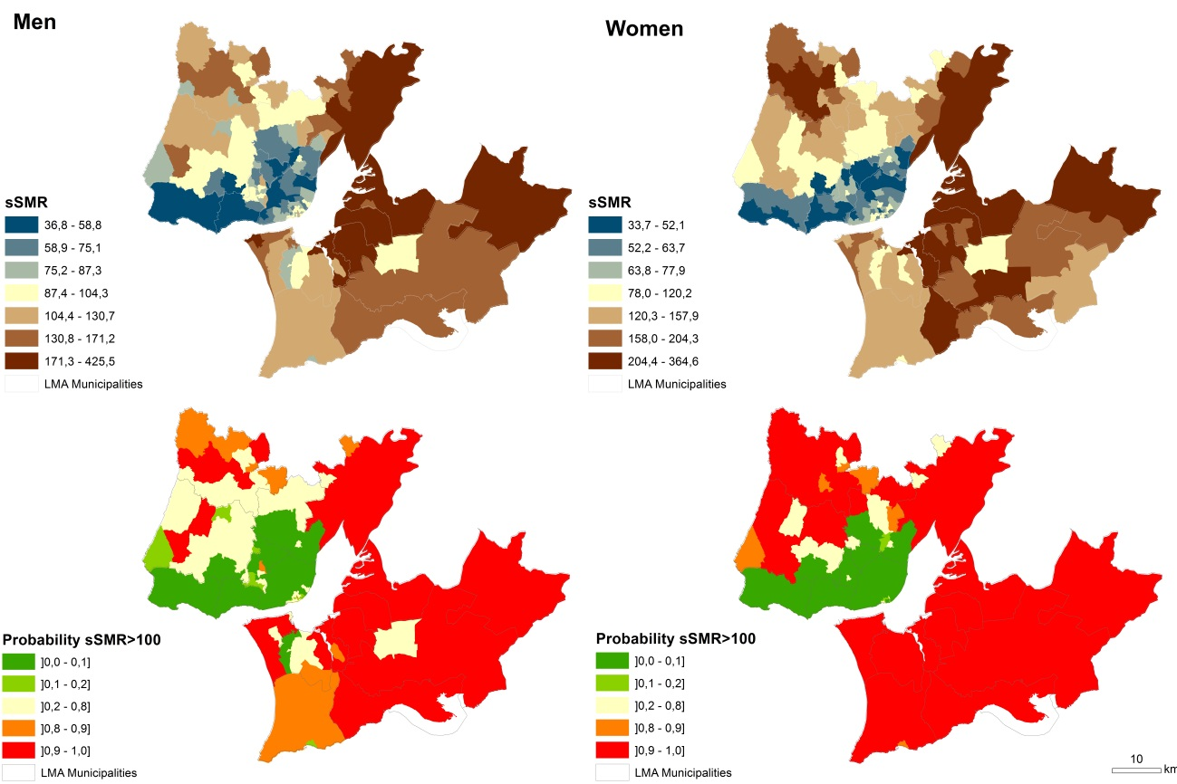
Source: based on Portuguese National Statistics Institute, 1995-2008.

Smoothed standardized mortality ratios (sSMR) for Transport injuries in LMA and the probability that the sSMR is higher than 100
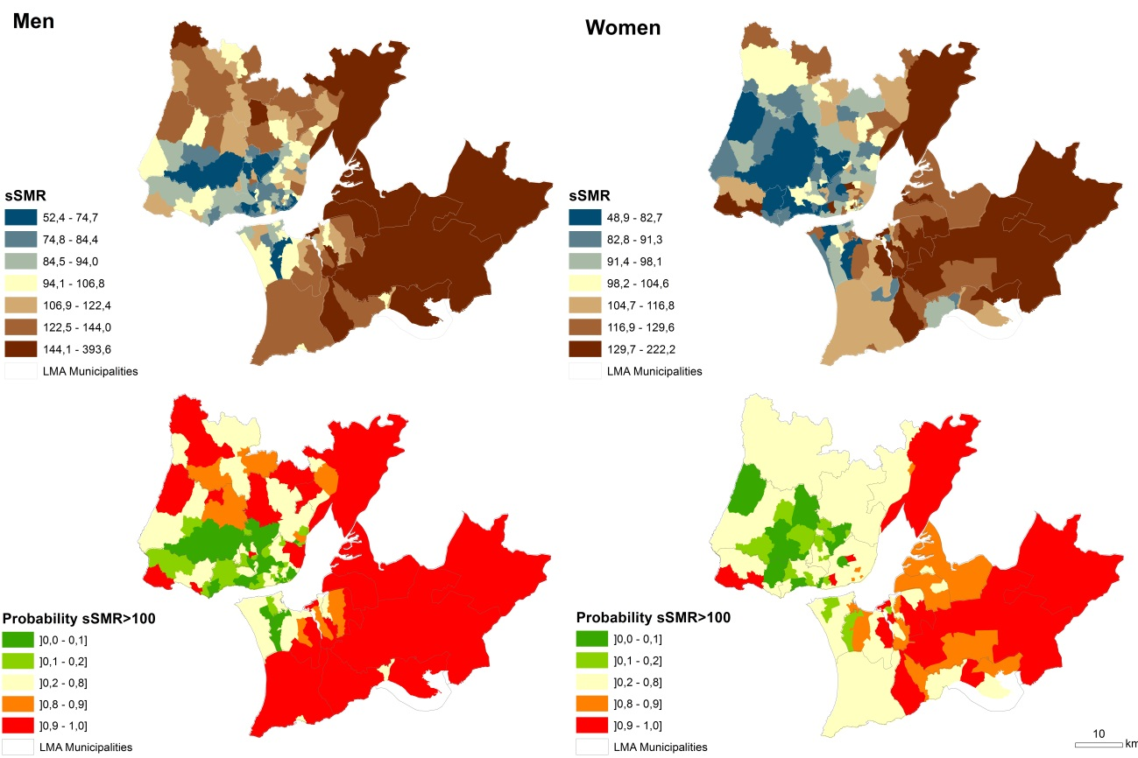
Source: based on Portuguese National Statistics Institute, 1995-2008.

Smoothed standardized mortality ratios (sSMR) for Suicide and intentional self-harm in LMA and the probability that the sSMR is higher than 100
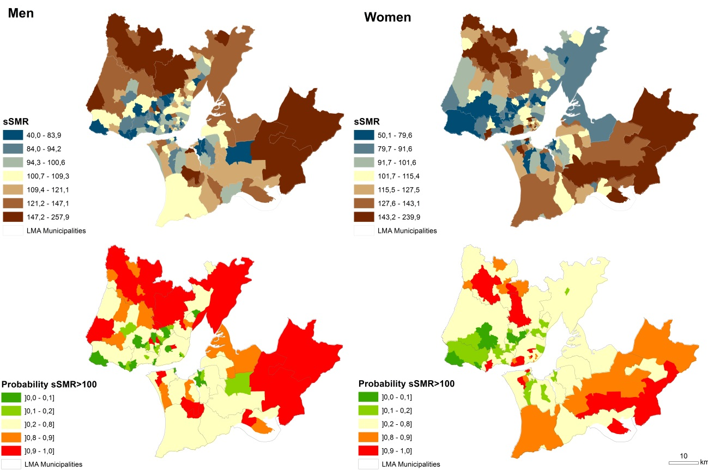
Source: based on Portuguese National Statistics Institute, 1995-2008.

