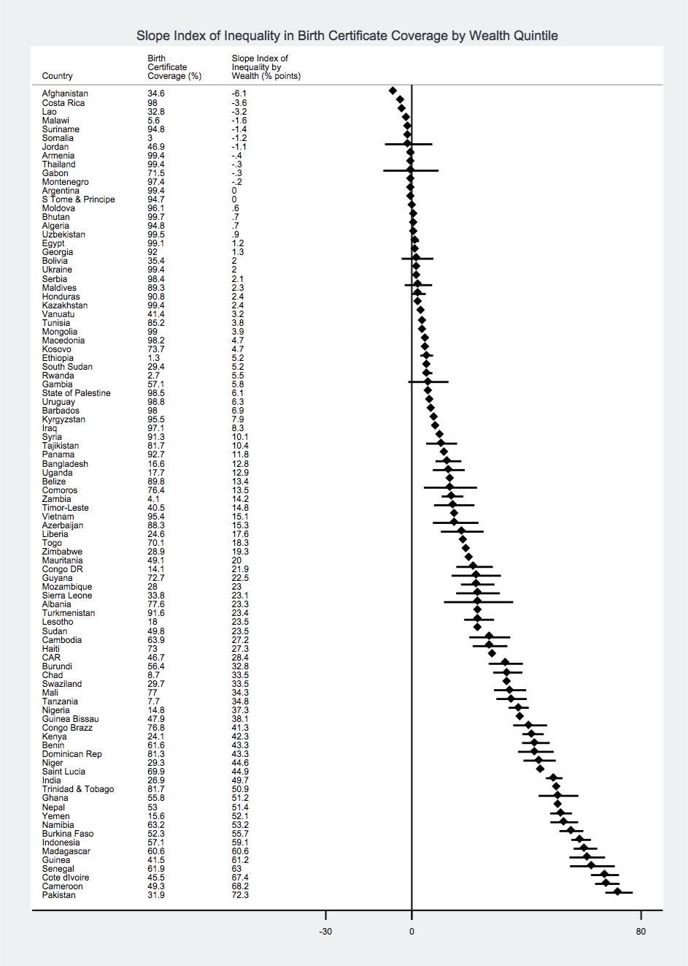
Additional File 4: Slope Index of Inequality in Birth Certificate Coverage by Wealth Quintile Among Children Under Five
Notes: Figure shows point estimates and confidence intervals, and zero indicates the null value. Positive values show a “pro-rich” bias – a higher birth certificate coverage among children in the richest wealth quintile compared to the poorest.

SII (% points)

