Additional File 5: Absolute Difference in Birth Certificate Coverage between Urban and Rural Residence Among Children Under Five
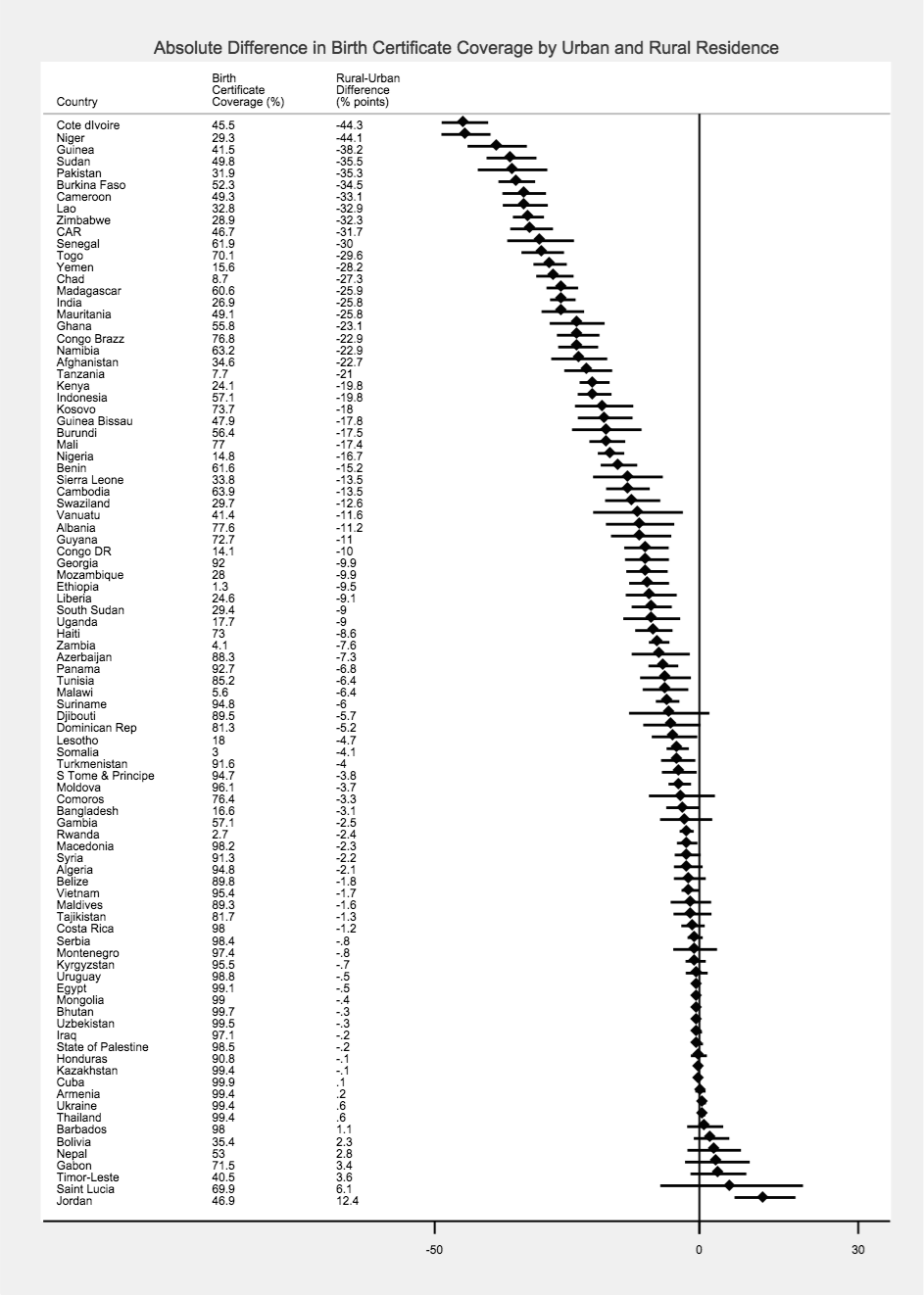
Notes: Figure shows point estimates and confidence intervals, and zero indicates the null value. Negative values indicate a “pro-urban” bias - a lower birth certificate coverage among children in rural areas compared to urban areas

Absolute Difference (% points)

