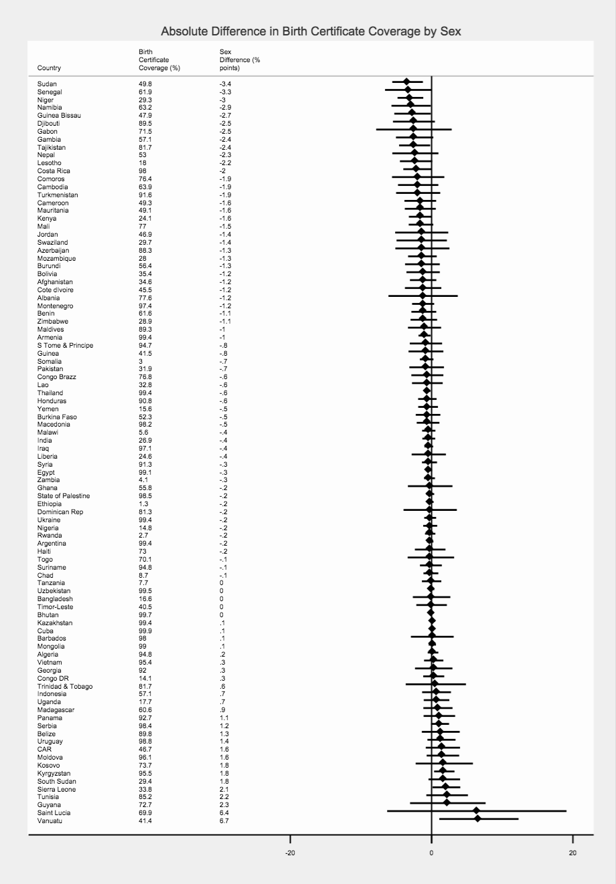
Additional File 6: Absolute Difference in Birth Certificate Coverage between Boys and Girls Under Five
Notes: Figure shows point estimates and confidence intervals, and zero indicates the null value. Negative values indicate a “pro-male” bias – a lower birth certificate coverage among girls compared to boys
Absolute Difference (% points)

