Additional file 3 - Concentration curves for inpatient and outpatient care utilization by provider ownership

Outpatient care
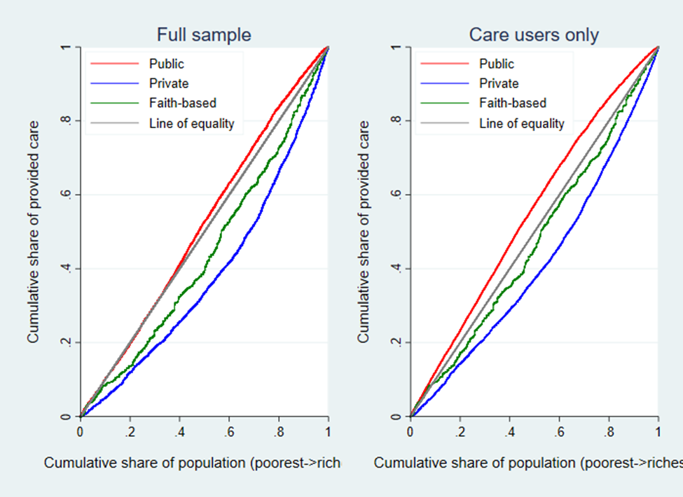
Inpatient care
