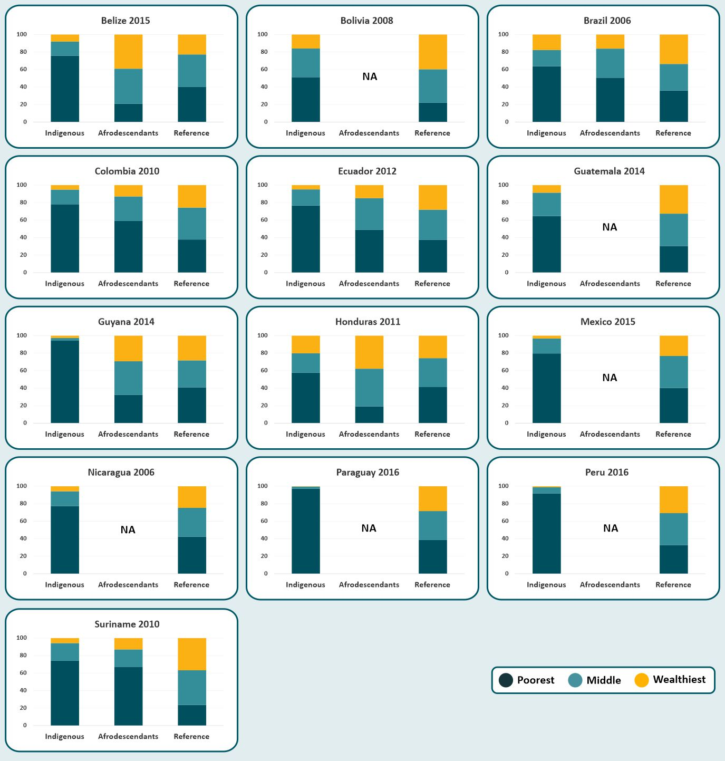
Supplementary figure 1. Distribution of indigenous, afrodescendants and reference children according to national wealth tertiles
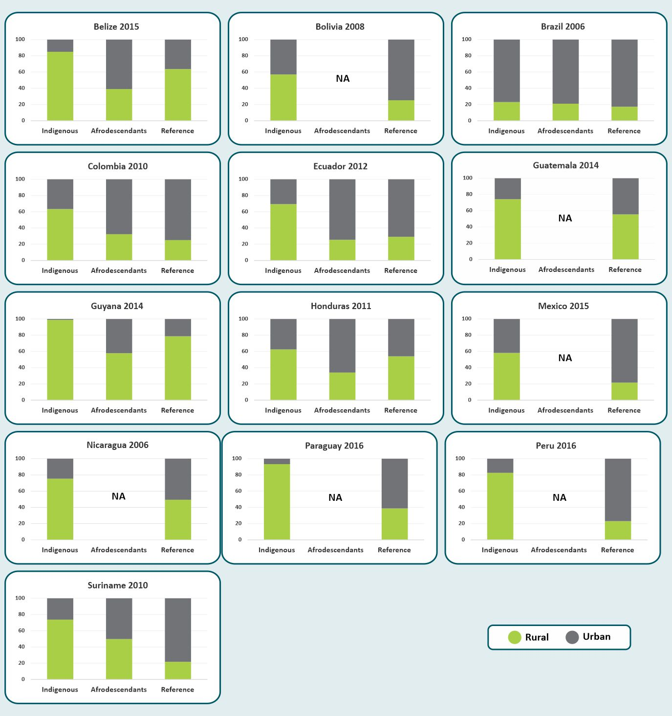
Supplementary figure 2. Distribution of indigenous, afrodescendants and reference children according to place of residence

