Additional File 2: Search strategy for databases

Pubmed database
Search on May 15th 2019; updated on September 27, 2019
Search | Query | Items found
#1 | (expressed OR reflected) AND racial identit*) OR "ascribed rac*" OR colorism OR colourism OR "interviewer ascribed" OR "interviewer assigned" OR "observer ascribed" OR "observer assigned" OR "phenotypic classification" OR "racial appraisal" OR "racial attribution" OR "racial contestation" OR "socially-assigned ethnicity" OR "socially-assigned race" | 627
#2 | "Outcome Assessment (Health Care)"[MeSH Terms]) OR (health status disparities[MeSH Terms]) OR "ethnic disparities" OR "health advantage" OR "health disparities" OR "health equity" OR "health outcomes" OR "health risk" OR "racial disparities" | 1,124,379
#1 AND #2 | (expressed OR reflected) AND racial identit*) OR "ascribed rac*" OR colorism OR colourism OR "interviewer ascribed" OR "interviewer assigned" OR "observer ascribed" OR "observer assigned" OR "phenotypic classification" OR "racial appraisal" OR "racial attribution" OR "racial contestation" OR "socially-assigned ethnicity" OR "socially-assigned race"))) AND ((("Outcome Assessment (Health Care)"[MeSH Terms]) OR (health status disparities[MeSH Terms]) OR "ethnic disparities" OR "health advantage" OR "health disparities" OR "health equity" OR "health outcomes" OR "health risk" OR "racial disparities" | 66

Web of Science
Search on May 15th, 2019; updated on September 27, 2019
Search | Query | Items found
#1 | TS=(((expressed OR reflected) AND racial identit*) OR "ascribed rac*" OR colorism OR colourism OR "interviewer ascribed" OR "interviewer assigned" OR "observer ascribed" OR "observer assigned" OR "phenotypic classification" OR "racial appraisal" OR "racial attribution" OR "racial contestation" OR "socially-assigned ethnicity" OR "socially-assigned race") | 1,342
#2 | TS=("health status disparities" OR "ethnic disparities" OR "health advantage" OR "health disparities" OR "health equity" OR "health outcomes" OR "health risk" OR "racial disparities") | 99,880
#1 AND #2 | TS=(((expressed OR reflected) AND racial identit*) OR "ascribed rac*" OR colorism OR colourism OR "interviewer ascribed" OR "interviewer assigned" OR "observer ascribed" OR "observer assigned" OR "phenotypic classification" OR "racial appraisal" OR "racial attribution" OR "racial contestation" OR "socially-assigned ethnicity" OR "socially-assigned race") AND TS=("health status disparities" OR "ethnic disparities" OR "health advantage" OR "health disparities" OR "health equity" OR "health outcomes" OR "health risk" OR "racial disparities") | 43

Web of Science Core Collection includes the following Citation Indexes:
- Science Citation Index Expanded (SCI-EXPANDED) --1945-present
- Social Sciences Citation Index (SSCI) --1956-present
- Arts & Humanities Citation Index (A&HCI) --1996-present
- Conference Proceedings Citation Index- Science (CPCI-S) --1990-present
- Conference Proceedings Citation Index- Social Science & Humanities (CPCI-SSH) --1990-present
- Book Citation Index– Science (BKCI-S) --2005-present
- Book Citation Index– Social Sciences & Humanities (BKCI-SSH) --2005-present
- Emerging Sources Citation Index (ESCI) --2015-present

EBSCO databases
Search on May 15th 2019; updated on September 27, 2019
((expressed OR reflected) AND racial identit*) OR "ascribed rac*" OR colorism OR colourism OR "interviewer ascribed" OR "interviewer assigned" OR "observer ascribed" OR "observer assigned" OR "phenotypic classification" OR "racial appraisal" OR "racial attribution" OR "racial contestation" OR "socially-assigned ethnicity" OR "socially-assigned race"
AND
"health status disparities" OR "ethnic disparities" OR "health advantage" OR "health disparities" OR "health equity" OR "health outcomes" OR "health risk" OR "racial disparities"

To search all EBSCO databases simultaneously, the search was performed using the “Choose Databases” filter.
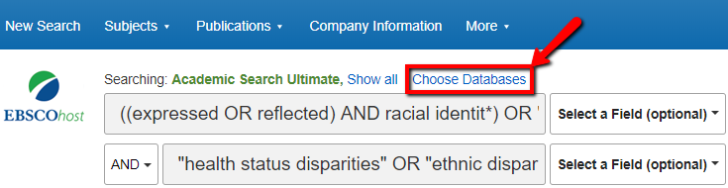

 | EBSCO Databases | Items found
1 | Academic Search Ultimate | 34
2 | ERIC | 28
3 | SocINDEX with Full Text | 27
4 | Education Source | 25
5 | PsycINFO | 24
6 | MEDLINE | 22
7 | Criminal Justice Abstracts | 13
8 | Race Relations Abstracts | 9
9 | CINAHL | 6
10 | CINAHL Plus with Full Text | 6
11 | Business Source Complete | 5
12 | Family Studies Abstracts | 5
13 | Health Source: Nursing/Academic Edition | 5
14 | MasterFILE Premier | 5
15 | OpenDissertations | 5
16 | America: History and Life with Full Text | 2
17 | Communication & Mass Media Complete | 2
18 | Family & Society Studies Worldwide | 2
19 | Historical Abstracts with Full Text | 2
20 | MLA International Bibliography with Full Text | 2
21 | Professional Development Collection | 2
22 | Psychology and Behavioral Sciences Collection | 2
23 | SPORTDiscus with Full Text | 2
24 | Abstracts in Social Gerontology | 1
25 | EconLit | 1
26 | Film & Television Literature Index with Full Text | 1
27 | LGBT Life with Full Text | 1
28 | National Criminal Justice Reference Service Abstracts | 1
 | TOTAL | 240

Proquest databases
Search on May 15th 2019; updated on September 27, 2019
noft(((expressed OR reflected) AND racial identit*) OR "ascribed rac*" OR colorism OR colourism OR "interviewer ascribed" OR "interviewer assigned" OR "observer ascribed" OR "observer assigned" OR "phenotypic classification" OR "racial appraisal" OR "racial attribution" OR "racial contestation" OR "socially-assigned ethnicity" OR "socially-assigned race") AND ("health status disparities" OR "ethnic disparities" OR "health advantage" OR "health disparities" OR "health equity" OR "health outcomes" OR "health risk" OR "racial disparities")
noft = Anywhere except full text

To search all Proquest databases simultaneously, the search was performed using the “Choose Databases” filter.
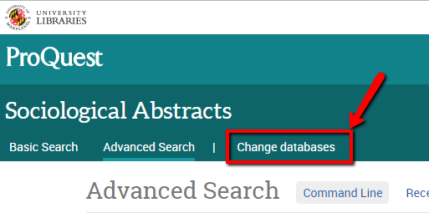
Fifty-five databases were searched simultaneously.
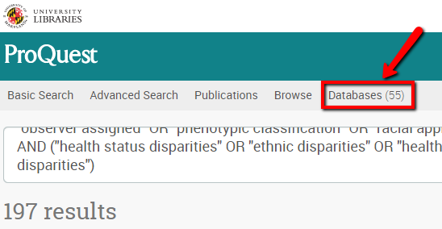

 | Database | Items found
1 | ProQuest Dissertations & Theses Global‎ | 133
2 | ProQuest Dissertations & Theses Global: Social Sciences‎ | 131
3 | ProQuest Dissertations & Theses Global: Health & Medicine‎ | 63
4 | Sociological Abstracts‎ | 37
5 | Sociological Abstracts‎ | 33
6 | Ethnic NewsWatch‎ | 17
7 | Public Health Database‎ | 17
8 | Social Services Abstracts‎ | 11
9 | ProQuest Dissertations & Theses Global: History‎ | 11
10 | ProQuest Dissertations & Theses Global: Literature & Language‎ | 10
11 | GenderWatch‎ | 9
12 | ProQuest Dissertations & Theses Global: The Arts‎ | 9
13 | Criminal Justice Database‎ | 7
14 | Ebook Central‎ | 7
15 | Materials Science & Engineering Collection‎ | 5
16 | Engineering Collection‎ | 5
17 | PAIS Index‎ | 4
18 | Engineering Index‎ | 4
19 | Worldwide Political Science Abstracts‎ | 4
20 | Engineering Database‎ | 4
21 | ProQuest Dissertations & Theses Global: Business‎ | 4
22 | ProQuest Dissertations & Theses Global: Science & Technology‎ | 4
23 | Materials Science Collection‎ | 2
24 | Materials Science Database‎ | 2
 | TOTAL | 533
 | Note: Proquest database removed the duplicates across its databases when displaying the final set of unique items. | 197

