Supplementary material

Supplementary material 1 Estimations of waiting times for specialist services with the Spanish NHS by country of origin.

Table S1 Waiting time estimations for country of origin.

Waiting times | Primary care | Specialist care
Native | Ref.
Double nationality | 0.057*** | -0.189
 | (0.017) | (0.154)
European Union | 0.009 | -0.224**
 | (0.035) | (0.105)
Europe | 0.046 | -0.065
 | (0.060) | (0.332)
Latin American | 0.028 | -0.109
 | (0.034) | (0.132)
North American | -0.106 | -0.314
 | (0.295) | (0.268)
African | 0.029 | 0.095
 | (0.057) | (0.205)
Asian | 0.081 | -0.209
 | (0.083) | (0.290)
High fluency | Ref.
Medium fluency | -0.123 | 0.043
 | (0.085) | (0.179)
Low fluency | -0.062 | -0.461
 | (0.039) | (0.474)
Specialist FEs | No | Yes
Regions FEs | Yes | Yes
Year FEs | Yes | Yes
Observations | 24,872 | 6,799
R-squared | 0.261 | 0.051
AIC | 50789 | 21440
BIC | 50919 | 21550

¹ For primary care, our individual of reference is a male with no studies; inactive; between 18 and 34 years old; no chronic disease; one visit to public GP; no visit to private GPs; Spanish; fluent and living in a urban area. For specialist consultations, our individual of reference is a male who has visited Traumatology services; with no studies; employed; between 18 and 34 years old; with no chronic disease; one visit to public GP; no visits to private specialist doctor; Spanish; fluent and living in a urban area.
² Full model specification: SES and severity variables + area of residence+ immigrant status + private healthcare utilization + region-year fixed effects.
³ Note: *** p<0.01, ** p<0.05, * p<0.1

Supplementary material 2 Estimations of waiting times for primary and specialist services with the Spanish NHS by disaggregated employment status.

Table S2 OLS estimations for waiting including disaggregated employment status

Waiting times in specialist care | Primary care | Specialist care
Education
No qualifications | Ref.
Primary studies | -0.007 | -0.085
 | (0.023) | (0.056)
Secondary studies | -0.009 | -0.173***
 | (0.023) | (0.036)
University studies | -0.021 | -0.155***
 | (0.023) | (0.052)
Employment status
Inactive | Ref.
Retirement pensioner | -0.013 | 0.129
 | (0.009) | (0.088)
Unemployed | -0.022*** | 0.179***
 | (0.006) | (0.048)
Managers (private and public institutions) | -0.026 | 0.060
 | (0.023) | (0.149)
Technical and profesional scientists and intellectuals | -0.083*** | -0.003
 | (0.021) | (0.102)
Support technicians and professionals | 0.002 | -0.007
 | (0.036) | (0.084)
Office workers | 0.004 | 0.217
 | (0.045) | (0.155)
Hospitality and shop workers | -0.001 | 0.092
 | (0.022) | (0.072)
Security workers | -0.065 | 0.226
 | (0.052) | (0.234)
Qualified workers in the agricultural industry | 0.049 | 0.044
 | (0.058) | (0.073)
Artisans and qualified workers in the industry, building and mining sectors | -0.013 | 0.195
 | (0.041) | (0.126)
Industrial machinery and installations´ operators | -0.004 | 0.335**
 | (0.020) | (0.119)
Unqualified workers | -0.030 | 0.159
 | (0.024) | (0.093)
Gender
Male | Ref.
Female | 0.038*** | 0.218***
 | (0.012) | (0.035)
Severity
Age (years)
18 to 24 | Ref.
35 to 44 | -0.047*** | 0.018
 | (0.011) | (0.038)
45 to 64 | -0.039*** | -0.001
 | (0.009) | (0.029)
65 to 75 | -0.065*** | -0.003
 | (0.016) | (0.050)
75 or more | -0.131*** | -0.198***
 | (0.025) | (0.057)
Chronic illness
Presence of chronic illness | 0.053*** | 0.192***
 | (0.013) | (0.035)
Public visits
1 visit | Ref.
2 visits | 0.029 | 0.032
 | (0.017) | (0.028)
3 or more visits | 0.039* | -0.172***
 | (0.019) | (0.040)
Area of residence
Urban | Ref.
Rural | -0.237*** | -0.031
 | (0.044) | (0.043)
Citizenship status
Native Spanish | Ref.
Spanish acquired | 0.060*** | -0.166
 | (0.015) | (0.138)
Foreign | 0.033 | -0.120*
 | (0.030) | (0.067)
Fluency
High | Ref.
Medium | -0.068** | -0.328
 | (0.029) | (0.598)
Low | -0.105 | 0.008
 | (0.071) | (0.139)
Private healthcare visits
0 visits | Ref.
1 to 2 visits | 0.007 | 0.168*
 | (0.020) | (0.080)
3 or more visits | 0.128** | 0.017
 | (0.048) | (0.072)
Region fixed effects | Yes | Yes
Year fixed effects | Yes | Yes
Specialist FE | No | Yes
Constant | 0.957*** | 3.601***
 | (0.039) | (0.084)
Observations | 24,935 | 6,825
R-squared | 0.261 | 0.050
AIC | 50905 | 21522
BIC | 51035 | 21631

¹ For primary care, our individual of reference is a male with no studies; inactive; between 18 and 34 years old; no chronic disease; one visit to public GP; no visit to private GPs; Spanish; fluent and living in an urban area. For specialist consultations, our individual of reference is a male who has visited Traumatology services; with no studies; employed; between 18 and 34 years old; with no chronic disease; one visit to public specialist services; no visits to private specialist doctor; Spanish; fluent and living in a urban area.
² Full model specification: SES and severity variables + area of residence+ immigrant status + private healthcare utilization + region-year fixed effects.
³ Note: *** p<0.01, ** p<0.05, * p<0.1

Table S3 Quantile estimations for waiting time in specialist services including disaggregated employment status

Waiting time for specialist | Q(0.10) | Q(0.25) | Q(0.50) | Q(0.75) | Q(0.90)
Education
Primary | -0.0235 | -0.118 | 0.00259 | -0.0367 | 0.0433
Secondary | -0.199 | -0.276** | -0.0962 | -0.0926 | 0.00312
University | -0.134 | -0.218 | -0.136 | -0.11 | -0.0591
Employment status
Retirement pensioner | 0.125 | 0.158* | 0.0993 | 0.133** | 0.0689
Unemployed | 0.348*** | 0.221** | 0.0912 | 0.137** | 0.0851
Managers (private and public institutions) | -0.0879 | 0.134 | 0.025 | 0.153 | -0.0642
Technical and profesional scientists and intellectuals | 0.0637 | -0.129 | -0.0618 | -0.00464 | 0.0758
Support technicians and professionals | 0.0958 | 0.000607 | -0.0134 | 0.0384 | 0.083
Office workers | -0.107 | 0.168 | 0.15 | 0.000631 | -0.101
Hospitality and shop workers | 0.0458 | 0.136 | 0.0413 | 0.117 | 0.106
Security and protection workers | -0.0024 | 0.0504 | -0.199 | 0.0314 | 0.335
Qualified workers in the agricultural industry | -0.0468 | 0.168 | 0.113 | 0.182 | -0.0738
Artisans and qualified workers in the industry, building and mining sectors | 0.186 | 0.166 | 0.0655 | 0.12 | 0.142
Industrial machinery and installations´ operators | 0.346 | 0.417*** | 0.199 | 0.145 | 0.293
Unqualified workers | 0.161 | 0.0767 | 0.0886 | 0.227** | 0.125
Gender
Female | 0.313** | 0.248*** | 0.180*** | 0.161*** | 0.106**
Age (years)
35 to 44 | 0.0995 | 0.0231 | 0.0127 | -0.0442 | -0.125**
45 to 64 | 0.167 | -0.02 | -0.0108 | -0.0571 | -0.0687
65 to 74 | 0.0258 | 0.000425 | -0.0591 | -0.0538 | -0.0276
75 or more | -0.0878 | -0.338** | -0.183** | -0.174*** | -0.0722
Chronic illness
Presence of chronic illness | 0.126 | 0.180** | 0.206*** | 0.201*** | 0.171***
Number of visits to GP
2 visits | 0.252** | 0.127** | 0.0519 | -0.021 | -0.0833*
3 or more visits | 0.00293 | -0.111** | -0.150*** | -0.240*** | -0.258***
Area of residence
Rural | -0.0681 | -0.0643 | -0.0702 | -0.00355 | 0.00946
Citizenship status
Spanish | -0.0173 | -0.217 | -0.00882 | -0.13 | -0.169
Foreign | -0.322 | -0.0692 | -0.149 | -0.222* | -0.237**
Fluency
Medium | -1.591 | -0.882 | -0.0272 | 0.164 | 0.0622
Low | 0.127 | -0.0654 | 0.159 | 0.132 | 0.265
Private consultations
1 or 2 visits | 0.12 | 0.165 | 0.146 | 0.138* | 0.0632
3 or more visits | -0.393 | 0.0341 | 0.154 | 0.139 | 0.022
Year fixed effects | Yes | Yes | Yes | Yes | Yes
Region fixed effects | Yes | Yes | Yes | Yes | Yes
Specialist fixed effects | Yes | Yes | Yes | Yes | Yes
Constant | 1.992*** | 3.109*** | 3.793*** | 4.314*** | 4.977***
Observations | 6825 | 6825 | 6825 | 6825 | 6825

¹ Our individual of reference is a male who has visited Traumatology services; with no studies; inactive; between 18 and 34 years old; with no chronic disease; one visit to public specialist services; no visit to a private specialist doctor; Spanish citizenship; fluent and living in a urban area.
² Full model specification: SES and severity variables + area of residence+ immigrant status + private healthcare utilization + region and -year fixed effects.
³ Note: *** p<0.01, ** p<0.05, * p<0.1

Supplementary material 3 Estimations of waiting times for specialist services with the Spanish NHS including household income

Table S4 OLS estimations for waiting times by SES including disaggregated employment status and household income.

Waiting times | Primary care | Specialist care
Education
No qualifications | Ref.
Primary studies | -0.016 | -0.032
 | (0.026) | (0.063)
Secondary studies | -0.007 | -0.081**
 | (0.030) | (0.034)
University studies | -0.035 | -0.106**
 | (0.033) | (0.043)
Employment status
Inactive | Ref.
Retirement pensioner | -0.019 | 0.159
 | (0.017) | (0.099)
Unemployed | -0.020 | 0.165***
 | (0.011) | (0.049)
Managers (private and public institutions) | -0.077** | 0.089
 | (0.030) | (0.098)
Technical and profesional scientists and intellectuals | -0.075** | 0.129
 | (0.028) | (0.131)
Support technicians and professionals | -0.005 | -0.003
 | (0.045) | (0.094)
Office workers | 0.010 | 0.189
 | (0.055) | (0.165)
Hospitality and shop workers | -0.019 | 0.118
 | (0.029) | (0.076)
Security and protection workers | -0.161*** | 0.410
 | (0.047) | (0.262)
Qualified workers in the agricultural industry | -0.001 | -0.056
 | (0.070) | (0.129)
Artisans and qualified workers in the industry, building and mining sectors | -0.040 | 0.167
 | (0.038) | (0.133)
Industrial machinery and installations´ operators | -0.005 | 0.361**
 | (0.021) | (0.129)
Unqualified workers | -0.029 | 0.153
 | (0.033) | (0.089)
Household income
Q1 income | Ref.
Q2 income | -0.020 | -0.034
 | (0.015) | (0.029)
Q3 income | -0.003 | -0.038
 | (0.020) | (0.043)
Q4 income | -0.012 | -0.184**
 | (0.018) | (0.075)
Q5 income | -0.017 | -0.356
 | (0.028) | (0.208)
Region fixed effects | Yes | Yes
Year fixed effects | Yes | Yes
Region-Trend | Yes | Yes
Specialist fixed effects | No | Yes
Constant | 0.995*** | 3.466***
 | (0.050) | (0.076)
Observations | 16,994 | 5,104
R-squared | 0.237 | 0.060
AIC | 34885 | 16045
BIC | 35008 | 16149

¹ For primary care, our individual of reference is a male with no studies; inactive; Q1 household income (below 600 monthly euros); between 18 and 34 years old; no chronic disease; one visit to public GPno visit to private GPs; Spanish and living in a urban area. For specialist consultations, our individual of reference is a male who has visited Traumatology services; with no studies; Q1 household income (below 600 monthly euros); inactive; between 18 and 34 years old; with no chronic disease; no visits to private specialist doctor; Spanish and living in a urban area.
² Full model specification: SES and severity variables + area of residence+ immigrant status + private healthcare utilization + region-year fixed effects.
³ Note: *** p<0.01, ** p<0.05, * p<0.1

Table S5 Quantile estimations for waiting times by SES including disaggregated employment status and household income.

Waiting time for specialist | Q(0.10) | Q(0.25) | Q(0.50) | Q(0.75) | Q(0.90)
Education
Primary | -0.123 | -0.132 | 0.0148 | 0.00158 | 0.0728
Secondary | -0.0826 | -0.255** | -0.0529 | -0.0345 | 0.00664
University | 0.018 | -0.167 | -0.119 | -0.161** | -0.112
Employment status
Retirement pensioner | 0.12 | 0.146** | 0.0815 | 0.201*** | 0.103**
Unemployed | 0.299** | 0.213*** | 0.0866 | 0.176*** | 0.114**
Managers (private and public institutions) | 0.0571 | 0.216** | 0.103 | 0.202* | -0.068
Technical and profesional scientists and intellectuals | 0.0682 | -0.121 | 0.0676 | 0.154* | 0.0971
Support technicians and professionals | 0.199 | 0.0658 | -0.00585 | 0.00851 | 0.0925
Office workers | -0.268 | 0.0379 | 0.123 | 0.0753 | 0.0205
Hospitality and shop workers | 0.146 | 0.186 | 0.0774 | 0.127 | 0.064
Securityand protection workers | 0.217 | 0.197 | 0.292 | 0.167 | 0.525
Qualified workers in the agricultural industry | -0.584 | 0.162 | 0.0272 | 0.235** | -0.099
Artisans and qualified workers in the industry, building and mining sectors | 0.122 | 0.103 | -0.00149 | 0.148 | 0.216*
Industrial machinery and installations´ operators | 0.373 | 0.431*** | 0.113 | 0.232** | 0.218
Unqualified workers | 0.206 | 0.0969 | 0.0834 | 0.249*** | 0.217***
Household income
Q2 | -0.0477 | 0.0302 | -0.0778 | -0.049 | 0.0522
Q3 | -0.0483 | -0.0085 | -0.069 | 0.0419 | 0.122
Q4 | -0.235 | -0.0601 | -0.247** | -0.0953 | 0.0401
Q5 | -0.397 | -0.314** | -0.713** | -0.286** | -0.202
Gender
Female | 0.314** | 0.267*** | 0.158*** | 0.205*** | 0.127***
Age (years)
35 to 44 | 0.168 | 0.0903 | 0.0611 | -0.0296 | -0.0816
45 to 64 | 0.227** | 0.0246 | 0.0274 | -0.0736 | -0.071
65 to 74 | 0.169 | 0.0704 | 0.0443 | -0.0236 | 0.0478
75 or more | 0.144 | -0.193* | -0.0682 | -0.124* | -0.0354
Chronic illness
Presence of chronic illness | 0.160** | 0.159*** | 0.197*** | 0.197*** | 0.195***
Number of visits to GP
2 visits | 0.247*** | 0.107** | 0.0334 | -0.0189 | -0.0559
3 or more visits | 0.0544 | -0.0871 | -0.128*** | -0.210*** | -0.205***
Area of residence
Rural | 0.00745 | -0.041 | -0.0667 | -0.0188 | 0.0232
Citizenship status
Spanish | -0.13 | -0.225 | -0.0146 | -0.187** | -0.0921
Foreign | -0.278 | 0.00257 | -0.169* | -0.170** | -0.223***
Fluency
Medium | 0.137 | 0.0287 | 0.240* | 0.166 | 0.2
Low | 0.334 | -0.447 | 0.113 | 0.207 | 0.241
Private consultations
1 or 2 visits | 0.255* | 0.152 | 0.114 | 0.103* | 0.0469
3 or more visits | -0.629** | 0.0149 | 0.186** | 0.170* | 0.0572
Year fixed effects | Yes | Yes | Yes | Yes | Yes
Region fixed effects | Yes | Yes | Yes | Yes | Yes
Specialist fixed effects | Yes | Yes | Yes | Yes | Yes
Constant | 1.793*** | 2.934*** | 3.745*** | 4.128*** | 4.688***
Observations | 5104 | 5104 | 5104 | 5104 | 5104
¹ Our individual of reference is a male who has visited Traumatology services; with no studies; Q1 household income (below 600 monthly euros); inactive; between 18 and 34 years old; with no chronic disease; one visit to public specialist care; no visit to a private specialist doctor; Spanish citizenship; fluent and living in a urban area.
² Full model specification: SES and severity variables + area of residence+ immigrant status+fluency + private healthcare utilization + region and -year fixed effects.
³ Note: *** p<0.01, ** p<0.05, * p<0.1

Supplementary material 4 Estimations of waiting times for specialist services with the Spanish NHS including household income

Table S6 OLS estimations for waiting times in primary care by SES including disaggregated employment status and personal income.

Waiting times | Primary care
Education
No qualifications | Ref.
Primary studies | -0.028
 | (0.021)
Secondary studies | -0.037
 | (0.025)
University studies | -0.047*
 | (0.027)
Employment status
Inactive | Ref.
Retirement pensioner | -0.019
 | (0.017)
Unemployed | -0.020
 | (0.011)
Managers (private and public institutions) | -0.077**
 | (0.030)
Technical and profesional scientists and intellectuals | -0.075**
 | (0.028)
Support technicians and professionals | -0.005
 | (0.045)
Office workers | 0.010
 | (0.055)
Hospitality and shop workers | -0.019
 | (0.029)
Security and protection workers | -0.161***
 | (0.047)
Qualified workers in the agricultural industry | -0.001
 | (0.070)
Artisans and qualified workers in the industry, building and mining sectors | -0.040
 | (0.038)
Industrial machinery and installations´ operators | -0.005
 | (0.021)
Unqualified workers | -0.029
 | (0.033)
Personal income
Q1 income | Ref.
Q2 income | -0.001
 | (0.015)
Q3 income | -0.008
 | (0.038)
Q4 income | 0.003
 | (0.054)
Q5 income | 0.142
 | (0.149)
Region fixed effects | Yes
Year fixed effects | Yes
Region-Trend | Yes
Specialist fixed effects | No
Constant | 0.977***
 | (0.044)
Observations | 14,344
R-squared | 0.276
AIC | 29998
BIC | 30120

¹ Full model: our individual of reference is a male with no studies; inactive; Q1 household income (below 600 monthly euros); between 18 and 34 years old; no chronic disease; one visit to public GPno visit to private GPs; Spanish and living in a urban area.
²Note: Standard errors are shown in parentheses. *** p<0.01, ** p<0.05, * p<0.1
³ Akaike Information Criterion (AIC) and the Bayesian Information Criterion (BIC) were calculated to compare the goodness-of-the-fit. A smaller AIC or BIC indicates a better-fitting model.
⁴Source: The authors, based on the Spanish National Health Barometer

Supplementary material 5 Differences in waiting times by region.

Figure 1. Coefficients for regional fixed effects. Waiting times for primary care (2011-2019).
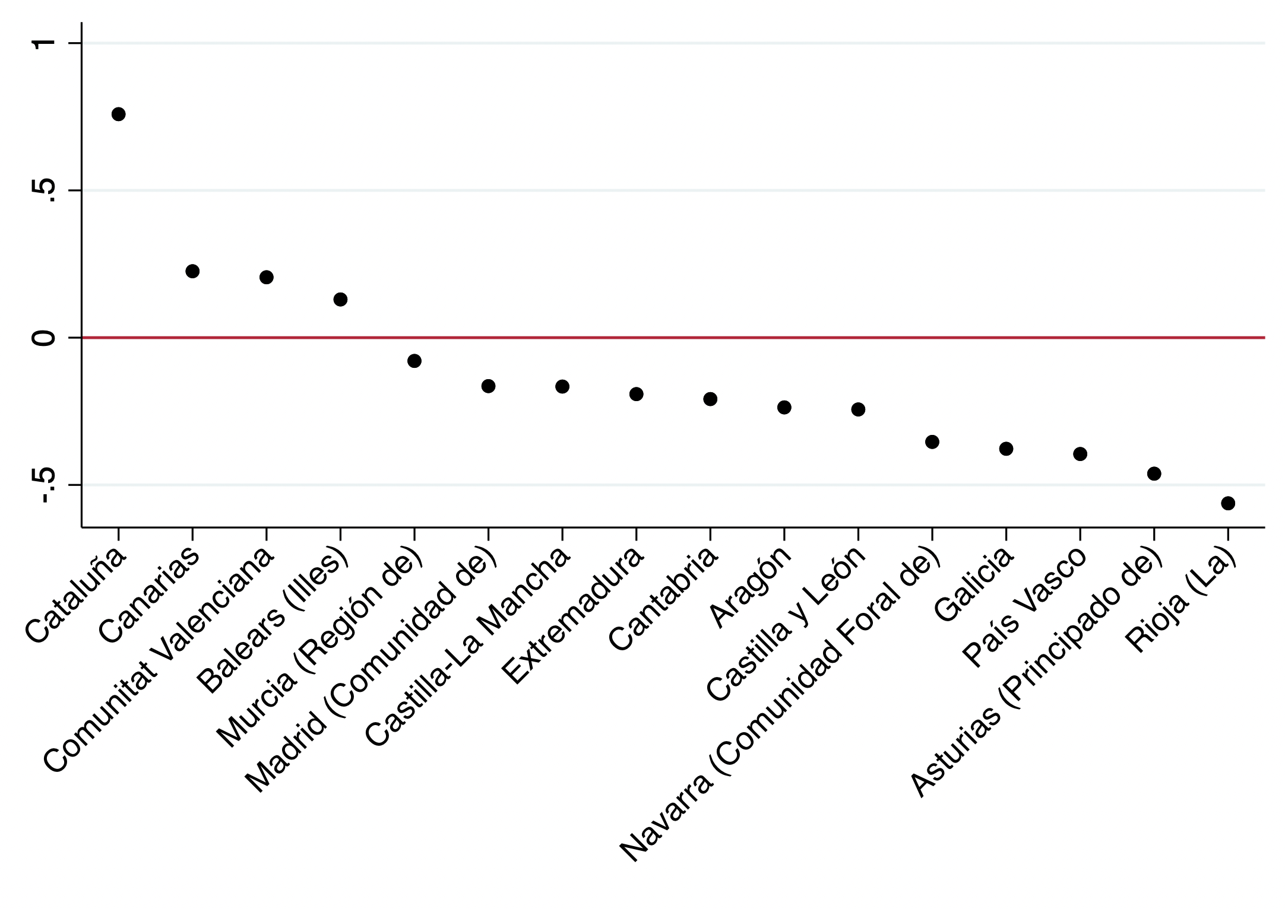
Notes:
- Andalucía is the region of reference.
- Coefficients from OLS estimations ranked from highest to lowest (Table 2).

Figure S2. Coefficients for regional fixed effects .Waiting times for specialist service (2011-2013).
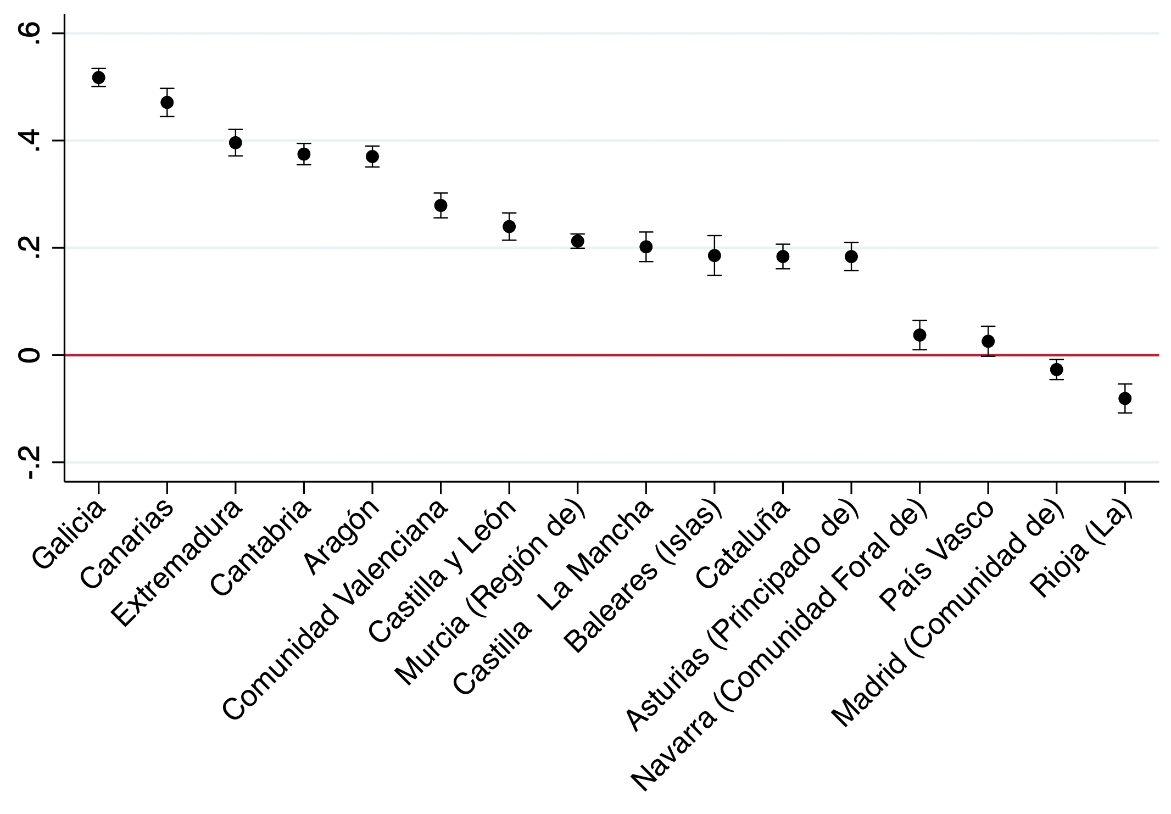
Notes:
- Andalucía is the region of reference.
- Coefficients from OLS estimations ranked from highest to lowest (Table 3).

