Additional File 1. Examples of customized graph and map outputs generated by the WHO Health Equity Assessment Toolkit: (a) horizontal line graph; (b) vertical bar graph; (c) horizontal bar graph; (d) map
- Horizontal line graph
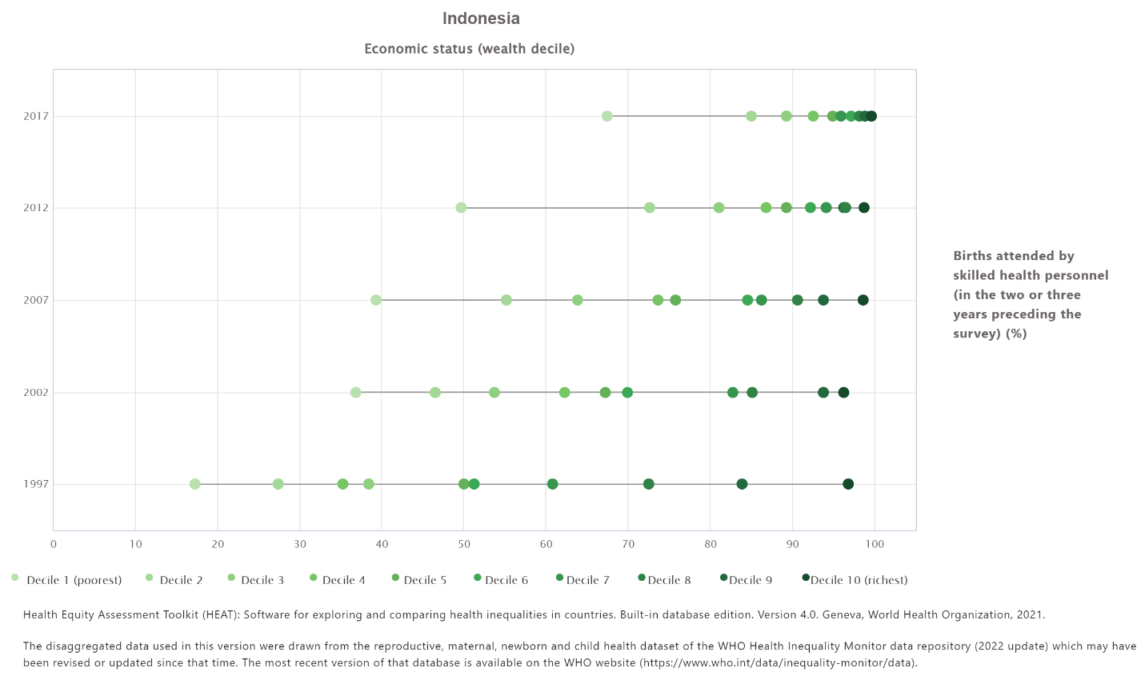
- Vertical bar graph
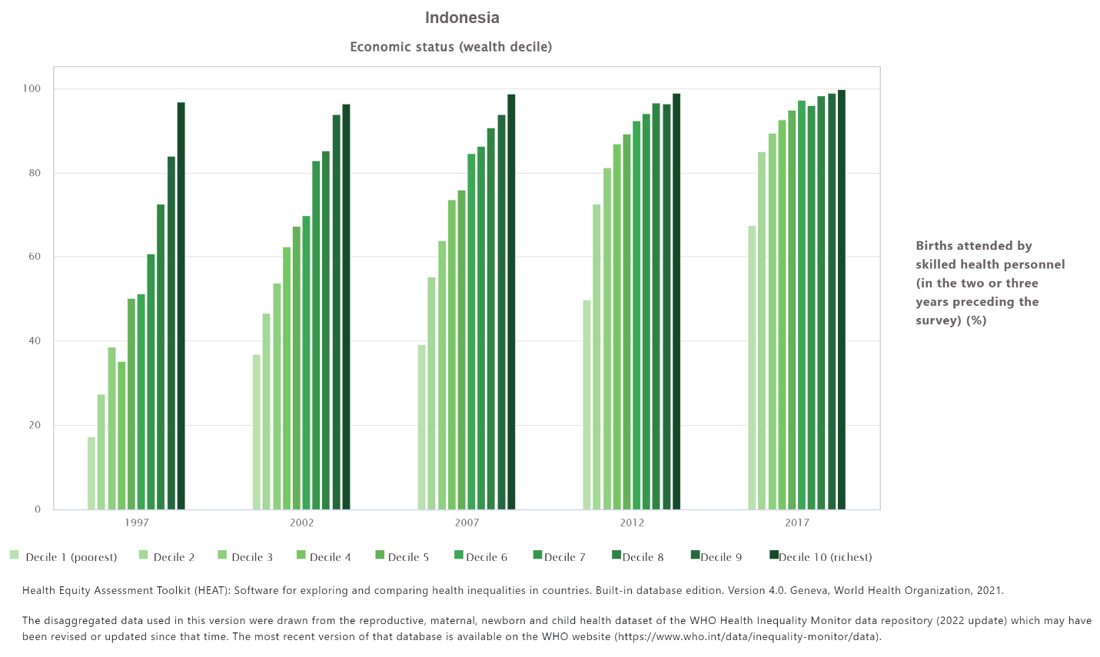

- Horizontal bar graph
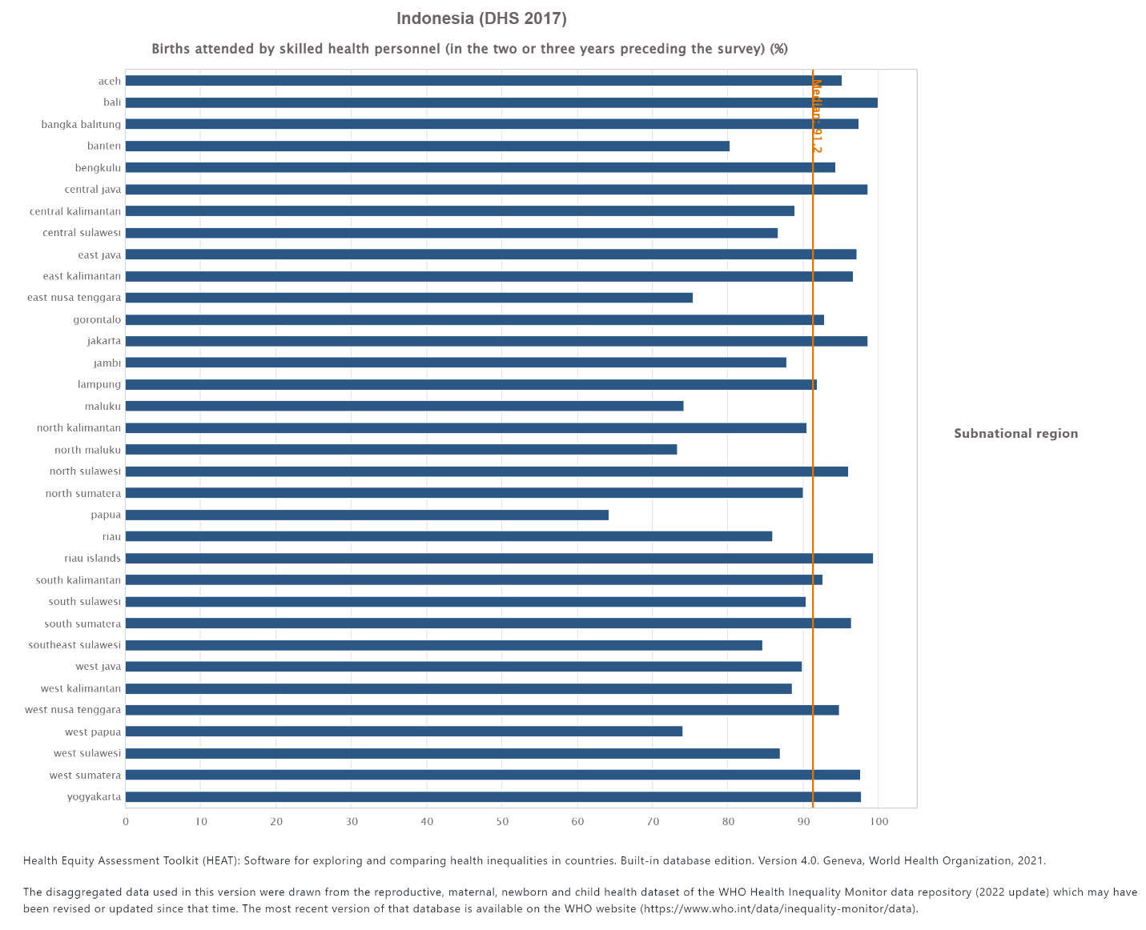

- Map
