Supplementary Material

Table A1 - Questions from the 2019 National Health Survey used for measuring violence victimization
Type of violence | Questions
Psychological | In the last 12 months, did someone humiliate, offend or ridicule you in front of other people?
Psychological | In the last 12 months, did someone scream at you or insult you?
Psychological | In the last 12 months, did someone use social networks or a cell phone to threaten, offend, insult or expose images without your consent?
Psychological | In the last 12 months, did someone threaten to hurt someone important to you?
Psychological | In the last 12 months, did someone destroy something yours on purpose?
Physical | In the last 12 months, did someone slap you?
Physical | In the last 12 months, did someone push, shove or throw something at you?
Physical | In the last 12 months, did someone punch you, hit you, or kick you?
Physical | In the last 12 months, did someone choke or burn you on purpose?
Physical | In the last 12 months, did someone threaten or hurt you with a weapon?
Sexual | In the last 12 months, did someone touch you, kiss you or expose part of your body without your consent?
Sexual | In the last 12 months, did someone threaten or force you to have sexual relationships without your consent?

Figure A1 - Lifetime victimization (sexual violence)
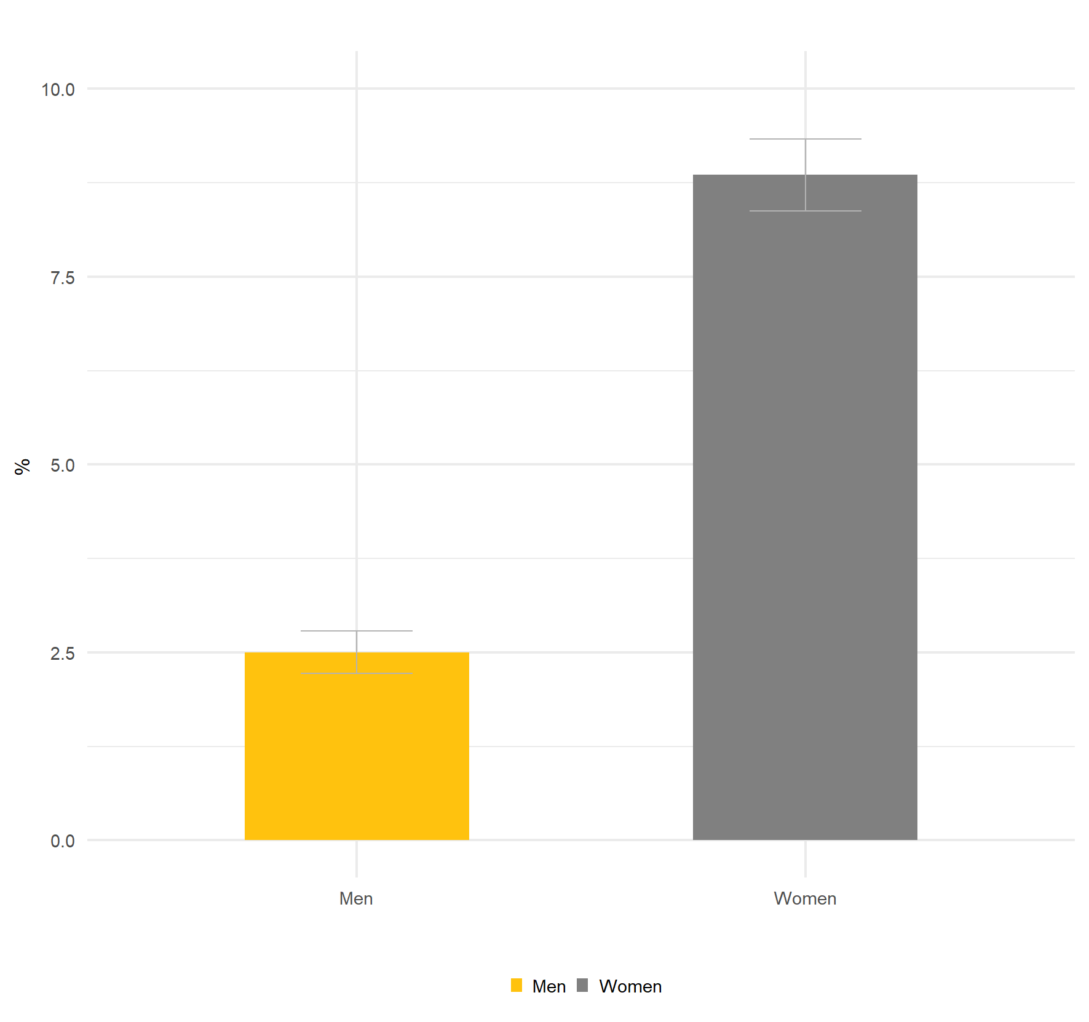
Note: The figure shows the prevalence of lifetime victimization to sexual violence. Victimization was defined as being the victim of at least one episode of sexual violence ever. All data were weighted according to the PNS survey design and survey weights.

Figure A2 - Frequency of aggressions and primary aggressor by type of violence
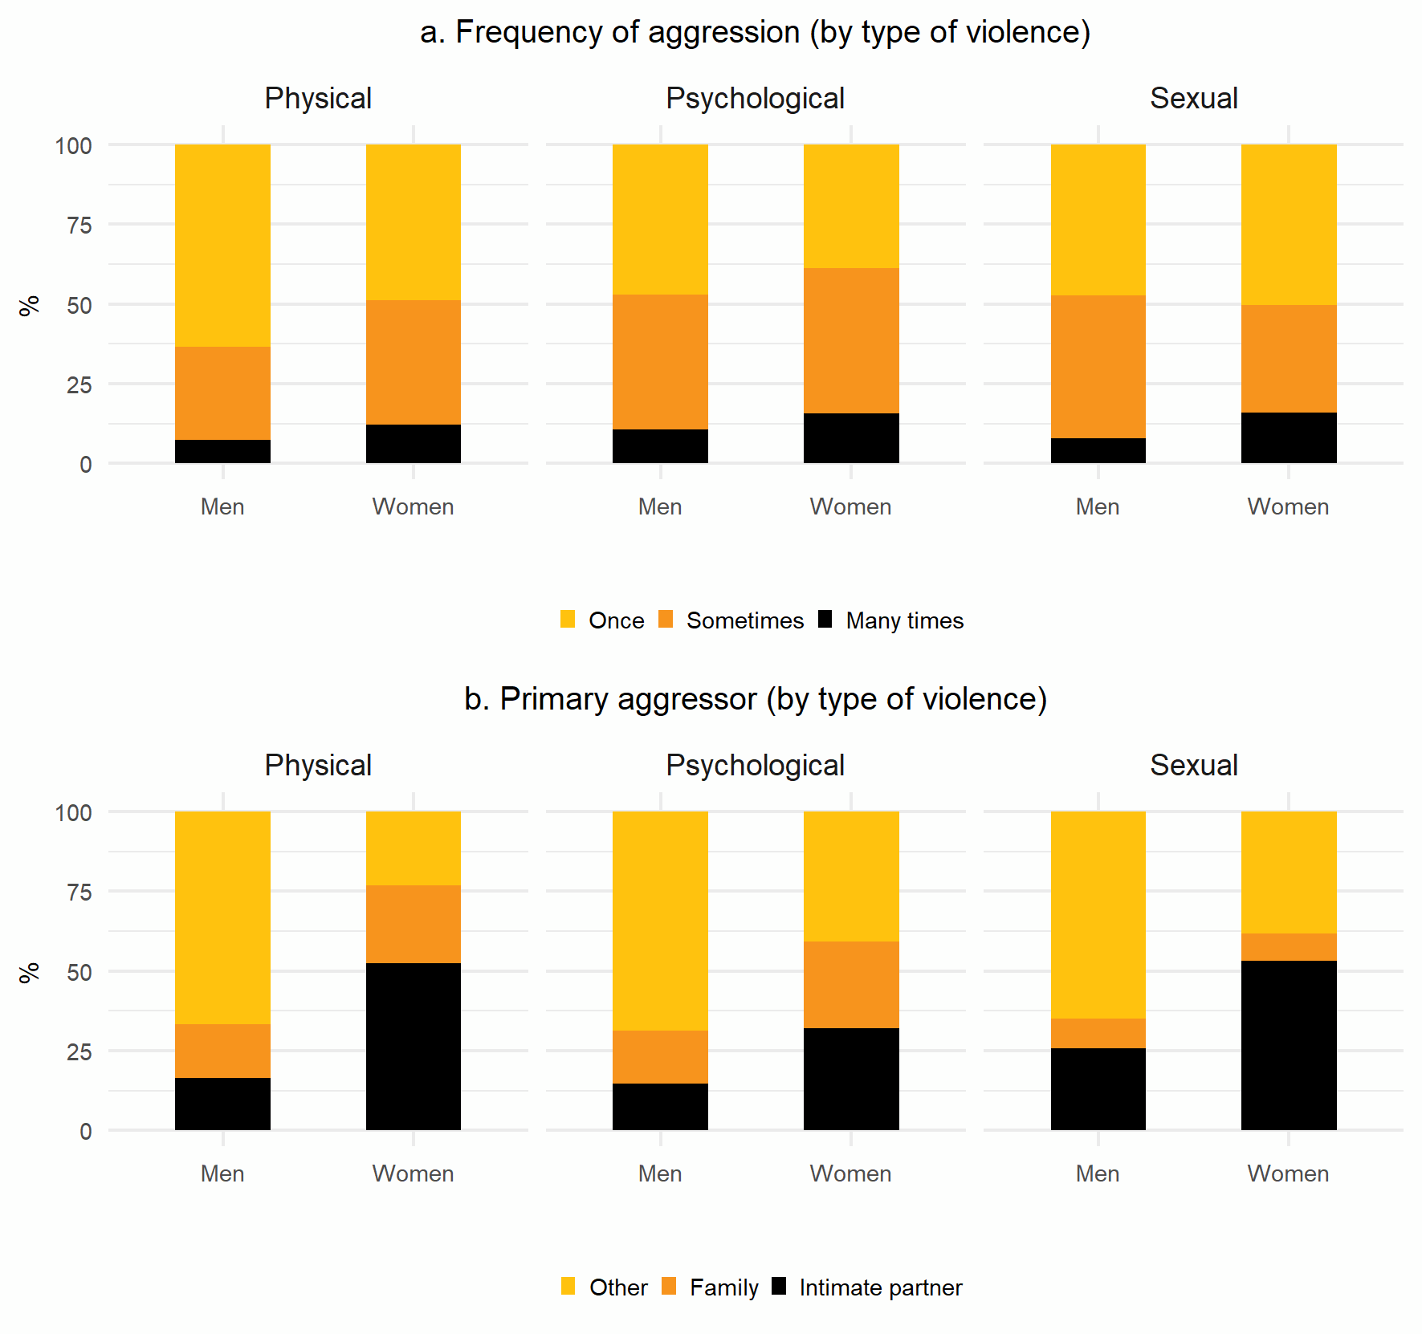
Note: The figure shows, for each type of violence, the frequency that it occurred (panel a) and the primary aggressor (panel b) according to sex/gender. For each type of violence, victimization was defined as being the victim of at least one violent episode in the past 12 months. Intimate partner includes any present or past intimate partner, family includes any family member other than the intimate partner, other known person includes friends/colleagues, employers and/or employees. All data were weighted according to the PNS survey design and survey weights.

Figure A3 - Inequality patterns in victimization and depression
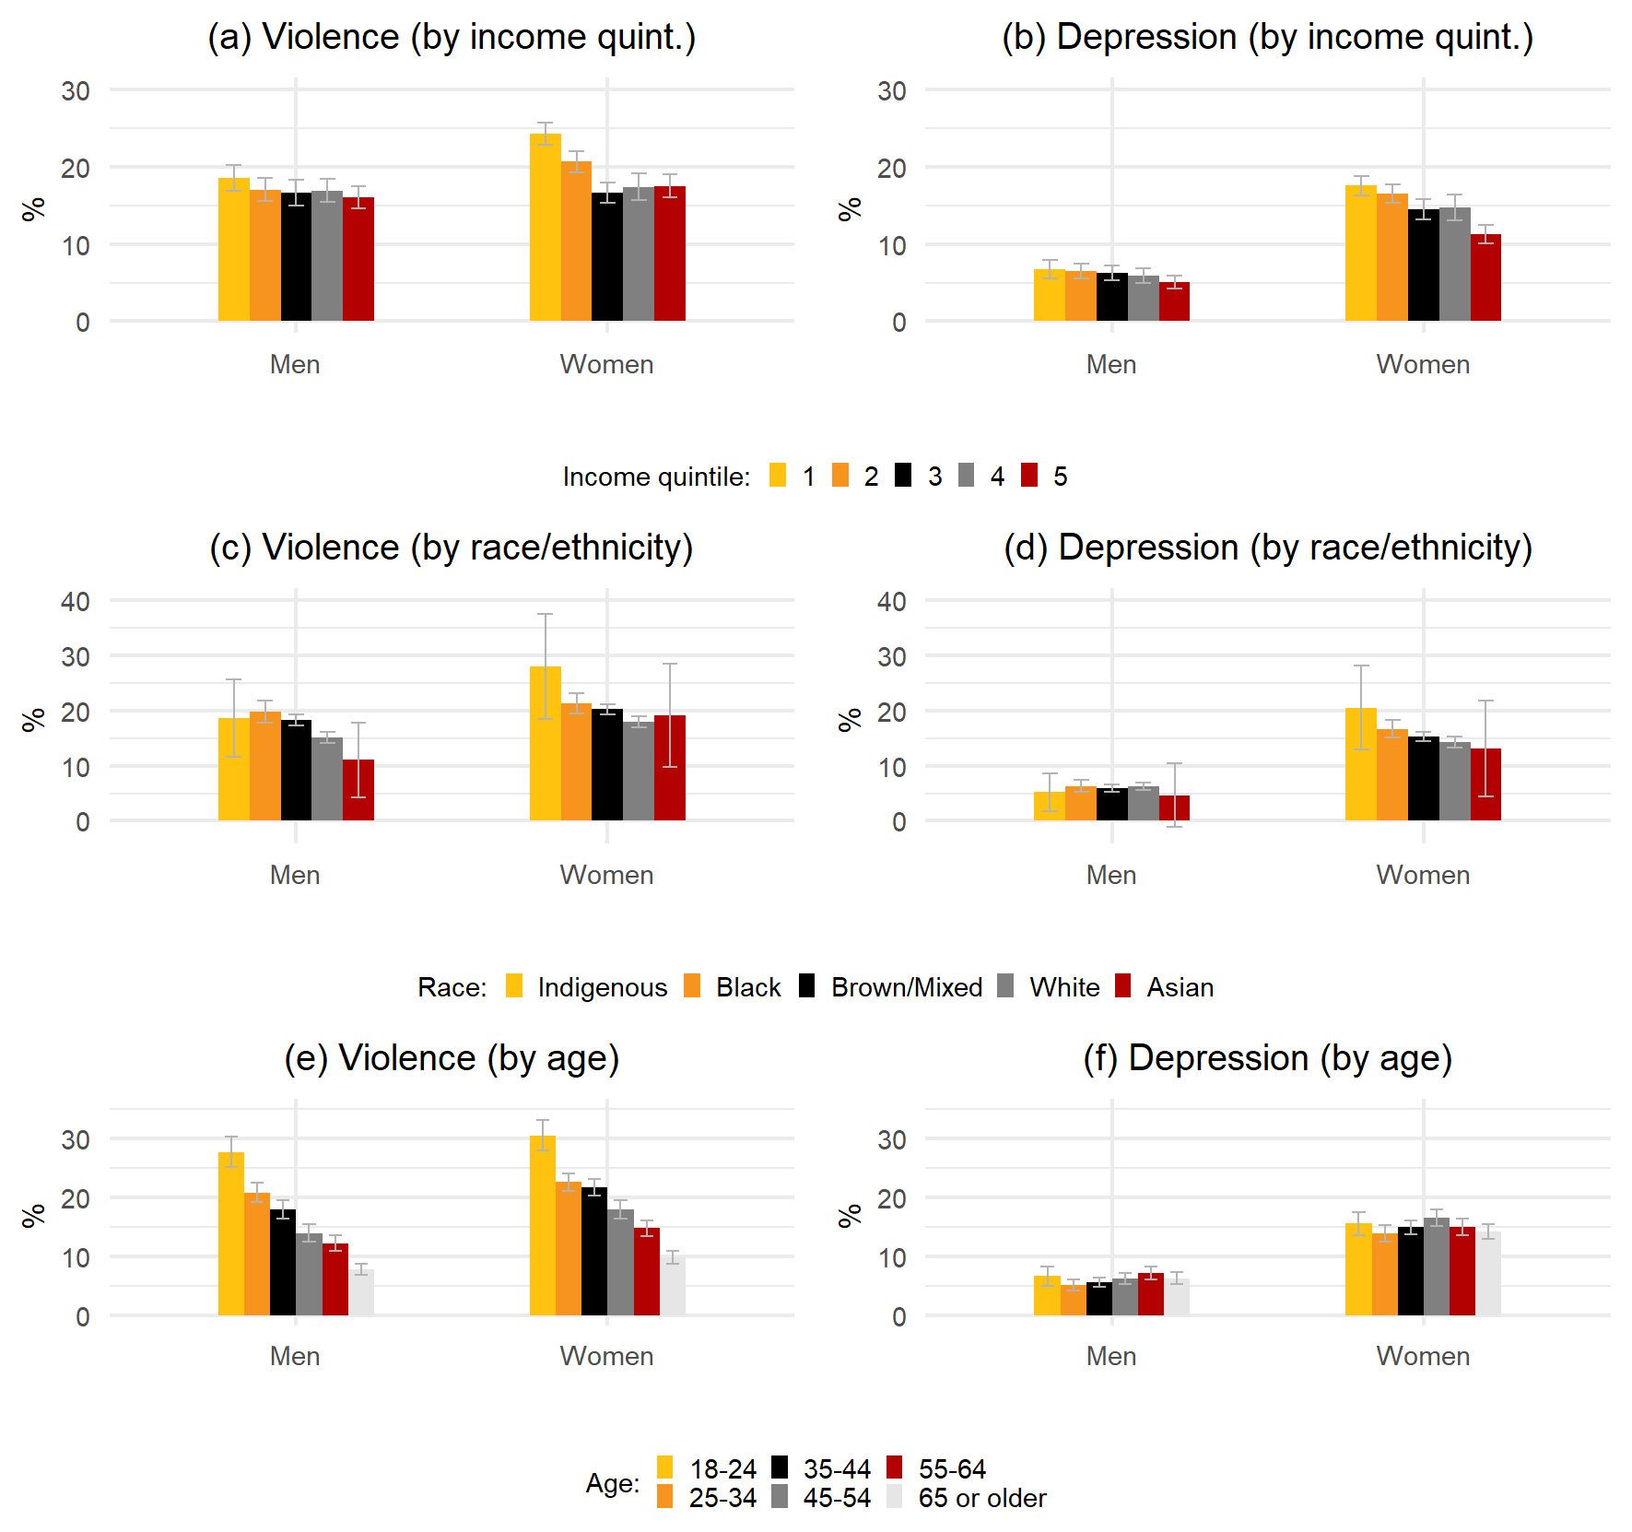
Note: The figure shows the prevalence of victimization and depression by sex/gender and income quintile (panels a and b), by sex/gender and race/ethnicity (panels c and d) and by sex/gender and age (panels e and f). Depression was defined as having a PHQ-9 score >= 10. Victimization was defined as being the victim of at least one violent episode in the past 12 months. Income quintile was defined according to household income per capita. All data were weighted according to the PNS survey design and survey weights.

Table A2 - Association between observable characteristics and violence victimization
 | (1) |  | (2) |  | (3) |  | (4)
 | Violence (any) |  | Psychological violence |  | Physical violence |  | Sexual violence
 | OR | 95%CI | OR | 95%CI | OR | 95%CI | OR | 95%CI
Sex (omitted: Men) | 1.331 | 1.238 - 1.430 | 1.351 | 1.254 - 1.455 | 1.300 | 1.123 - 1.505 | 3.215 | 2.336 - 4.426
Age (omitted: 18-24)
25-34 | 0.695 | 0.619 - 0.781 | 0.714 | 0.634 - 0.805 | 0.693 | 0.580 - 0.828 | 0.683 | 0.466 - 1.002
35-44 | 0.635 | 0.568 - 0.710 | 0.648 | 0.578 - 0.725 | 0.539 | 0.431 - 0.673 | 0.449 | 0.291 - 0.691
45-54 | 0.496 | 0.438 - 0.562 | 0.519 | 0.456 - 0.589 | 0.397 | 0.318 - 0.496 | 0.665 | 0.341 - 1.297
55-64 | 0.418 | 0.365 - 0.480 | 0.430 | 0.374 - 0.495 | 0.293 | 0.220 - 0.391 | 0.279 | 0.157 - 0.496
65 or older | 0.301 | 0.257 - 0.353 | 0.311 | 0.264 - 0.367 | 0.171 | 0.117 - 0.250 | 0.157 | 0.081 - 0.304
Income quintile (omitted: 1st)
2nd | 0.887 | 0.804 - 0.978 | 0.883 | 0.800 - 0.975 | 0.912 | 0.772 - 1.077 | 0.582 | 0.338 - 1.001
3rd | 0.835 | 0.749 - 0.932 | 0.830 | 0.741 - 0.928 | 0.828 | 0.687 - 0.999 | 0.591 | 0.313 - 1.119
4th | 0.825 | 0.719 - 0.947 | 0.825 | 0.716 - 0.950 | 0.834 | 0.608 - 1.144 | 0.777 | 0.391 - 1.541
5th | 0.805 | 0.699 - 0.928 | 0.797 | 0.689 - 0.922 | 0.836 | 0.629 - 1.112 | 0.617 | 0.282 - 1.348
Race/ethnicity (omitted: White)
Asian | 0.911 | 0.586 - 1.418 | 0.945 | 0.605 - 1.477 | 0.267 | 0.134 - 0.535 | 0.093 | 0.020 - 0.438
Black | 1.183 | 1.073 - 1.306 | 1.157 | 1.045 - 1.281 | 1.382 | 1.141 - 1.675 | 0.857 | 0.498 - 1.476
Brown/Mixed | 1.131 | 1.046 - 1.224 | 1.125 | 1.037 - 1.220 | 1.338 | 1.156 - 1.548 | 0.760 | 0.491 - 1.177
Indigenous | 1.417 | 0.958 - 2.096 | 1.450 | 0.978 - 2.151 | 1.127 | 0.668 - 1.902 | 0.993 | 0.395 - 2.498
Region of residence (omitted: South-East)
Center-West | 0.897 | 0.803 - 1.002 | 0.886 | 0.791 - 0.992 | 0.907 | 0.732 - 1.124 | 1.186 | 0.733 - 1.920
North | 0.903 | 0.806 - 1.012 | 0.880 | 0.783 - 0.989 | 1.010 | 0.830 - 1.229 | 1.106 | 0.654 - 1.869
North-East | 0.991 | 0.902 - 1.088 | 0.978 | 0.890 - 1.076 | 1.004 | 0.845 - 1.193 | 1.131 | 0.669 - 1.910
South | 0.927 | 0.833 - 1.032 | 0.925 | 0.829 - 1.031 | 1.051 | 0.845 - 1.306 | 0.654 | 0.370 - 1.155
Marital status (omitted: Single)
Married | 0.872 | 0.793 - 0.959 | 0.876 | 0.793 - 0.966 | 0.792 | 0.654 - 0.959 | 0.493 | 0.233 - 1.041
Divorced | 1.295 | 1.150 - 1.458 | 1.280 | 1.134 - 1.444 | 1.278 | 1.023 - 1.597 | 1.096 | 0.597 - 2.010
Widow | 0.791 | 0.672 - 0.931 | 0.816 | 0.690 - 0.965 | 0.900 | 0.606 - 1.337 | 0.448 | 0.206 - 0.972
Cohabitation (omitted: Alone)
Partner | 0.793 | 0.718 - 0.876 | 0.801 | 0.724 - 0.886 | 0.763 | 0.636 - 0.916 | 0.605 | 0.342 - 1.069
Other person | 0.903 | 0.823 - 0.989 | 0.897 | 0.817 - 0.985 | 0.910 | 0.766 - 1.082 | 1.013 | 0.719 - 1.427
Education (omitted: Basic incomplete)
Basic | 0.983 | 0.889 - 1.087 | 1.001 | 0.903 - 1.110 | 1.004 | 0.822 - 1.226 | 0.859 | 0.511 - 1.444
Secondary | 0.991 | 0.867 - 1.132 | 1.025 | 0.895 - 1.175 | 0.653 | 0.502 - 0.850 | 0.681 | 0.387 - 1.199
Higher | 0.896 | 0.822 - 0.977 | 0.915 | 0.838 - 1.000 | 0.686 | 0.569 - 0.827 | 0.763 | 0.481 - 1.210
Physical activity (omitted: No)
Less than weekly | 1.518 | 1.187 - 1.941 | 1.540 | 1.200 - 1.976 | 1.706 | 1.145 - 2.543 | 0.877 | 0.374 - 2.056
Once or twice a week | 1.142 | 1.037 - 1.259 | 1.133 | 1.026 - 1.252 | 1.104 | 0.904 - 1.348 | 1.346 | 0.901 - 2.013
Three or more times a week | 1.054 | 0.974 - 1.141 | 1.052 | 0.970 - 1.141 | 1.000 | 0.855 - 1.169 | 1.300 | 0.938 - 1.802
Alcohol consumption (omitted: Never)
Less than weekly | 1.105 | 1.007 - 1.213 | 1.086 | 0.989 - 1.192 | 1.283 | 1.075 - 1.530 | 1.321 | 0.905 - 1.928
Once a week | 1.115 | 0.999 - 1.245 | 1.112 | 0.994 - 1.243 | 1.132 | 0.934 - 1.371 | 1.096 | 0.704 - 1.704
More than once a week | 1.315 | 1.184 - 1.461 | 1.285 | 1.152 - 1.432 | 1.876 | 1.559 - 2.258 | 2.009 | 1.354 - 2.982
Employed (omitted: No) | 1.168 | 1.084 - 1.259 | 1.171 | 1.084 - 1.266 | 0.985 | 0.850 - 1.143 | 1.387 | 0.911 - 2.112
Urban area (omitted: No) | 1.437 | 1.314 - 1.572 | 1.430 | 1.305 - 1.567 | 1.508 | 1.268 - 1.793 | 1.079 | 0.728 - 1.599
Smokes tobacco (omitted: No) | 1.351 | 1.236 - 1.478 | 1.321 | 1.205 - 1.449 | 1.658 | 1.418 - 1.938 | 1.464 | 0.910 - 2.355
Private health insurance (omitted: No) | 0.990 | 0.903 - 1.084 | 0.998 | 0.909 - 1.096 | 0.836 | 0.677 - 1.031 | 0.765 | 0.518 - 1.129
Registered in public primary healthcare (omitted: No) | 0.973 | 0.905 - 1.047 | 0.974 | 0.904 - 1.050 | 0.994 | 0.851 - 1.162 | 1.276 | 0.929 - 1.751

Note: The table shows odd ratios (OR) quantifying the association between all covariates included in the analysis and violence victimization (total and by type of violence). Odds ratios were estimated using the results from four different fully adjusted logit models. All data were weighted according to the PNS survey design and survey weights.

Table A3 - Association between observable characteristics and depression
 | (1) |  | (2) |  | (3) |  | (4)
 | Depression |  | Depression, by type of violence |  | Depression, by primary aggressor |  | Depression, by frequency of violence
 | OR | 95%CI | OR | 95%CI | OR | 95%CI | OR | 95%CI
Violence (omitted: No) | 3.811 | 3.450 - 4.210
Type of violence (omitted: None)
Only physical |  |  | 1.764 | 1.207 - 2.578
Only psychological |  |  | 3.128 | 1.772 - 5.521
Only sexual |  |  | 3.494 | 3.155 - 3.870
Two types |  |  | 5.591 | 4.521 - 6.913
All types |  |  | 8.280 | 5.274 - 12.999
Primary aggressor (omitted: None)
Family (not partner) |  |  |  |  | 4.458 | 3.817 - 5.207
Intimate partner violence |  |  |  |  | 4.380 | 3.667 - 5.231
Other |  |  |  |  | 3.209 | 2.845 - 3.620
Frequency of violence (omitted: Never)
Low |  |  |  |  |  |  | 2.621 | 2.274 - 3.022
Moderate |  |  |  |  |  |  | 3.971 | 3.474 - 4.539
High |  |  |  |  |  |  | 6.100 | 5.188 - 7.172
Sex (omitted: Men) | 2.340 | 2.116 - 2.588 | 2.316 | 2.094 - 2.560 | 2.267 | 2.050 - 2.506 | 2.303 | 2.084 - 2.545
Age (omitted: 18-24)
25-34 | 1.026 | 0.866 - 1.215 | 1.028 | 0.866 - 1.219 | 1.019 | 0.860 - 1.207 | 1.020 | 0.860 - 1.209
35-44 | 1.118 | 0.943 - 1.325 | 1.136 | 0.958 - 1.348 | 1.116 | 0.941 - 1.323 | 1.120 | 0.945 - 1.327
45-54 | 1.256 | 1.055 - 1.495 | 1.268 | 1.063 - 1.513 | 1.252 | 1.051 - 1.492 | 1.247 | 1.047 - 1.486
55-64 | 1.083 | 0.893 - 1.314 | 1.105 | 0.911 - 1.340 | 1.084 | 0.894 - 1.315 | 1.083 | 0.892 - 1.314
65 or older | 0.911 | 0.740 - 1.121 | 0.928 | 0.754 - 1.142 | 0.907 | 0.737 - 1.117 | 0.912 | 0.740 - 1.123
Income quintile (omitted: 1st)
2nd | 1.020 | 0.904 - 1.151 | 1.027 | 0.909 - 1.161 | 1.024 | 0.907 - 1.156 | 1.032 | 0.914 - 1.166
3rd | 0.937 | 0.821 - 1.069 | 0.946 | 0.829 - 1.080 | 0.944 | 0.827 - 1.077 | 0.949 | 0.831 - 1.084
4th | 0.993 | 0.849 - 1.161 | 0.998 | 0.855 - 1.164 | 0.997 | 0.852 - 1.166 | 1.004 | 0.860 - 1.173
5th | 0.840 | 0.702 - 1.006 | 0.846 | 0.707 - 1.011 | 0.843 | 0.705 - 1.008 | 0.854 | 0.714 - 1.022
Race/ethnicity (omitted: White)
Asian | 0.793 | 0.435 - 1.444 | 0.810 | 0.444 - 1.477 | 0.786 | 0.437 - 1.414 | 0.807 | 0.433 - 1.506
Black | 1.020 | 0.896 - 1.160 | 1.023 | 0.899 - 1.164 | 1.025 | 0.900 - 1.166 | 1.021 | 0.897 - 1.162
Brown/Mixed | 0.959 | 0.875 - 1.052 | 0.956 | 0.871 - 1.049 | 0.961 | 0.876 - 1.054 | 0.954 | 0.869 - 1.048
Indigenous | 1.077 | 0.693 - 1.675 | 1.083 | 0.699 - 1.678 | 1.068 | 0.681 - 1.675 | 1.078 | 0.690 - 1.686
Region of residence (omitted: South-East)
Center-West | 1.016 | 0.895 - 1.154 | 1.019 | 0.898 - 1.156 | 1.015 | 0.894 - 1.153 | 1.023 | 0.901 - 1.160
North | 0.702 | 0.616 - 0.800 | 0.703 | 0.616 - 0.801 | 0.700 | 0.615 - 0.798 | 0.706 | 0.619 - 0.805
North-East | 0.896 | 0.807 - 0.996 | 0.899 | 0.808 - 1.000 | 0.897 | 0.807 - 0.997 | 0.901 | 0.810 - 1.002
South | 0.923 | 0.808 - 1.054 | 0.923 | 0.809 - 1.054 | 0.923 | 0.809 - 1.054 | 0.923 | 0.808 - 1.055
Marital status (omitted: Single)
Married | 1.012 | 0.906 - 1.130 | 1.021 | 0.913 - 1.141 | 1.015 | 0.909 - 1.134 | 1.017 | 0.911 - 1.136
Divorced | 1.197 | 1.040 - 1.378 | 1.205 | 1.046 - 1.387 | 1.191 | 1.034 - 1.371 | 1.197 | 1.039 - 1.379
Widow | 0.961 | 0.832 - 1.110 | 0.963 | 0.834 - 1.112 | 0.960 | 0.831 - 1.109 | 0.964 | 0.833 - 1.115
Cohabitation (omitted: Alone)
Partner | 0.877 | 0.767 - 1.002 | 0.878 | 0.767 - 1.004 | 0.868 | 0.759 - 0.992 | 0.878 | 0.767 - 1.004
Other person | 1.030 | 0.916 - 1.157 | 1.029 | 0.916 - 1.156 | 1.023 | 0.911 - 1.149 | 1.031 | 0.917 - 1.159
Education (omitted: Basic incomplete)
Basic | 0.916 | 0.800 - 1.049 | 0.906 | 0.791 - 1.039 | 0.912 | 0.797 - 1.045 | 0.915 | 0.799 - 1.049
Secondary | 0.836 | 0.713 - 0.981 | 0.841 | 0.717 - 0.987 | 0.844 | 0.720 - 0.990 | 0.853 | 0.727 - 1.001
Higher | 0.810 | 0.723 - 0.908 | 0.814 | 0.727 - 0.912 | 0.815 | 0.727 - 0.912 | 0.822 | 0.734 - 0.920
Physical activity (omitted: No)
Less than weekly | 1.077 | 0.767 - 1.514 | 1.062 | 0.752 - 1.498 | 1.062 | 0.757 - 1.491 | 1.080 | 0.760 - 1.534
Once or twice a week | 0.659 | 0.569 - 0.763 | 0.656 | 0.567 - 0.761 | 0.659 | 0.570 - 0.763 | 0.660 | 0.570 - 0.764
Three or more times a week | 0.674 | 0.605 - 0.751 | 0.674 | 0.605 - 0.750 | 0.674 | 0.604 - 0.751 | 0.675 | 0.606 - 0.752
Alcohol consumption (omitted: Never)
Less than weekly | 0.900 | 0.800 - 1.013 | 0.899 | 0.798 - 1.011 | 0.897 | 0.796 - 1.010 | 0.903 | 0.802 - 1.017
Once a week | 0.811 | 0.703 - 0.936 | 0.811 | 0.702 - 0.936 | 0.812 | 0.704 - 0.936 | 0.814 | 0.705 - 0.940
More than once a week | 0.835 | 0.725 - 0.962 | 0.818 | 0.708 - 0.944 | 0.831 | 0.721 - 0.957 | 0.830 | 0.720 - 0.957
Employed (omitted: No) | 0.657 | 0.600 - 0.718 | 0.657 | 0.600 - 0.718 | 0.660 | 0.603 - 0.722 | 0.659 | 0.602 - 0.721
Urban area (omitted: No) | 1.540 | 1.375 - 1.725 | 1.542 | 1.377 - 1.728 | 1.548 | 1.383 - 1.734 | 1.538 | 1.373 - 1.723
Smokes tobacco (omitted: No) | 1.507 | 1.344 - 1.691 | 1.500 | 1.335 - 1.685 | 1.500 | 1.337 - 1.683 | 1.485 | 1.322 - 1.668
Private health insurance (omitted: No) | 1.055 | 0.934 - 1.192 | 1.062 | 0.943 - 1.196 | 1.062 | 0.941 - 1.198 | 1.058 | 0.937 - 1.194
Registered in public primary healthcare (omitted: No) | 1.059 | 0.965 - 1.162 | 1.055 | 0.962 - 1.158 | 1.058 | 0.964 - 1.161 | 1.053 | 0.960 - 1.155
Note: The table shows odd ratios (OR) quantifying the association between all covariates included in the analysis and depression. Odds ratios were estimated using the results from four different fully adjusted logit models. In each model, a different variable was used to measure violence victimization (i.e., total, by type of violence, by primary aggressor, and by frequency of violence). All data were weighted according to the PNS survey design and survey weights.

Figure A4- Predicted probabilities for falling in the treatment gap for depression according to sex/gender and victimization
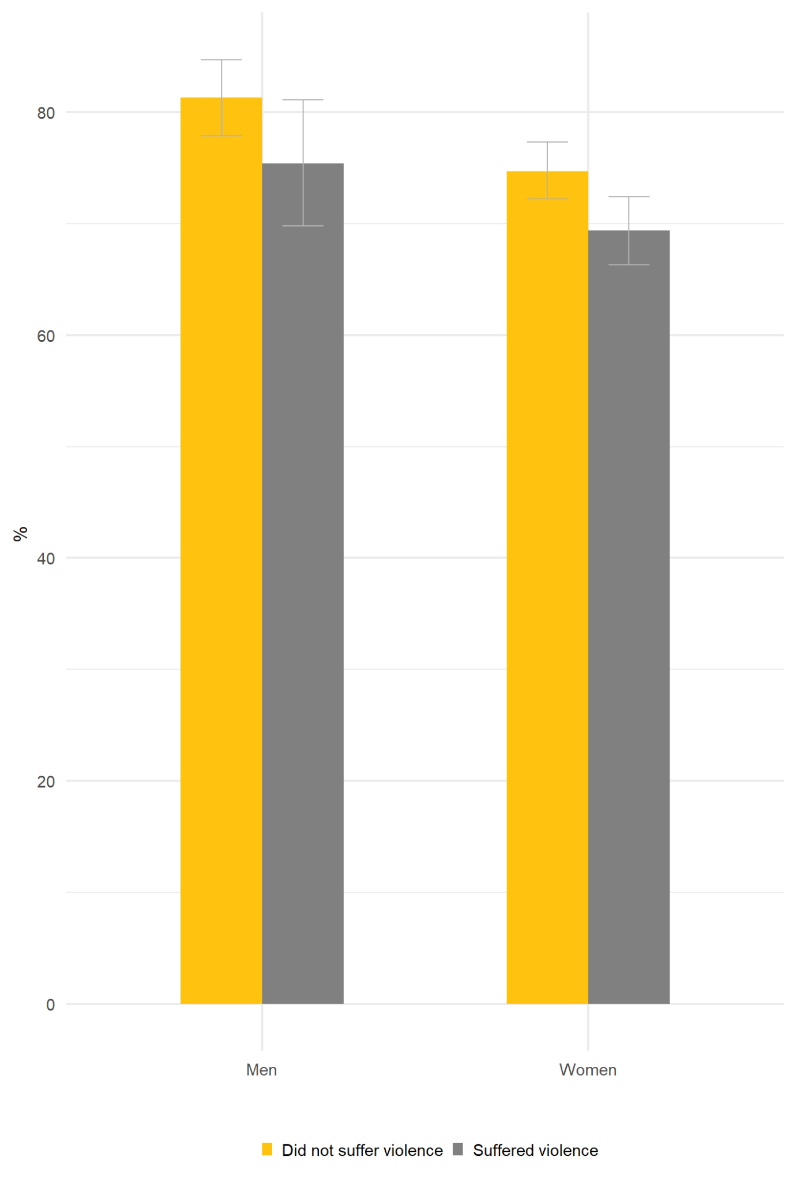
Note: The figure shows the predicted probabilities for falling in the treatment gap (i.e., being untreated, conditional on having depression) according to sex/gender, and violence victimization. Victimization was defined as being the victim of at least one violent episode in the past 12 months. Falling in the treatment gap was defined as having a PHQ-9 score >= 10 and not receiving any medical treatment for depression. Predicted probabilities were estimated using the results of logit models that included as covariates: sex/gender, victimization, the interaction term between sex/gender and victimization, income quintile, race/ethnicity, age, region of residence, area of residence (urban/rural), marital status, cohabitation, employment, education, alcohol consumption, tobacco consumption, physical activity, health insurance and registered in primary healthcare services. All other covariates were fixed at means. All data were weighted according to the PNS survey design and survey weights.

