SUPPLEMENTARY MATERIAL
Figure 5. Comparison of average cluster importance and applicability ratings according to sex
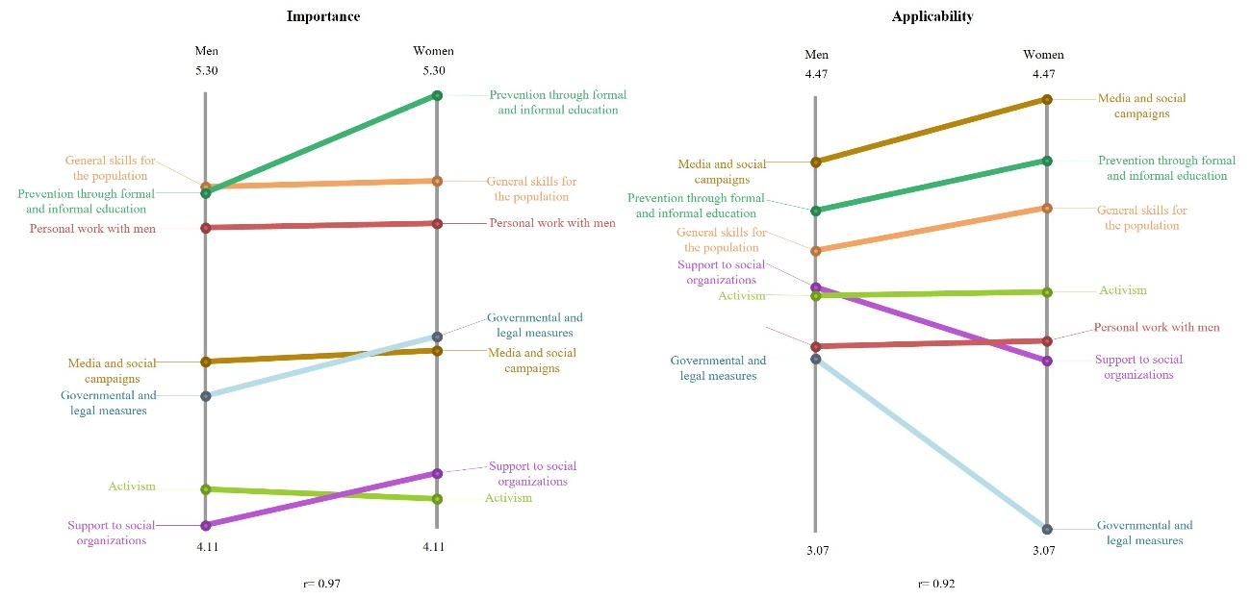
Source: Own elaboration

Figure 6. Comparison of average cluster importance and applicability ratings according to sexual orientation
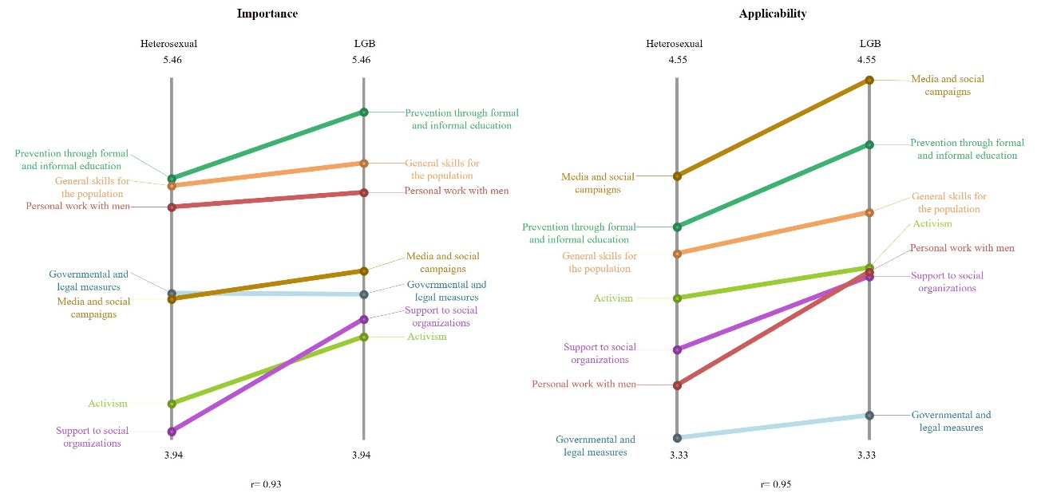
Source: Own elaboration

